Idea 1:
Create 1 or more completely unique t-shirt designs targeted at turntable/vinyl enthusiasts. Text ideas could be: ‘Turntable Technician’ / ‘Vinyl is Final’ / ‘Strictly Vinyl’ / ‘Vinyl Sounds Better’

Examples for reference only:

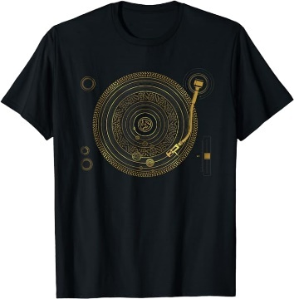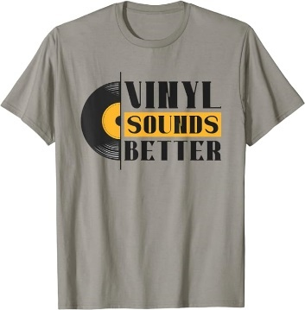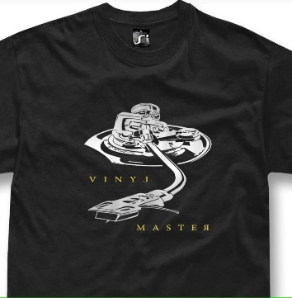

Idea 2:
Create 1 or more completely unique t-shirt designs targeted at ‘Technics’ enthusiasts. Text ideas could be: ‘Technics Till I Die’ / ‘Technics: The Gold Standard’

Example for reference only:

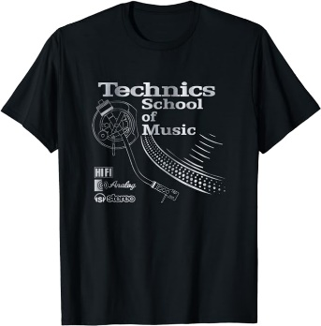

Idea 3:

Recreate a completely unique version of this idea. Use the same text but change everything else.

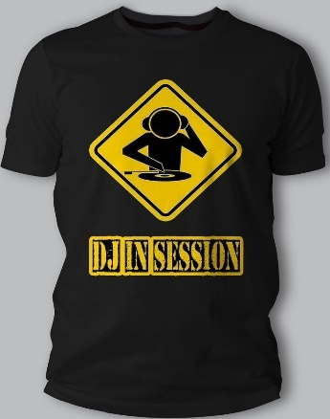

Idea 4:

Create a unique T-shirt design using the text ‘’don’t suck corporate cock’’

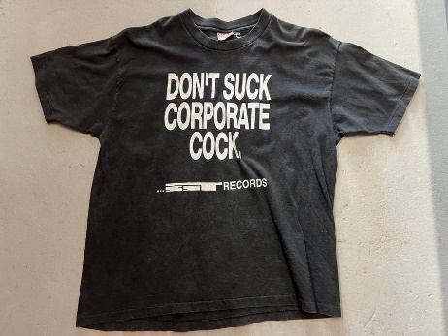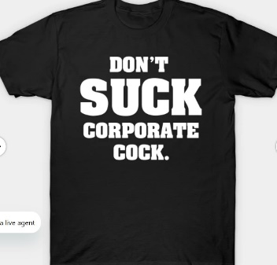

Idea 5:

Create a completely unique design (in any way you see fit) using the text: ‘’Because your Spotify playlist just wasn't enough’’.

Idea 6:

Create a completely unique design (in any way you see fit) using the text: ‘’Sure, I'll turn down the bass... if you leave’’

Idea 7:

Create a completely unique design (in any way you see fit) using the text: ‘’I'm only here for the free drinks’’ (from a DJs perspective).

Idea 8:

Create a completely unique design (in any way you see fit) using the text: ‘’DJing: The art of ignoring song requests’’

Idea 9:

Create a completely unique design (in any way you see fit) using the text: ‘’DJs: Making bad dancers look good since forever’’

Idea 10:

Create a completely unique design (in any way you see fit) using the text: ‘’My neighbours love my bass... whether they like it or not’’

Idea 11:

Create a completely unique design (in any way you see fit) using the text: ‘’Oh, you DJ too? How original’’

Idea 12:

Create a completely unique design (in any way you see fit) using the text: ‘’DJing: The perfect job for ignoring everyone’’

Idea 13:

Create a completely unique design (in any way you see fit) using the text: ‘’Oh, you're a music expert now? Fascinating’’

