GRAPHIC DESIGN CREATIVE BRIEF

CLIENT
PROJECT TITLE
Surepath Logo Design Brief
CLIENT NAME
Michael Zerafa

BRAND
Surepath
PRODUCT
Electrical engineering consultants
AUTHOR NAME | TITLE | DATE
JASON LE | Director | 16/7/2024
AGENCY INFO
POINT OF CONTACT NAME | EMAIL ADDRESS | PHONE
Jason Le | jason@eastenddigital.com.au | 0413 702 703
MAILING ADDRESS
3/777 George St. Sydney NSW 2000
PROJECT OVERVIEW
PURPOSE why?
We are looking to create a logo for an electrical engineering company. Most of their services focus on providing electrical engineering services to commercial building developers.
OPPORTUNITY ultimate impact?
The ultimate impact of this project is to ensure that the logo stands out and gives it a pop to get people drawn into our logo. They also want to create something , that would let them target targets electrical design and construct commercial projects - generally new builds or major refurbishments but also diversifying to service and maintenance type works for existing buildings/facilities, and other specialty areas within this space.
SO finding a healthy balance in between the two is a key factor for the creative logo.

OBJECTIVE what does the project work to achieve?
The objective is to create logo design that provides a modern, friendly, cost effective and trades look and feel. To achieve this, Surepath wants a logo that stands out and can be used across various online marketing channels and traditional marketing channels (Letterheads, signage, business cards, uniforms, hardhats and vehicles). The design should also align with our brand's values and personality, creating a strong and cohesive visual representation of our business.
CREATIVE / DESIGN ELEMENTS what are the fundamental creative / design components of the project?
i.e. style guides, look and feel, specific printed pieces
- Look and feel of the logo:
- Modern
- Friendly
- Cost effective
- Trades.

- Colour palettes:
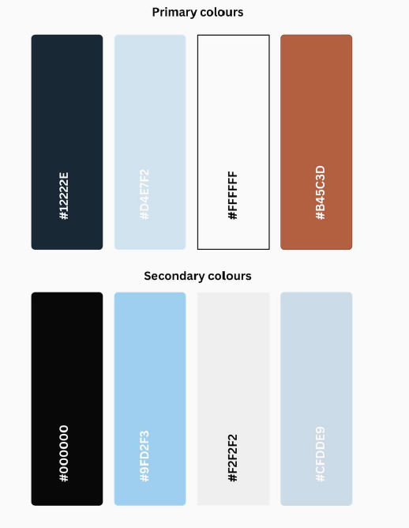
- Font example:


- Symbol example:

- We like the pathway it creates. A path running through the logo/symbol.
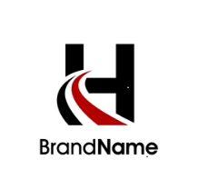


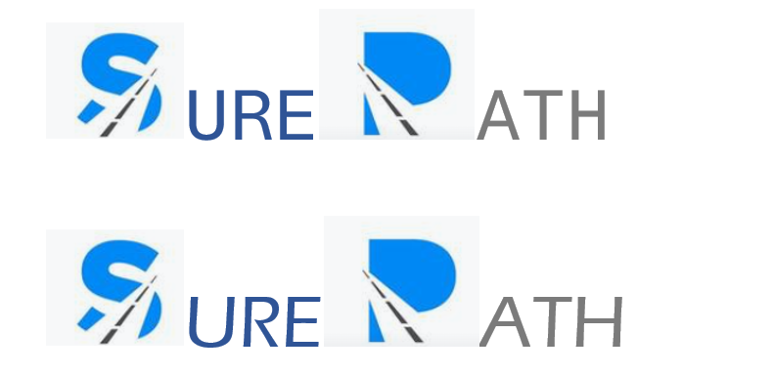
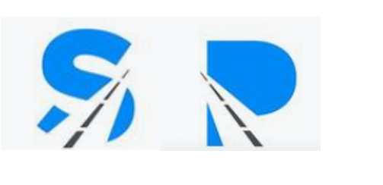

BUSINESS INFORMATION

BUSINESS OVERVIEW: what do you do? what is unique about your business?
Surepath is a new company that provides electrical engineering services.
- Design, supply, installation and project management of electrical services in the construction industry.
To build a diverse and well-structured business that can offer services in a broad range of sectors and market segments.

TARGET AUDIENCE
PROJECT TARGET who are we trying to reach?
Construction – Principal Contractors (builders)
Fit out works - Principal Contractors (builders)
Service and CAPEX – Facility managers, business owners & Principal Contractors.
Labour hire – Electrical and other subcontractors (not sure if we’re going to pursue this one)
Market | Potential Clients (Examples)
Construction | ADCO  ICON  Buildcorp
Fit out Works | Renascent
Service CAPEX | Colliers
Labour Hire & Minor Works | Electrical contractors

BRAND TARGET who does the brand speak to?
Surepath is a new B2B company. The location at this stage is Sydney only, but we would look to expand our reach in the future. Some of our current clients have national reach and a presence overseas also.

DESIRED REACTION what actions do you wish your market to take?
We promote robust project controls and systems to ensure we remain proactive with respects to, procurement, labour and resource management, program management and quality and safety and quality management.
ATTITUDE
PROJECT TONE what traits are we trying to convey?
We aim are competitive, whilst offering a full service.
BRAND PERSONALITY what characteristics define the brand?
  - Building solid relationships with clients and partners.
  - Building good business culture for staff at all levels.
  - Build simple but robust company systems and processes. Characterize and build the behavior we want to see.
  - To embrace industry & technology changes for efficiencies & profitability – don’t get left behind

COMPETITIVE ANALYSIS
REFERENCES research, inspiration, and styles
https://gridelectrical.com.au/

https://www.utechpty.com.au/

https://www.fipelectrical.com.au/

Our main competitors
  - Grid Electrical Services
  - FIP Electrical
  - Kerfoot
  - Utech
  - ARA Group

THE TAKEAWAY what is the key idea to be remembered?
The primary objective of our logo is to create a design that is visually striking and memorable. It should immediately capture attention and convey our brand’s identity in a compelling way. The logo needs to stand out effectively across various marketing materials, including digital platforms, print media, merchandise, and any other promotional assets.
TAG LINE prepared copy, key words, or theme
n/a

CREATIVE
VERBIAGE  what name should be included in the logo? | 2 variations.  One of the logos saying: “Surepath”  The other one saying “SP” saying the same.
TAG LINE  if applicable | n/a
IMAGERY  what images, if any, should be included in the logo? | A path running through the logo.
DESIRED DESIGN STYLE  include reference images, if applicable | Font example:  Symbol example:  - We like the pathway it creates.
COLORS  & OTHER VISUAL CONSIDERATIONS | - Color palettes:
INTENDED USE  signage, business cards, etc. | Letterheads, signage, business cards, uniforms, hardhats and vehicles.

