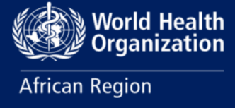

Progress Report:

Managing the Unprecedented Dengue Surge in the WHO African Region - Insights, Achievements, Challenges, and Future Directions

June 2024

World Health Organization (WHO) Regional Office for Africa – Dengue Incident Management Support Team

- EXECUTIVE SUMMARY
The World Health Organization's African Regional Office (WHO AFRO) is proactively addressing dengue outbreaks across the African continent. The report presents a detailed account of the present situation, recent advancements, major challenges, and comprehensive efforts by WHO AFRO to manage and minimize the impact of dengue. The purpose is to consolidate resources, improve coordination, and bridge critical gaps in regional response to dengue.

Since early 2023, dengue has surged globally, with over 5 million cases and 5,000 deaths reported in all WHO regions. The WHO declared the global dengue risk to be high and issued a G3 emergency response grade in late 2023. The WHO- AFRO is addressing an unprecedented outbreak across Africa, where cases rose 9.42 times compared to 2019. WHO-AFRO aims to reduce dengue incidence by 25% by 2030, employing strategic interventions and activating the Regional Dengue Incident Management Support Team (IMST). The dengue regional IMST supports affected countries or member states by efficiently implementing core IMS functions: enhancing leadership and coordination, ensuring planning and monitoring, providing operational support and logistics, offering technical expertise in health operations, ensuring health information and epidemiology, coordinating and engaging partners, and mobilizing resources. It also ensures the implementation and evaluation of performance standards and procedures for the first 90 days.

In terms of epidemiology, dengue outbreaks were reported in 15 out of 47 countries within the region in 2023, including notable outbreaks in Burkina Faso, Ethiopia, and Nigeria. Peak outbreaks occurred during epidemiological week 44, with 16,000 suspected and nearly 8,000 confirmed cases. By epidemiological week 17 of 2024, 13 countries remained affected, reporting 31,074 cases and 57 deaths, with a significant portion of cases in Burkina Faso and Mauritius. Priority country evaluations indicated severe outbreaks, such as Burkina Faso's report of 174,356 cases and nearly 772 deaths since early 2023, and Mauritius' 7,177 cases with 1,523 deaths in the early months of 2024.

Significant achievements include activating the Regional Dengue IMST, which includes experts in neglected tropical diseases and health emergencies, developing dengue preparedness and response guidance in multiple languages, deploying highly qualified specialists such as senior entomologists and epidemiologists, and mobilizing $2 million USD to support critical dengue response initiatives. Other important achievements included the development and implementation of a comprehensive dengue risk mapping tool, as well as the regular production and dissemination of comprehensive regional situation reports (SITREPs). WHO AFRO's capacity-building initiatives included a significant 5-day dengue webinar series in early 2024, featuring 20 reputable global experts and attended by over 500 professionals from around 50 countries. These webinars formed a crucial resource for sharing innovative solutions and best practices, enhancing regional preparedness and response efforts. In terms of operations support and logistics, WHO AFRO sent more than 6.44 tons of vector control materials, essential medicines, laboratory reagents, and other supplies from strategic hubs in Nairobi and Dakar. These hubs established a robust logistics system that provided essential support for member states.

Nevertheless, the report identifies ongoing critical gaps such as shortages of supplies, funding, skilled personnel, and technical capacities. Specific needs include more insecticides, rapid diagnostic tests, sample kits, funding for comprehensive response plans, and trained staff for vector control and data management. Vital next steps involve enhancing integrated surveillance systems for arboviral diseases, advancing vector control strategies, improving resource mobilization, and documenting experiences to inform future responses. These measures are crucial for WHO AFRO's continuous effort to reduce dengue's impact and build resilience against future outbreaks in the African region. The collaborative approach between WHO AFRO, regional entities, and member states underscores the collective effort required to effectively manage and mitigate dengue outbreaks.

- INTRODUCTION
Since the beginning of 2023, the world has been facing an upsurge in dengue cases and deaths reported in endemic areas, with further spread to areas previously free of dengue. All six WHO regions have recorded over 5 million dengue cases and over 5,000 dengue-associated deaths. WHO assessed the global risk of dengue as high on November 30, 2023, and subsequently assigned a WHO internal emergency response grade of G3 at the global level on December 1, 2023. Given the current scale of dengue outbreaks, the potential risk of further international spread, and the complexity of factors impacting transmission, we continue to assess the overall risk at the global level as high, thereby maintaining dengue as a global threat to public health. The resurgence of dengue is a reminder of the global threat of mosquito-borne diseases.
The World Health Organization's African Regional Office (WHO AFRO) is proactively addressing an unprecedented dengue outbreak since 2023 across the African continent. The on-going multi-country dengue outbreak began in 2023, with cases rising 9.42 times compared to 2019, marking an unprecedented spike in the African region. The escalating dengue menace in Africa demands immediate, unified action. Climate change, vector expansion, fragile healthcare systems, and demographic shifts drive its rise. This report aims to streamline the regional response to dengue.
WHO-AFRO’s strategic goals aim to significantly reduce the dengue burden by 2030, including empowering nations to counter outbreaks, eliminating preventable deaths, and reducing incidence by 25% from the 2010–2020 baseline. To support these goals, WHO-AFRO has mobilized the Regional Dengue Incident Management Support Team (IMST) to enhance coordination, follow-up response activities, disseminate situation reports and preparedness guidelines, conduct risk assessments, and implement strategic interventions in priority countries. The rapid spread of dengue in Africa, driven by climate change, vector proliferation, healthcare weaknesses, and demographic changes, necessitates a coordinated response. WHO-AFRO is actively addressing outbreaks across multiple countries.
This progress report outlines the current situation, progress, challenges, and WHO-AFRO’s efforts to manage and mitigate dengue's impact. It serves as a strategic guide to bolster and streamline regional dengue preparedness and response, detailing key activities, achievements, challenges, and next steps. The report aims to consolidate resources, improve coordination, and address critical gaps in the regional response.
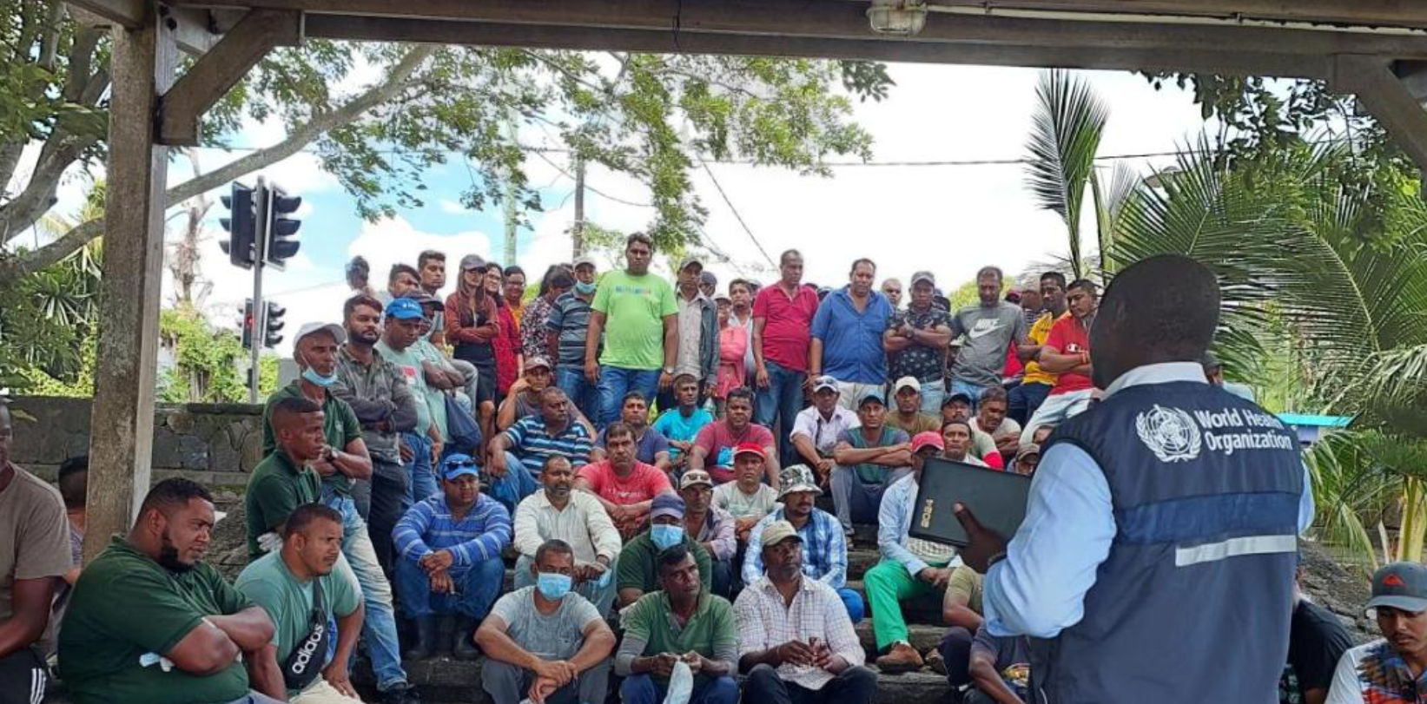

- EPIDEMIOLOGICAL SITUATION
Epidemiology of Dengue
Dengue virus (DENV) is transmitted to humans through the bite of infected mosquitoes typically in tropical and sub-tropical climates worldwide, mostly in urban and semi-urban areas. The primary vectors that transmit the disease are Aedes aegypti and, to a lesser extent, Aedes albopictus mosquitoes, though in some regions such as Europe and North America this latter vector is more widespread.
DENV has four serotypes (DENV-1, DENV-2, DENV-3, DENV-4). Infection with one serotype provides long-term immunity to the same serotype and only transient immunity to the other serotypes, after which secondary infections with a different serotype increase the risk for severe dengue. Dengue cases are most commonly asymptomatic or result in mild febrile illness. However, some cases will develop severe dengue, which may involve shock, severe bleeding or severe organ impairment. This stage often starts after the fever has gone away and it is preceded by warning signs such as intense abdominal pain, persistent vomiting, bleeding gums, fluid accumulation, lethargy or restlessness, and liver enlargement.
There is no specific treatment for dengue, but the timely diagnosis of dengue cases, identification of warning signs for severe dengue, and appropriate clinical management are key elements of care to prevent the progression to severe dengue and deaths.
Global dengue situation update
The global dengue situation has significantly worsened, with over 5 million cases and 5,000 deaths reported since 2023, prompting WHO to upgrade dengue to a Grade 3 emergency. By April 30, 2024, more than 7.58 million dengue cases, including 3.4 million confirmed, over 15,000 severe cases, and over 4,000 deaths, had been reported, with a sharp increase, particularly in the Region of the Americas, reaching over 7 million cases in 2024 alone. This represents a threefold increase compared to the same period in 2023.
Dengue transmission is ongoing in five of the six WHO regions, with no cases reported in the European region so far in 2024. Factors contributing to the rising risk include longer dengue transmission seasons, changes in vector distribution, climate change effects, fragile health systems in crisis-stricken countries, and the movement of infected people and vectors. Currently, 91 Member States are experiencing active dengue transmission in 2024, but the true burden of dengue is likely underestimated due to inadequate detection and reporting. Robust dengue surveillance systems are urgently needed to monitor the epidemiological situation, address co-circulation and misdiagnosis issues, and control the spread effectively. WHO is establishing a global dengue surveillance system with monthly reporting across all regions to strengthen global monitoring and response.
Figure 1: Geographical distribution of reported cases from January to April 2024*.
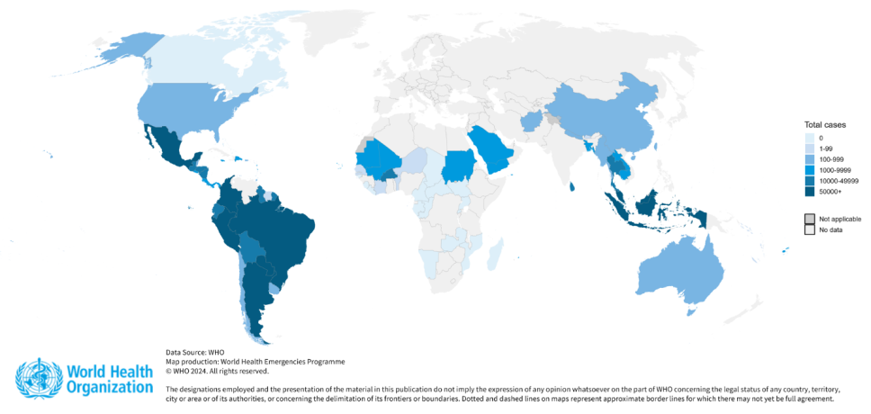
*Note; only 109 countries integrated in the WHO global surveillance system are shown
Summary of the Dengue Situation in the WHO African Region (as of April 28, 2024)

Outbreaks in 2023:
- Affected Countries: Benin, Burkina Faso, Cabo Verde, Chad, Côte d'Ivoire, Ethiopia, Ghana, Guinea, Mali, Mauritius, Niger, Nigeria, São Tomé and Príncipe, Senegal, and Togo.
- Peak Period: During epidemiological week 44, there were 16,000 suspected cases and nearly 8,000 confirmed cases.
- Trend: Dengue cases surged 9.42 times compared to 2019, indicating an unprecedented spike in the region.

2024 Update:
- Current Status: As of epidemiological week 17 (April 28, 2024), active transmission continues in 13 countries.
- Cases & Deaths: A total of 31,074 cases (14,095 confirmed) and 57 deaths have been reported.
- Surveillance Data: Reports are available from 29 countries, with 16 countries recording zero cases through their Integrated Disease Surveillance and Response (IDSR) frameworks.
- Recent Data: In the past four weeks (epi weeks 14-17), there have been 4,992 new cases and six deaths reported.
- High-Burden Areas: Burkina Faso and Mauritius account for over three-quarters of the reported cases in 2024.
- Serotypes: Three dengue serotypes (DENV-1, DENV-2, DENV-3) have been identified circulating in the region.

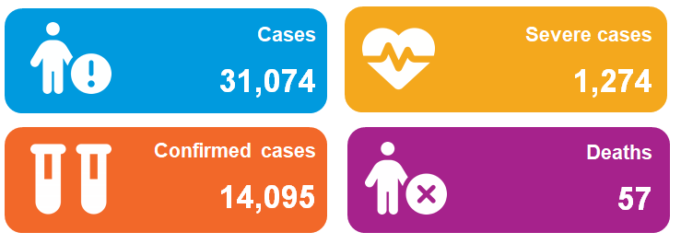
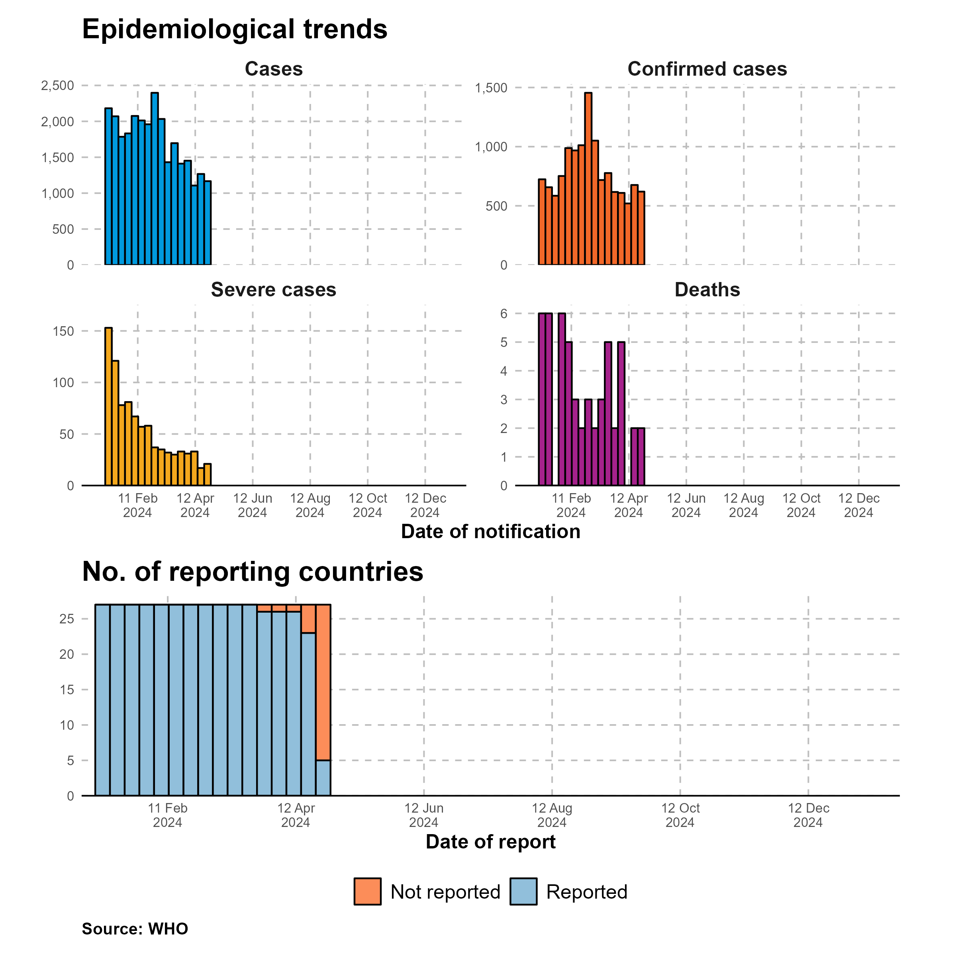

Figure . Regional trends in reported dengue cases from 2017 to 2024 in the WHO African Region, as of 31 May 2024
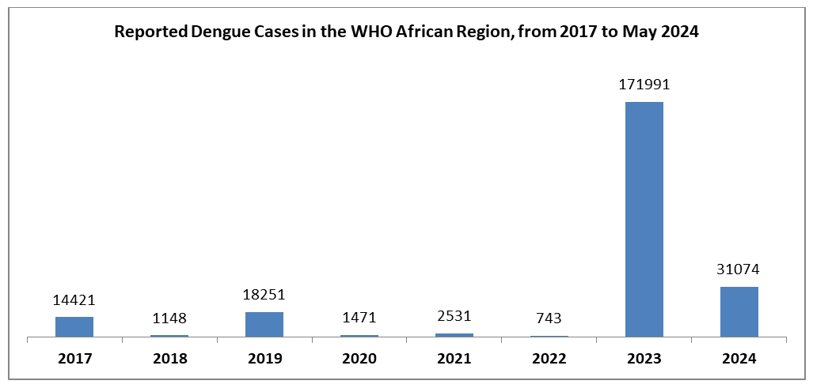

Contributing Factors:
Aedes Mosquitoes:
- Primary Vector: The transmission of dengue is chiefly driven by the Aedes mosquito population, which has seen a significant increase.
Variable Climate:
- Impact: Climate fluctuations, particularly the ongoing El Niño phenomenon, have impacted mosquito breeding and virus transmission.
Rapid Urbanization and Humanitarian Crises:
- Effect: Rapid urbanization and complex humanitarian crises have increased population density and mosquito habitats, escalating the risk of dengue. Approximately 40% of the global population is at risk.

This comprehensive analysis underscores the severe and escalating dengue situation in the African region. It highlights the urgent need for robust surveillance systems and targeted interventions to effectively mitigate the impact of dengue.
Priority Country Overviews
- Burkina Faso: Reports 174,356 cases and 771,780 deaths since the beginning of 2023. In 2024, there have been 17,098 cases and 38 deaths. A recent uptick in cases is noted. Burkina Faso continues to be heavily affected, with a significant number of cases and deaths reported. The recent increase in cases after a period of decline is worrisome.
- Mauritius: Has 7,177 cases and 1,523 deaths in the first 17 weeks of 2024. The cumulative attack rate on Rodrigues Island is 4.87%. Mauritius has experienced a high attack rate, particularly on Rodrigues Island, and the situation remains critical despite a plateau in case numbers.
- Mali: Reports 8,709 cases and 3,839 deaths since September 2023. In 2024, there have been 3,231 cases and 3 deaths, with a significant decline in cases observed. Mali has seen a dramatic decrease in cases, which is encouraging, but continued vigilance is necessary.
- Cabo Verde: Reports 1,127 cases with no deaths in 2024. Peaks were observed in weeks 3 and 8. Cabo Verde has reported its first cases since 2017, with fluctuations in case numbers but no deaths. The co-circulation of multiple serotypes requires attention.
- Ethiopia: Since April 2023, there have been 26,512 cases and 21 deaths. In 2024, 735 cases have been reported with no deaths. Ethiopia has reported cases across several regions, with the majority in Dire Dawa and Somali, but no deaths in 2024.

- ACTIVITIES BY PILLARS

4.1. WHO Leadership and Coordination
In response to the escalating dengue situation, WHO has fortified its leadership and coordination efforts, especially in the African region. The Regional Dengue Incident Management Support Team (IMST) was activated to align the Preparedness and Response Cluster (EPR/EMR) with the Communicable and Vector-Borne Diseases Cluster (UCN/TVD). This team serves as a collaborative mechanism to enhance coordination and follow-up on dengue response activities.

Key Initiatives and Actions:
- Incident Management Support Teams: WHO AFRO assist member states to dengue incident management system (IMS) teams to steer in-country responses, integrating their efforts with the Global Arbovirus Initiative to address dengue, chikungunya, and Zika viruses collectively.
- Capacity Building and Training: A five-day webinar series conducted between February 26 and March 1, 2024, involved over 500 professionals from 50 countries and featured 20 distinguished panelists. This series promoted the exchange of innovative solutions and best practices, with all sessions made publicly accessible.
- Operational Plan for 2024–2025: A comprehensive regional operational plan was formulated to guide dengue preparedness and response efforts for 2024–2025.
- Dengue Preparedness and Response Guidance: Tailored guidelines were developed for the WHO African Region, providing a robust framework for response activities.
- Specialist Deployment: Experts in entomology, vector control, epidemiology, risk communication, and community engagement were strategically deployed to support high-priority nations.
- Financial Allocations: A significant fund allocation of $2 million USD from the Dengue Regional WHO Contingency Funds for Emergencies (WHO CFE) and the African Public Health Emergency Funds (APHEF) supported initiatives in key countries like Burkina Faso, Mauritius, Cabo Verde, Mali, and Ethiopia.
- Regional Dengue Risk Assessments: These assessments categorized countries based on their dengue transmission status, providing a detailed and adaptable tool for dengue risk mapping that has been implemented across all WHO regions.
- Situation Reports (SITREPs): Six comprehensive SITREPs were published, offering consolidated data and insights to inform ongoing response efforts.
- Webinars and Educational Outreach: Apart from the five-day webinar series, dengue was highlighted during the WAHO/ECOWAS webinar, engaging over 80 delegates from 15 countries.
- Alignment and Global Strategy Contribution: The WHO AFRO guidance on preparedness and response was aligned with the HQ systematic review for updated arbovirus clinical guidance. This alignment supports the WHO Global NTD roadmap by 2030 and the Global Vector Control Response 2017–2030.
- PRSEAH Interventions: Measures to prevent and respond to sexual exploitation, abuse, and harassment are integrated into the dengue operational response, tailored to the type and phase of the response.
- Operational Support and Logistics: Maintaining a pipeline of dengue kits and bulk items, with suppliers contacted to ensure availability.
- Technical Support and Advocacy: Ongoing technical support addressing epidemiology, laboratory, case management, risk communication, community engagement, vector control, and advocacy for research initiatives.
These concerted efforts underscore WHO's commitment to enhancing regional and global dengue preparedness and response, addressing critical gaps, and ensuring a coordinated approach to tackling the dengue crisis.

4.2. Clinical Case Management

Technical Assistance and Standardization
- Burkina Faso: Provided technical assistance to the Burkina Faso Ministry of Health in developing its National Dengue ClinicaProvided technical assistance to the Burkina Faso Ministry of Health in developing its National Dengue Clinical Case Management Guidelines.
- Standardized Forms: Developed forms to support clinical management in hospitalized patients and outpatients, aimed at reducing the Case Fatality Rate (CFR).

Analysis of Dengue Case Management in WHO African Region

Table: Dengue clinical dengue features in six targeted countries in the WHO African Region

Country | Most Common Clinical Features | Deaths Reported | Suspected Cases | Confirmed Cases | Hospitalized/ Severe Cases
Mauritius | Fever, headache, weakness | 15 | 7177 | 7177 | 0
Cote D’Ivoire | Fever, jaundice, asthenia | 0 | 128 | 9 | NA
Cabo Verde | Fever (95.1%), headache (76.5%), myalgia (69.1%) | 0 | 1199 | 417 | 81
Mali | Fever, headache, physical asthenia | 4 | 4604 | 613 | 5
Ethiopia | Fever (99.8%) and headache (97%) | 0 | 0 | 805 | 142
Burkina Faso | Headache, fever, myalgia, weakness | 38 | 17098 | 5097 | 1046
Country-specific observations
- Mauritius:
  - Clinical Features: Fever, headache, weakness.
  - Observations:
    - The most common symptoms align with typical dengue symptoms.
    - The number of deaths reported (15) is concerning, especially considering the relatively small population of Mauritius.
    - The absence of reported hospitalized or severe cases appears to be a positive sign. However, this should be interpreted with caution due to the possibility of underreporting.
- Cote D’ivoire:
  - Clinical Features: Fever, jaundice, asthenia.
  - Observations:
    - Jaundice as a symptom is notable and may indicate severe dengue.
    - The low number of deaths reported (0) is a positive sign.
    - The NA value for hospitalized/severe cases requires further investigation.
- Cabo Verde:
  - Clinical Features: Fever (95.1%), headache (76.5%), myalgia (69.1%).
  - Observations:
    - High prevalence of fever and headache aligns with dengue.
    - The absence of reported deaths is reassuring.
    - The proportion of hospitalized/severe cases (81) indicates a need for medical attention.
- Mali:
  - Clinical Features: Fever, headache, physical asthenia.
  - Observations:
    - Physical asthenia (weakness) is an interesting additional symptom.
    - The low death count (4) suggests effective management.
    - The proportion of hospitalized/severe cases (5) is relatively low.
- Ethiopia:
  - Clinical Features: Fever (99.8%) and headache (97%).
  - Observations:
    - Nearly universal fever and headache are consistent with dengue.
    - The absence of deaths is encouraging.
    - The proportion of hospitalized/severe cases (142) warrants monitoring.
- Burkina Faso:
  - Clinical Features: Headache, fever, myalgia, weakness.
  - Observations:
    - Multiple symptoms (headache, fever, myalgia) indicate a broader impact.
    - The higher death count (38) warrants attention.
    - The proportion of hospitalized/severe cases (1046) is significant and requires urgent medical attention.
General Observations:
- The region is experiencing an explosive increase in dengue cases with consistent clinical presentations.
- While most cases are mild, approximately 1-5% of patients require hospitalization.
- The primary approach to treatment has been symptomatic management.
- Mortality rates are relatively low, ranging from 0% to 0.7%.
Challenges:
- There is a notable delay in patients presenting to healthcare facilities, often due to misdiagnosis rather than access issues.
- Clinical misdiagnosis is common as symptoms often resemble those of other tropical infections/diseases, including malaria and various arboviruses.
- There is a delay in fluid resuscitation during the critical phase of severe dengue cases.
- Many patients are receiving excessive fluid, indicating poor management and monitoring.
- A lack of contextualized clinical guidelines for dengue management hampers effective treatment.
- There is an insufficiency in training for clinicians to detect dengue cases accurately.
- Diagnostic and laboratory capacities are limited, particularly regarding point-of-care (POC) testing.
Recommendations:
- Expand POC testing to ensure accurate bedside diagnosis and facilitate timely, appropriate treatment.
- Enhance training for clinicians to improve the detection of dengue and raise the index of suspicion.
- Intensify vector control measures to reduce the spread of the disease.
- Provide supportive care, including analgesics, fluid replacement, and bed rest, to manage symptoms effectively.
Overall, while some countries show concerning death rates, others exhibit effective management. Monitoring and public health interventions remain crucial to control dengue outbreaks in these African countries.

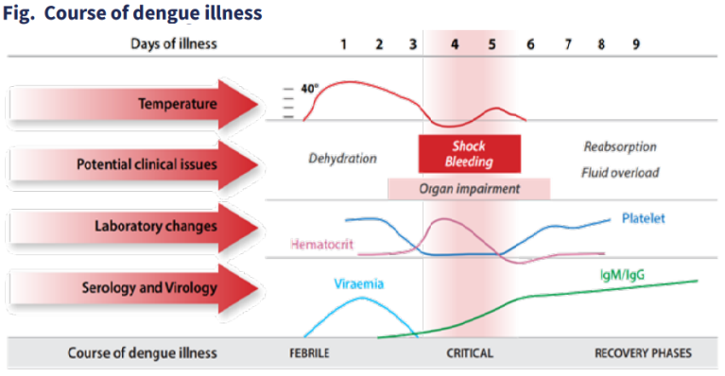

4.3. Surveillance and Health Information Management


WHO-AFRO plays a pivotal role in advancing global dengue surveillance and information management. Key contributions and initiatives include:
- Global Dengue Surveillance Dashboard: WHO Headquarters created this dashboard, incorporating significant data contributions from WHO AFRO, which uses data from countries facing dengue outbreaks and routine integrated disease surveillance and response (IDSR).
- Regional Situation Reports (SITREPs): Six comprehensive SITREPs have been compiled and published, offering consolidated data and actionable insights to guide ongoing response efforts.
- Technical Assistance Deployment: Epidemiologists have been deployed to Mauritius and Cabo Verde to provide critical technical assistance.
- Dengue Case Reporting: Dengue case counts from the five WHO endemic regions are reported and updated monthly. As more countries' data becomes available, it will be added to the reports.
- Active Transmission Mapping: A map indicating countries with active dengue transmission is regularly updated as new data becomes available.
These efforts underscore WHO AFRO’s commitment to enhancing dengue surveillance and enabling timely and informed public health responses.

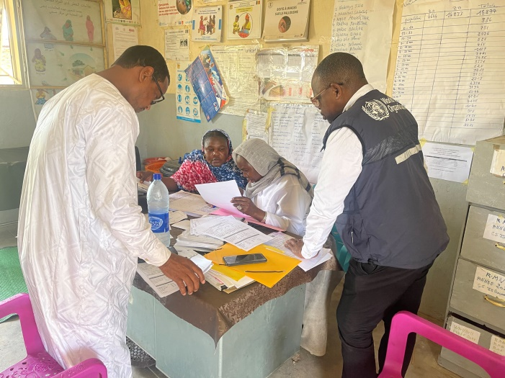
Review of dengue case records from Chad health facilities.

4.4. Operational Support and Logistics (OSL)

The WHO AFRO Operations Support and Logistics (OSL) cluster has been instrumental in combating dengue fever in the African region. Since the beginning of the year, OSL’s dedicated efforts have ensured that member states receive essential support from strategic stockpiles, regardless of the origin of the items.
Key initiatives and contributions include:
- Strategic Stockpiles: Dakar and Nairobi Hubs: Both hubs have been crucial in providing the necessary supplies for the dengue response.
- Dispatch from Nairobi Hub: Inventory Dispatched: 38,045 items, including mosquito repellents and nets. Weight and Value: Total weight of 6,263.34 kg with a value of $134,145.
- Dispatch from Dakar Hub: Inventory Dispatched: 1,290 items. Weight and Value: Total weight of 279.7 kg with a value of $53,661.
- Overall Contribution: Total Value: Goods valued at $187,806. Total Weight: 6.44 tons.

The collaboration between the AFRO OSL cluster, regional warehouses, and member states highlights the solidarity and collective effort in addressing dengue outbreaks. This coordinated response ensures that all countries receive the critical support needed to combat dengue effectively, leaving no country behind.

AFRO Emergency Hub - Kenya
Mauritius | Quantity | Weight | Item Value
Ballet Mosquito Repellant Lotion 130Ml | 360.0 | 59.70 | $636
Ballet Mosquito Repellant Lotion 65Ml | 1,440.0 | 118.80 | $1,491
Ballet Mosquito Repellent 130Ml | 8,408.0 | 1,422.76 | $14,844
Ballet Mosquito Repellent Petroleum Jelly 100G | 12,160.0 | 1,545.26 | $64,015
Ballet Mosquito Repellent Petroleum Jelly 50G | 7,632.0 | 444.14 | $28,664
Chemical Respirator Mask Double Vent | 700.0 | 196.00 | $1,936
Chemical Respirator Mask Single Vent | 4,300.0 | 807.48 | $10,881
K-Othrine – Sachets Of 20G | 45.0 | 1.62 | $291
Mosquito Net – Olyset Brand, Size 160 X 180 X 150Cm | 100.0 | 43.48 | $294
Mosquito Net – Olyset Plus Brand, Size 190 X 180 X 150Cm | 2,900.0 | 1,624.10 | $11,093
Total | 38,045.00 | 6,263.34 | $134,145
AFRO Regional Warehouse - Senegal
Mali - Dengue Response | Quantity | Weight | Item Value
RDT Dengue (Standard Q-09Den30A), Ns1 Ag+Igg/Igm, Ser/Pl/Wb, W/O Acc., Kit-10 | 790 | 132.2 | $32,796
Mauritius - Dengue Response | Quantity | Weight | Item Value
RDT Dengue (Standard Q-09Den30A), Ns1 Ag+Igg/Igm, Ser/Pl/Wb, W/O Acc., Kit-10 | 500 | 147.5 | $20,865
Total | 1,290.0 | 279.7 | $53,661
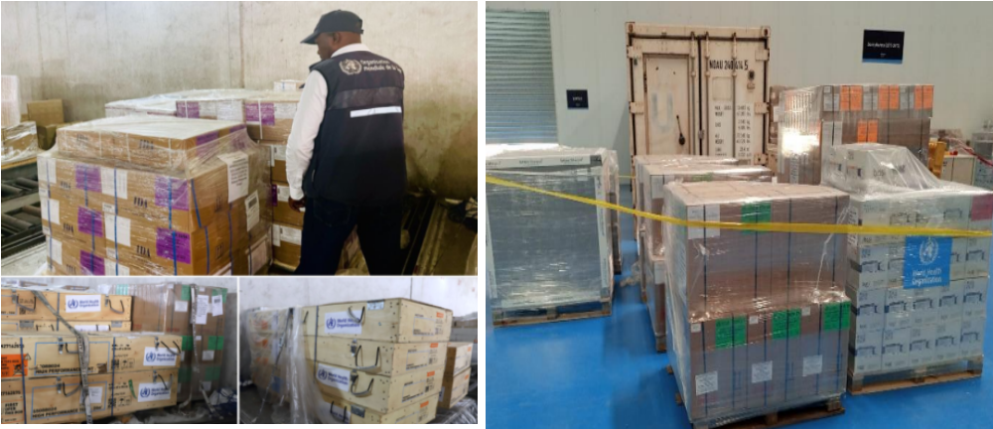

4.5. Risk Communication and Community Engagement (RCCE)

Toolkit and Media Enhancements
- RCCE Toolkit Development: Crafted specifically for dengue awareness and response.
- Public Awareness Campaigns: Releases, briefing notes, and RCCE videos by the AFRO communication team to elevate public knowledge and responsiveness.

Piloting and Adaptation
- Toolkit Piloting: Introduced in countries actively experiencing dengue transmission.
- Community Conversation Kits: Adapted to include dengue-specific topic sheets for local relevance.

Expertise Deployment
- RCCE Expert Deployment: A specialist from WCO Cote D’Ivoire, supported by WHO AFRO Dengue IMST, was sent to Mauritius to oversee RCCE operations.

Mauritius: A Case Study

Strategic Approach
- RCCE Coordination: Regular coordination meetings are established to unify response efforts and improve public communication.

SWOT analysis for improvement
Coordination:
- Current: Infrequent stakeholder meetings and isolated activities.
- Strategy: Increase meeting frequency and inclusivity to ensure coordinated efforts.
Public Communication:
- Current: minimal media presence and social media engagement.
- Strategy: Boost visibility through media appearances, social media campaigns, and distributing awareness materials.
Community Engagement:
- Current: effective briefings and door-to-door activities.
- Strategy: Expand the reach and coverage of community engagement efforts.
Infodemic Management:
- Current: Conducted two KAP surveys.
- Strategy: Use survey insights to tailor communication and address misinformation.

Action Points
Coordination:
- Enhance Stakeholder Meetings: Increase frequency and unify activities.
Public Communication:
- Bolster Media Presence: Strengthen social media engagement, increase traditional media appearances, and distribute awareness materials widely.

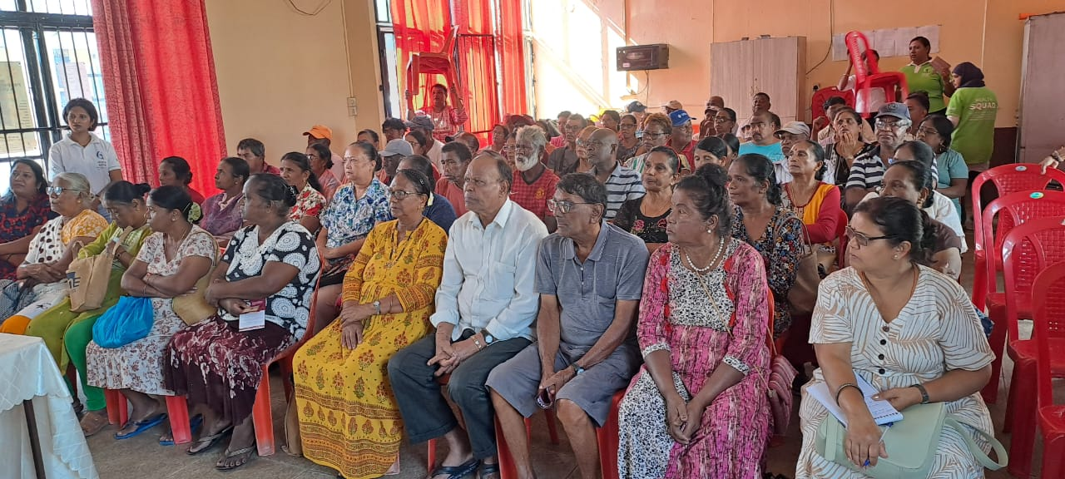
RCCE activities in Mauritius

Progress Overview
Consistent Coordination:
- Weekly RCCE Meetings: Regular meetings ensure alignment and information sharing.
- Unified Activity Framework: A collaborative approach guides partners' weekly activities.
Educational Outreach:
- MOHW Staff Briefings: Continuous education of health workers on RCCE principles.
- Press Conferences: Weekly updates from the Health Minister boost public awareness.
Media Engagement:
- Private Radio Campaign: Effective awareness campaigns with expert contributions.
- Media Field Visits: Weekly visits to dengue hotspots bring attention to frontline efforts.
Community Involvement:
- Socio-professional Briefings: focused sessions for community leaders and educators.
- School Education: Teachers discuss dengue for five minutes daily, enhancing youth awareness.
Communication Material Development:
- Creative Content: Development of posters, videos, and social media spots.
- Influencer Collaboration: Engagement with influencers to amplify dengue prevention messages.

Challenges and Priority Actions
Challenges:
- Limited district council commitment.
- Lack of key communication partners.
- Ineffective mosquito breeding site eradication.
- Insufficient involvement of religious leaders.
Priority Actions:
- Short-Term:
  - Validate the RCCE strategic plan.
  - Approve guides on key messages and misconceptions.
  - Map affected areas and intensify door-to-door activities.
  - Engage religious leaders in briefings.
  - Amplify media communication efforts.
- Intermediate/Long-Term:
  - Train stakeholders on RCCE principles.
  - Establish a comprehensive national RCCE system.

By addressing these strategic areas, WHO-AFRO aims to enhance the efficiency of its dengue response in Mauritius, ultimately improving community health outcomes.

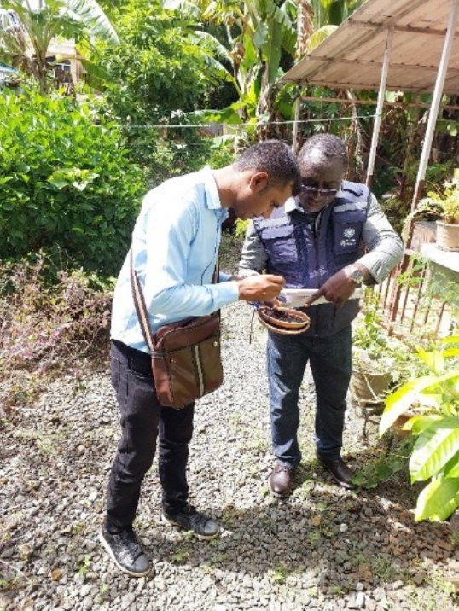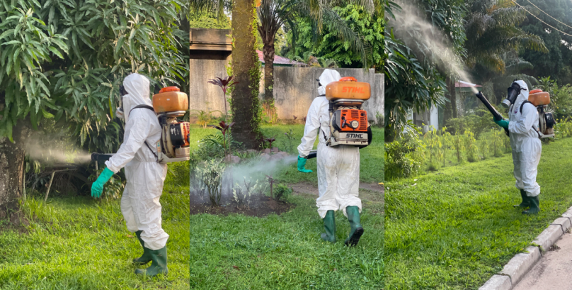

4.6. Laboratory Support

Provision of Critical Supplies
- Diagnostic Supplies: Supplied essential laboratory diagnostics to all member states experiencing active dengue transmission, including RDT Dengue (Standard Q-09Den30A), Ns1 Ag+IgG/IgM, Ser/Pl/Wb, W/O Acc., Kit-10.

Product Evaluation and Quality Assurance
- Planned Product Evaluation: Scheduled evaluation of diagnostic tests by the WHO NTD-WHE Expert Review Panel for dengue.
- External Quality Assurance: Establishing an external quality assurance system to ensure the reliability and accuracy of dengue diagnostics.

Knowledge Sharing and Coordination
- Development of Best Practices: Preparing a comprehensive paper on the challenges, best practices, and lessons learned in dengue diagnosis.
- Coordination Meetings: Regular coordination meetings with lab technicians through the WHO AFRO laboratory network, including collaborative and regional reference centers.

These efforts underscore WHO AFRO’s commitment to strengthening laboratory capabilities and ensuring effective dengue diagnosis across member states.



4.7. Vector Control

Technical Support and Field Operations
- Support to Mauritius and Cabo Verde: Provided technical assistance for field operations, including ongoing studies on insecticide resistance and susceptibility.

Training and Capacity Building
- Online Training Courses: WHO HQ developed and launched online vector control training courses on the OpenWHO platform.

Vector Control Supplies
- Supply Distribution: Distributed essential vector control supplies, including Ballet Mosquito Repellent P and K-Othrine sachets (20g) to support field operations.

Through these initiatives, WHO AFRO is enhancing vector control efforts, strengthening local capacities, and ensuring effective management of dengue vectors in affected regions.

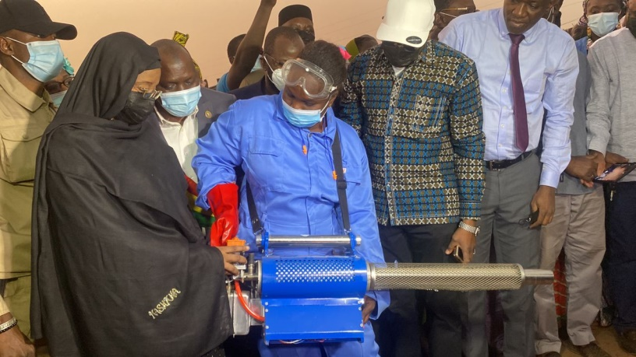
Mali's response to the dengue epidemic. The Minister of Health and Social Development attending a fumigation session at a displaced persons site in Faladjié, Bamako. December 19, 2023.

4.8. Partnership Contributions to the Dengue Outbreak in the WHO African Region

- Role of Public Health Partners:
  - Engagement and Coordination: Public health partners are crucial in outbreak responses, coordinated through country-level mechanisms.
  - Global Collaboration: Contributions from global entities like the Red Cross and Crescent focus on integrated vector control and innovative community health strategies.
  - Strategic Initiatives: Long-term community responses are proposed for affected countries, such as Burkina Faso.
  - Comprehensive Support: Various forms of support, including financial allocations, are provided to different countries.
  - Innovative Strategies: National and international collaborations foster innovative funding and operational strategies.
  - Collaborative Efforts: Partners such as the Red Cross, Médécins Sans Frontière, and Médecins du Monde, along with WHO and The Global Fund, contribute despite challenges like administrative barriers and security concerns in conflict-affected areas.
  - Significant Contributions: Public health partners, NGOs, aid organizations, and the private sector have played critical roles in outbreak response.
  - Enhanced Capacities: Contributions also include inputs from FETP and enhancements in IDSR/epidemiology capacities.

- Best Practices and Lessons Learned:
  - Collaboration: Strong partnerships between public health organizations enhance surveillance, outbreak investigation, and risk communication.
  - Resource and Data Management: Successes in data sharing and technology transfer are noted, though resource mobilization remains a concern.
  - Training and Capacity Building: Enhanced training for health workers in community-based interventions and case management is vital.
  - Prompt Responses: Partners help develop task forces, guidelines, and strategic frameworks for dengue prevention and control.
  - Challenges: African nations face difficulties due to ongoing humanitarian emergencies and strained healthcare systems.

- The Way Forward:
  - Resource Mobilization: Support for redirecting resources to manage dengue without impacting routine health programs.
  - Cross-Border Collaboration: Strengthening cross-border collaboration and intersectoral actions is emphasized.
  - Enhanced Surveillance: Urgent reinforcement of dengue surveillance with increased monitoring.
  - Early Warning Systems: Developing scalable and sustainable early warning systems and robust clinical management during outbreaks.
  - Health Surveillance Systems: Partners support the establishment and improvement of health surveillance systems.
  - Research and Innovation: Collaboration with academic institutions to drive research on new treatments, vaccines, and health systems management strategies.

These contributions highlight the pivotal role of partnerships in coordinating an effective response to dengue outbreaks in the WHO African region.

4.9. Readiness and Preparedness: Significant Accomplishments

Comprehensive Guidance Development
- Public Health Preparedness:
  - Created a detailed guide for dengue outbreak preparedness and response in the WHO African Region, which:
    - Enhances integrated surveillance systems that combine epidemiological and entomological data.
    - Promotes sustainable, locally adapted vector control strategies, including environmental management and community participation.
    - Incorporates risk communication and community engagement (RCCE) strategies to boost public awareness and involvement in dengue prevention.
    - Establishes research priorities to deepen understanding of dengue and foster new control and prevention tools.

Key and Minimum Readiness Requirements for Priority Countries
- Awareness and Education: Increase dengue awareness among authorities and health sector partners, including clear working case definitions.
- Surveillance and Response: Enhance active surveillance and ensure Rapid Response Teams are ready, in collaboration with community and partners, especially in neighboring areas.
- Prepositioning Resources: Preposition equipment and supplies, including Personal Protective Equipment and VHF kits, in high-risk areas.
- Contingency Planning: Develop plans for domestic or imported dengue scenarios, including incident management and response planning.
- Technical Assistance: Provide in-country technical assistance, guidance, and training in areas such as RCCE, surveillance, vector control, detection, clinical management, laboratory diagnosis, and safe burials.

Tools and Assessment
- Readiness Checklist and Dashboard: Developed an online dengue readiness checklist to assess and visualize country readiness capabilities. Collected checklist data from AFRO region member states to identify strengths and gaps, guiding targeted support from WHO.

Recent Submissions as of February 13, 2024:
- Received readiness data from Cote d'Ivoire, Cameroon, CAR, Eswatini, Eritrea, Equatorial Guinea, Guinea-Bissau, Mali, Mozambique, Nigeria, Rwanda, Seychelles, Tanzania, Togo, and Uganda.

Challenges Faced
- Resource Allocation: Countries with active dengue emergencies receive immediate resources, potentially limiting focus on long-term preparedness initiatives in nations without active outbreaks.
- Laboratory Capacity: Limited lab capacity and resources hinder timely detection and confirmation of dengue cases, leading to underreporting and misclassification, affecting overall readiness and response efforts.

These accomplishments and challenges highlight the efforts and ongoing needs in supporting member states' readiness and preparedness for dengue outbreaks in the WHO African Region.

Readiness by countries’ pillars score
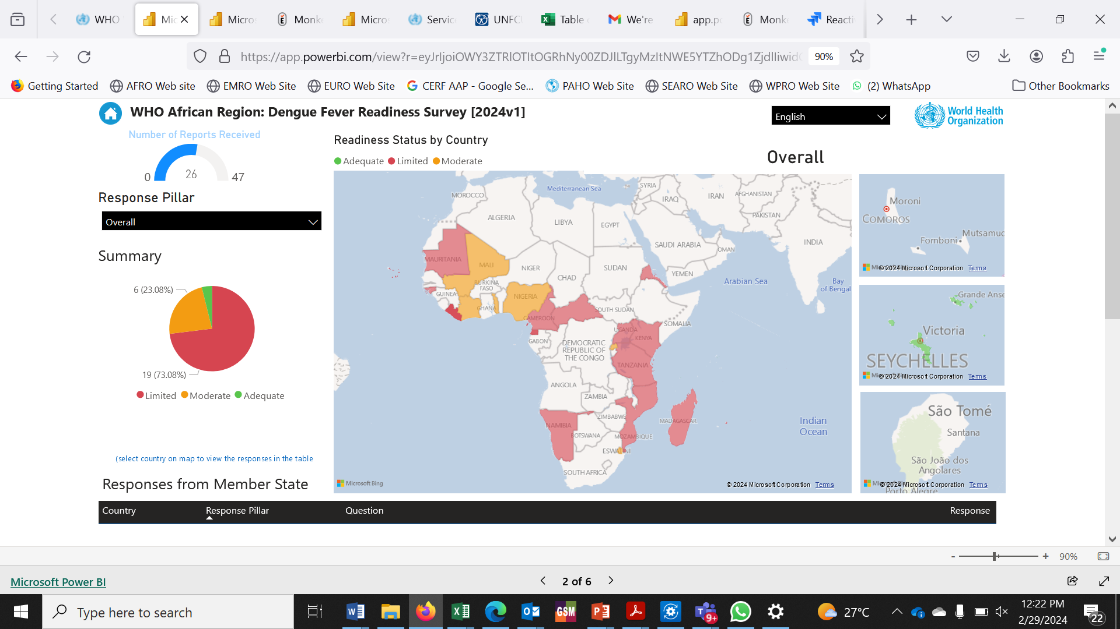

4.10. Financial Overview: Dengue Outbreak Support

Mobilized Funds
- Total funds mobilized: $2 million from WHO CFE and APHEF.

Allocations to Affected Countries
- Initial CFE Allocation ($1.2 million):
  - Burkina Faso: $240,000
  - Mali: $180,000
  - Ethiopia: $180,000
  - Côte d'Ivoire: $150,000
  - São Tomé and Príncipe: $130,000
  - Mauritius: $100,000
  - AFRO: $220,000
- Second CFE Allocation ($420,000):
  - Mauritius WCO: $150,000
  - Cabo Verde WCO: $100,000
  - Mali WCO: $80,000
  - AFRO Support WCO: $90,000
- APHEF Allocation:
  - Cabo Verde: $300,773

Utilization of Funds
- CFE 76712 Total ($1,515,000):
  - Mali: $260,000 (96.8% utilization)
  - Côte d'Ivoire: $150,000 (99.8% utilization)
  - Mauritius: $250,000 (31.8% utilization)
  - EPR AFRO: $305,000 (81.2% utilization)
  - São Tomé: $130,000 (54.4% utilization)
  - Ethiopia: $180,000 (44.7% utilization)
  - Burkina Faso: $240,000 (68.2% utilization)
  - Total Utilization: 69%
- APHEF 60076 (Cabo Verde):
  - Cabo Verde: $300,773 (99.70% utilization)

Key Insights
- High Utilization: Countries like Côte d'Ivoire (99.8%) and Cabo Verde (99.70%) demonstrated near-complete utilization of their funds, indicating effective use.
- Low Utilization: Mauritius has a significant portion of unutilized funds (31.8%), suggesting slower expenditure or deployment.
- Overall Utilization: The average utilization rate of CFE funds stands at 69%, suggesting room for improvement in some areas.
- Strategic Management: This financial data is crucial for planning and ensuring funds are efficiently and effectively used to achieve their goals.

These insights help highlight areas of success and identify where additional support and oversight may be needed to enhance the effectiveness of financial resource utilization in combating dengue outbreaks.

4.11. Headquarters Support to AFRO Dengue IMST

WHO Headquarters (HQ) has provided critical support to the African Region Dengue Incident Management Support Team (IMST) in several key areas:

- Data Management: Created a consolidated and validated database for 27 countries by collating information from country sitreps, Ministry of Health reports, and routine surveillance data through the Integrated Disease Surveillance and Response (IDSR) system.
- Development of Public Sector Reports: Developed dengue regional public sector report number 6, incorporating data from 29 countries.
- On-the-Ground Epidemiological Support: Deployed an epidemiologist to Mauritius for 4 weeks to assist with the dengue emergency response.
- Funding Release: Released Contingency Fund for Emergencies (CFE) for response activities.
- Surveillance Dashboard Development: Created a global surveillance dashboard, including regional and country-level profiles, to guide activities in the region.
- Technical Reviews: Conducted technical reviews of strategic documents, such as the regional dengue operational plan and comprehensive guidelines for preparedness and response.
- Webinar Organization: Significantly contributed to the 5-day webinar on dengue preparedness and response (February 26 to March 1, 2024), by assembling a panel of global experts. Over 500 participants from more than 50 countries attended, enhancing dengue management strategies across the African region.

These initiatives reflect WHO HQ's crucial role in strengthening the Dengue IMST's capacity to manage and mitigate dengue outbreaks effectively.

- KEY ACHIEVEMENTS AND MILESTONES
- Regional Coordination:
  - Activated the Regional Dengue Incident Management Support Team (IMST) with dedicated staff.
  - Mobilized experts in Neglected Tropical Diseases (NTD) and Emergency Preparedness and Response (EPR).
  - Provided effective technical support to affected countries.
- Guidance Development:
  - Created comprehensive dengue preparedness and response guidelines tailored to the African context.
  - Made available in English, French, and Portuguese.
- Situation Reports:
  - Compiled six comprehensive regional situation reports (SITREPs) that provided vital data to inform ongoing response efforts.
- Strategic Expert Deployment:
  - Deployed specialists, including entomologists, vector control experts, epidemiologists, and RCCE specialists, to high-priority and affected countries such as Burkina Faso, Cabo Verde, and Mauritius.
- Financial Support:
  - Mobilized $2 million from WHO CFE and APHEF and allocated funds to affected countries.
- Webinar Series:
  - Organized a 5-day webinar on all aspects of dengue preparedness and response.
  - Engaged over 500 professionals from approximately 50 countries, with contributions from 20 global experts.
- Risk Mapping Tool:
  - Developed and piloted a dengue risk mapping tool that classifies countries into three tiers with defined interventions:
    - Tier 1: Active outbreaks requiring emergency response.
    - Tier 2: High risk requiring readiness activities.
    - Tier 3: Medium risk requiring preparedness activities.
  - Successfully piloted in 47 African countries and implemented in other WHO regions.
- 7-1-7 Metrics Pilot:
  - Implemented in seven countries (Burkina Faso, Mauritius, Cabo Verde, Mali, Côte d'Ivoire, São Tomé and Príncipe, and Ethiopia).
  - Assessed performance, identified bottlenecks, and facilitated rapid performance improvement.

These achievements reflect significant progress in coordinating regional dengue responses, developing tailored guidance, and deploying strategic support to enhance preparedness and response in the African region.

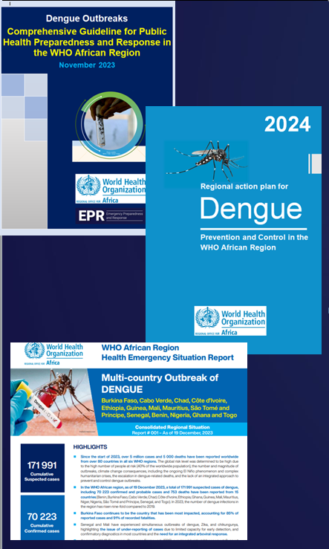

- CHALLENGES AND GAPS
Despite significant progress, several challenges remain:
- Resource Shortages:
  - Insufficient supplies of insecticides, larvicides, rapid diagnostic tests (RDTs), and laboratory kits.
  - Limited lab capacity for arboviral diagnosis.
- Funding Needs:
  - Additional funds are required to fully implement response plans and ensure comprehensive coverage.
- Human Resource Gaps:
  - Shortage of trained staff in vector control, surveillance, and data management.
  - Lack of key personnel, such as entomologists and vector control specialists.
- Technical Gaps:
  - Need for further technical support in areas like insecticide resistance studies, tailored risk communication and community engagement (RCCE) strategies, and coordination.
  - Recruitment and deployment challenges, including lengthy procedures that delay the prompt deployment of consultants such as entomologists, RCCE specialists, and epidemiologists.
- Data Collection and Management:
  - Need to establish a regular and timely data flow from WHO Country Offices (WCOs), rather than relying on cumulative counts or scraping from situation reports (sitreps).
  - Inclusion of currently uncaptured countries in data collection efforts.
  - Consolidation of data for other arboviruses, such as Chikungunya and Zika, in the region.

Addressing these challenges is crucial for enhancing the effectiveness and efficiency of dengue response efforts in the African region.

- CONCLUSION
In conclusion, the World Health Organization's African Regional Office (WHO AFRO) has made commendable strides in addressing dengue outbreaks across the African continent. Their comprehensive strategy, anchored by the activation of the Regional Dengue Incident Management Support Team (IMST), is designed to significantly mitigate the dengue burden from 2021 to 2030. This includes enhancing country capacities to detect, prevent, and respond to outbreaks, striving to eliminate preventable deaths, reducing the disease burden, and decreasing incidence by 25%.
The report highlights several key achievements: early activation of the Regional Dengue Incident Management Support Team (IMST) with tropical disease and emergency response experts; development of comprehensive dengue preparedness and response guidance for Africa with six regional situation reports; deployment of specialists such as entomologists and epidemiologists to priority countries; mobilization of approximately $2 million from WHO CFE and APHEF for dengue response efforts; a webinar series reaching over 500 professionals from 50 countries and 20 distinguished panelists, with sessions publicly shared to disseminate innovative solutions; creation of a regional risk mapping tool for all 47 African countries, classifying them into preparedness, readiness, and response tiers; and implementation of a 7-1-7 Metrics Pilot in seven countries to assess performance in alignment with the WHO Emergency Response Framework (ERF) version 2.1.

Despite these successes, the report outlines ongoing challenges such as shortages of supplies, funding needs, gaps in human resources, and technical deficiencies. Additionally, improving early detection and response mechanisms remains critical. To address these issues, WHO AFRO emphasizes the need for enhanced surveillance systems, advanced vector control strategies, improved resource mobilization, and thorough documentation of experiences to guide future responses.
Overall, WHO AFRO's coordinated, collaborative efforts with regional entities and member states are vital in effectively managing and reducing the impact of dengue outbreaks across the African region. Their ongoing commitment underscores a robust approach to overcoming the persistent challenges and achieving long-term public health resilience against dengue.
This report highlights WHO AFRO’s dedicated efforts to manage and mitigate dengue outbreaks in the African region. Through strategic coordination, capacity building, and targeted interventions, WHO AFRO has significantly reduced the dengue burden, improved public health outcomes, and fostered resilience against future outbreaks.

- NEXT STEPS

Next Steps for Enhancing Dengue Response in the WHO AFRO Region include:

- Challenge Mitigation: Prioritize key challenges with targeted interventions and increased resources
- Ensure Proper Documentation: Create a repository for lessons learned and ensure proper publication of technical reports and scientific publications
- Strengthening Surveillance Systems: Support WHO Regional Offices in enhancing dengue and arbovirus surveillance by standardizing documents and improving testing capacities
- Regular Data Updates: Encourage weekly data updates to the Global Surveillance Dashboard from member states
- Integrated Vector Control: Update vector control strategies as part of the Global Arboviral Initiative.
- Resource Mobilization: Organize joint resource mobilization to respond to case surges, sustain progress, and enhance preparedness, including prepositioning supplies and reinforcing capacity.
- Transition to Routine Program: Develop a transition roadmap to routine programs with UCN/TVD by November 2024, updating the "Global Arbovirus Initiative" for the African region and integrating dengue, zika, and chikungunya into routine surveillance (IDSR) for most member states.

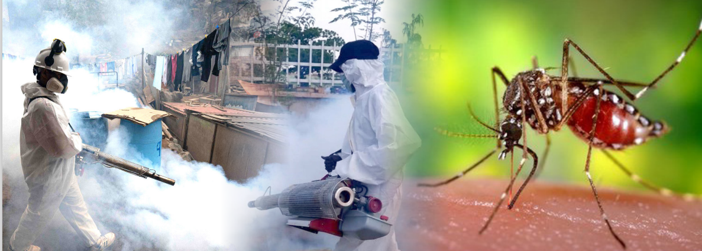

- APPENDICES
- Appendix 1: WHO Dengue Information

Source: World Health Organization (30 May 2024). Disease Outbreak News; Dengue – Global Situation Available at: https://www.who.int/emergencies/disease-outbreak-news/item/2023-DON518

Epidemiology
Dengue virus is transmitted to humans through the bite of infected mosquitoes typically in tropical and sub-tropical climates worldwide, mostly in urban and semi-urban areas. The primary vectors that transmit the disease are Aedes aegypti and, to a lesser extent, Aedes albopictus mosquitoes, though in some regions such as Europe and North America, this latter vector is more widespread. DENV has four serotypes (DENV-1, DENV-2, DENV-3, DENV-4). Infection with one serotype provides long-term immunity to the same serotype and only transient immunity to the other serotypes, after which secondary infections with a different serotype increase the risk for severe dengue. Dengue cases are most commonly asymptomatic or result in mild febrile illness. However, some cases will develop severe dengue, which may involve shock, severe bleeding or severe organ impairment. This stage often starts after the fever has gone away and it is preceded by warning signs such as intense abdominal pain, persistent vomiting, bleeding gums, fluid accumulation, lethargy or restlessness, and liver enlargement. There is no specific treatment for dengue, but the timely diagnosis of dengue cases, identification of warning signs for severe dengue, and appropriate clinical management are key elements of care to prevent the progression to severe dengue and deaths.

Public health response
The overall capacity for countries to respond to multiple, concurrent outbreaks continues to be strained due to the global lack of resources, including shortages of good quality dengue diagnostic kits for early disease detection, lack of trained clinical and vector control staff and community awareness. Emergency response mechanisms have been established, and WHO supports high-risk countries across affected regions; however, the needs continue to outweigh the available resources. Coordination with partners, including UNICEF, has led to the development and implementation of common analyses and priority-setting tools. Nevertheless, it is imperative to sustain and enhance partner collaboration. Countries are encouraged to learn and adopt successful examples of effective case management, prevention, and control of dengue and other arboviruses through heightened research projects, which is also aimed at limiting the vectors reducing their ability to spread across the urban context. WHO should closely review local interventions and under the best evidence to accept and recommend them for public health programmes, facilitating early adaptation to reduce the growing health impact of dengue.

WHO advice
Dengue is primarily an urban disease of the tropics and the viruses that cause it are maintained in a cycle that involves humans and Aedes aegypti mosquitoes. The same mosquitoes transmit chikungunya and Zika viruses. The proximity of mosquito vector breeding sites to human habitation is a significant risk factor for dengue virus infection. Aedes species mosquitoes can become infected with the virus after biting individuals infected with DENV and then transmit the virus to others in the vicinity. This cycle, therefore, makes the infective mosquito capable of spreading the dengue virus within households and in the neighbourhoods of cases, leading to clusters. Effective vector control interventions are key to the prevention and control of dengue. Vector control activities should target all areas where there is a risk of human-vector contact, such as residences, workplaces, schools, and hospitals. WHO promotes Integrated Vector Management (IVM) to control Aedes species. IVM should include removing potential breeding sites, reducing vector populations, and minimizing individual exposure. This should involve vector control strategies for larvae and adults (i.e., environmental management and source reduction), especially monitoring water storage practices, draining and cleaning household water storage containers weekly, larvicide in non-potable water using WHO-prequalified larvicides at correct dosages, distribution of insecticide-treated nets (ITNs) for fever/dengue inpatients to contain spread of the virus from health facilities. Indoor space spraying for rapidly containing dengue-infected mosquitoes may be challenging to deliver in densely populated areas.
Personal protective measures during outdoor activities include topical repellents to exposed skin or the treatment of clothing and using long-sleeved shirts and pants. Additionally, indoor protection can include the use of household insecticide aerosol products, or mosquito coils during the day; window and door screens can reduce the chances of mosquitoes entering the house and insecticide-treated nets offer good protection to people against mosquito bites while sleeping during the day. Personal protective measures are recommended from dawn to dusk due to the diurnal Aedes aegypti. These measures and mosquito control should also cover workplaces and schools since the vectors are day-biting mosquitoes. Entomological surveillance should be undertaken to assess the breeding potential of Aedes mosquitoes in containers to target vector control activities and monitor insecticide resistance to help select the most effective insecticide-based interventions. There is no specific treatment for dengue infection. However, early detection and access to appropriate healthcare for case management reduces mortality, as can rapid detection of dengue cases with warning signs and timely referrals of severe cases to tertiary healthcare facilities. Case surveillance should continue to be enhanced in all affected countries and globally. Where feasible, resources should be allocated for the strengthening of case referral mechanisms and for the confirmation and serotyping of the dengue viruses.
Vaccination against dengue should be viewed as part of an integrated strategy to control the disease, including vector control, proper case management, community education, and community engagement. WHO recommends the use of TAK-003 (only available vaccine) in children aged 6–16 years in settings with high dengue transmission intensity. Countries are encouraged to learn and adopt successful examples of effective case management, prevention, and control of dengue and other arboviruses through heightened research projects, particularly given the recent WHO recommendations on clinical trials. Implementing clinical surveillance and case and death report forms for dengue could be particularly useful in understanding the disease better and also form a basis for developing clinical trials for new therapies or quality improvement initiatives. WHO should closely review local interventions and under the best evidence to accept and recommend them for public health programmes, facilitating early adaptation to reduce the growing health impact of dengue. Ministries of Health and partners should closely review local interventions to accept and recommend them for public health programmes for early adaptation to reduce the growing health impact of dengue.
WHO does not recommend that any general travel or trade restrictions be applied to countries based on the available information.
- Appendix 2: Terms of Reference of Key IMST Positions:
-Incident Manager: The primary responsibility of the Incident Managers includes the day-to-day technical and operational management of the response, assigning responsibility for critical functions, and supervising IMT/IMST leads. They manage the overall WHO response and the subsequent phase-out plan, supervise functional leads under the IMS, provide technical and operational guidance to the Ministry of Health and other health sectors, track progress, and implement necessary course corrections. Establishing and maintaining a coordination mechanism with partners is also part of their remit (this duty can be delegated to the Deputy Incident Manager).
- Health Operations and Technical Expertise (HOTE): Personnel responsible for this subfunction ensure that health operations are informed by the best available technical expertise and adhere to recognized standards and best practices. They coordinate activities of sub-pillar leads, including case management, IPC, vector control, laboratory operations, operational research, vaccination, and RCCE. They ensure response plans are technically and operationally sound, identify knowledge gaps, support WHO Country Offices in meeting their training needs, and provide and develop necessary materials.
- Epidemiologist in Charge of Information Products: This role involves consolidating situation analyses for multicounty emergencies, developing a weekly update presentation, and providing technical support and tools for health information activities. The epidemiologist’s duties also include consolidating, reviewing, and clearing monthly regional situation reports and disseminating information products to regional partners. They oversee the quality of information products, maintain the regional dengue database, update the RRA (or PHSA if the situation changes), and support operational reviews where appropriate.

- Appendix 3: WHO AFRO Suggested Dengue Case Definitions
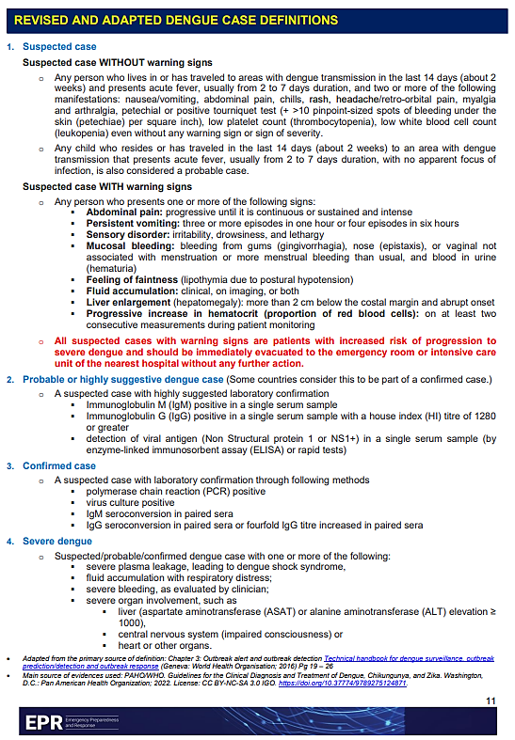
- Appendix 4: WHO Dengue Clinical Case Classification By Severity
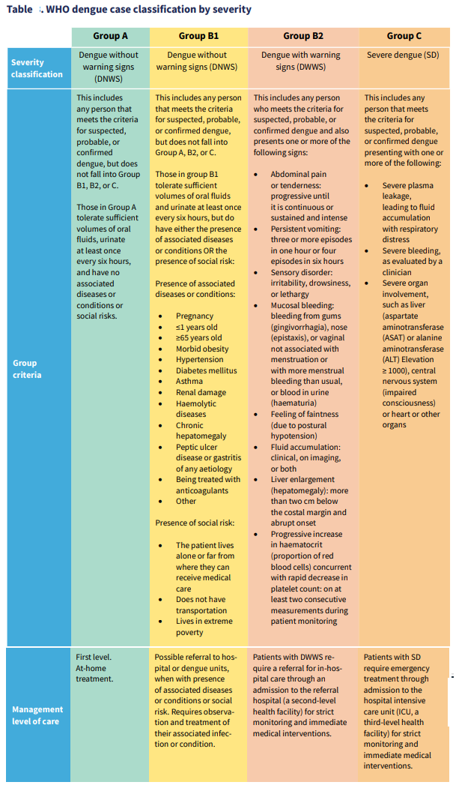

- Appendix 5: Key WHO AFRO Dengue IMST Activities
Meetings and deliverables:
Since December 2023, the Dengue Incident Management Support Team (IMST) has been actively coordinating efforts to manage the dengue outbreak. A total of 12 IMST meetings have been organized, with dedicated pillar leads contributing to the strategic response. The timeline of these meetings is as follows:
- December 2023: The inaugural meeting was convened on 21st December.
- January 2024: Three meetings were held to assess and adapt strategies for the new year.
- February 2024: Four meetings took place, reflecting an intensified response during a critical period of the outbreak.
- March 2024: A single meeting was conducted to review the progress and outcomes of the implemented measures.
- April 2024: One meeting focused on evaluating the long-term impact of the interventions.
- May 2024: Two meetings have been held, with the most recent on 16th May, indicating ongoing vigilance.
In parallel, six multi-country three-level (3L) Technical Coordination (TC) meetings have been held with affected countries from January to May 2024, fostering international collaboration and knowledge sharing. The distribution of these meetings is as follows:
- January: Initiated the year with one coordination meeting.
- February: Continued collaborative efforts with another meeting.
- March: The frequency increased to two meetings, highlighting a proactive approach to the evolving situation.
- April: Held one meeting to consolidate the action plans across countries.
- May: The latest meeting this month ensures that the response remains dynamic and responsive to the needs of the affected regions.
- Every Tuesday from 11:00 AM to 1:00 PM: Coordination meeting with affected countries.
[Join Zoom Meeting](https://who-e.zoom.us/j/96805723500) | Passcode: @dengue24
- Every Thursday from 3:00 PM to 4:00 PM: Dengue Weekly IMST Meeting with pillar leads.
[Join Zoom Meeting](https://who-e.zoom.us/j/95814956890) | Passcode: @frosho24
- Every Wednesday: Collection of epidemiological week data from WCOs by the epidemiologist.
- Every first week of each month: Development, review, and release of the regional dengue situation report.
Background and Timeline of key events:
- November 30, 2023: The WHO assessed the global risk of dengue as high.
- December 1, 2023: Dengue was classified as a Global Grade 3 public health event.
- December 14, 2023: Activation of the regional WHO AFRO Dengue IMST.
- May 16, 2024: WHO again assessed the global risk of dengue as high, approximately six months later.
- May 21, 2024: A Global Grading review recommended the following:
  - Extend the IMST (Incident Management Support Team) for an additional six months.
  - Strengthen the global surveillance system and develop guidelines.
  - Maintain momentum and continuously support the dengue response in priority countries such as Mauritius, Burkina Faso, Mali, Cabo Verde, and Ethiopia.
  - Address resource gaps and raise funds for an effective response.

- Appendix 6: Dengue Focal Points :
WHO AFRO :
- John Otshudiema (<otshudiemaj@who.int>); Dorothy Achu (<fosaha@who.int>); Emmanuel Chanda (<chandae@who.int>); Freddy Banza-Mutoka (<fbanzamutoka@who.int >); Tieble Traore (<traoret@who.int>); Nicksy Gumede (<gumedemoeletsih@who.int>); Kamara Rashidatu (<rashidatuk@who.int>); Williams, George Sie (<gwilliams@who.int>); Charles Njuguna (<njugunach@who.int>); Aminata Kobie (<mahoia@who.int>); Souleymane Kone (<koneso@who.int>). Clarisse Kingweze (<ckingweze@who.int>); Jean Paul Kimenyi (<kimenyij@who.int>); Michel Muteba (<mutebam@who.int>) ; Mendizabal Joffre, Carla (<mendizabalc@who.int>); Zinedine Kada (<kadaz@who.int>); Lionel Addiso (<adissoe@who.int>); Diallo, Mamadou Saliou Kalifa (<mamadiallo@who.int>); Woldetsadik, Solomon Fisseha (<woldetsadiks@who.int>); Katoto, Patrick (<katotop@who.int>) ; Jerry-Jonas Mbasha (<mbashaj@who.int>); Samuel Boland (<sboland@who.int>); Ibrahim Mamadu (<mamadui@who.int>); Jean marc Santime Kabeya (<santimej@who.int>); Patrick Ramadan (<ramadano@who.int>).
- AFRO IMST Pillar Leads: AF RGO/ Dengue AFRO IMST (<afrgodengueimst@afro.who.int>);
- AF RGO/AFRO SHOC (<afrgoafroshoc@who.int>); Beryl Njeba (<njeban@who.int>); Yan Kawe (<kawey@who.int>); Olaolu Moses Aderinola (<aderinolao@who.int>).
WHO Country Offices (WCOs) :
- Mauritius: Jodheea Jutton, Abha (<jodheeajuttona@who.int>)
- Cabo Verde: Semedo, Flavia (<semedof@who.int>)
- Mali: Dieng, Alle (<diengal@who.int>)
- Burkina Faso: Sonia Ouedraogo (<ouedraogos@who.int>); Ngoy Kapete, Alain (<ngoya@who.int>)
- Ethiopia: Abok, Patrick (<abokp@who.int>);Amer, Safa (<amers@who.int>);Dinku Zewde (<dinkuz@who.int>)
- Cote d'Ivoire: Yam, Abdoulaye (<yamab@who.int>); Kouadio, Bah Ives Olivier (<kouadiob@who.int>)
- São Tomé and Príncipe: Santana Gil, Vilfrido (<santanagilv@who.int>)
- Kenya: Livinus, Martins Chibueze (<livinusm@who.int>)
WHO HQ:
- Ndir, Awa (<ndira@who.int>); Velayudhan, Raman (<velayudhanr@who.int>); Rojas Alvarez, Diana (<drojas@who.int>); Rabe, Ingrid (<rabei@who.int>); McMenamin, Martina (<mcmenaminm@who.int>); Belizaire, Marie Roseline Darnycka (<belizairem@who.int>); Holden, Robert Andrew (<holdenr@who.int>); Mahamud, Abdi Rahman (<mahamuda@who.int>); Huang, Liying (<lhuang@who.int>); Abdirahman, Faiza (<abdirahmanf@who.int>); Pavlin, Boris (<pavlinb@who.int>); Solomon, Tsione (<tsolomon@who.int>) ; Henry Laurenson-Schafer (<laurensonschaferh@who.int>); Kassamali Zyleen (<kassamaliz@who.int>).

WHO AFRO Regional Dengue IMST
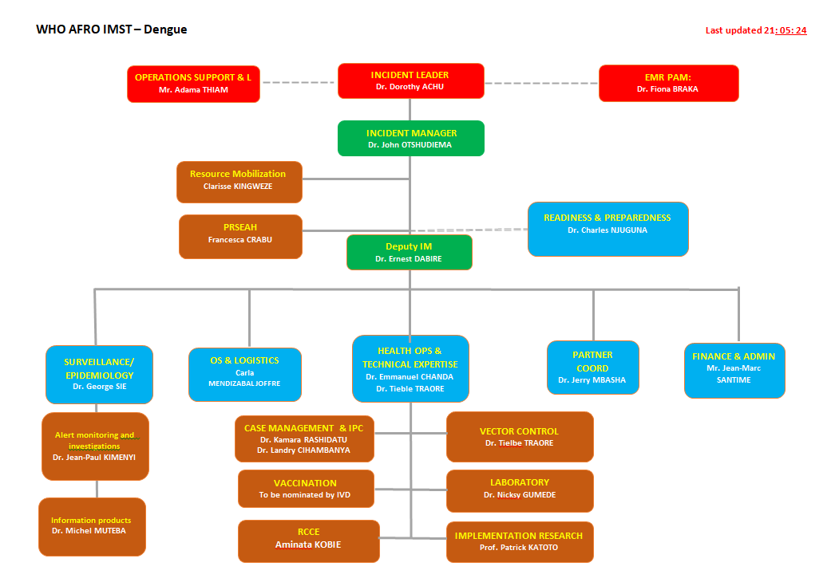

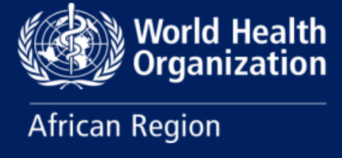

For additional information, please contact:

WHO AFRO Regional Dengue Incident Management Support Team:

- Regional Dengue Incident Manager: Dr John Otokoye OTSHUDIEMA, e-mail: otshudiemaj@who.int
- Health Operations and Technical Expertise Leads: Dr Emmanuel CHANDA, e-mail: chandae@who.int
Dr Freddy Banza-Mutoka, e-mail: fbanzamutoka@who.int

Dr Tieble Traore, e-mail: traoret@who.int
WHO AFRO Dengue Incident Leaders:

- Regional Emergency Director: Dr Abdou Salam GUEYE , e-mail: gueyea@who.int
- Communicable and Non-communicable Disease Director: Dr Benido IMPOUMA, e-mail: impoumab@who.int
- Emergency Response Program Area Manager: Dr Fiona BRAKA , e-mail: brakaf@who.int
- Emergency Preparedness Program Area Manager: Dr Dick CHAMLA , e-mail: chamlad@who.int
- Health Emergency Information & Risk Program Area Manager: Dr Etien KOUA , e-mail: kouae@who.int
- Dengue Incident Lead and Tropical Vector-Borne Diseases Teal Lead: Dr Dorothy ACHU, e-mail: fosaha@who.int

WHO Headquarters – Global Dengue Incident Leaders:

- Global Dengue Incident Manager: Dr Awa NDIR, e-mail: ndira@who.int
- Technical lead & Unit Head of VVE / Vector Control : Dr Raman Velayudhan, e-mail: velayudhanr@who.int
- Health Operations and Technical Expertise Lead: Dr Diana ROJAS ALVAREZ, e-mail: drojas@who.int

