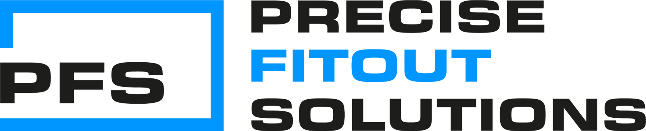
https://www.precisefitout.com/#

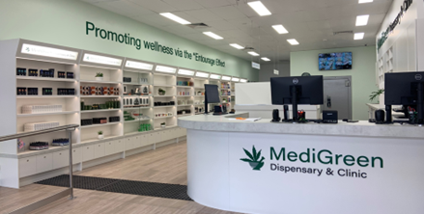

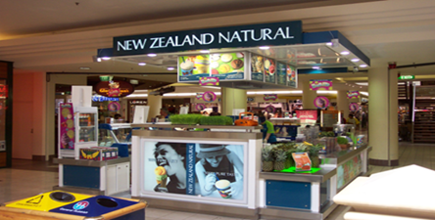
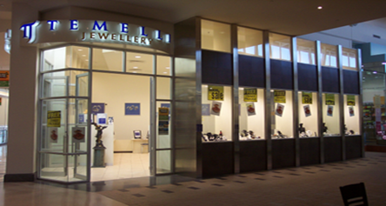
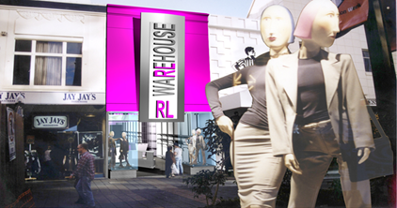

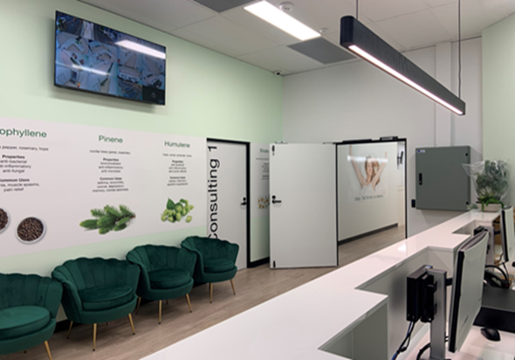

Meet the Team Mark on the left, Will on the right, please use relevant photos about Will and Mark.
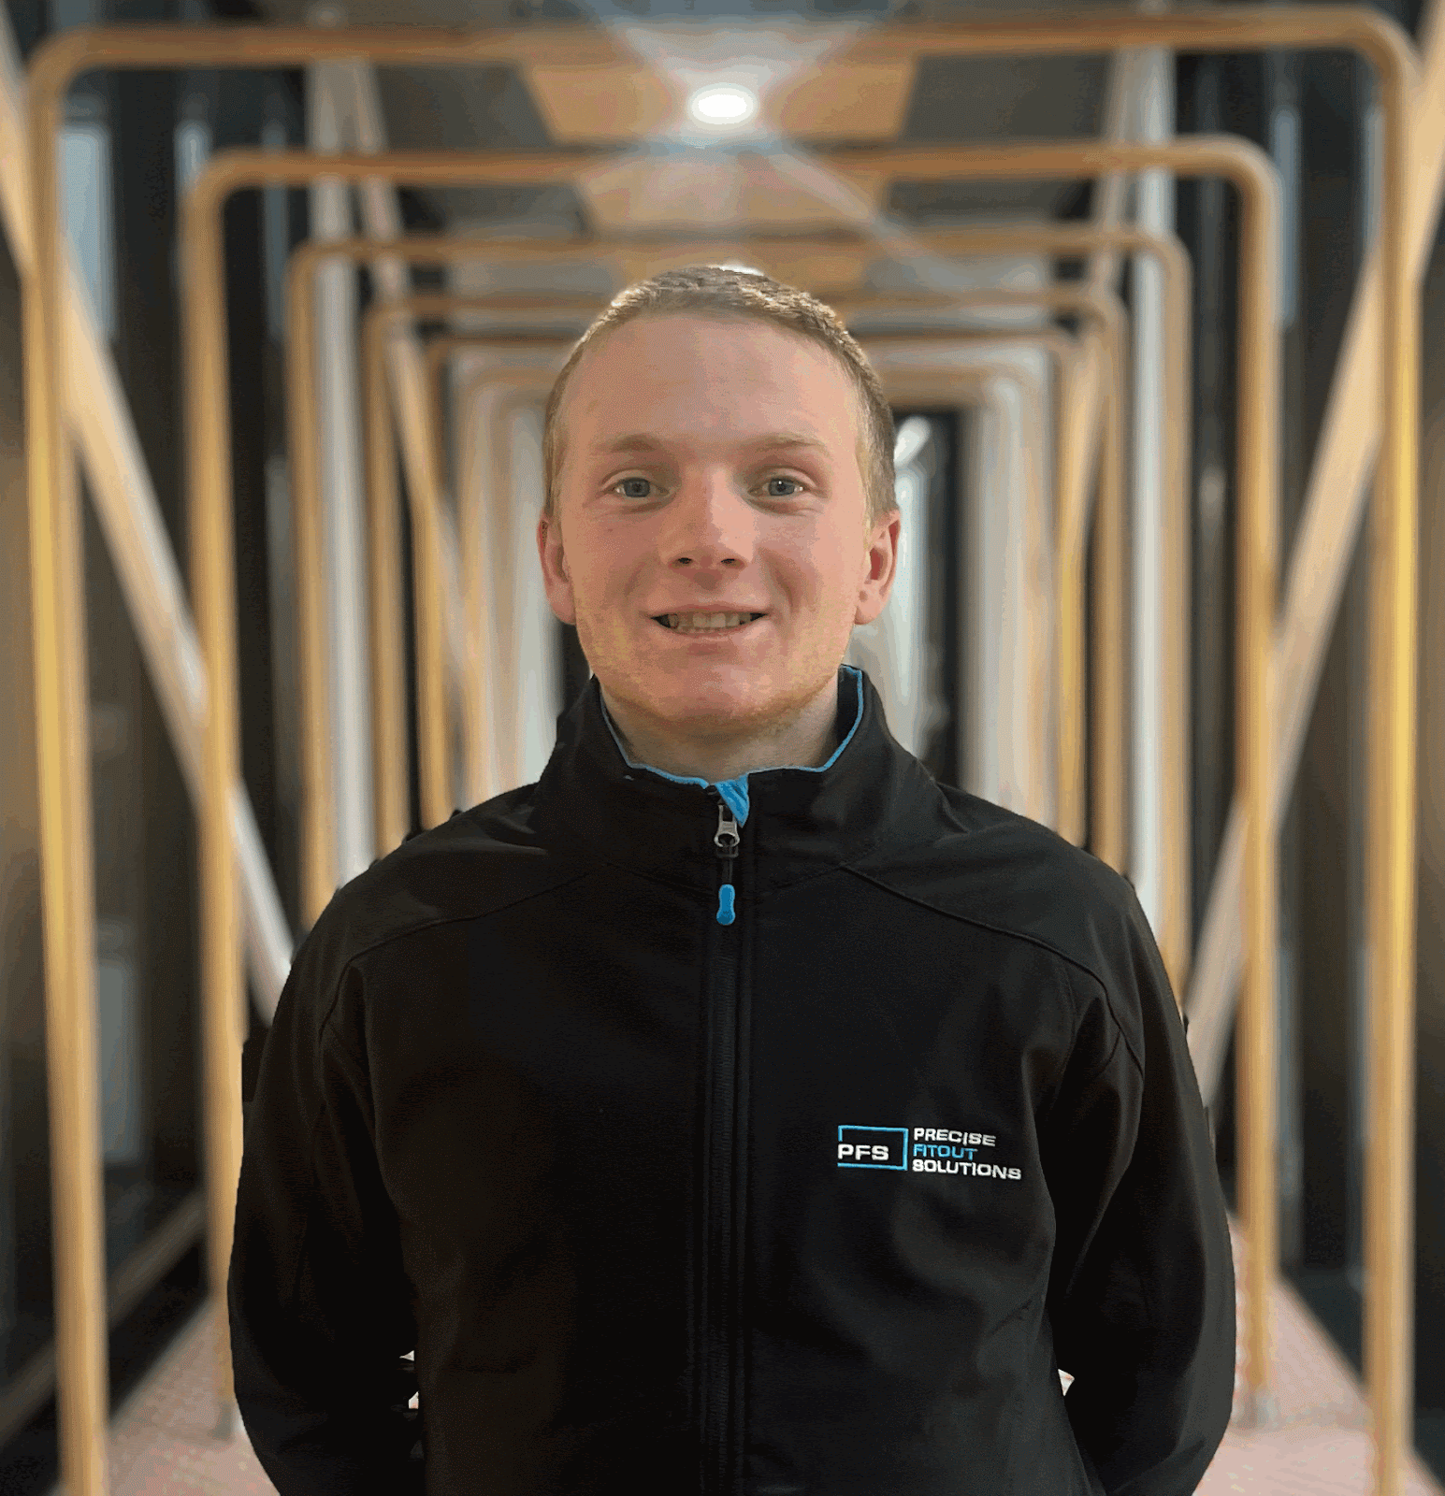

Please use these 2 photos for Will’s Bio page (down below)
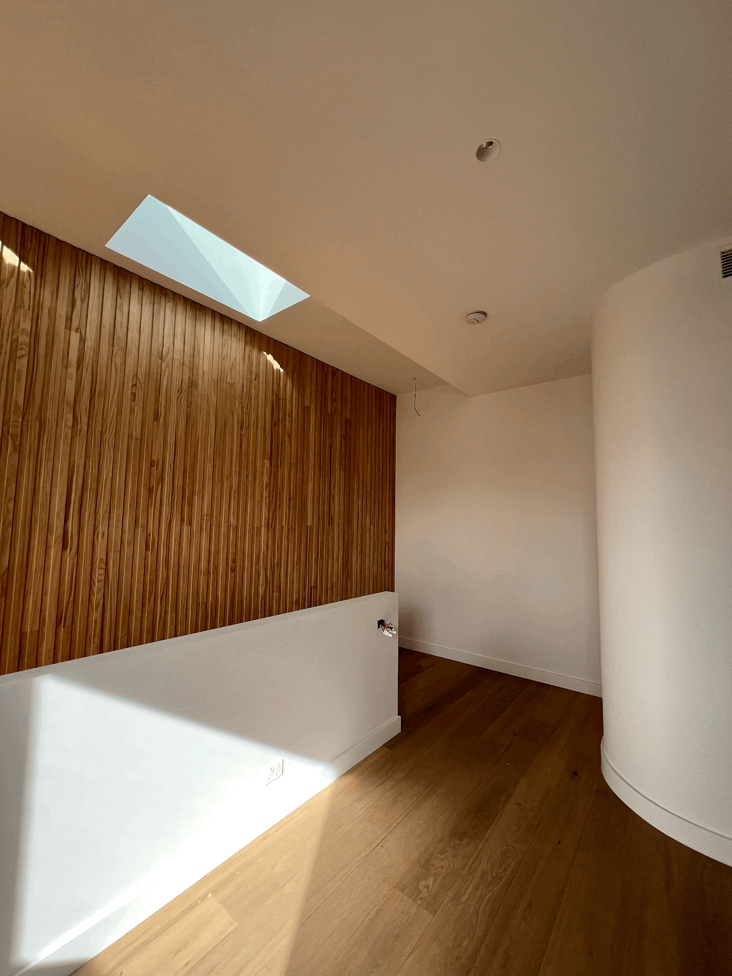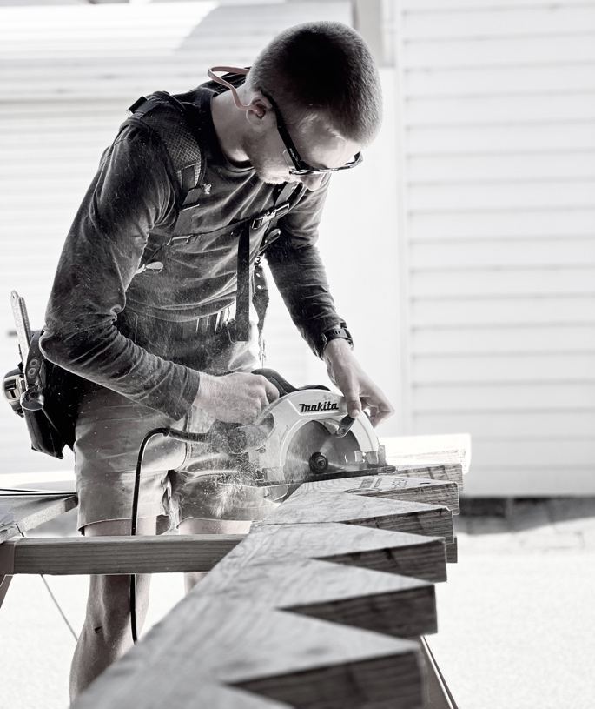

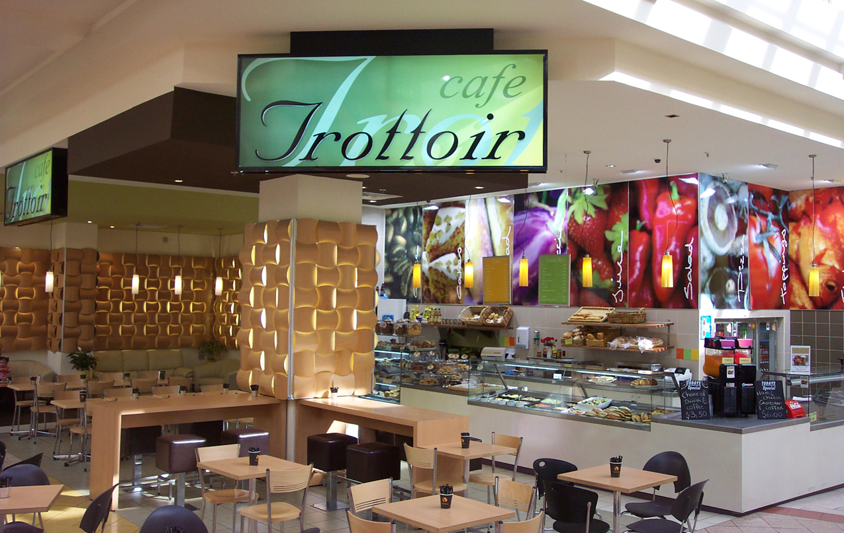
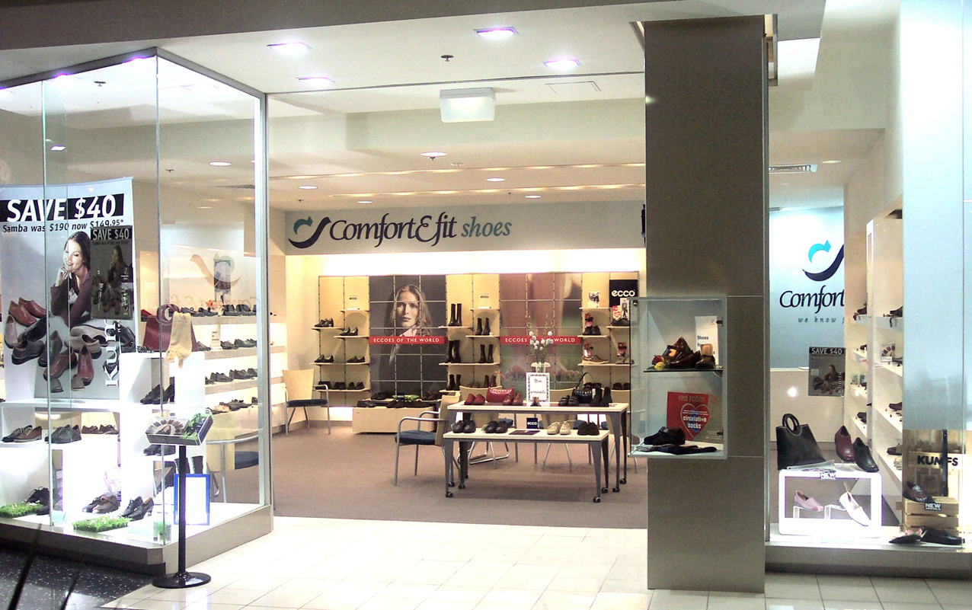

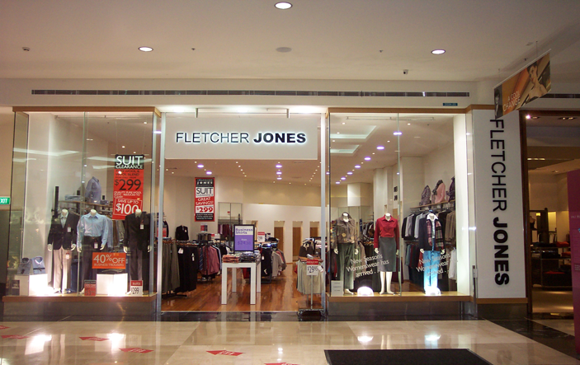

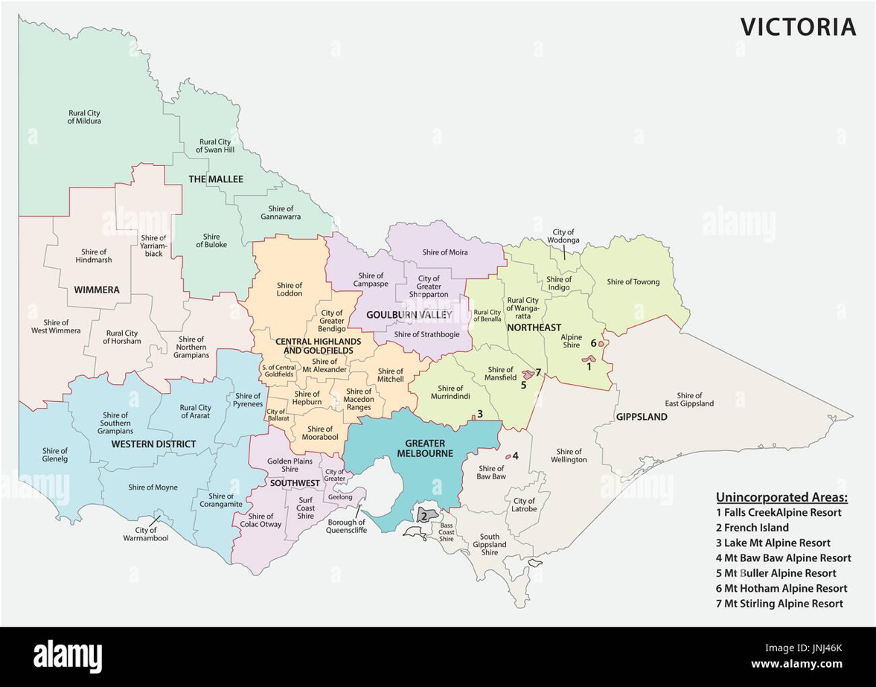

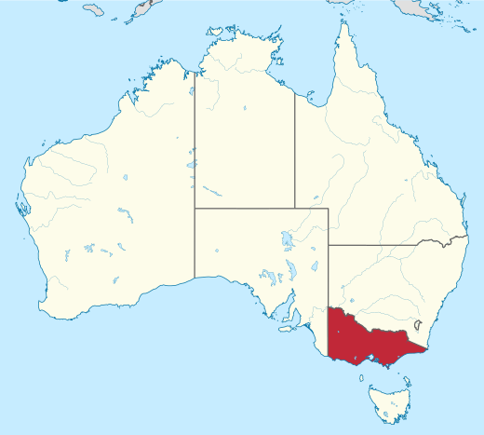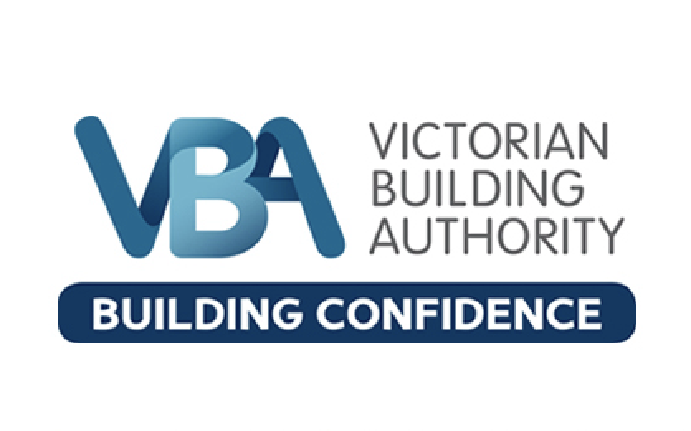

WELCOME TO PRECISE FITOUT SOLUTIONS!
At Precise Fitout Solutions (PFS), we were founded with your needs at the forefront—a dedication to delivering transformative results for your commercial and retail projects.
Our pride lies in surpassing client expectations through meticulous planning and proactive problem-solving. PFS specializes in:
- Pharmacy, medical centers, allied health, retail, hospitality, and commercial interior fitouts.
- General tenancy relocations, renovations, rebranding, demolishing, and make good of existing sites.
- Pre-lease based building site inspections and reports.
- Costings, feasibility studies on the design and construction of projects.
Our competitive edge lies in our proficiency in delivering professional services, ensuring compliance, and providing informed recommendations. We prioritize the protection of our clients across all facets of the interior design business, including on-site safety in accordance with WorkSafe standards. Additionally, we have a nuanced understanding of the construction and manufacturing industry standards.
Our Story
Precise Fitout Solutions emerged from a crucial need: assisting two pharmacists in designing and building a medical center and pharmacy. These pharmacists, familiar with Mark Garbelotto's background as both an interior designer and commercial builder, sought his expertise. Despite being retired from the building industry, Mark was approached to review drawings and quotations for the project, revealing significant design flaws and regulatory non-compliance among the quotes that varied by 40%. Mark agreed to assist, reactivating his licenses with the Victorian Building Authority. He coordinated with various consultants to refine the design, secure necessary permits, including town planning and change of use, and oversee the project through to completion. Collaborating with a skilled team of industry experts and even his son, Will, a third-year carpenter apprentice at the time, Mark ensured the project's success. Inspired by this experience, Mark and his son Will have united to support others unfamiliar with the complexities of design and construction compliance in interior fitouts.

Mark Garbelotto
Mark Garbelotto is an accomplished interior designer and commercial builder. Graduating as an interior designer in 1992, he faced the challenges of a recessionary job market, which led him to work as a sales representative for a commercial lighting manufacturer for two years. Despite the limited opportunities in his field, Mark’s determination and vision drove him to establish his own interior design practice in 1994.
In 1996, Mark solidified his professional standing by becoming a registered interior design practitioner with the National Building Commission, demonstrating his commitment to quality and compliance within the industry. His pursuit of excellence continued as he expanded his skill set, becoming a registered commercial builder in 2000, allowing him to seamlessly integrate design and construction services.
Mark is the Founder and CEO of Precise Fitout Solutions, a company dedicated to transforming the commercial and retail fitout industry. With a client-centric approach, the goal is to exceed expectations by delivering exceptional results for projects ranging from medicinal cannabis dispensaries to medical centers, pharmacies, commercial, retail, and hospitality interiors. Their holistic methodology, meticulous planning, and proactive problem-solving ensure that every project is completed on time, on budget, and hassle-free.
Will Garbelotto
Will is set to complete his Certificate III carpentry apprenticeship by the end of 2024. His journey has seen him work on a variety of residential and commercial projects, where he has developed a broad skill set in carpentry and site management.
In June 2024, Will joined Precise Fitout Solutions, adding a valuable trade-based perspective to the design and construction of fitouts. His hands-on experience and comprehensive skills significantly enhance the team's capability to deliver high-quality projects.
Will's expertise includes operating elevated work platforms up to 11 meters (boom lift, scissor lift), reading and interpreting plans, specifications, and drawings for carpentry work, and applying Work Health and Safety requirements, policies, and procedures on all job sites. He is adept at identifying construction work hazards and selecting appropriate risk control strategies. Additionally, Will can set out design layouts for site construction, is licensed to erect and dismantle restricted height scaffolding, and works safely at heights.
His ability to conduct workplace communication, provide basic emergency life support (HLTAID002), and administer first aid (HLTAID003) further underscores his comprehensive skill set. Will's dedication to his craft and his practical expertise make him a key asset to PFS.

Our Expert Teams:
- Consulting Team: Our consulting team comprises project managers, interior designers, architects, town planners, acoustic, structural, mechanical, fire services engineers, building surveyors, and DDA consultants, ensuring compliant and innovative design and construction solutions.
- Construction Team: The PFS construction team consists of skilled professionals, including site supervisors, carpenters, plasterers, electricians, data and IT specialists, security experts, plumbers, flooring specialists, joiners, glazers, and painters.
- Finance Team: Explore fitout and construction finance options with our finance consulting team, providing you with alternatives to fund your projects without tapping into your business, home loan, or superannuation.
Services We Offer:
- Lead project consultant, project management, and construction management
- Site inspection: Pre-lease site inspections and advice on base building works.
- Town planning: Assessment for occupancy use and change of use.
- Budgeting: Expert advice on construction budgets and required services.
- Planning services: Comprehensive planning from start to finish.
- Permit applications: Assistance in obtaining building, health, and town planning permits.
- Design approval: Submission and approval processes for design fitouts in shopping centers and commercial body corporations.
- Consultation: Collaborate with disability access consultants, architects, interior designers, and various engineering disciplines.
- Design and construction: Seamless coordination of design and construction solutions.
- Joinery manufacturing: Specialized joinery solutions for all needs.
- Renovations and rebranding: Vacant and demolishing works, shop front renovations, signage updates, and removals.
Designing and constructing compliant commercial interiors involves a systematic approach that ensures adherence to regulations and standards set by authorities such as the Victorian Building Authority (VBA). This process methodology outlines key steps to achieve a successful project outcome while meeting legal requirements.
Step 1: Initial Consultation and Briefing
The process begins with an initial consultation where client requirements, project objectives, and regulatory constraints are discussed. This phase is crucial for establishing clear goals and understanding the scope of work.
Step 2: Concept Development and Design
Following the briefing, concept development takes place. Designers and architects collaborate to create conceptual layouts and plans that align with the client's vision and functional needs. Consideration of VBA regulations regarding building codes, accessibility, and safety standards is integrated into the design process.
Step 3: Detailed Design and Documentation
Once the concept is approved, detailed design work commences. This phase involves creating comprehensive drawings, specifications, and documentation that outline materials, finishes, and construction methods. These documents are essential for obtaining necessary approvals from the building surveyor.
Step 4: Regulatory Compliance Review
Prior to submission, all design and documentation undergoes a thorough review to ensure compliance with VBA regulations. This includes structural integrity, fire safety measures, environmental considerations, and accessibility standards. Amendments are made as needed to meet regulatory requirements.
Step 5: Permitting and Approvals
With compliant documentation in hand, the next step involves securing permits and approvals from the building surveyor and relevant authorities. This process includes applications for building permits, occupancy permits, and any specific approvals required for commercial use.
Step 6: Construction and Project Management
Once permits are obtained, construction begins under the close supervision of our project managers and site supervisors. Our site supervisor remains onsite throughout the project's duration, coordinating daily activities and ensuring seamless communication with the project manager. Regular site inspections and quality checks by the project manager ensure that all construction practices align with approved designs and regulatory standards.
Step 7: Final Inspections and Handover
Upon completion of construction, final inspections are conducted to verify compliance with all regulatory requirements. This includes inspections by building surveyors to ensure adherence to building codes and safety standards. After successful inspections, the project is formally handed over to the client.
Please insert the attached case study and summarise it. (power point attached)

Conclusion
By following this structured process methodology, PFS can navigate the complexities of designing and constructing compliant commercial interiors in alignment with the stringent requirements of the Victorian Building Authority. This approach not only ensures legal compliance but also enhances project efficiency, safety, and client satisfaction.

If you are in search of a fresh approach to guarantee superior outcomes for your upcoming commercial interior fitouts please contact us.

