Can we reduice size of pics in the top of the home pase ? ….. they are cutted ! miss also the fourth one …. Just added it in the brief…. Mini pool spa ! (see just below)
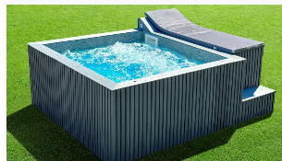
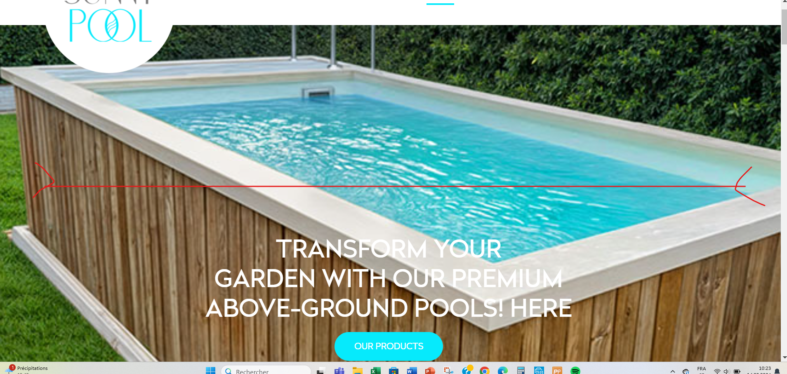
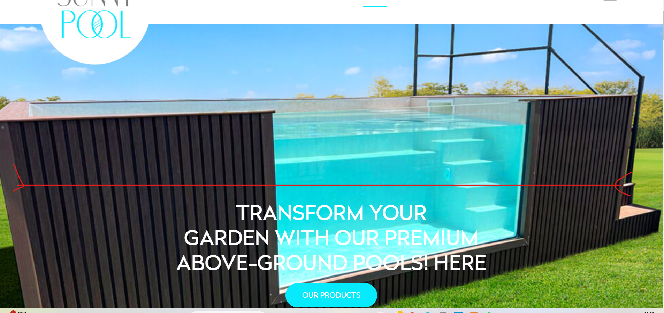
The edges are good !! thanks
Please aligne also this ….

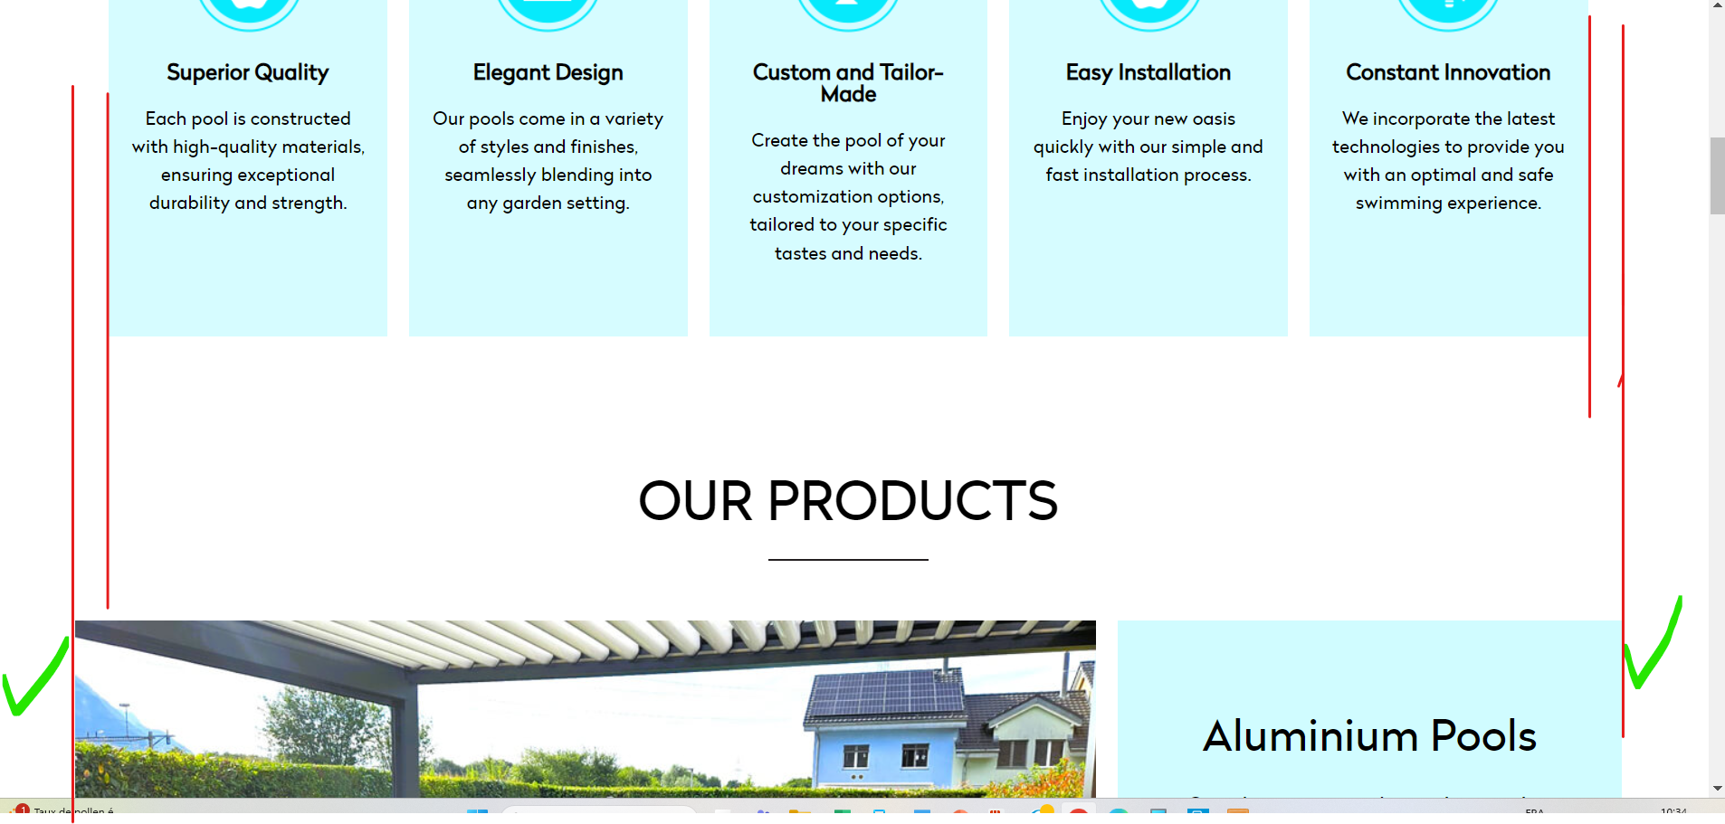

c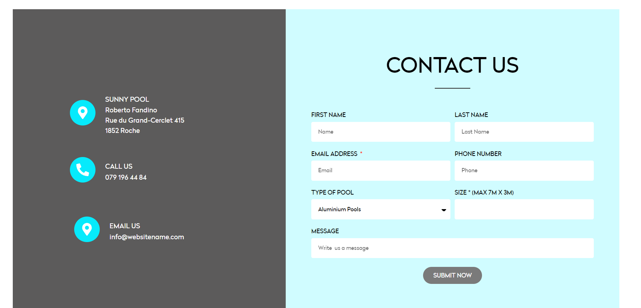
Please aligne and replace the last by an enveloppe.
contact@sunnypool.ch
New number +41797871852
Remove my mame, no need
SUNNY POOL -Please fix it to avoid a translation
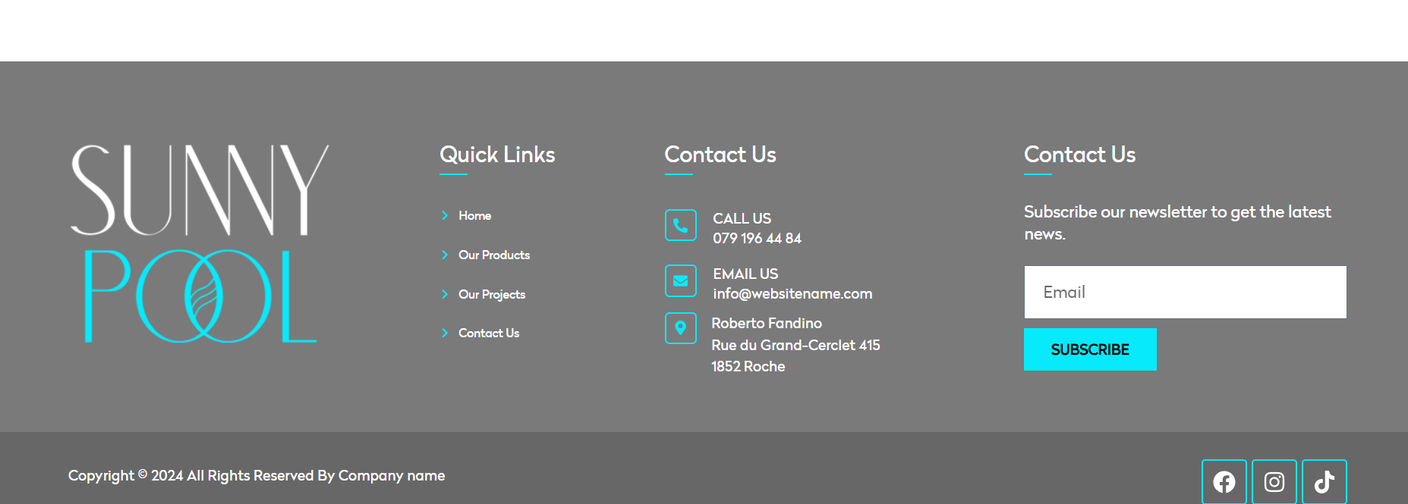
Replace by Sunnypool, fix it to avoid translation
New number +41797871852
contact@sunnypool.ch

