Please see below some comments:
1 – I have updated new pics in the brief to add them under our projetc tab …

2- Please check error below:

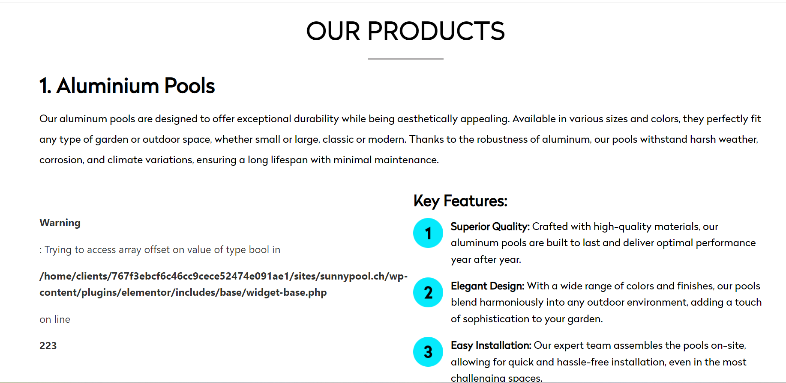
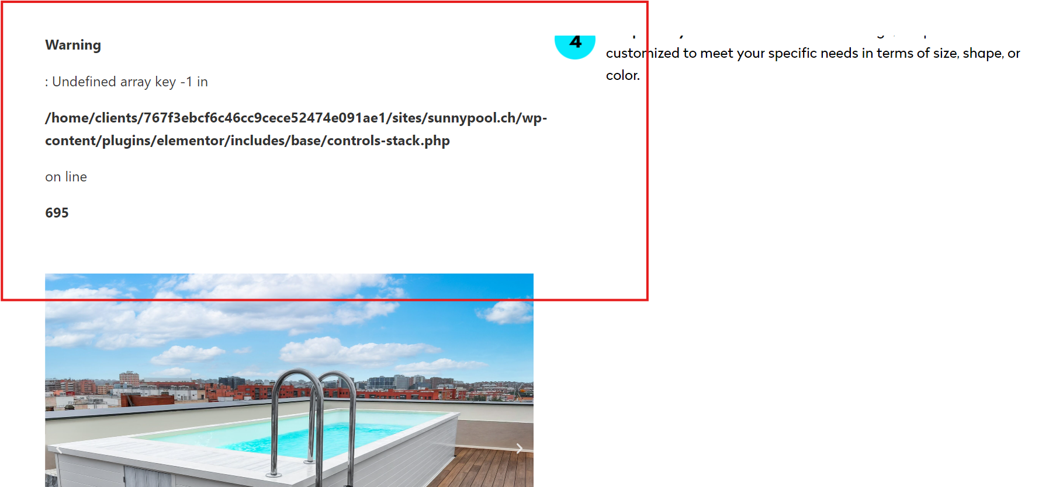

Résolution 1920x1080 (standart)
1 - As you can see picture are not ok, to much zoom! As I know is possible to make it with and automatically tool to be automatycally adated in differents screen sizes, smartphone, tablet, laptop, bigger screen, etc ….. Did you try the smartphone view? To big too
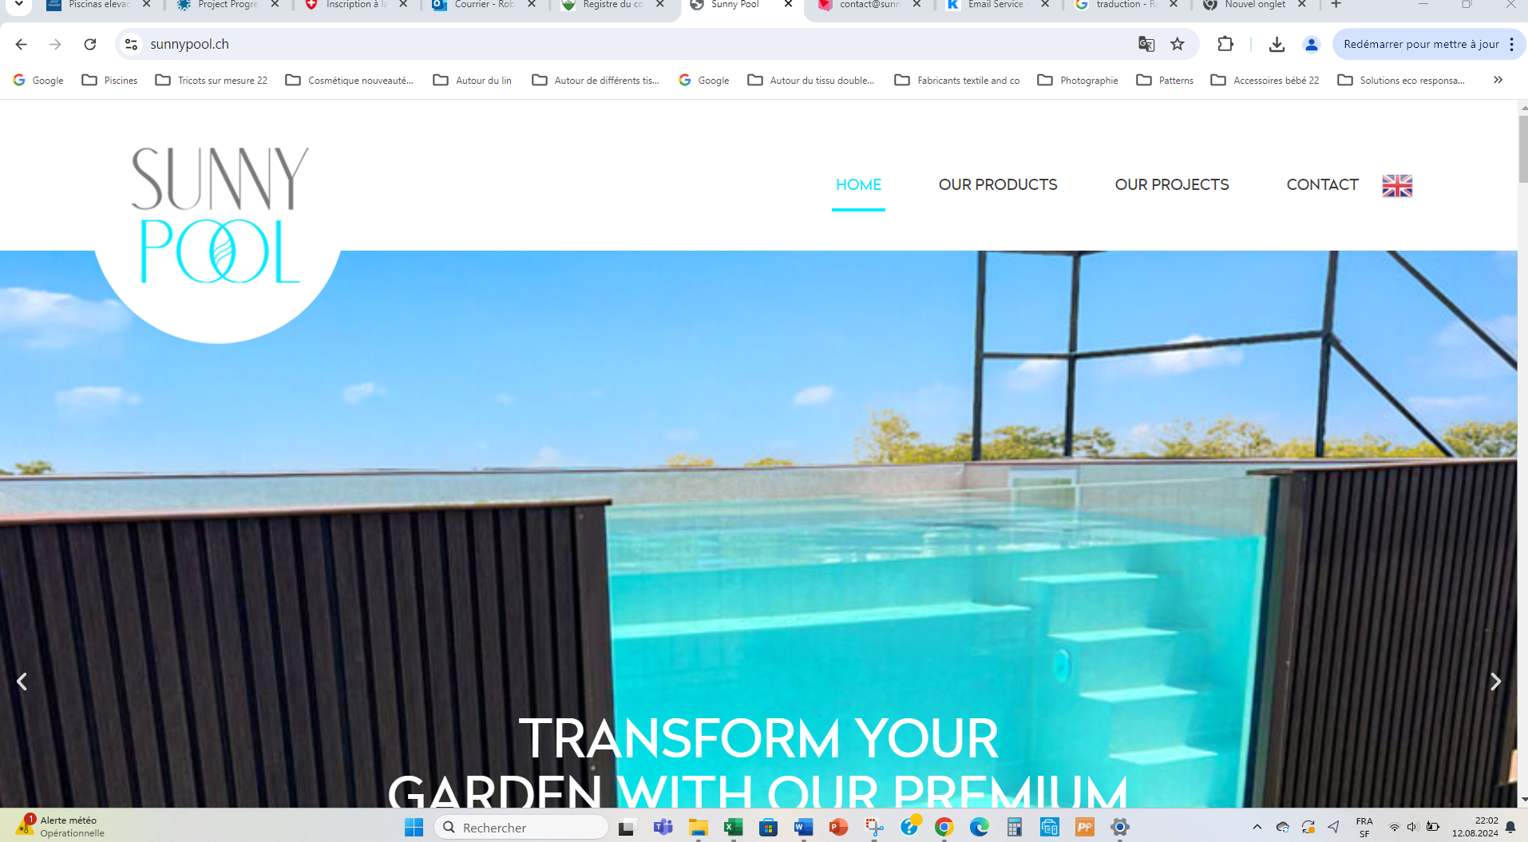
2 - Do yout think that there is a possibility to reduce all content and create ab blanc space in both sides? Without cutting anything just reduce all size page and create a blanc space of each side. Please see bellow.
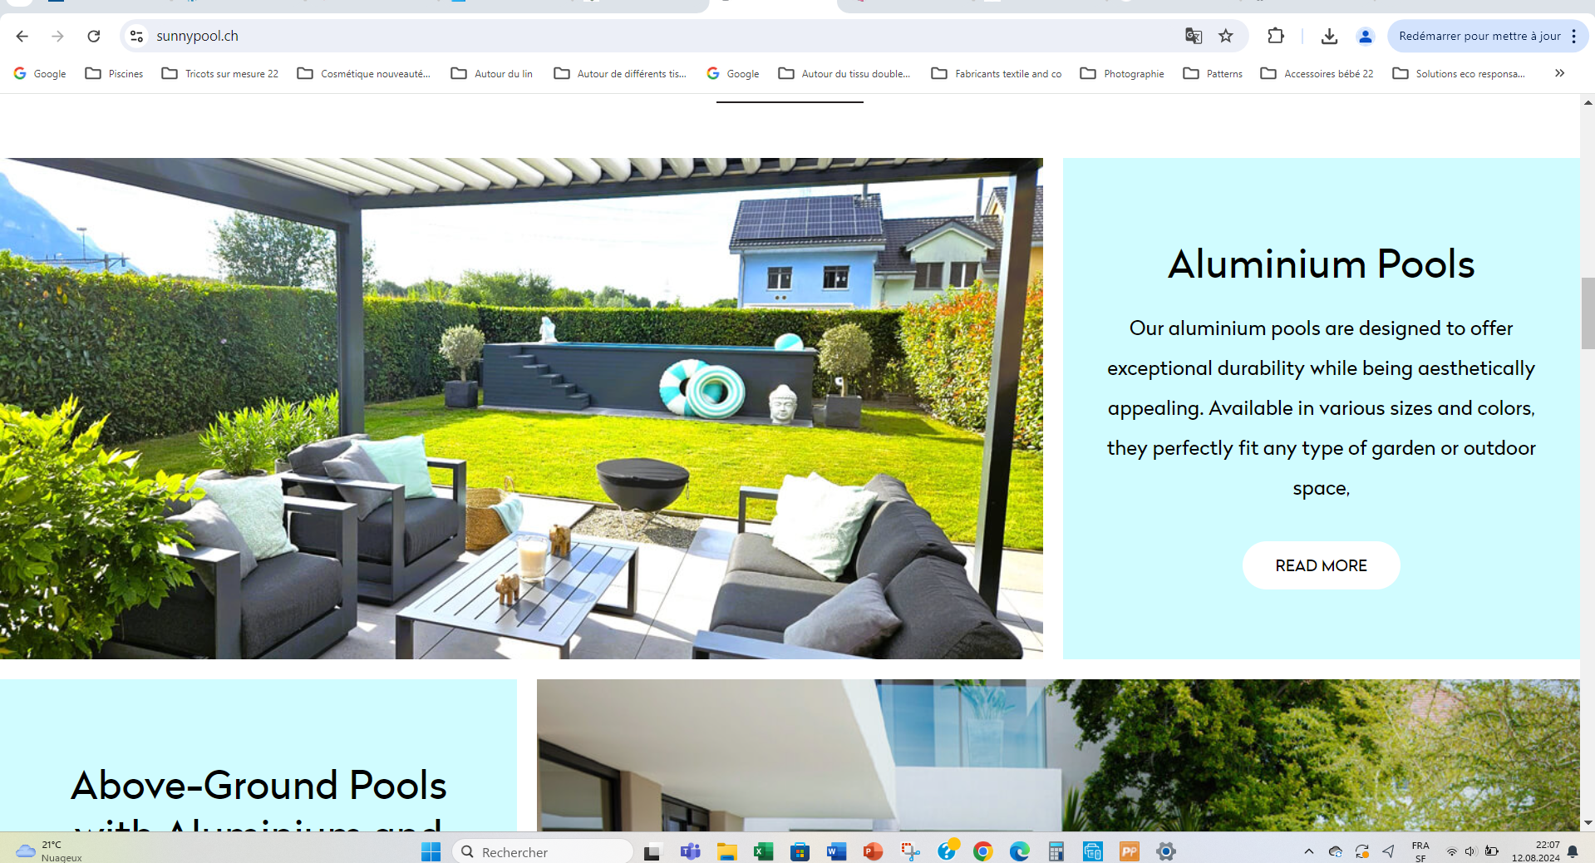

Résolution 3440x1440 (big screen)
As you can see picture are not ok too, to much pixelaized! Realy not ok

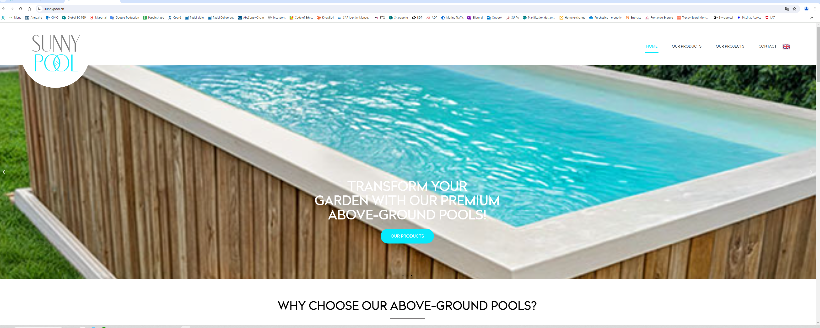
Pics sizes exceeds the screen
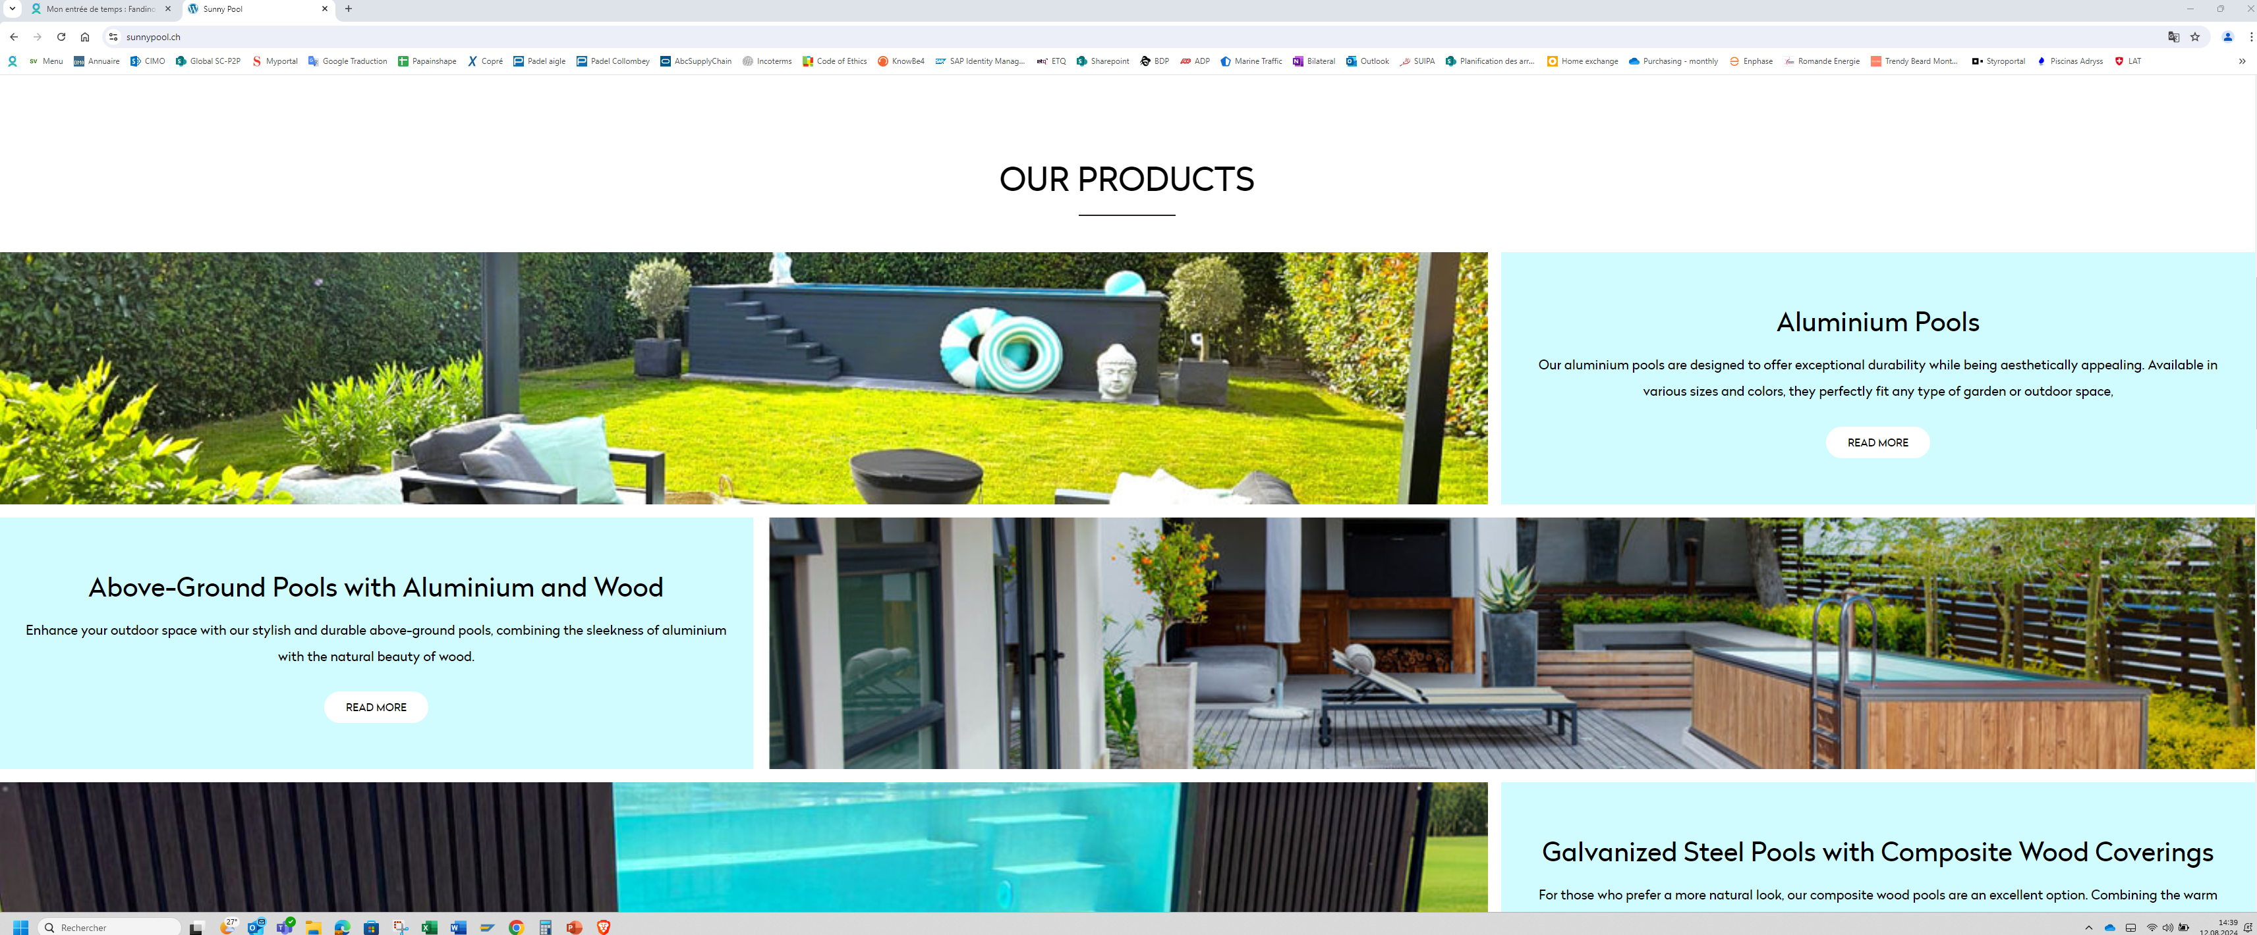
Photos and text are overwritten

6 – Please change contact as follow:

Phone number: +41797871852
Email address: contact@sunnypool.ch

