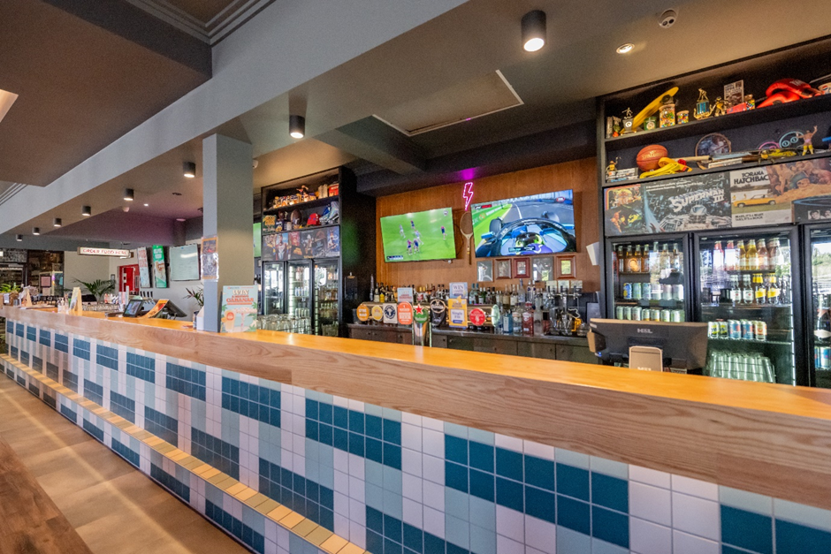
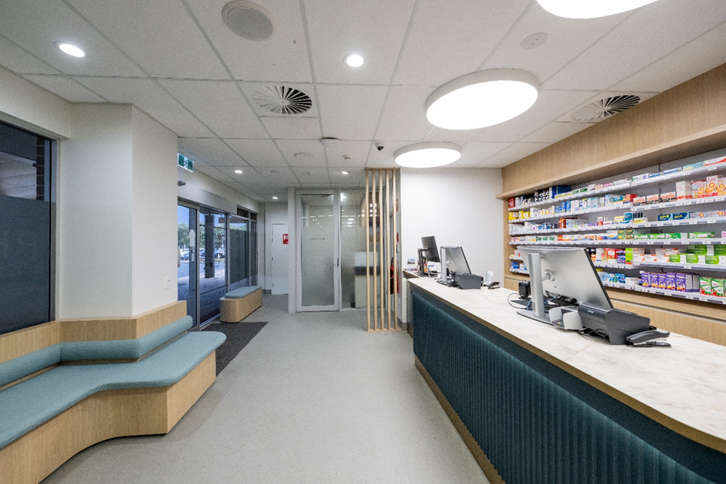

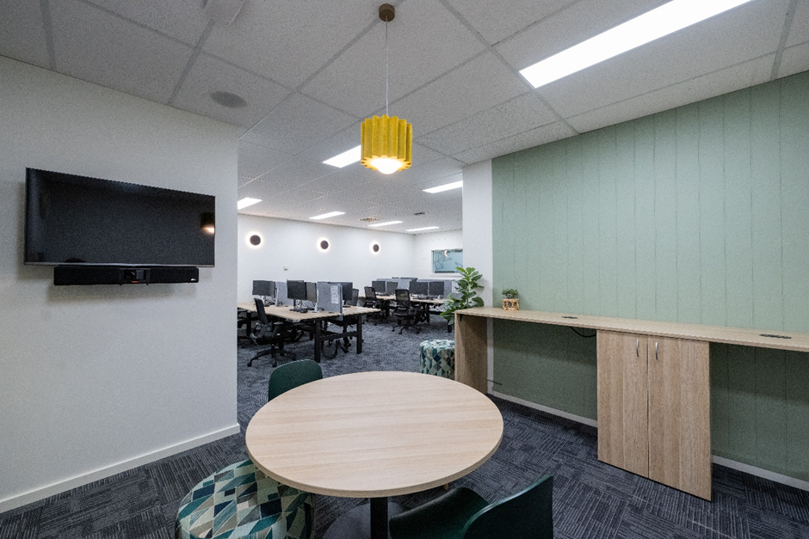
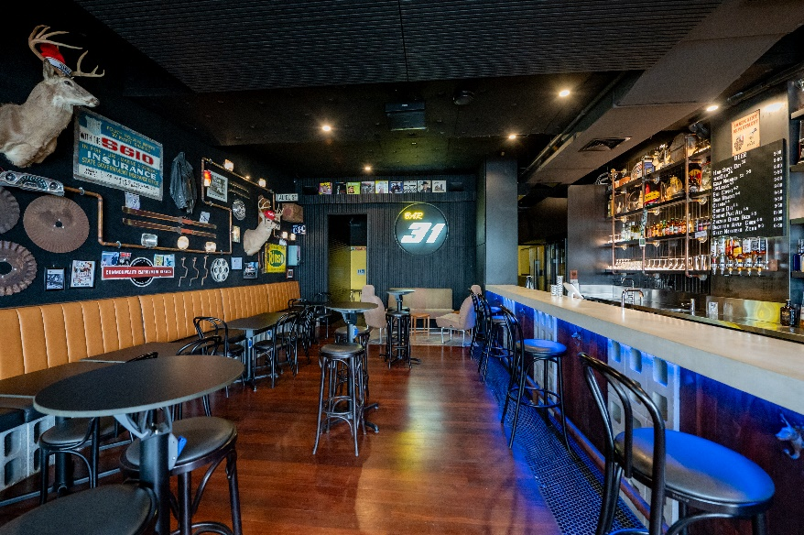

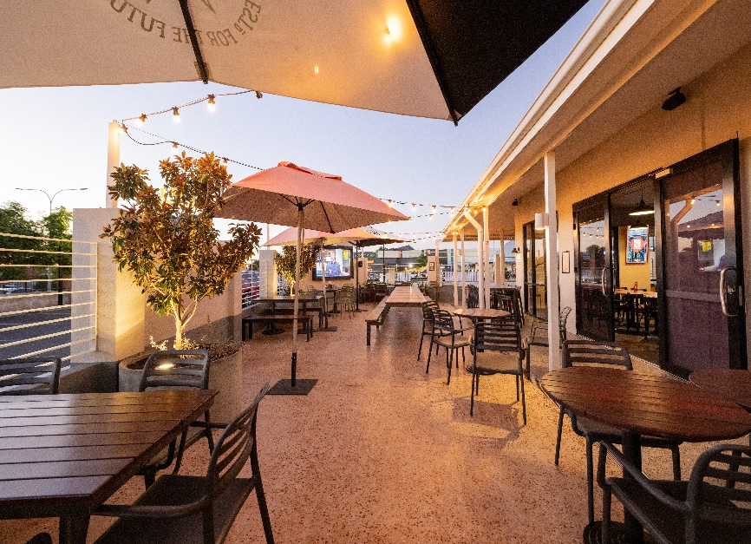
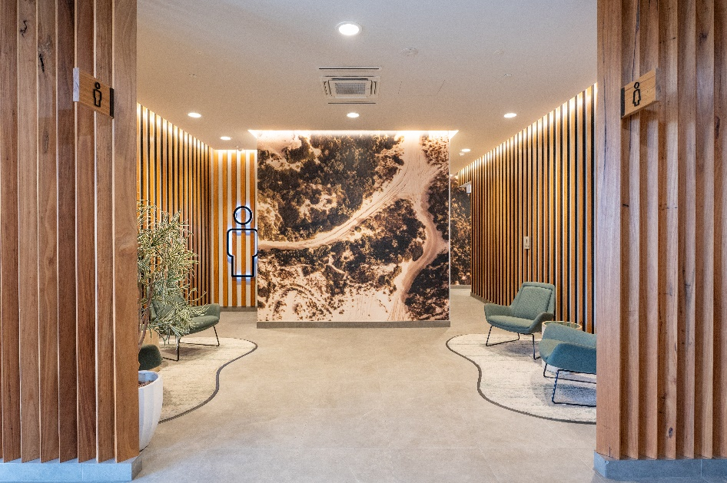

COMMERCIAL FITOUTS COMMERCIAL REFURBISHMENTS COMMERCIAL MAINTENANCE



Capability Statement
Phone: (08) 9787 9888 www.changingspaces.net.au info@changingspaces.net.au
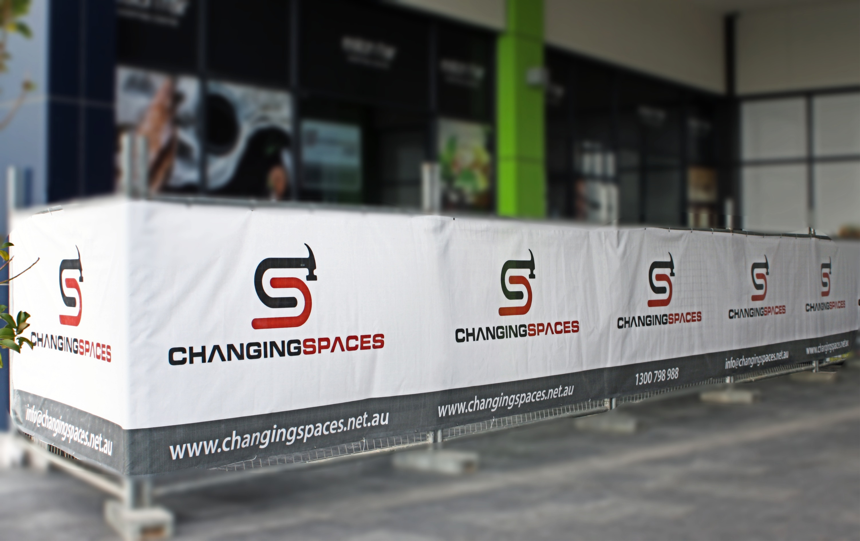
“ Building with quality,
Integrity ”
transparency and

COMPANY PROFILE
Changing Spaces if a full- service building and construction business, specialising in the construction of creative, inspiring and productive business and commercial workplaces.
Based in Bunbury and servicing areas from Perth to Albany, Changing Spaces has the capabilities, credentials and experience to handle building works for all types of commercial and business premises, including the regulatory requirements of the food service and medical sectors.
Through clever design, professionalism and quality workmanship we add value, increase productivity in your workplace and streamline the entire building process so it is an exciting and enjoyable experience.
Creating that all- important first impression to customers, projecting your company image and providing an environment which fosters productivity and employee engagement for your team.
Our services are specifically designed to transform workplaces with minimal downtime and disruption to your business

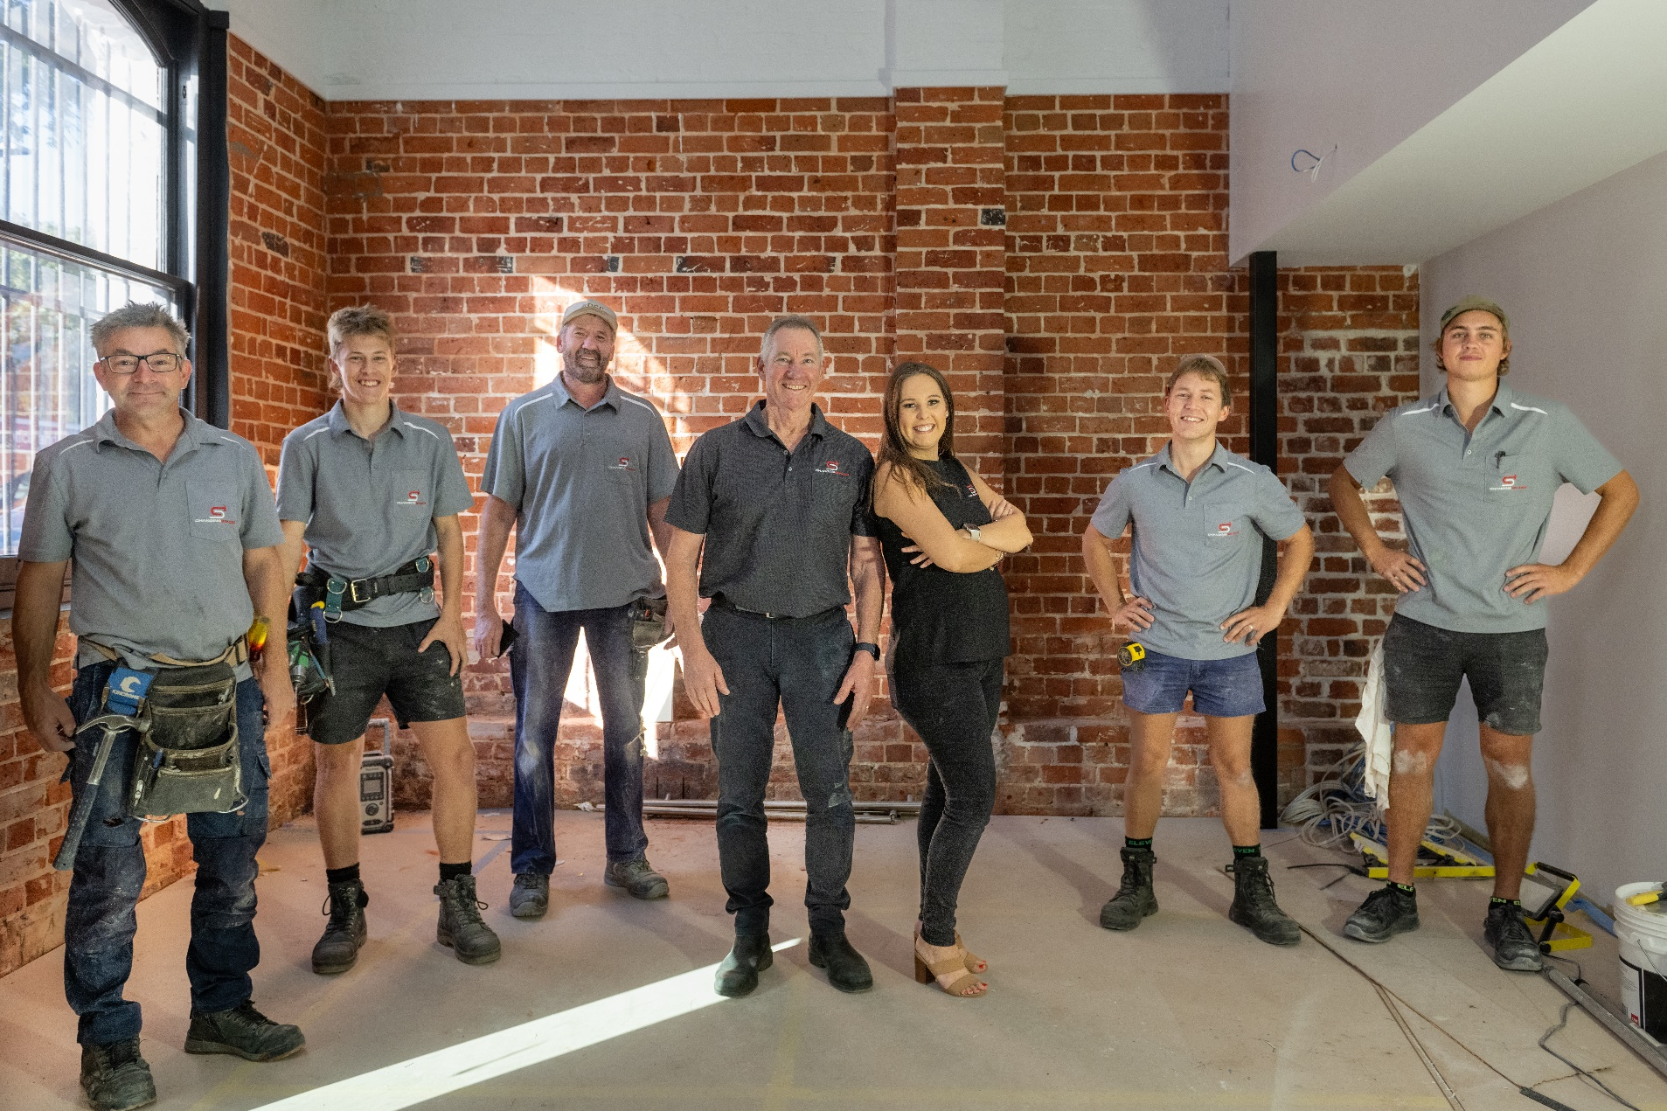


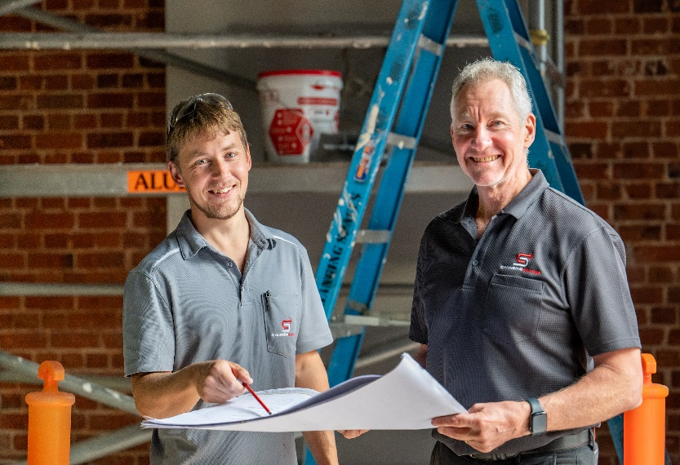

- Accessible- Based in Bunbury and completing projects from Perth to Albany
- Trustworthy- Your engaging a solid company that you can entrust to complete your job
- Hands on Experience- Not just ‘office jockey’ project managers. Our staff have hands on building experience
- Fully Qualified- Registered building licence No 13227
- Industry recognition – you can be assured your dealing with a reputable business, members of the Master builders association and Australian shop and office fitting association
- In house expertise ensure consistent quality control – including specialist tradespeople, project managers, cabinetry and carpentry specialists
- Skills to handle the complete job start to finish, interiors and exteriors including structural work, aesthetics, design, roofing and wet areas
- Proven capabilities across the spectrum of commercial premises-
Traditional offices for law, accounting, finance, general business operators;
Multi-purpose workplaces incorporating office with workshop and warehouse;
Retail stores of all sizes including medical, dental, veterinary, takeaway food outlets, restaurants, bars and specialty stores
- Reliability to complete your job on time and on budget with an impressive track record which is evidenced in our portfolio

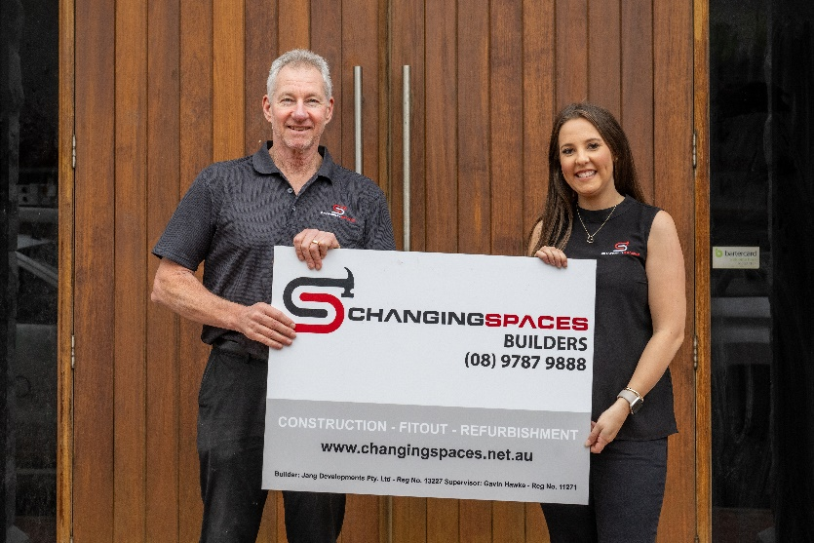

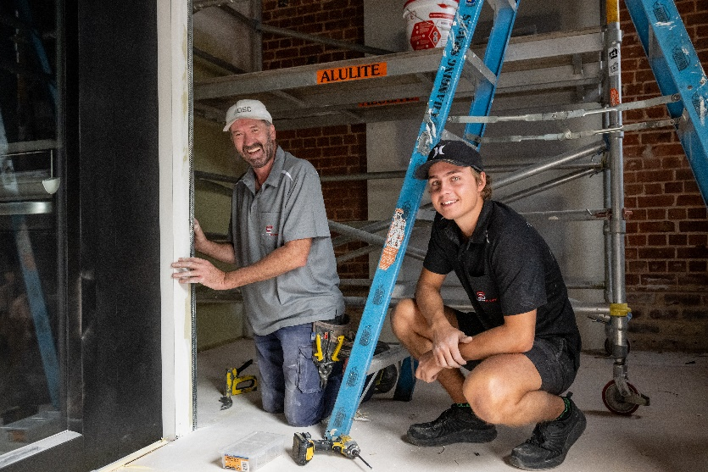


CASE STUDY

BUNBURY VET REFURBISHMENT
B

Bunbury Vet engaged Changing Spaces to carry out a refurbishment of their existing premises in Bunbury. Changing Spaces were responsible for the full fit out works including contractor selection, project delivery and assistance with design and selections.

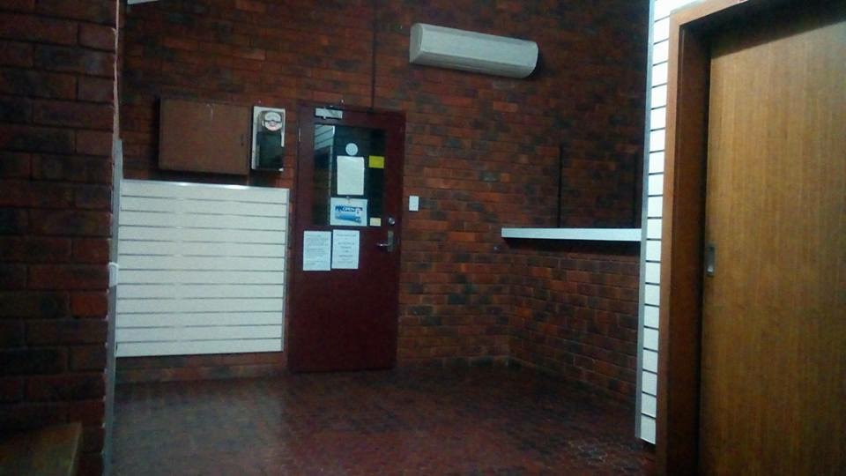
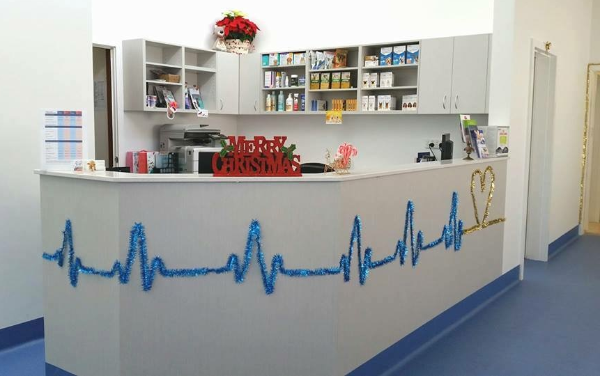

PROJECT OBJECTIVES:
- Provide a full refurbishment to the front and back of house of the clinic that is practical and suitable for the use (wear and tear from animals and large amounts of traffic)
- Stick to a budget provided by the clinic and carry out works in a low cost way
- Lift the environment to incorporate diverse needs
- Complete the works as timely as possible while the clinic continues to operate day to day
- Provide a solution to accommodate the animals in the back of house kennels ensuring the kennels are strong and comfortable for the animals.

Phone: (08) 9787 9888 www.changingspaces.net.au info@changingspaces.net.au
CASE STUDY

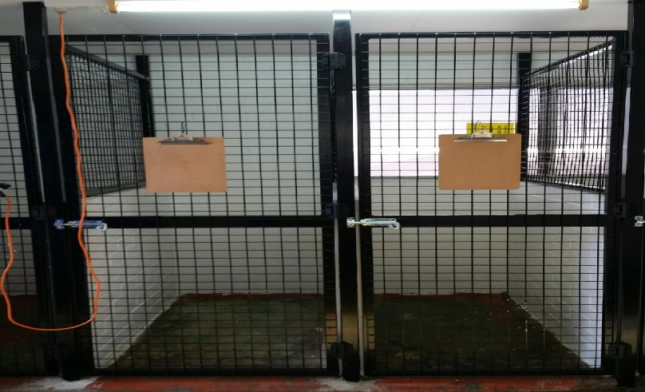
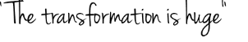
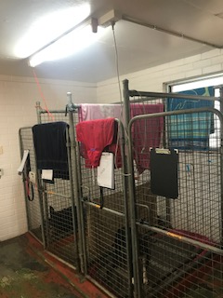
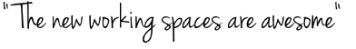
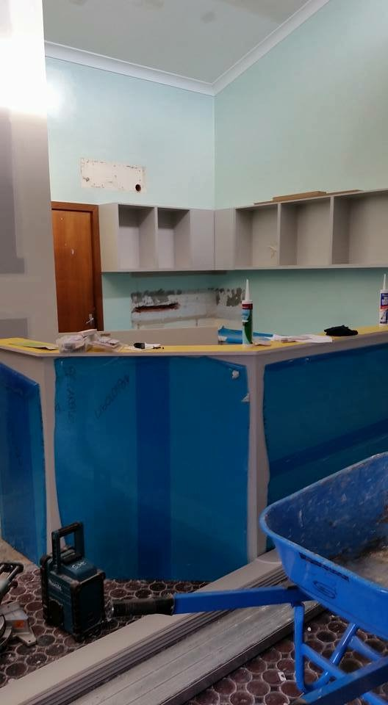
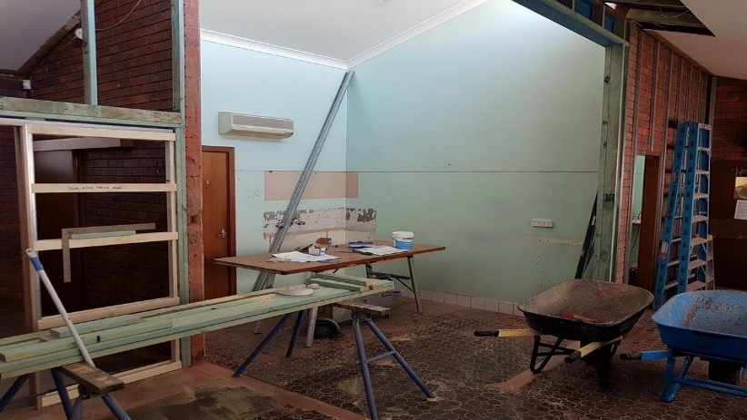
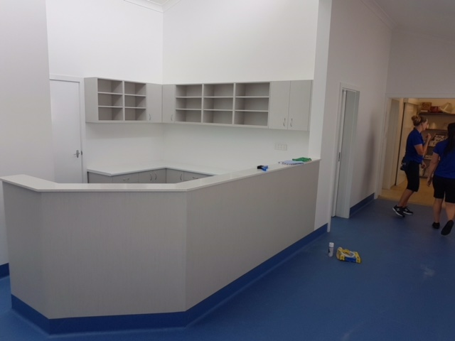
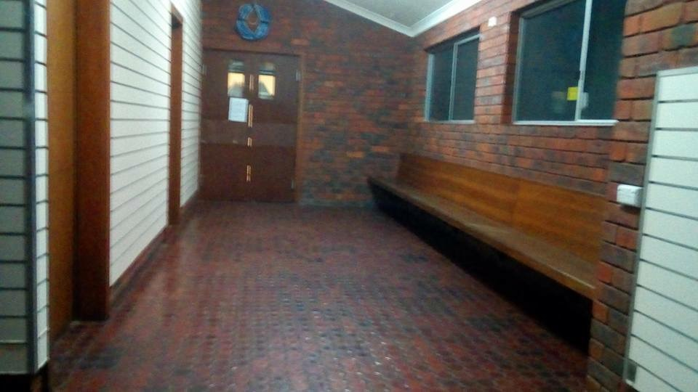
- Joe, Managing Director

Phone: (08) 9787 9888 www.changingspaces.net.au info@changingspaces.net.au
CASE STUDY

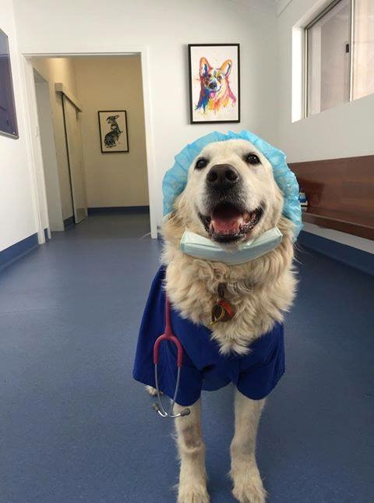

PROJECT CHALLENGES:
- Given the practice wanted to continue operating while the works were taking place the project had an extremely tight time frame. The challenge was to complete the works as quickly as possible while causing little disruption and accommodating the needs of every animal brought into the clinic as their safety and comfort was our highest priority
- Meeting the clients budget required a few alternative option quotes to be provided. Given the tenancy is leased the client understandably did not want to spend a fortune on a premises they did not own
- Functionality was important in the small premises and we had to ensure that the layout was practical for staff efficiency without been able to make any changes to the size of the building
- The products and materials used had to be very hard wearing, given the clients are all animals everything had to be suitable for the environment and long lasting – from the type of paint used right down to the type of flooring

RESULTS:
- The project was completed safely, on time and in budget!
- The process of effectiveness and pro- activity that led to such great outcomes is typical of what to expect from Changing Spaces

Phone: (08) 9787 9888 www.changingspaces.net.au info@changingspaces.net.au
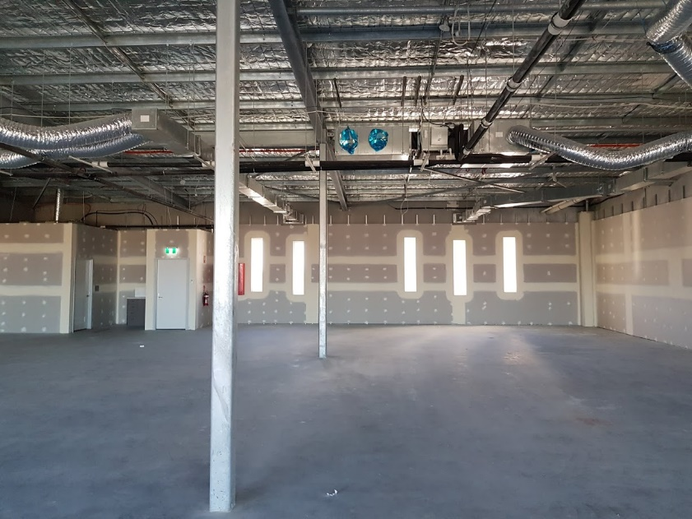
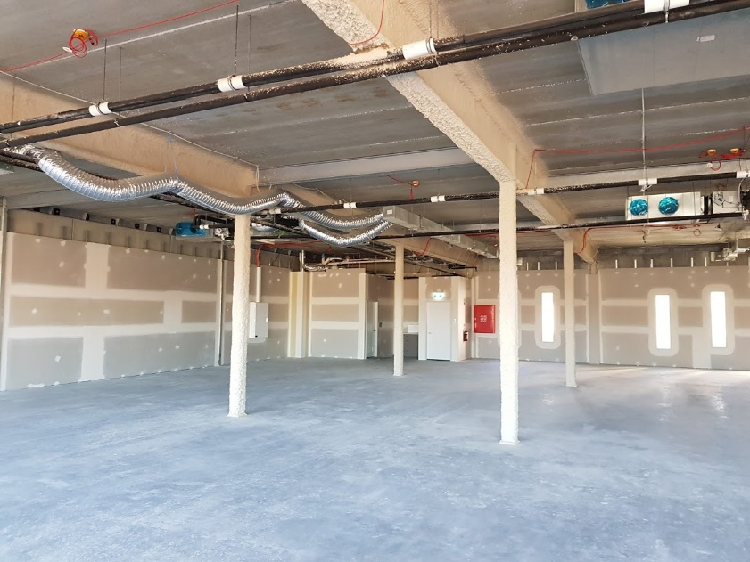

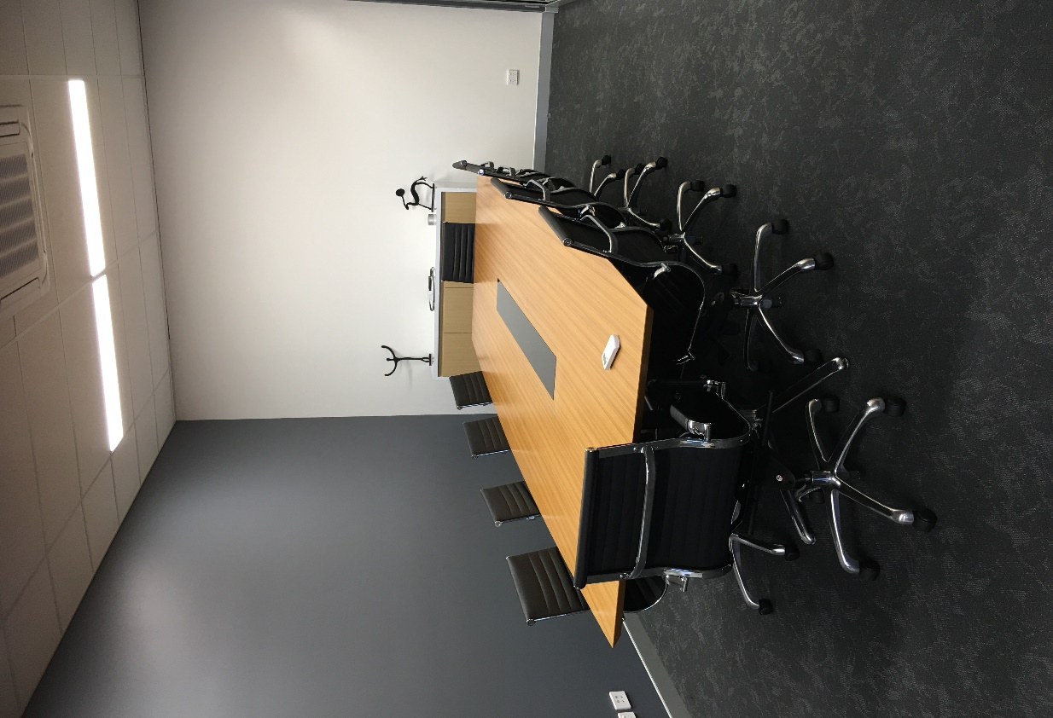
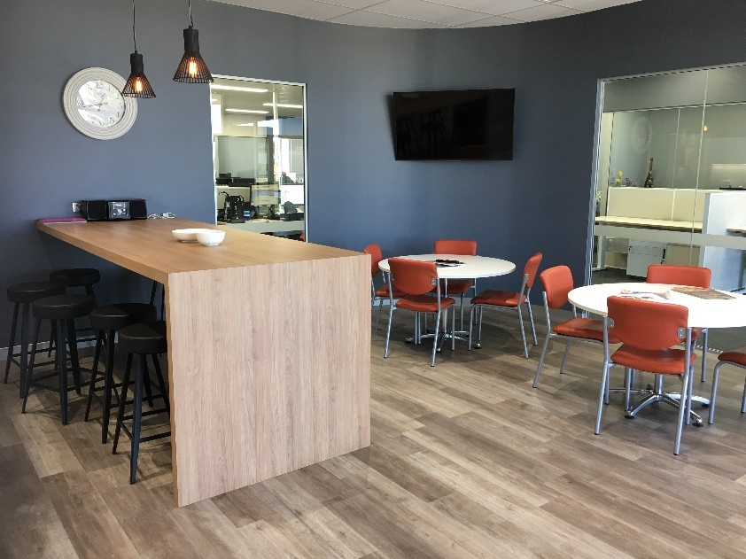

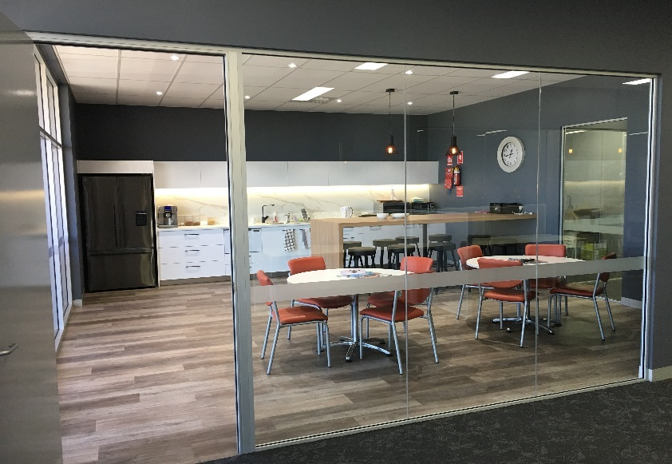

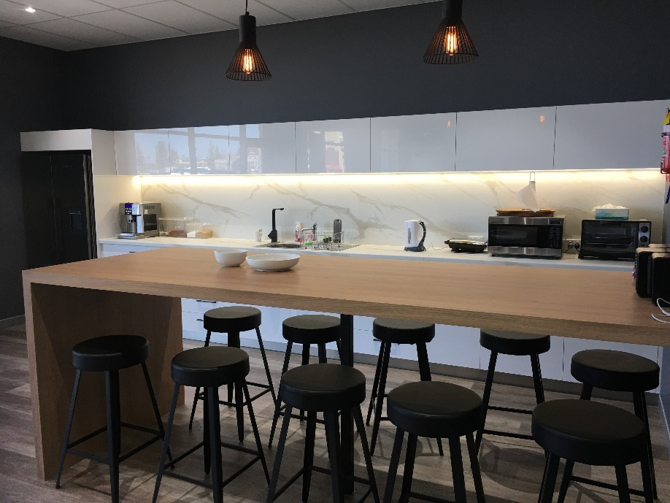



Phone: (08) 9787 9888 www.changingspaces.net.au info@changingspaces.net.au
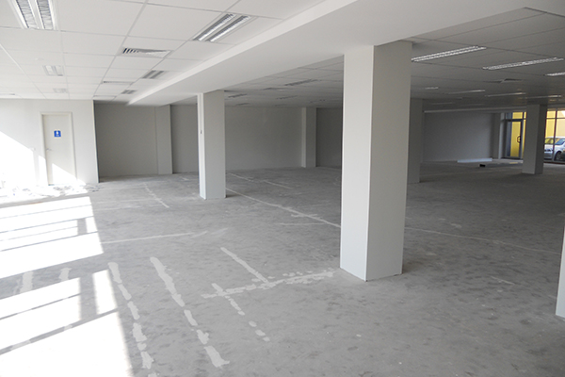
BHR Papalia Accounting Practice
Starting from a classic, ‘forest of columns’ office floor space. Changing Spaces created a contemporary and engaging new corporate face for a local accounting practice.
Proud of their brand, BHR Papalia’s corporate colours are featured significantly throughout the design, creating a strong brand identity while pops of contrasting colours introduce that distinctive element of fun.
A key feature is the custom screens that close off workstations to provide privacy while adding interest, without overpowering.
With a progressive focus to allow for future growth. Success was achieved and reflected in the clients overall satisfaction

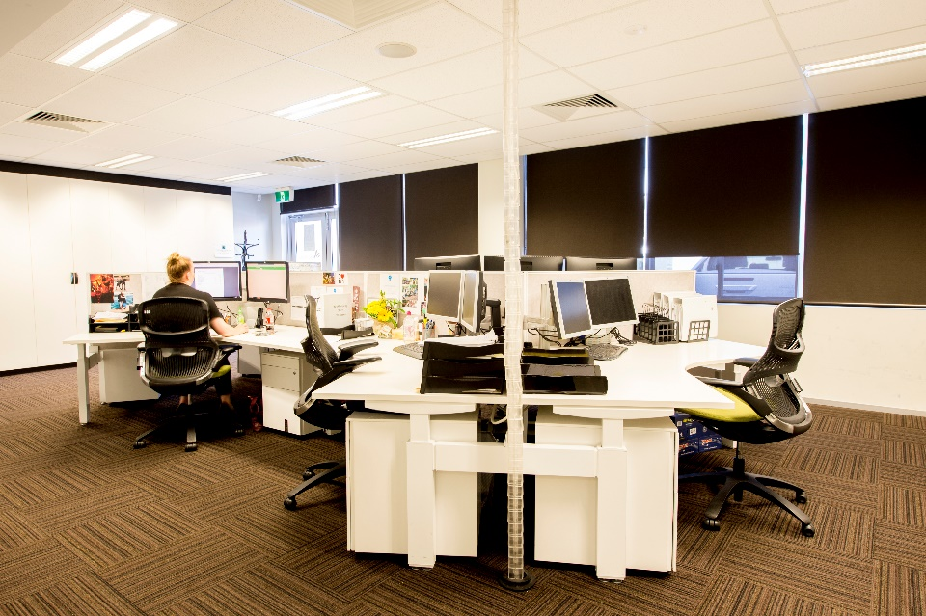
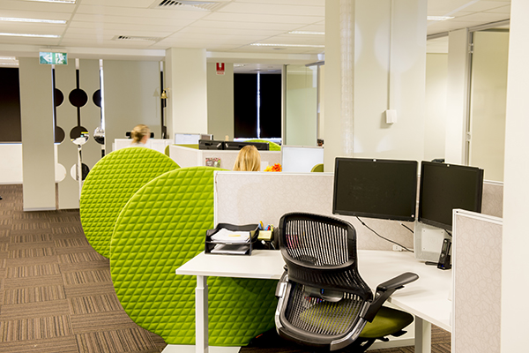
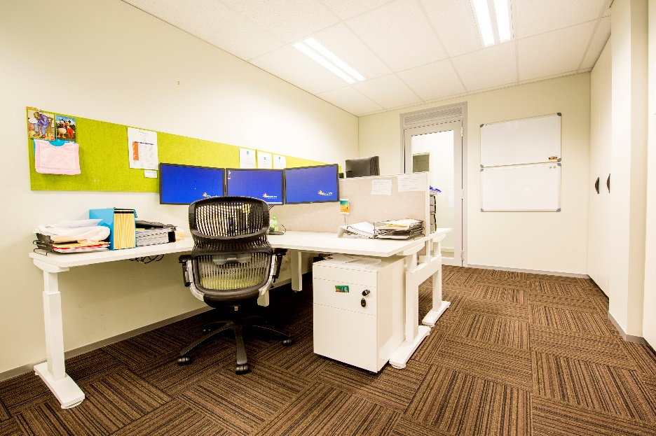
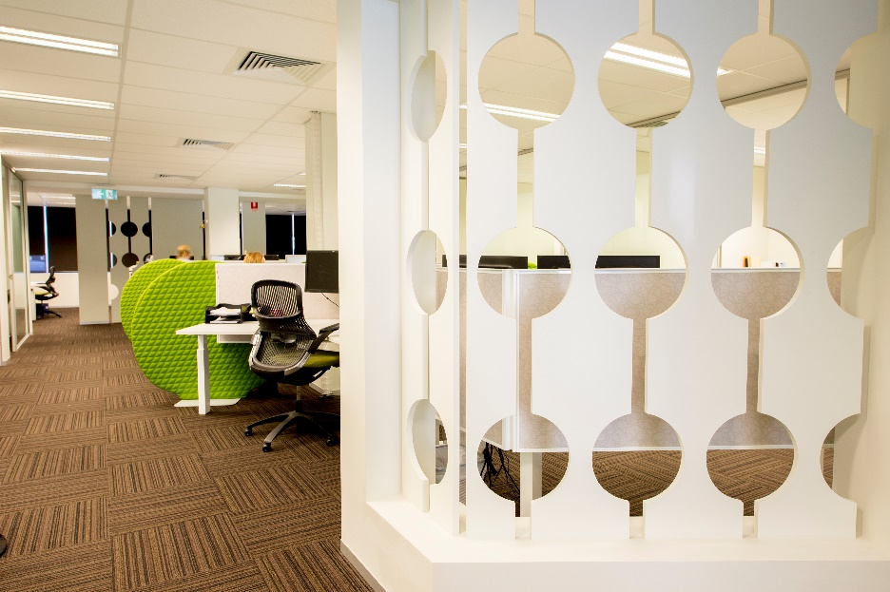

Phone: (08) 9787 9888 www.changingspaces.net.au info@changingspaces.net.au
Smalls Bar
Changing Spaces was especially proud to complete the fit out for Smalls Bar as they offer an exceptional hospitality experience and are passionate about showcasing the best produce from the South West region

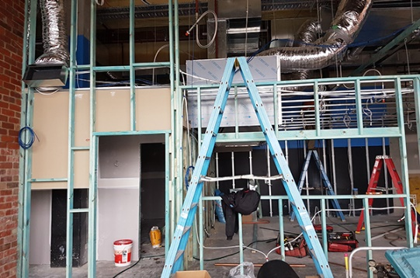
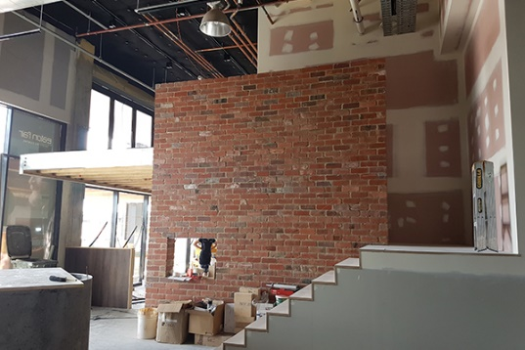
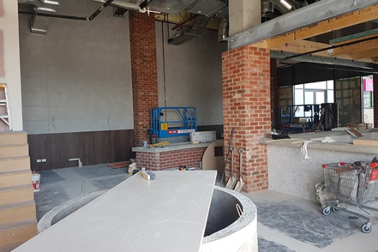

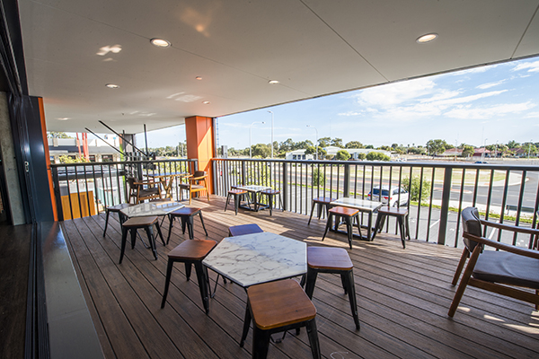
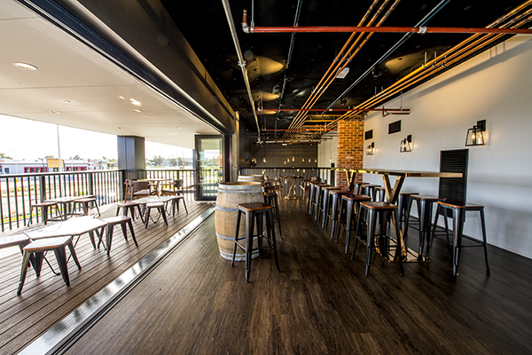
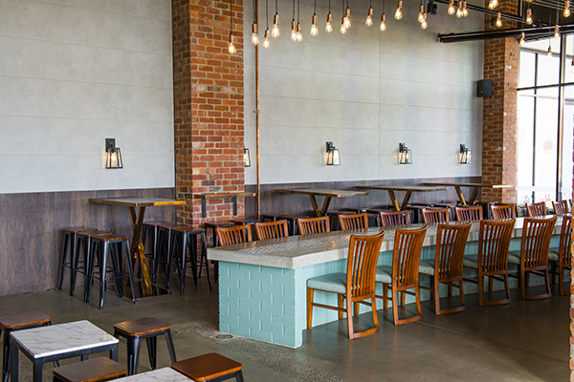
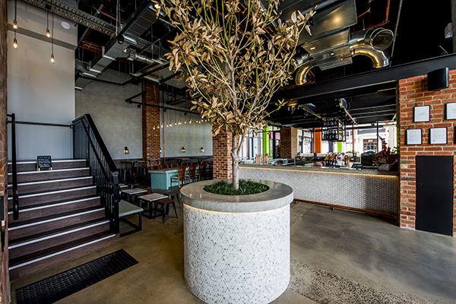
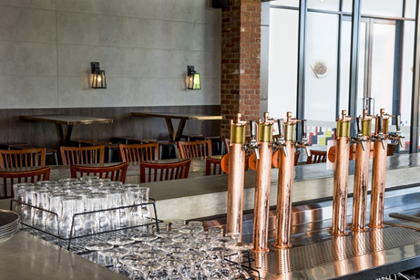
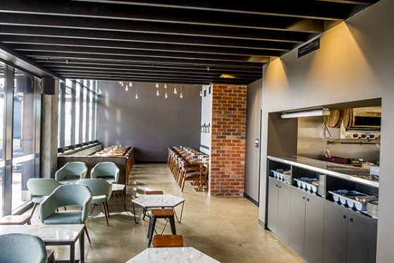
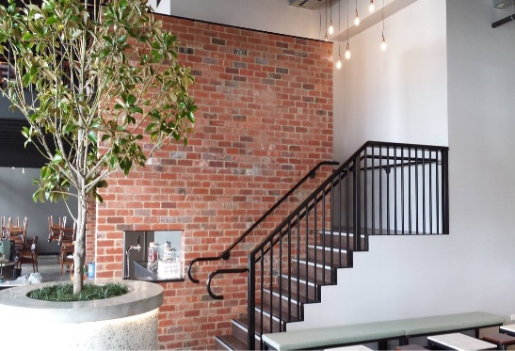
The local designers Merge, worked with the owners to produce a design that utilised raw and natural materials – with concrete, red brick and exposed ceiling contrasted against plants and feature walls to give an authentic natural and slightly rustic ambience… that is exactly what we delivered!

Phone: (08) 9787 9888 www.changingspaces.net.au info@changingspaces.net.au


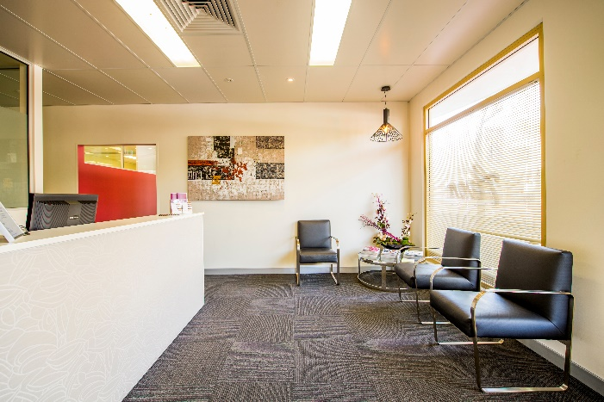
Communication
Our company ethos is 100% client focused and excellent communication is a key element of our policy.
You will always be able to contact us to discuss your job and we will keep you updated and informed at all stages.

Workmanship
Quality techniques using quality materials and expert skills to deliver a quality finish is a defining characteristic of our work

Service
Being an experienced building company gives us the distinct advantage to give you the individual attention that you should rightly expect when embarking on a building project.
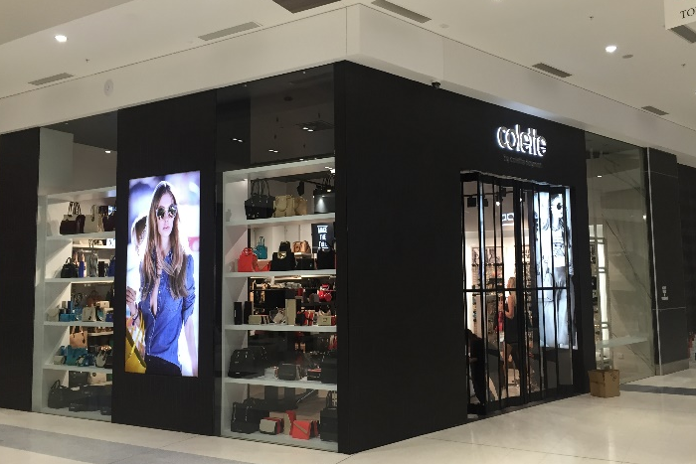

Integrity
We do not wait to be asked, we take the initiative to draw your attention to any potential problems we identify at the initial consultation and pre quotation stage

