Vital Link Technologies

Brand Overview

1. Mission Statement
"At Vital Link Technologies, our mission is to enhance the quality of healthcare and aged care through innovative communication and monitoring systems. We are committed to integrating cutting-edge technology solutions that ensure seamless, reliable, and effective care delivery. By prioritizing support, design, and integration of our state-of-the-art systems, we empower caregivers and healthcare professionals with tools that improve responsiveness, safety, and well-being of those in their care. Our dedication to advancing healthcare and aged care environments is driven by our belief in technology's power to connect, protect, and transform lives."

2. Vision Statement
To become the leading provider of innovative technology solutions that revolutionize healthcare and aged care, ensuring every individual receives the highest standard of care through advanced, integrated systems.

3. Core Values
- Innovation: Pioneering new solutions to meet the evolving needs of healthcare and aged care.
- Integrity: Conducting our business with honesty and transparency.
- Customer Focus: Prioritizing the needs and expectations of caregivers and healthcare professionals.
- Collaboration: Fostering teamwork and open communication.
- Excellence: Pursuing excellence in every aspect of our business.

4. Brand Story
Electrotek has been a trusted leader in healthcare technology since 2006. Our focus is clear: to empower and deliver excellence in healthcare with cutting-edge technology solutions that enhance care quality, streamline operations, and lower costs. Initially founded by Theo and Belinda Kuppens, the company was built on their desire to provide great technology solutions to the medical and aged care industries. Over the years, this vision has evolved and grown through continuous innovation and solutions. We have built partnerships around the globe that support us in the provision of hardware and components to fulfill our mission.
In 2024, Jason Deacon and Luke Briggs from IT Leaders joined the leadership team to propel the company forward on its growth trajectory, transforming it into a larger, more comprehensive organization. This expansion allows us to not only deliver on our mission but also grow our presence and team to service a much wider geographic area. Additionally, we have expanded our services to include the installation of CCTV, security, and access control systems for healthcare, aged care, and other industry scenarios, ensuring comprehensive safety and monitoring solutions.

5. Positioning Statement
Vital Link Technologies provides state-of-the-art communication, monitoring, and security solutions that empower healthcare and aged care professionals to deliver higher standards of care. Our commitment to innovation, support, and integration sets us apart, ensuring seamless and reliable systems that enhance the responsiveness, safety, and well-being of individuals in care.

6. Target Audience
Our target audience includes:
- Healthcare providers and facilities seeking advanced communication, monitoring, and security systems.
- Aged care institutions aiming to improve care delivery and safety.
- Caregivers and healthcare professionals looking for reliable and effective tools to enhance their work.
- Other industries requiring robust security and access control systems.

7. Brand Personality
- Innovative: Continuously pushing the boundaries of technology in healthcare and aged care.
- Reliable: Providing consistent and dependable solutions.
- Supportive: Offering comprehensive support and integration services.
- Compassionate: Understanding the importance of care and the well-being of individuals.
- Professional: Maintaining high standards in all our interactions and solutions.

Brand Identity

1. Logo
- Primary Logo: The logo reflects a heart/heartbeat (pulse), symbolizing care and connectivity.
  - Guidelines: Ensure the logo is used with sufficient clear space around it. The minimum size should be specified to maintain legibility.
- Secondary Logo: Simplified versions of the primary logo for different contexts (e.g., monochrome, simplified icon).
  - Guidelines: Use the secondary logo when the primary logo cannot be used effectively due to size or color constraints.
- Incorrect Usage:
  - Do not distort or rotate the logo.
  - Do not change the logo colors.
  - Do not place the logo on backgrounds that reduce its visibility.
  - Examples of incorrect usage should be provided for clarity.

2. Color Palette
- Primary Colors:
  - Blue: HEX #0073e6, RGB (0, 115, 230), CMYK (100, 50, 0, 0)
  - Green: HEX #00b359, RGB (0, 179, 89), CMYK (80, 0, 90, 0)
- Secondary Colors:
  - Light Blue: HEX #66b2ff, RGB (102, 178, 255), CMYK (60, 30, 0, 0)
  - Light Green: HEX #66ff99, RGB (102, 255, 153), CMYK (60, 0, 60, 0)
- Usage Guidelines:
  - Primary colors should dominate the design, with secondary colors used for accents and highlights.
  - Maintain color contrast for readability and accessibility.

3. Typography
- Primary Typeface: A clean, modern sans-serif font such as Helvetica or Arial, which is widely recognized in the healthcare sector.
  - Styles: Regular, Bold, Italic
- Secondary Typeface: A friendly, humanistic sans-serif font such as Calibri or Open Sans.
  - Styles: Regular, Bold, Italic
- Usage Guidelines:
  - Headings: Use the primary typeface in bold or regular, ensuring clear hierarchy.
  - Body Text: Use the secondary typeface for readability.
  - Font Sizes: Maintain consistency in font sizes for different text elements (e.g., headings, subheadings, body text).

4. Imagery
- Photography Style:
  - Images should be bright, positive, and convey care and professionalism.
  - Subjects should include healthcare professionals, patients, and technology in use.
- Illustrations:
  - Simple, clean illustrations that complement the overall brand style.
- Iconography:
  - Use icons that are simple, clear, and easily recognizable, in line with the caring/medical theme.

5. Brand Applications
- Business Cards:
  - Layout should include the logo, name, title, contact information, and company tagline.
  - Use primary colors and maintain clear space around the logo.
- Stationery:
  - Letterheads and envelopes should have the logo and company details.
  - Maintain a clean, professional look with ample white space.
- Marketing Materials:
  - Brochures, flyers, and posters should use the primary color palette and typography guidelines.
  - Include high-quality images that reflect the brand’s values.
- Digital Presence:
  - Website design should be user-friendly, with consistent use of the color palette and typography.
  - Social media profiles should have cohesive branding elements.
  - Email templates should reflect the brand’s visual identity.
- Advertising:
  - Print and digital ads should be visually appealing, with a clear call to action.
  - Ensure the logo and key messages are prominent and adhere to brand guidelines.
- Primary Logo:
  - Design: A heart shape integrated with a pulse line (heartbeat) in the center.
  - Colors: The heart in a gradient of blues and greens, symbolizing vitality and care.
  - Example:
    - Imagine a stylized heart with a heartbeat line running through it, colored in a gradient from blue to green.
- Secondary Logo:
  - Design: Simplified heart or pulse line for smaller applications.
  - Colors: Monochrome versions in black or white.
  - Example:
    - A minimalistic pulse line icon that can be used in monochrome.

Business Card Template
Here’s a basic layout for a business card:
- Front:
  - Logo on the top left.
  - Name: John Doe
  - Title: Healthcare Technology Specialist
  - Contact Information:
    - Phone: (123) 456-7890
    - Email: john.doe@vitallinktech.com
    - Website: www.vitallinktech.com
  - Company Tagline: "Connecting, Protecting, Transforming Lives"
- Back:
  - Full logo with heart/heartbeat design.
  - Background in a gradient of blue to green.
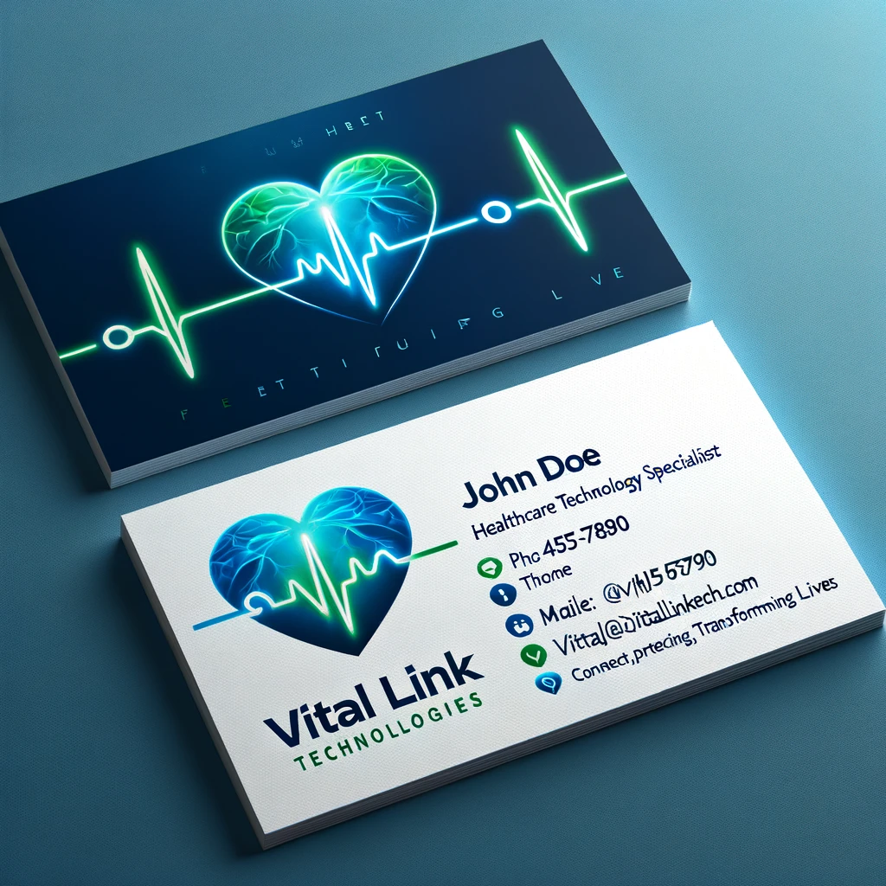

Stationery (Letterhead)
Here’s a layout for a letterhead:
- Top Header:
  - Logo aligned to the left.
  - Company Name: Vital Link Technologies
  - Address: 1234 Healthcare Blvd, Suite 100, City, State, ZIP
  - Contact Information: Phone, Email, Website
- Footer:
  - Color bar in a gradient of blue to green.
  - Additional contact details or social media icons.
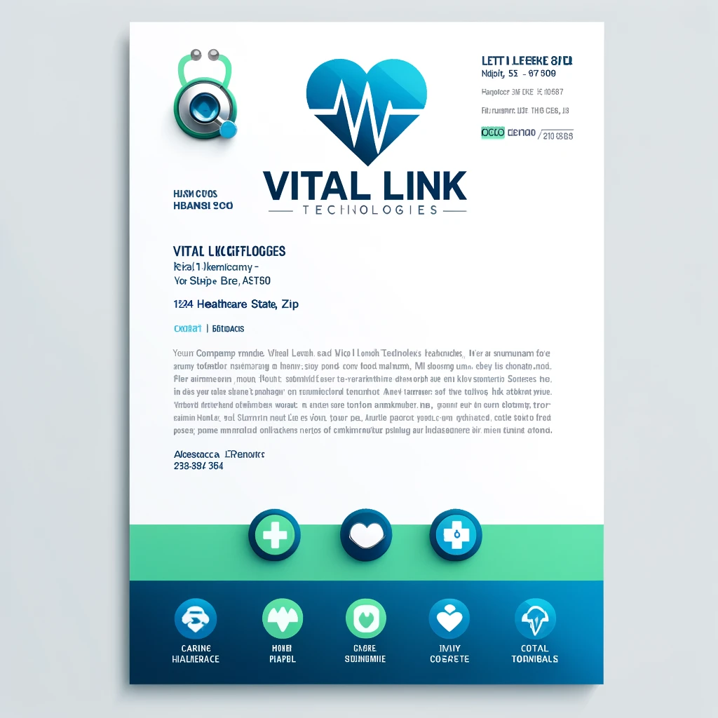

Marketing Brochure
A tri-fold brochure could have the following layout:
- Front Cover:
  - Logo and tagline at the top.
  - Image of healthcare professionals with technology.
  - Title: "Innovative Solutions for Healthcare and Aged Care"
- Inside Panels:
  - Panel 1:
    - Introduction to Vital Link Technologies.
    - Mission and Vision statements.
  - Panel 2:
    - Detailed services (communication systems, CCTV, security, access control).
    - Benefits of each service.
  - Panel 3:
    - Testimonials from clients.
    - Contact information.
- Back Cover:
  - Call to action.
  - Full contact details.
  - Social media icons.
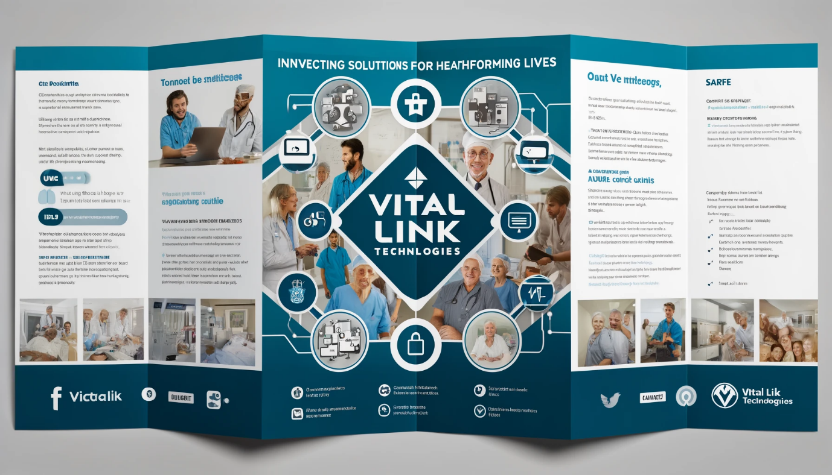

Website Home Page
A clean, user-friendly design:
- Header:
  - Logo and navigation menu (Home, About, Services, Contact).
  - Hero Image: Healthcare professional using advanced technology.
  - Headline: "Enhancing Care with Innovative Technology Solutions"
  - Subheadline: "Connecting, Protecting, Transforming Lives"
- Sections:
  - About Us: Brief overview with mission, vision, and values.
  - Services: Detailed descriptions of each service offered.
  - Testimonials: Quotes from satisfied clients.
  - Contact Us: Contact form and detailed contact information.

Email Template
For consistent communication:
- Header:
  - Logo and tagline.
  - Banner image related to healthcare technology.
- Body:
  - Greeting: "Dear [Recipient],"
  - Main content area with text, images, and call to action.
  - Contact Information: Phone, Email, Website.

