Sports for Schools rebrand 2024

Why are we changing our name?
The current name Sports for Schools does not reflect what we do. For example, we do not do ‘sports’ for schools, we organise inspiring athlete visits to primary schools and inspire the children, whilst also raising funds for schools through sponsorship.

We have low brand recognition. What proportion of schools know exactly who we are and what we do when we call or visit them? We believe the name Sports for Schools is not well known and neither is the logo. While schools may remember having a visit from a top athlete, they often do not know which organisation it was that visited their school.

Our existing branding?
Sports for Schools current brand colours are restrictive meaning that we cannot use the logo on backgrounds of blue, green or red. Some of the existing colours also do not work well when used on a screen. For example, we cannot use the brighter blue or green as text on a white background as it does not show up well and is not accessible for visually impaired people.

What do we want to achieve?
A new logo and new colours that are recognisable, memorable, distinctive and describes who we are and what we do, whilst keeping to the GB and elite athlete theme. It is important that what we do is quickly and easily recognised both verbally over the phone and visually, from the name and strap line. We’d also like our name and branding to reflect on our social mission and our company brand values.

Who is our target audience?
We have several target audiences. The way we express our brand will have variations depending on who the material/communications is intended for however, when two of our target audiences get together, they both need to agree that it’s us. It’s useful to think about how we and our brand interacts with our target audiences in any of a range of “moments of truth”. In general, our audiences are:
- PE Coordinators – often the ones who book or coordinate an event.
- School administrators – the gatekeepers/message takers. This is a key audience to get our message to the PE Coordinator/head teacher. We need them to recognise us and understand what we do from looking at our materials (email/letter/phone call).
- Head teachers – have the final say on whether an event is booked and often have an impact on the success of an event.
- School children – children only see certain documents and we want the brand to be appealing to children from 4-12 years old. It is critical that they are excited in the run up and that lasting memories are created.
- Parents – we want parents to feel like their child could be the next champion to promote their engagement with the event and support for the fundraising. They will be excited if their children are excited. They need a good reason to donate

The new branding

What is our new name?
Great Athletes®

What is our new strapline?
Inspiring Every Child

Additional elements to our name/logo:
We also promote the total number of children we have inspired. We update the logo regularly to reflect the increase in numbers. At the moment, it would be the following:
‘2.5 Million Children Inspired’

What would we like to include in the look/feel/identity of the new branding?
We would like to include an element of the GB flag or at least the feeling of the GB flag/patriotism / international / elite / superstars while also embracing our Scottish, Welsh and Irish audiences. We would like to explore new colour options.

Logo
We require a logo that can be used online as well as on printed materials. The logo must reflect our brand personalities and values and include the elements stated above.
We would like the logo to be memorable and convey what we do.
The ‘people’ element (the blue, green and red graphic part of the logo) of the existing logo is something we do like, we would like to explore using this or something similar in the new logo however, we would not want to restrict ourselves to using this if it does not fit.
We would like to see options with and without the ‘2.5 Million Children Inspired’ part.
Our existing logo:
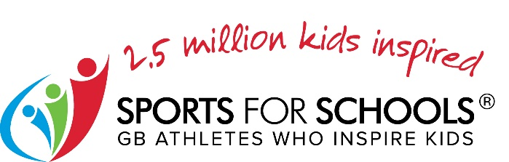

Colour palette
We would like to have different colourway options of our logo so that the logo can be used on different colour backgrounds. For example, we cannot use our current logo on a red, green, or blue background, as the logo contains all three primary colours. We would like to explore colour options.
We would like to see options of single colour logos or a main logo with multiple colours and a sub family of simple one colour logos.

Words to help describe Sports for Schools:
Fun, Active, Next generation, children, fundraising, physical activity is for everyone, future champions, playful, memorable, bold, resilient, strong, encouraging, mindset, wellbeing, elite athletes.
For example, if someone walked past our stand at a conference, we’d like them to be able to remember our name and something about what we do.

What are our brand personality traits?
Sports for Schools could be described as: Personable, playful, energetic, accessible, approachable, inclusive, fun, joyful, inspirational, cool, reliable.

Mission statement:
Our mission is to inspire children to be more active, more resilient and to lead healthy lives.

