Label Size, 6 inch x 4 inch (152.4mm x 101.6 mm )

Label requirements for each label,
Address: Harvey imports, Passfield Mill Business Park, Liphook, GU30 7QU
Contact: Sales@harveyimports.co.uk
Not for human consumption
May Contain Nuts
Expiry Date: (Needs a gap so we can exit the date)
Batch: (Needs a gap so we can exit the date)

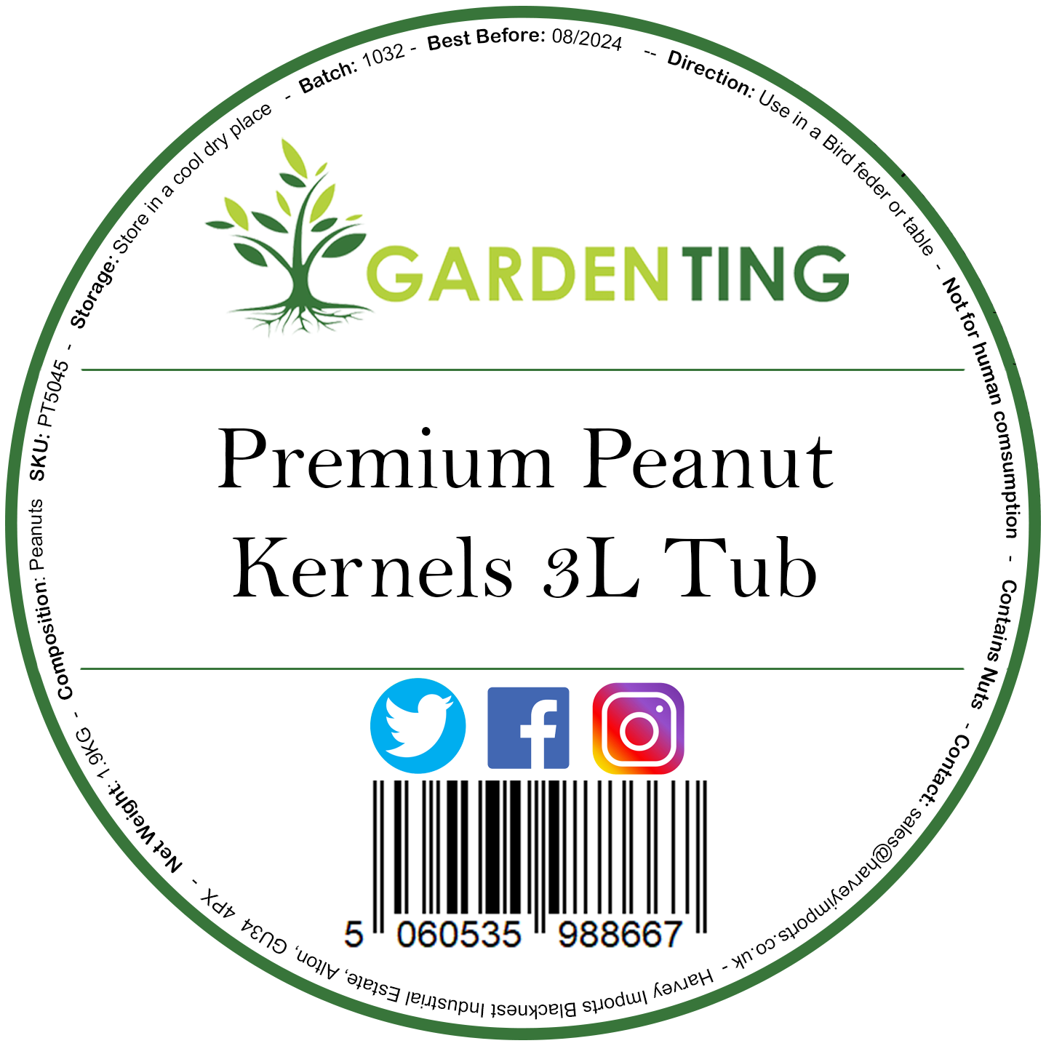<-------- Example old label

Ean barcode to be like the below



Product Name:
SKU:
EAN 13 BARCODE:
Net Weight:
Description:

1.
Product Name: Sunflower Hearts 5L Bag
SKU: HW21
EAN 13 BARCODE:
Net Weight: 2900g
Description:

Enhance Your Garden with the Best Bird Feed!
Transform your garden into a bird haven with our Sunflower Hearts 5L Bag, the ultimate bird food for attracting a wide variety of beautiful feathered friends. Packed with essential nutrients and energy, these premium sunflower hearts are a must-have for any bird enthusiast.

Easy to Use:
Simply fill your bird feeders, sprinkle on bird tables, or scatter on the ground to attract a delightful array of garden birds. Watch as they flock to your garden, bringing life, color, and joy to your outdoor space.

2.
Product Name: Peanuts 5L Bag
SKU: HW22
EAN 13 BARCODE:5060901892505
Net Weight: 3100g
Description:

Delight Your Garden Birds with Nutritious Peanuts!
Attract a vibrant variety of feathered friends to your garden with our Peanuts 5L Bag, the perfect choice for bird enthusiasts who want to provide their avian visitors with a high-energy, nutritious treat. Packed with essential nutrients, our premium peanuts are a favorite among many bird species, ensuring your garden becomes a lively and colorful sanctuary.

Easy to Use:
Fill your bird feeders, place on bird tables, or scatter on the ground to create an inviting space for birds. Watch as they flock to your garden, adding beauty and song to your outdoor area.

3.
Product Name: Dried Mealworms 5L Bag
SKU: HW23
EAN 13 BARCODE:5060901892512
Net Weight: 800g
Description:

Elevate Your Bird Feeding Experience with Nutritious Mealworms!
Create a thriving bird haven in your garden with our Dried Mealworms 5L Bag, the ultimate protein-rich treat for your feathered friends. Ideal for attracting a wide range of bird species, these premium dried mealworms are packed with essential nutrients, ensuring your garden birds stay healthy and energetic.

Easy to Use:
Add to your bird feeders, sprinkle on bird tables, or mix with other bird food to create an irresistible feast for your garden birds. Watch as they flock to your garden, bringing vibrant colors and joyful chirping to your outdoor space

4.
Product Name: Calci Worms 5L Bag
SKU: HW24
EAN 13 BARCODE:5060901892529
Net Weight: 800g
Description:

Boost Your Garden Birds' Health with Nutritious Calci Worms!
Attract a vibrant array of feathered friends to your garden with our Calci Worms 5L Bag, the ultimate calcium-rich treat for your avian visitors. Perfect for bird enthusiasts, these premium calci worms are packed with essential nutrients, ensuring your garden birds stay healthy, strong, and energetic.

Easy to Use:
Add to your bird feeders, sprinkle on bird tables, or mix with other bird food to create an irresistible feast for your garden birds. Watch as they flock to your garden, bringing vibrant colors and joyful chirping to your outdoor space

5.
Product Name: Peanuts In Shell 5L Bag
SKU: HW25
EAN 13 BARCODE:5060901892536
Net Weight: 1350g
Description:

Delight Your Garden Birds with Nutritious, Fun-to-Crack Peanuts!
Transform your garden into a lively bird sanctuary with our Peanuts in Shell 5L Bag, the perfect choice for bird enthusiasts who want to provide their avian visitors with a delicious and engaging treat. Packed with essential nutrients, our premium in-shell peanuts are a favorite among many bird species, ensuring your garden becomes a bustling hub of bird activity.

Easy to Use:
Fill your bird feeders, place on bird tables, or scatter on the ground to create an inviting space for birds. Watch as they flock to your garden, adding beauty and song to your outdoor area

6.
Product Name: Niger Seed 5L Bag
SKU: HW26
EAN 13 BARCODE:5060901892543
Net Weight: 3300g
Description:

Attract a Burst of Color to Your Garden with Nutritious Niger Seed!
Invite a beautiful array of small, colorful birds to your garden with our Niger Seed 5L Bag, the top choice for bird enthusiasts who want to provide their feathered friends with a nutrient-rich and highly desirable treat. Known for its appeal to finches and other small birds, this premium bird seed will make your garden a lively and vibrant bird haven.

Easy to Use:
Fill your nyjer seed feeders or sprinkle on bird tables to create an irresistible feast for your garden birds. Watch as they flock to your garden, bringing vibrant colors and cheerful chirping to your outdoor space.

7.
Product Name: Wild Bird Mix 5L Bag
SKU: HW27
EAN 13 BARCODE:5060901892550
Net Weight: 3300g
Description:

Transform Your Garden into a Bird Sanctuary with Our Nutritious Wild Bird Mix!
Invite a diverse array of feathered friends to your garden with our Wild Bird Mix 5L Bag, the perfect choice for bird enthusiasts who want to provide their avian visitors with a balanced and tasty diet. Packed with a variety of high-quality seeds and grains, this premium bird food is designed to attract and nourish a wide range of bird species, ensuring your garden becomes a vibrant and lively haven.

Easy to Use:
Fill your bird feeders, place on bird tables, or scatter on the ground to create an inviting space for birds. Watch as they flock to your garden, adding beauty and joyful song to your outdoor area.

8.
Product Name: No Mess Mix 5L Bag
SKU: HW28
EAN 13 BARCODE:5060901892567
Net Weight: 3200g
Description:

Enjoy a Clean and Vibrant Garden with Our Nutritious No Mess Mix!
Invite a diverse array of beautiful birds to your garden without the hassle of leftover shells and debris with our No Mess Mix 5L Bag. This premium bird food is specially formulated to provide a nutritious, easy-to-eat blend that leaves no waste, ensuring your garden remains clean and your feathered visitors are well-fed.

Easy to Use:
Fill your bird feeders, place on bird tables, or scatter on the ground to create an inviting and clean feeding space for birds. Watch as they flock to your garden, bringing vibrant colors and joyful chirping to your outdoor area.

9.
Product Name: Peanut Granules 5L Bag
SKU: HW29
EAN 13 BARCODE:5060901892574
Net Weight: 2800g
Description:

Nourish Your Garden Birds with Delicious, Nutritious Peanut Granules!
Transform your garden into a vibrant bird sanctuary with our Peanut Granules 5L Bag, the perfect choice for bird enthusiasts who want to provide their avian visitors with a high-energy, nutrient-rich treat. Ideal for a wide variety of bird species, these premium peanut granules are sure to make your garden a favorite feeding spot.

Easy to Use:
Fill your bird feeders, sprinkle on bird tables, or mix with other bird food to create an irresistible feast for your garden birds. Watch as they flock to your garden, bringing vibrant colors and joyful chirping to your outdoor space.

10.
Product Name: Black Sunflower 5L Bag
SKU: HW30
EAN 13 BARCODE: 5060901892581
Net Weight 2000g
Description:

Attract a Variety of Birds with Nutritious Black Sunflower Seeds!
Turn your garden into a lively bird sanctuary with our Black Sunflower 5L Bag, the perfect choice for bird enthusiasts who want to provide their avian visitors with a nutritious and high-energy treat. Known for their high oil content and appeal to a wide range of bird species, these premium black sunflower seeds are sure to make your garden a favorite feeding spot.

Easy to Use:
Fill your bird feeders, place on bird tables, or scatter on the ground to create an inviting space for birds. Watch as they flock to your garden, bringing vibrant colors and cheerful song to your outdoor area.

