Cover Page
- Company Logo.
- Title: "Expert Construction Services for Medium and Large-Scale Projects"
- Hero Image: A high-quality visual of one of your completed projects or a collage of various services you offer.
- Contact Information:
- Company Name: King Construction NY, Inc
- Phone Number: 516
- Email: dg@kcofny.com
- Website
- Address: 30 Commercial St, Freeport, NY

Introduction
- Company Overview:
With over 12 years of expertise in the construction industry in New York City and Long Island area, King Development NY, Inc. excels in delivering top-tier services in excavation, piling, footing, walls, slabs, and main structural frameworks. Our proficiency spans both concrete and steel construction systems, including hybrid approaches, ensuring robust and innovative solutions for shell and core projects.
Our Mission Statement: "Delivering Excellence and Quality in Every Project."

- Excavation: Precision excavation services for foundations and large-scale earthworks.
-Piling and Footing: Robust solutions for deep foundations and structural support.
-Concrete Walls and Slabs: Durable and high-quality reinforced concrete work for various structural needs.
- Superstructure: Expertise in constructing the main frameworks of buildings in reinforced concrete, steel or hybrid approaches.
- Masonry: Skilled masonry work for both structural and decorative purposes.
- Roofing: Comprehensive roofing solutions, including installation and repairs for commercial and residential projects.

Why Choose Us
- Value Proposition:
- Experienced Team: Our team comprises industry veterans and skilled professionals dedicated to delivering the highest standards.
- Quality Assurance: Commitment to using high-quality materials and adhering to best practices in construction.
- Timely Delivery: Proven track record of completing projects on schedule.
- Sustainability: Focus on environmentally friendly practices and sustainable building solutions.

Featured Projects
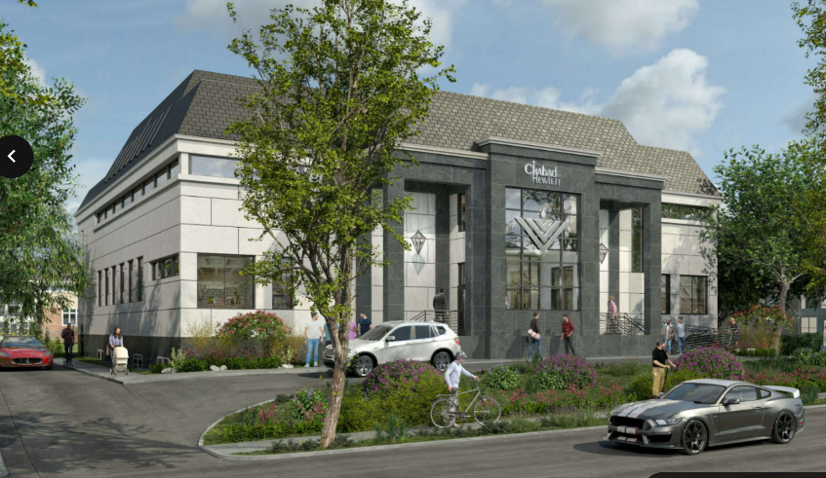
Judish Synagogue. Excavation, piling, footing, walls, framing, roofing.
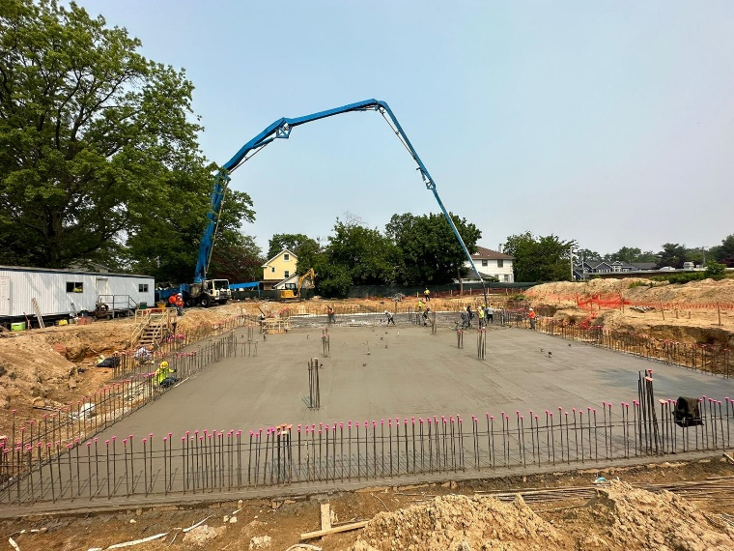

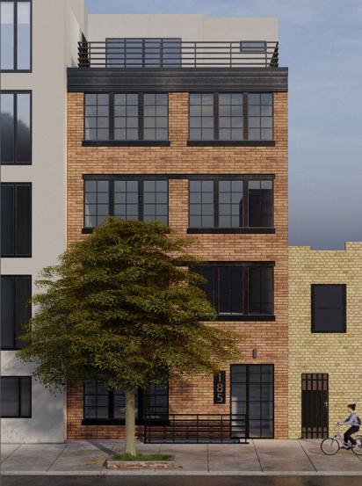
5 Stories building on Anslie St, Brooklyn

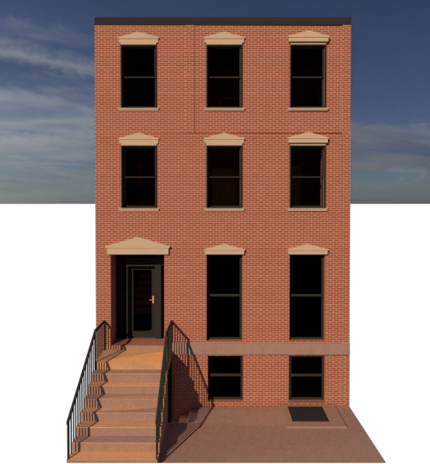
4 Stories Building at Degraw St, Brooklyn, NY.

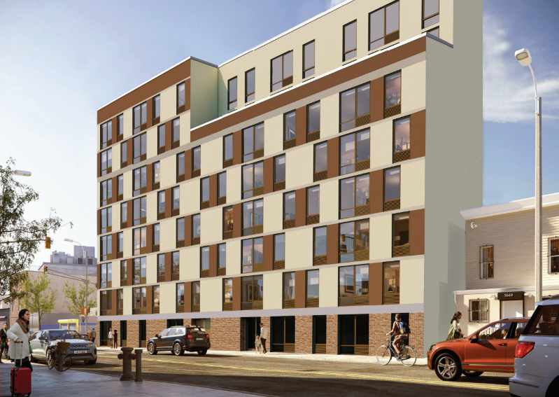

7 stories building at New York Ave, Brooklyn, NY

Visuals and Design Tips
- Design Style: Clean, modern, and professional layout.
- Color Scheme: Use the company’s branding colors.
- Typography: Clear, readable fonts that enhance the professional appearance.
- Images: Use high-quality images of completed projects, team at work, and relevant construction activities.
- Call to Action: Include a clear call to action, such as "Contact us today to discuss your project needs!"

