
FRP GRATING FOR BOARDWALKS
Boardwalks exposed to the full ravages of weather endure a range of challenges that can lead to degradation. These include mechanical damage, shrinkage cracks, fastener-initiated splitting, continuous wet and dry cycles, biological decay (rotting), and degradation by UV light. Any deck material must thus be tough, durable, stable, and safe in all conditions.
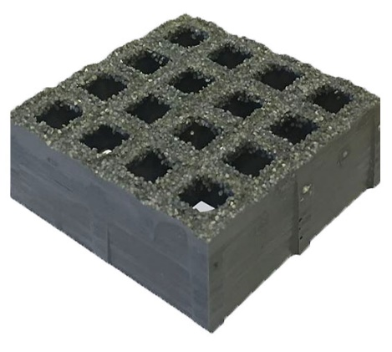
In practically every respect, Fiberglass Reinforced Plastic (FRP) grating emerges as the premier deck material, offering unparalleled durability, safety, and longevity.
Our SpanTrak grating panels are manufactured with isophthalic resins, aluminum fillers and UV stabilizers to ensure long service life and fire resistance in the most demanding conditions, offering outstanding benefits for all boardwalk applications.
Significantly Safer
The gritted surface provides exceptional slip resistance in wet, icy and dry conditions which accounts for its widespread use in industrial plants and offshore drilling rigs.
- Highly resistant to mold, mildew, and moss.
- Does not pose a slipping hazard for bike riders on wet bridge decks.
- Large flat panels ensure fully ADA compliant surfaces.
- Tripping hazard is greatly reduced. No decayed, twisted or loose wood planks.
- No danger from splinters when used on beach access steps or ramps.
- Smooth, even surface for wheeled trolleys, wheelchairs, shoe heels, prams.
- Permits safe, all year-round use, all weather conditions.
Highly Durable & Hard Wearing
Unlike traditional decking materials, FRP plastic grating does not suffer from corrosion, rust, or rot. Although estimates of service life will vary depending on site conditions, it is generally accepted that FRP lasts considerably longer than the next best material. Even in harsh, inhospitable environments, FRP grating can last from 20 to 50 years.
Structurally Strong
FRP grating is highly impact resistant and more resilient than steel. It has a very high strength to weight ratio, being less than half the weight of steel. For boardwalk applications, the panel thickness and span width is specified to keep deflection below ¼” for maximum pedestrian comfort.
Excellent Fire Resistance
Fiberglass grating with fire retardant additives including aluminum hydroxide filler easily achieves NFPA Class A rating under ASTM E84 Surface Burning Characteristics of Building Materials test with a flame spread index of 8 (Class A rating requires less than 25) and a Smoke Developed Index of 200 (Class A rating requires 450 max.). With wood, only very dense and hard species such as Ipe approach a Class A rating (Ipe is generally classified as Class A/B).
Best & Safest Deck and Stairway Surface for Coastal Boardwalks
- Unaffected by constant salt spray.
- Safer for stairways with gritted edge strip.
- No corrosion, rusting or decay.
- Maintains excellent slip resistance in constantly damp conditions-whether cold or humid.
- Open mesh keeps surface free of loose sand and drifts on sandy beaches.
Environmentally sound
- Reduced impact in sensitive areas as sunlight can reach vegetation below.
- Airflow and rainfall run off is virtually unobstructed.
- Eliminates any issue with wood preservative chemicals leaching into soils or waterways.
Faster and easier construction
- Panels can be cut to precise size on site or prefabricated off site.
- Large panel size minimizes installation time.
- Hold down and panel connection fixings only required every 24” approx.
- Reduced need for heavy machinery which can disrupt or damage sensitive sites.
- The comparatively light panels can be hand carried to the site if necessary.
- No special tools needed to cut, shape and install.
- can be used in combination with wood, steel or other deck materials.
Lower maintenance costs
- Avoids routine repair work due to deterioration from corrosion or decay.
- Lower life cycle maintenance cost.
- Panels can be easily replaced if damaged.
- Better for remote locations with restricted access for repairs.
Lower Lifetime Cost
Taking into account both product cost and installation cost, FRP grating is typically competitive with wood decking. It terms of total lifecycle costs, FRP grating generally offers a clear advantage.
Aesthetics
Whether an FRP boardwalk looks more or less attractive than a wood plank boardwalk and which material blends into the surrounding environment better is of course a matter of personal opinion. Many like the natural look of wood, while others like the neat, modern look of FRP grating.
But one advantage unique to FRP grating is that apart from the common dark grey option, panels can be supplied in colors to blend in with the surrounding environment, where railings can also be painted the same color if needed.
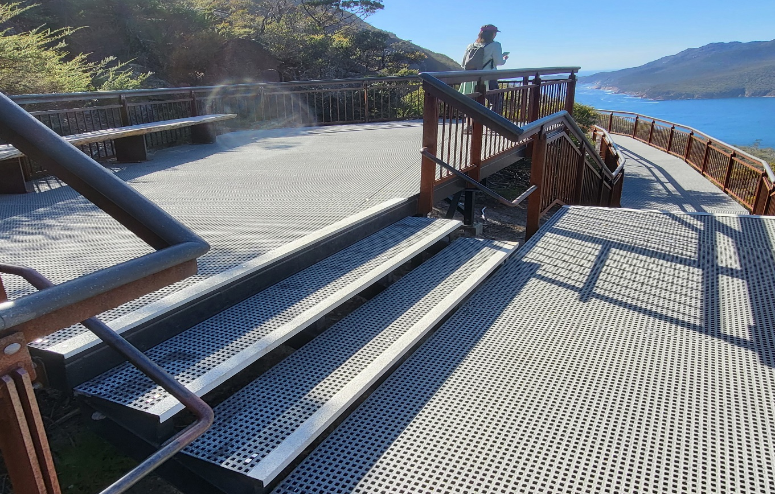
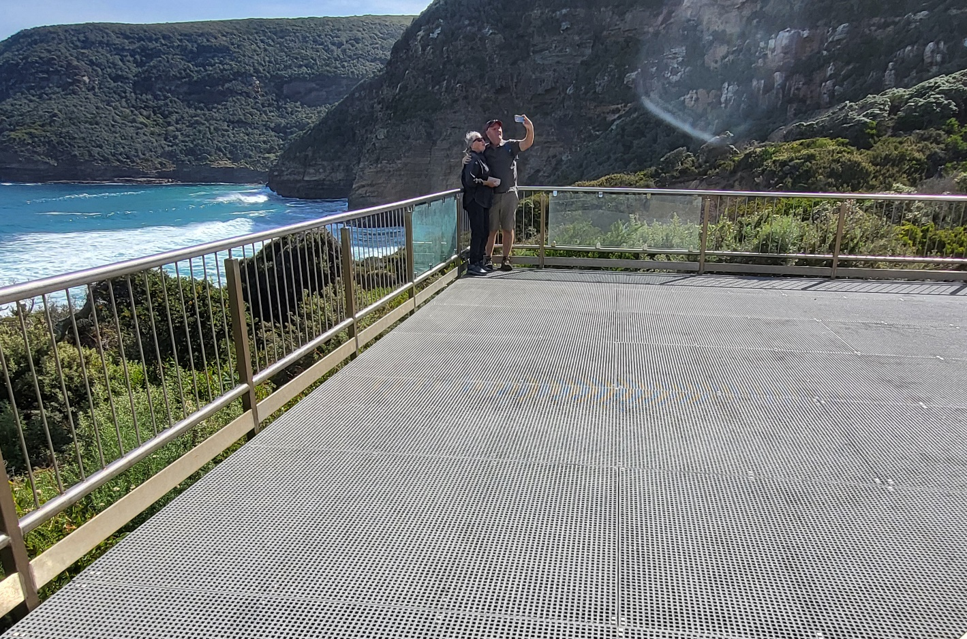
Viewing Platforms

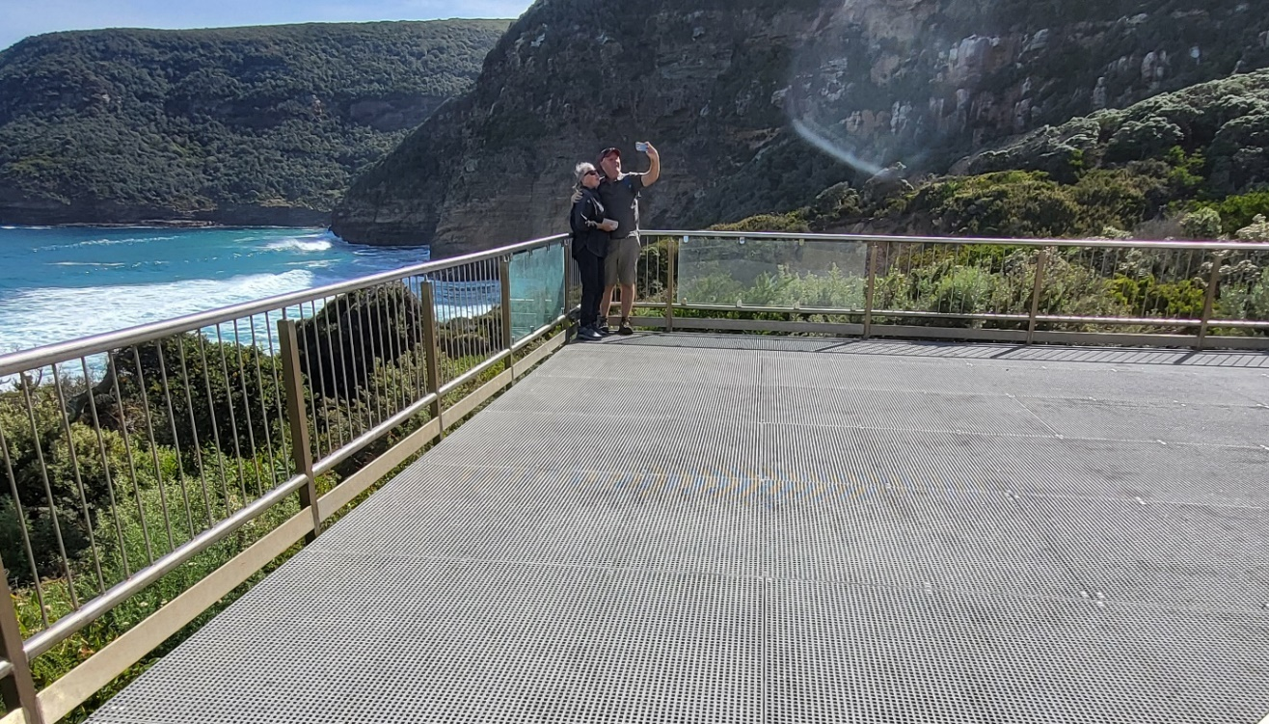
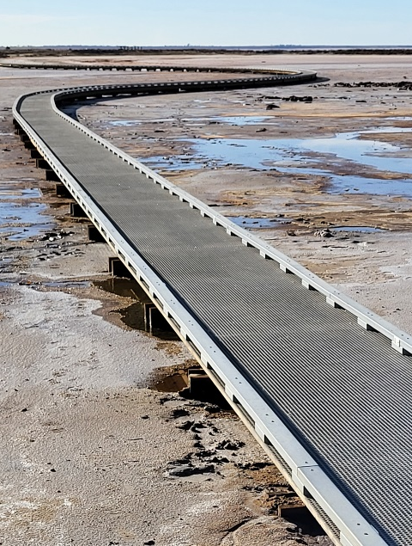
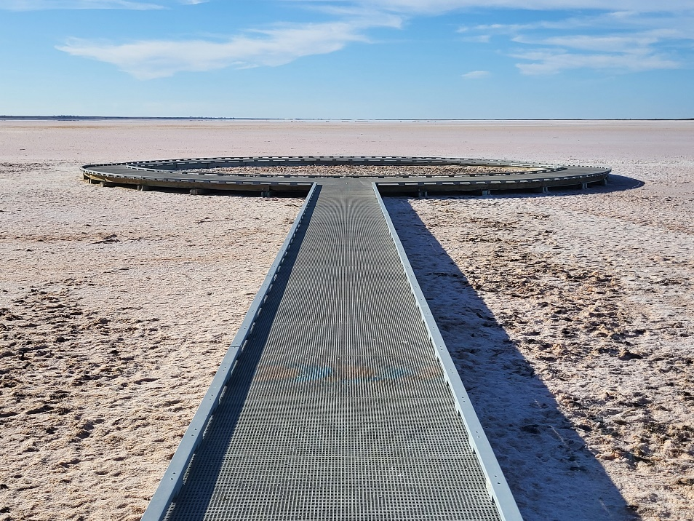
Coastal and Lakes
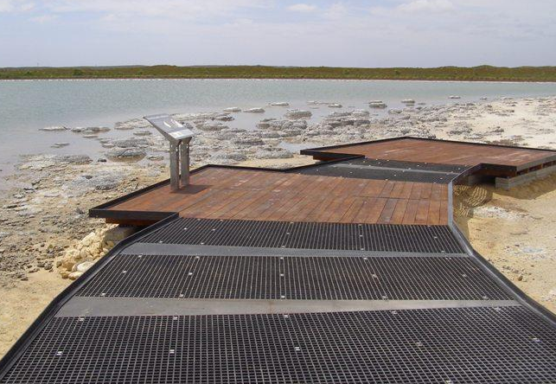
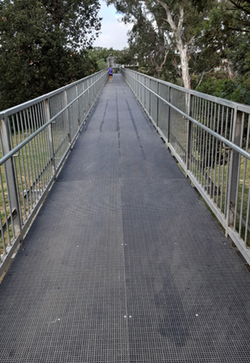
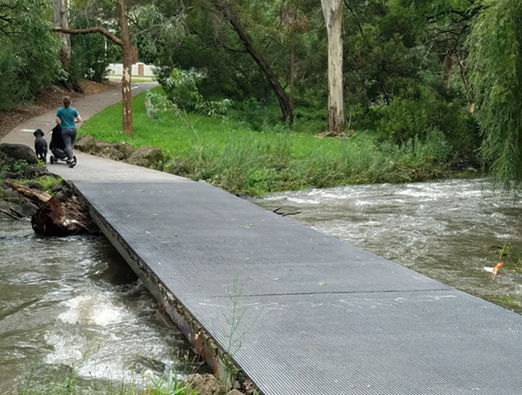
Bridges & Bridge Resurfacing
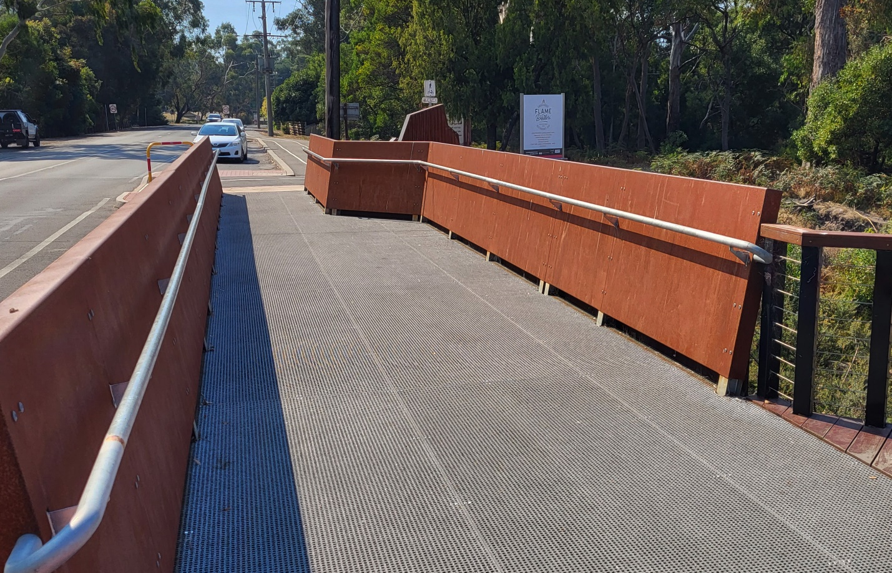
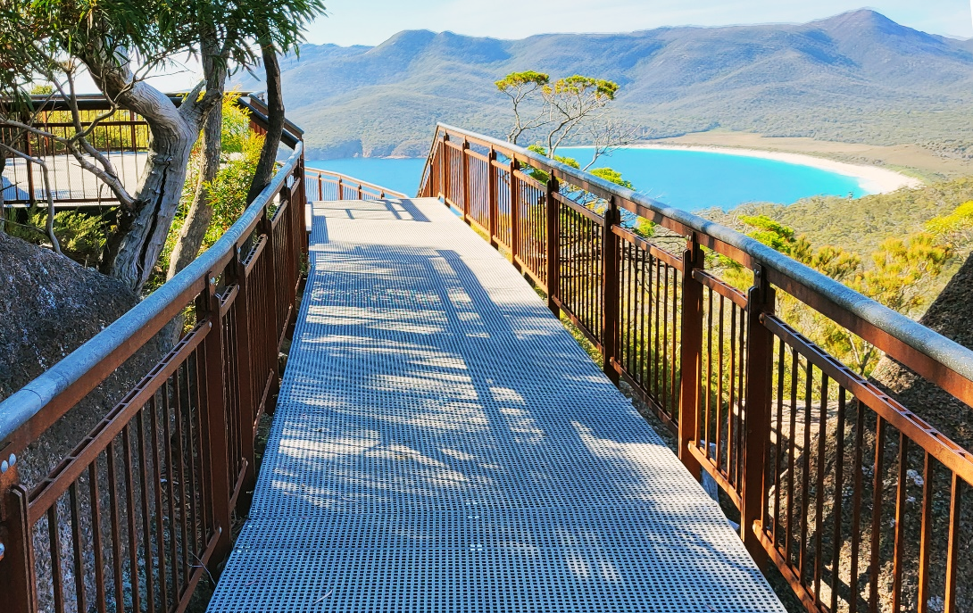
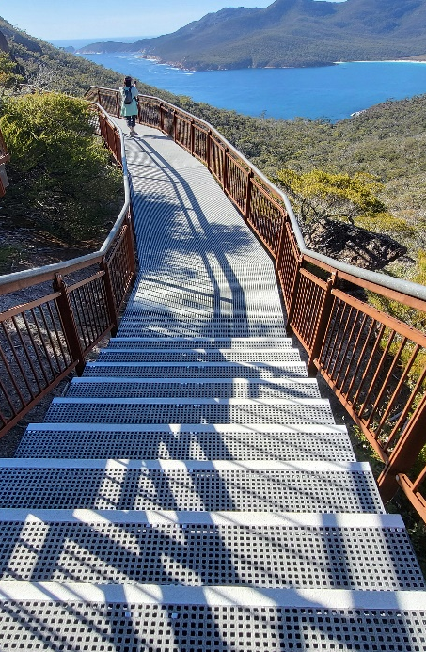
Stairways

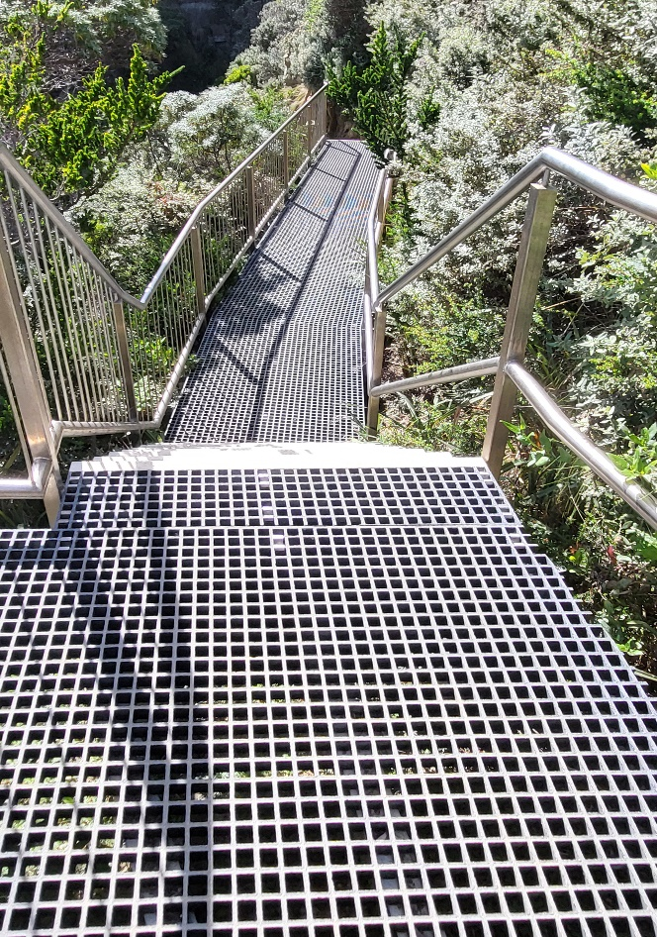
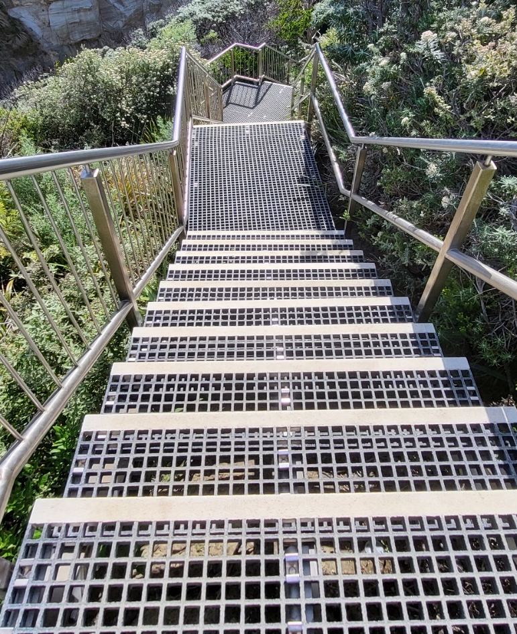

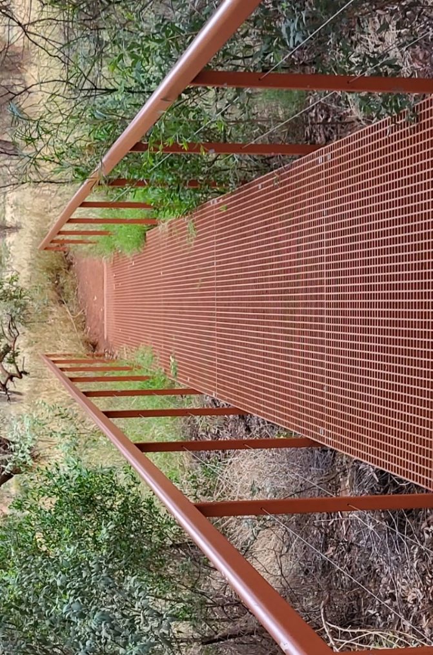
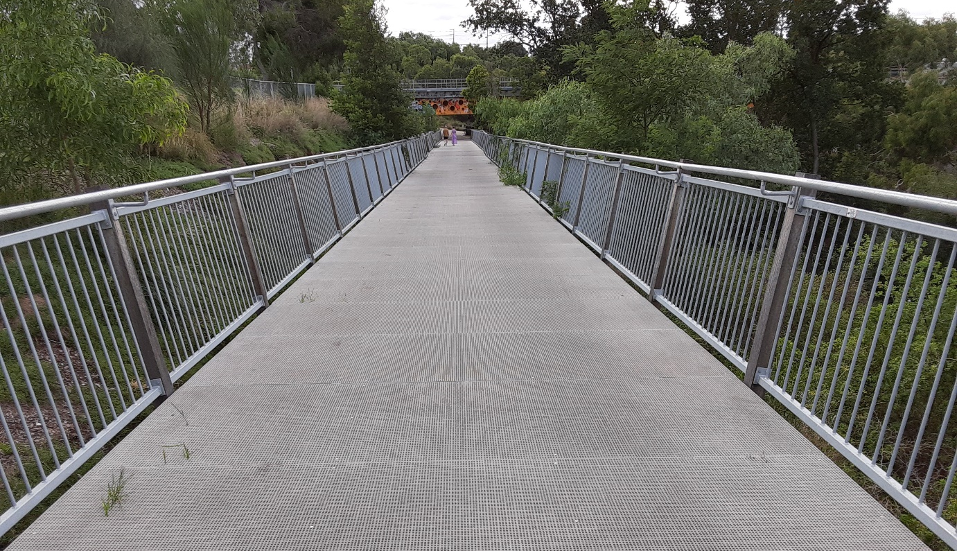
Access Ramps

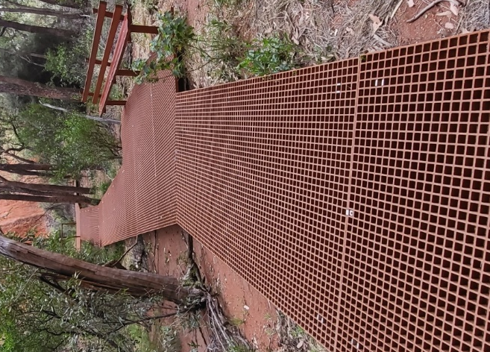
Environment Matching Colors


Specifications
Resin: Type-I isophthalic polyester, industrial grade
UV stabilized, fire retardant
Filler: Aluminum hydroxide
Glass fiber content: approx. 35%
Color Traffic grey (RAL 7043) – std. Other colors on special order.
Surface finish: Anti-slip bonded quartz grit
Size options:
MidiMesh: 1 ½” x 1 ½” primary load bars with an intermediate cross bar at the top of the grating, ½” deep giving apertures of ½” x ½” . MidiMesh grating panels are typically preferred for elevated public walkways, especially in parks and reserves, as well as pedestrian access decking on docks, piers, boat lifts, pontoons and jetties.
MiniMesh : 1 ½” x 1 ½” primary load bars with two intermediate crossbars at the top of the grating, ½” deep, giving apertures of ¼” x ¼”. This smaller aperture mesh is recommended for ‘pedestrian-friendly’ walkways frequented by pet walkers, strollers, carts, other small wheeled vehicles and especially high heel shoe wearers.
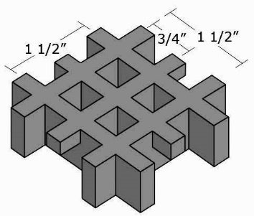
MIDIMESH MINIMESH

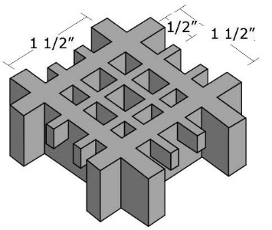
RAL7043

Primary grid bars | 1 ½ x 1 ½” (on center) | 1 ½” x 1 ½” (on center)
Secondary grid bars | ¾” x ¾” (on center) | ½” x ½” (on center)
Aperture | ½” x ½” | ¼” x ¼”
Load bar thickness | ¼” (primary)  ¼” (secondary) | ¼” (primary)  3/16” (secondary)
Open space | 42% | 30%
Panel height | 1 ¼” | 1 ¼”
Panel size | 4′ x 8′ | 4′ x 8′
Weight | 3.5 lb/sq.ft | 4.5 lb/sq.ft.
Panel dimensions may vary by up to 1/8″. Allowances should be made for this manufacturing tolerance when constructing frames to contain panels.
(Maybe add deflection chart for MidiMesh?)

