InfiniteStroke-Bolder font: https://www.whatfontis.com/FF_InfiniteStroke-Bolder.font?text=Zest#ct

Mafakenev Font: https://www.dafont.com/mafakanev.font?text=Zest&psize=l



Blacksword Font: https://www.whatfontis.com/FF_Blacksword.font?text=Zest#ct


https://globalfonts.pro/font/lhf-scriptana
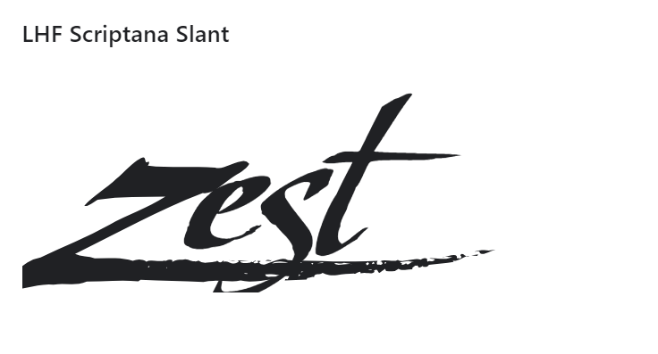

Font: Cherish https://boatletteringtoyou.com/design/t-boat-lettering/



