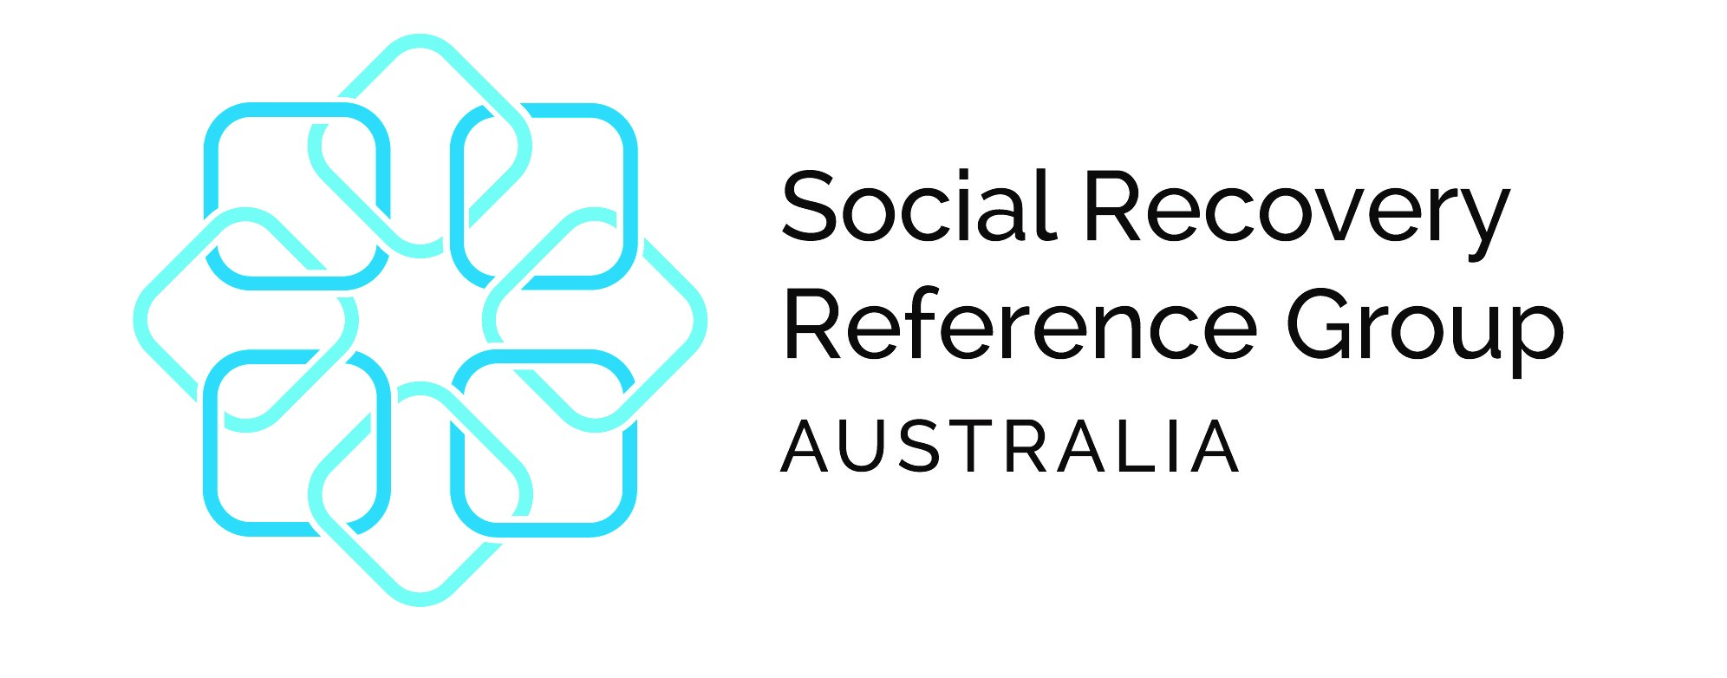
Post Disaster Temporary Housing Literature Review

What should government consider in order to improve planning and decision making for accommodation needs after a disaster, and to support people’s transition to stable housing?

The full report is available through the QR Code. The report was commissioned by the Social Recovery Reference Group and undertaken by Esther Charlesworth and John Fien through the Royal Melbourne Institute of Technology. The findings and recommendations may be utilised by stakeholders.

Purpose
There are currently significant challenges in supporting displaced people with timely and equitable access to emergency and temporary accommodation and assisting them on a path to stable housing in the aftermath of a disaster. This report seeks to support agencies and decision makers to formulate and implement appropriate approaches to post-disaster housing, factoring in the scale of a disaster and varying community cohorts.

Findings
1. Leading practice in disaster housing recovery
The analysis of leading practices in housing recovery led to the development of a checklist of actions that could be used to identify appropriate actions by housing recovery officers and their agencies in providing and managing emergency and short-term accommodation and temporary housing.
2. Innovative approaches to temporary housing
Innovative approaches to effective temporary housing practices are based upon the concept of resilient housing recovery, which has at least five dimensions: Wellbeing, Liveability, Sustainability, Community Connection, and Viability.
3. A decision-making framework for resilient housing recovery
The Framework seeks to integrate the steps in project management and to use the housing process as a lever for overall recovery. This involves aligning decisions at strategic and operational levels and managing the trade-offs between issues of location, tenure, housing types and procurement.

Recommendations
- Terminology
- Post Disaster Temporary Housing Principles
- National Principles for Disaster Recovery
- Guidelines
- Capacity Building
- Funding
- Further Research
- Pilot Project
- Decision Making Framework
- Capturing Learnings

Next Steps
The Social Recovery Reference Group is partnering with Natural Hazards Research Australia to analyse previous post disaster temporary housing assistance and support mechanisms used in Australia. The project aims to provide national guidance on the design and implementation of temporary housing from the research and resources developed.
For further information contact;
Catherine.gearing@reconstruction.nsw.gov.au

