Projects managed by AK Innovative design solutions Ltd
Tasks
- Creating working drawings
- Price breakdown of total build costs
- Liaising with severn trent waters for water connection, drainage connection
- Liaising with Cadent gas to get gas supply to site
- Liaising with National Grid to get electric supply
- Tendering out works to different tradesman
- Getting material orders
- Arranging structural engineer for the site
- Arranging Building control for the site
- Making sure material is on site on time
- Making sure all tradesman work is up to current British standards
- Daily walk rounds to check work is done according to approved plans
- Placing orders for bathrooms, kitchen, and flooring
- All snag work with main contactor

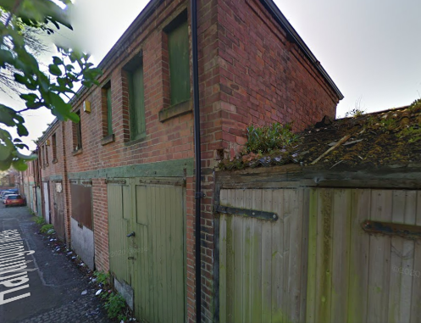
Project one
Garages at Hartington Mews, Hartington Street, Derby
Proposal: Change of use from garages to two dwelling houses (use class C3) including alterations to the front and side elevations

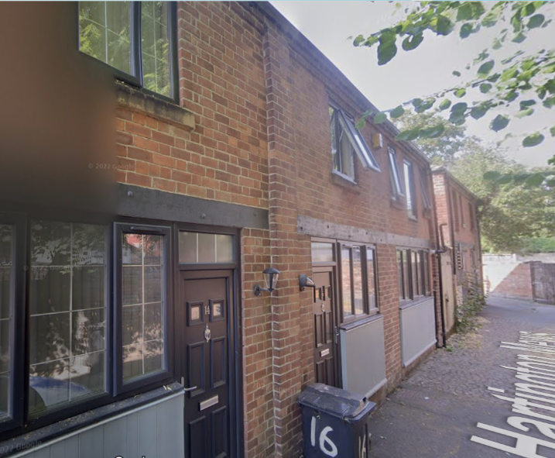
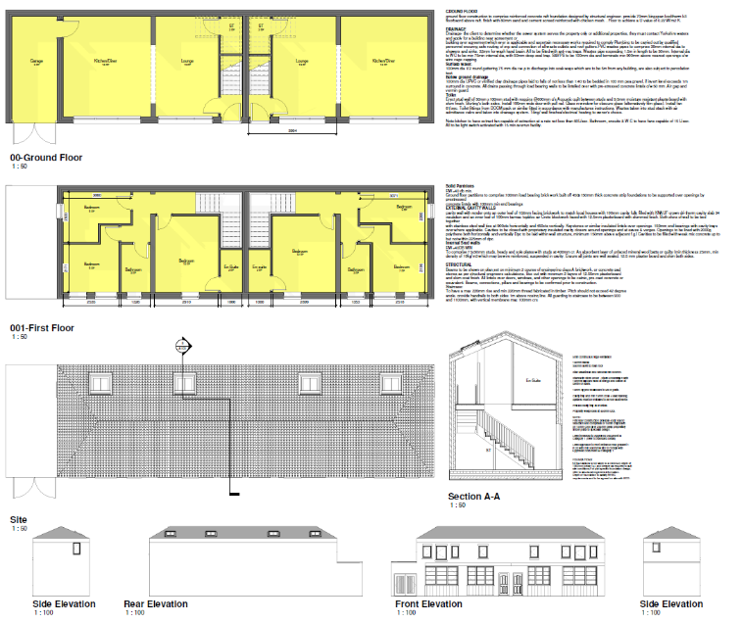

Project 2
Location: 124 Osmaston Road, Derby
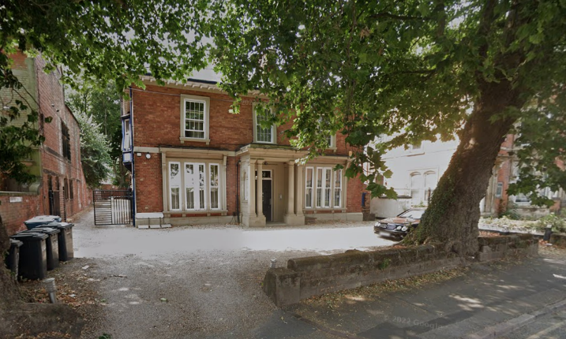
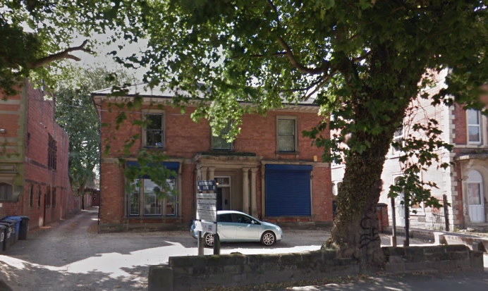
Proposal: Change of use from offices (use class B1) to 12 flats (use class C3)
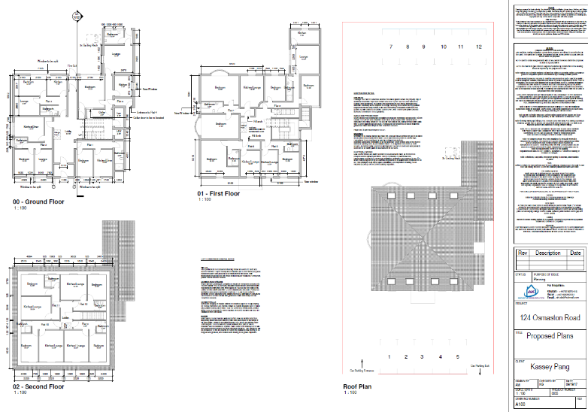

Project 3
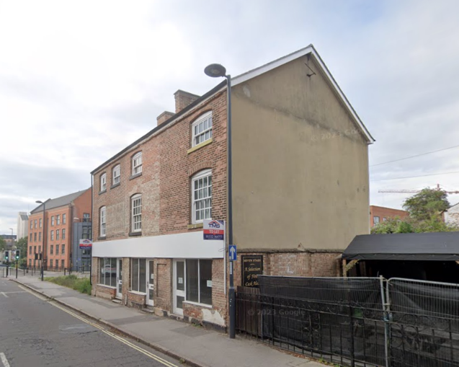
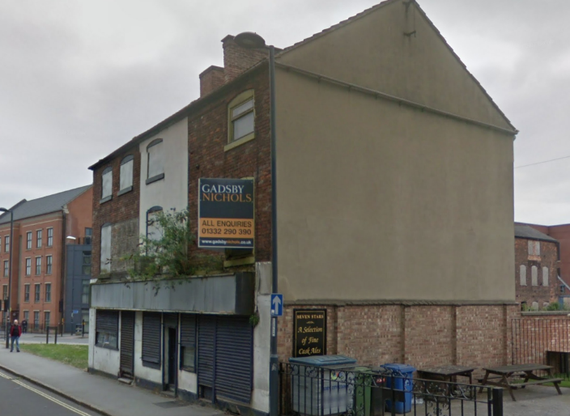
Location: 85-89 King Street Derby
Proposal: Refurbishment Of Commercial Ground Floor Units Together With Formation Of 6 Residential Units On First And Second Floors. Installation Of Glazing And Repair To External Masonry Including Bricking Up Of Existing Openings
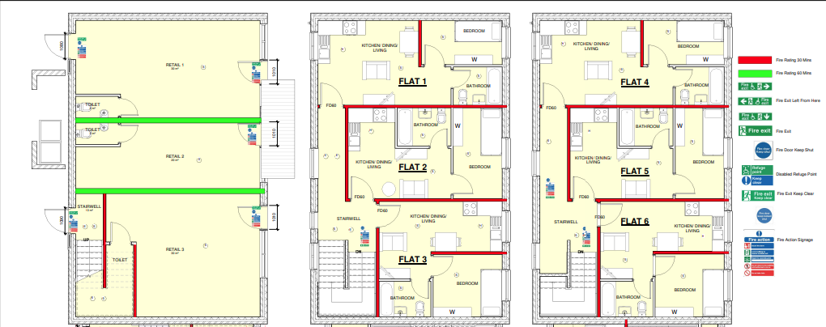
Project 4
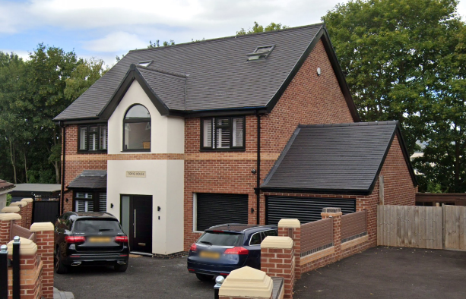
Location: Land At 1 Springfield Derby DE23 6EZ
Proposal: Erection of a dwelling house (use class C3)
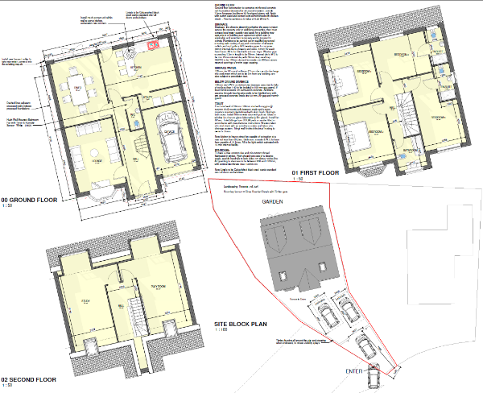
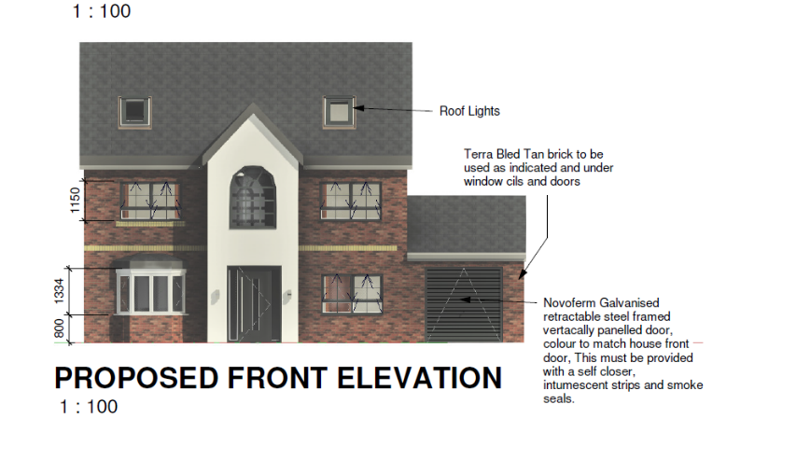
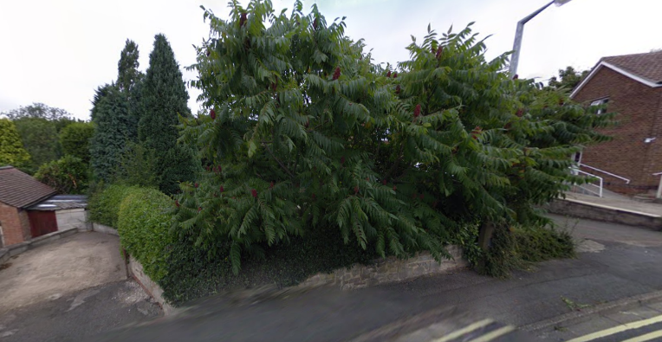

Project 5
Location: 27, Tenby Street, Birmingham
Proposal: Warehouse conversion to 4 town houses.
