DEAD CANYON RANCH
CELLAR SELECT (LUXURY)
FRONT AND BACK CABERNET SAUVIGNON
FRONT AND BACK WINE LABELS

This will be the third and most luxurious wine in a set of 3 wines. I am wanting the labels to be fairly monochromatic. I like the idea of a lighter, natural color like a white, cream or light gray with silver highlights. It will be shown alongside a black and charcoal gray label. This label needs to look more elite, and very expensive. This label could say a lot with texture.

FRONT LABEL: Size of front label: 3.25” W x 5”H

DEAD CANYON RANCH should be the most noticeable part of the label. CELLAR SELECT needs a big, elegant call out.
CABERNET SAUVIGNON needs to be readable from a shelf distance.

FRONT LABEL TITLE:

DEAD CANYON RANCH
HORSE HEAVEN HILLS
ESTATE VINEYARD
CELLAR SELECT
CABERNET SAUVIGNON
2022

Use some elements from this label.

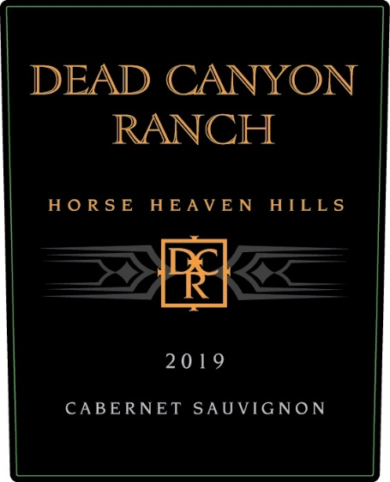

DEAD CANYON RANCH font.
DCR Badge - maybe enlarge the badge.
The banding to either side of the DCR badge
Also add a silver band across the bottom that says
“FAMILY STEWARDS OF THE LAND FOR 5 GENERATIONS”

BACK LABEL: Size of back label: 3” W X 3.5” H

DEAD CANYON CELLARS
CELLAR SELECT CABERNET SAUVIGNON

Please use this text in the puffery:

“Dead Canyon Ranch wines are exclusively sourced from our family's Estate Vineyard in the Horse Heaven Hills of Washington state. For five generations, we have cultivated this rugged and fertile land, embodying our deep-seated love and dedication. We believe that exceptional wine is the result of outstanding vineyards, limited production, and astute winemaking. With the utmost pride and joy, we present this exquisite Cabernet Sauvignon from our ranch to your table.”

Cheers, Ashley Stephens, Cheers, Rob Mercer
Ashley Stephens, Winemaker Rob Mercer, Farmer & Proprietor

GOVERNMENT WARNING: (1) According to the Surgeon General, women
should not drink alcoholic beverages during pregnancy because of the risk of
birth defects. (2) Consumption of alcoholic beverages impairs your ability to
drive a car or operate machinery, and may cause health problems.

750 ML
CONTAINS SULFITES
15% ALC. BY VOL.
PRODUCED AND BOTTLED BY MERCER WINE ESTATES, LLC, PROSSER WA, USA

LEAVE .5” BY 1.5” SPACE FOR A BAR CODE TO BE ADDED

Example of back label below. No pictures on the back label.

Include this crest in black or silver (1’’ x 1” appx size):



