NOTE: I updated all info below on June 18, 2024 now that we have clarity on what we want for the logo
Our sailboat:
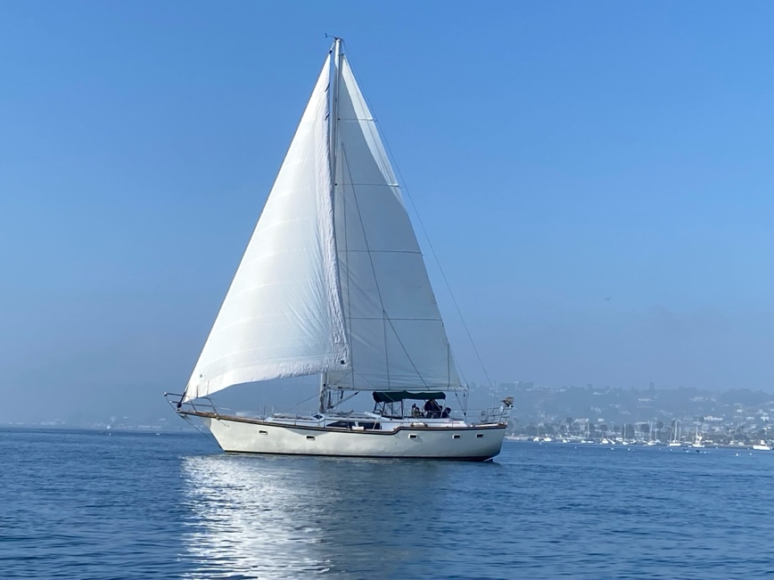
Unique feature (the step down that I highlighted in red)
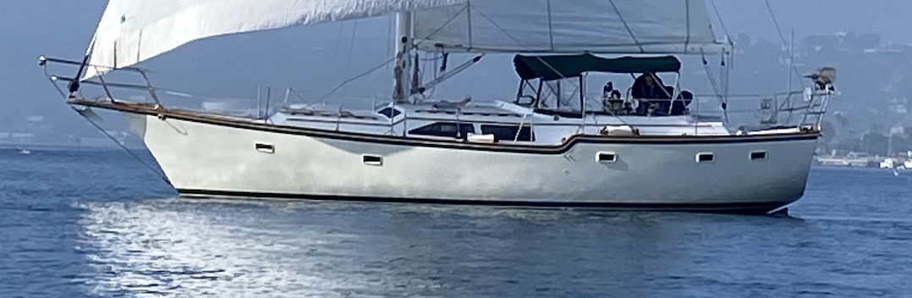

See Next Page

AI Attempt:
Below is something that AI came up for us and we think it is a good start, however we would like modifications as described below
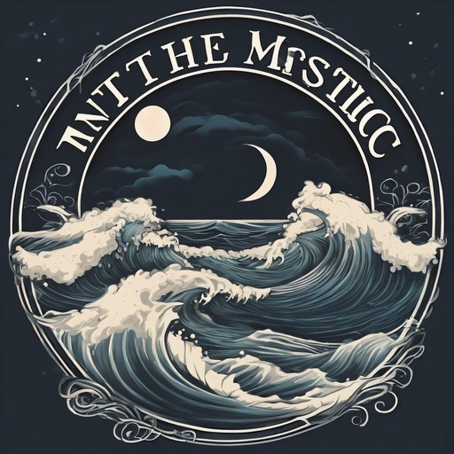
Modifications requested:
- the circle is a compass with the N, S, E, W indications, looks kind of like the compass below but without the star in the middle of the circle because that is where the boat and sea and star and moon, etc. will go
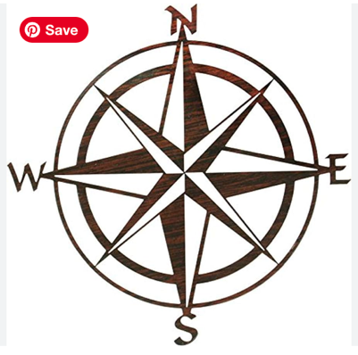
- the waves are less detailed and there are less of them, but still semi active seas,
- our boat name is spelt correctly (Into the Mystic)
- the font used in the name replicates the one on the back of our boat (picture below).

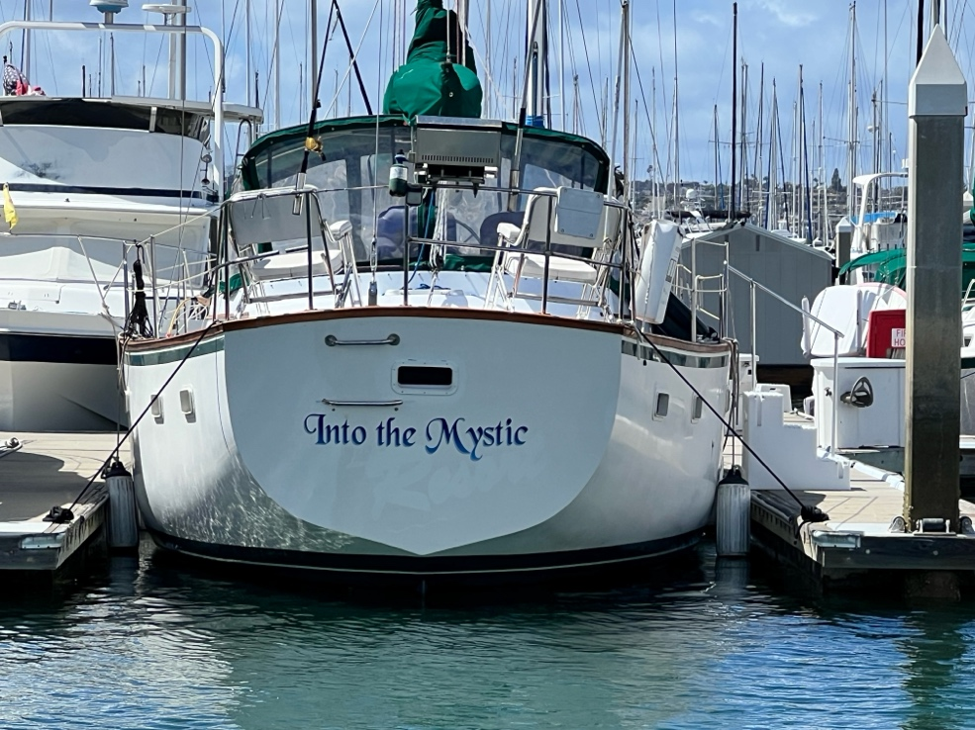
- Our sailboat is leaning with wind in the sails and sailing through the middle of the circle of the compass with our unique feature;
- the sailboat is leaning in the direction of this picture below to look like it is coming through the compass:

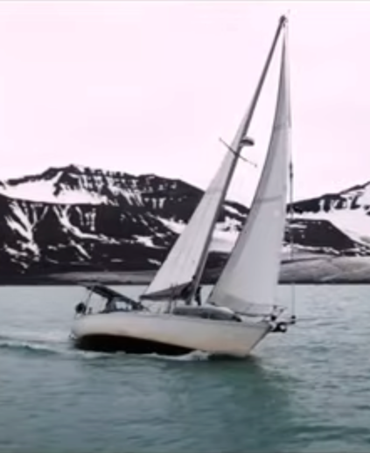
- we like the quarter moon and at least one star in the background

We aren’t sure if we would like the logo in color (like maybe the compass and name in gold while the rest is some kind of purple etc.
OR
If we would like the see the logo in dark grey/black and white like the logo below (from another sailing youtube channel—see next page)
