Grand Master Edition- T-shirt design
Chess, smoking a Cigars, very fine whisky in a whisky glass, Being wise, Rich, Battle & War
Can you combine all images and tidy up to create a clear picture- these AI images are basic
Scope” Have 2 girls playing chess- one blonde and one brown hair, have a good-looking chess board, one girl making a move and the other girl smoking a cigar. Have two glasses of fine whisky on the table. Make sure they have their eyes open
Banner Quote below
DON’T BE
AFRAID OF MAKING
BIG MOVES

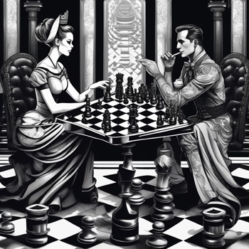
I like the seats and legs on the table

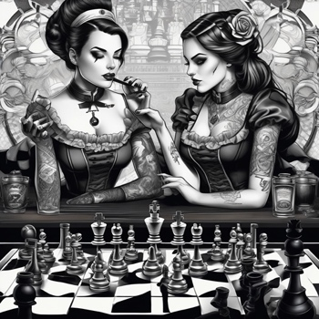
two girl sitting with there drinks, but only use one of those girls
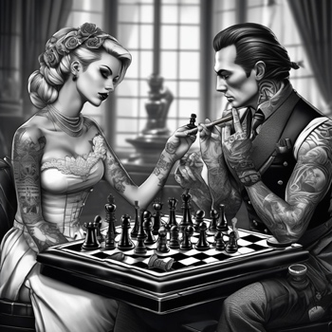
I like this chess board look and the blond female, the chess pieces and squares need to be aligned

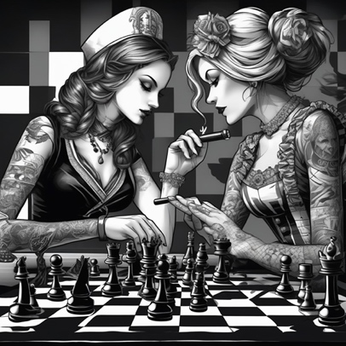
I would like to have- one girl making a move smilar to this and the other smoking a cigar

