Website Brief
Website inspiration
https://www.cudesign.com.au/

https://dribbble.com/shots/23676013-Men-s-fashion-wear-website

https://dribbble.com/shots/21698625-Glowskin-Skin-Care-Website-Design

https://dribbble.com/shots/23036243-Luxury-Real-Estate-Website

https://dribbble.com/shots/21054238-Everyday-Wear-Luxury-Jewellery-Landing-Page-Concept

Look/Feel
Luxury
Colourful, engaging
Bold, elegant
No white backgrounds
Use of copper tones
Mobile friendly

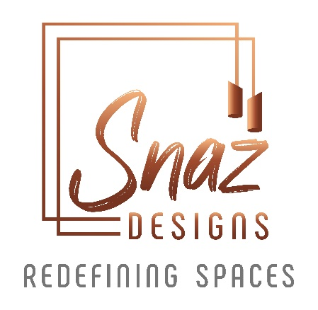
Logo/Business Card/Email Signature

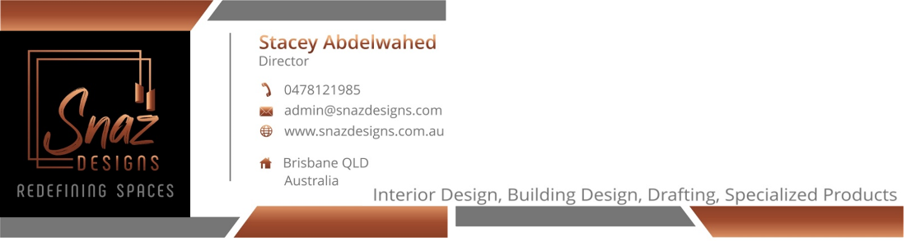

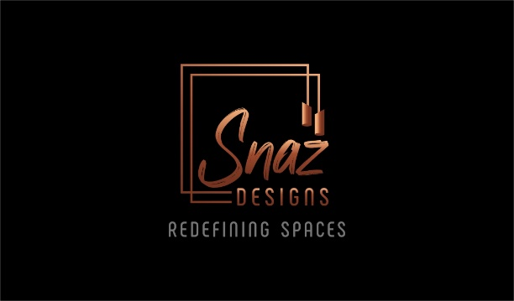
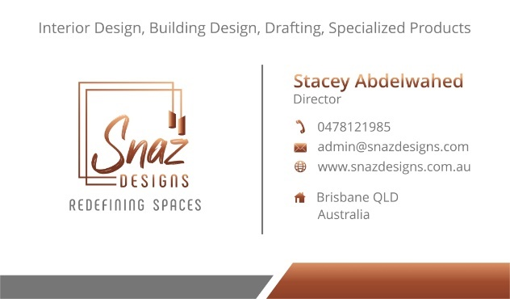

Colours Taken From Logo
Logo colour gradient of copper. RGb format
R 245, G 176, B 122
R 158, G 74, B 45
R 119, G 53, B 33

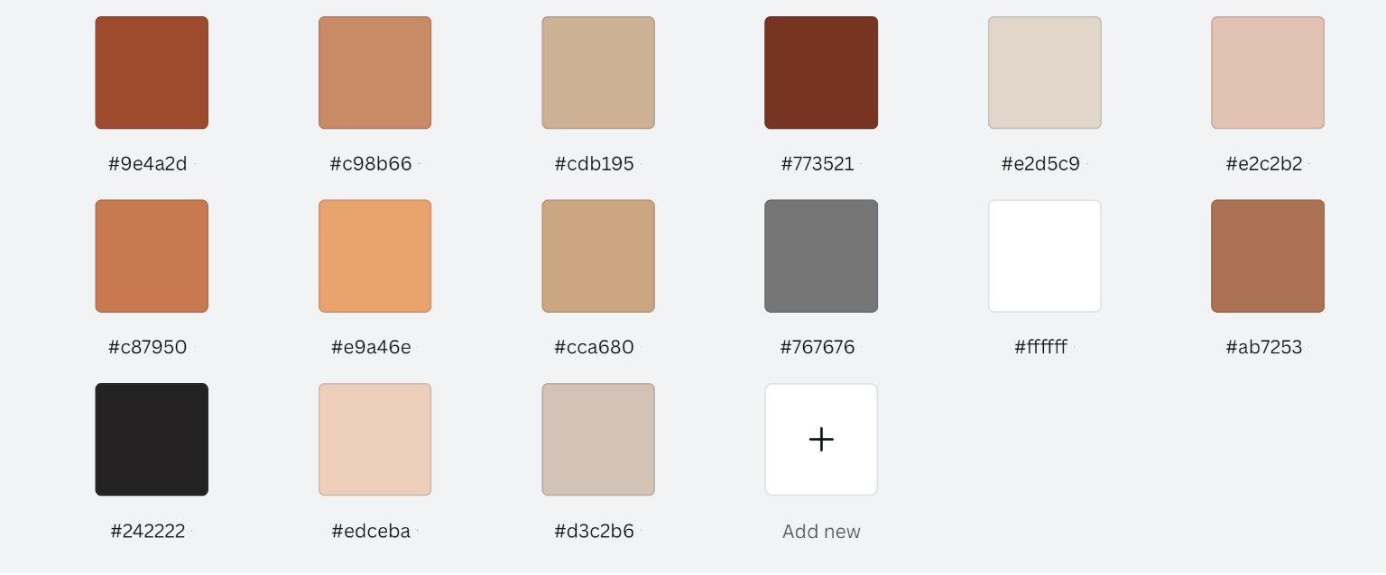

Brand Fonts
Logo font : Dexotick Font
Subtitle font : Phenomena Font

Website Content
- Home
- Who (we are)
- What (we do)
- Why (choose us)
- How (we do it)
  - Building Design Process
  - Construction Process
  - Interior Design Process
- Q and A - Frequently Asked Questions
- (Gallery) Previous projects and examples
- Resources/Blog – Weekly social media posts connected to this
- Reviews

