1 page of the Double Sided Summary of HJUBS – we like the design on the left with the truck but would like to replace the truck picture with the picture of Acqua Compressor HJUB as in right flyer.
- Change logo to new logo
- Remove the text in green that says: These 4 different types are:
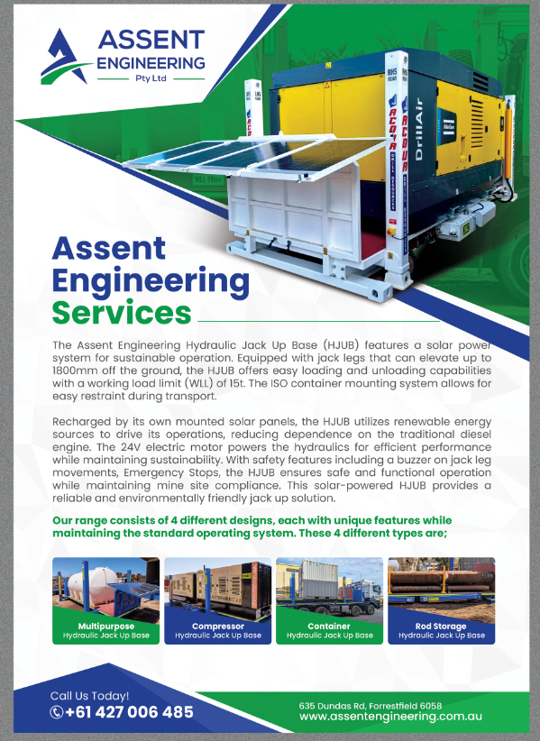
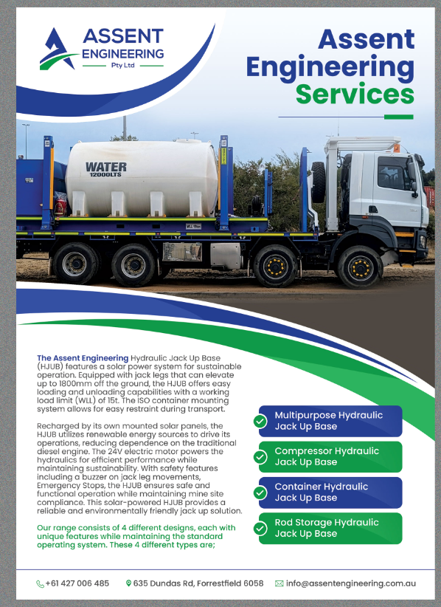
- Change the word Rod to Pipe – in the green box it should say Pipe Storage Hydraulic Jack Up Base

