- Rod Storage HJUB – Change the word Rod to pipe. Do this throughout the text below the new heading “Pipe Storage HJUB”
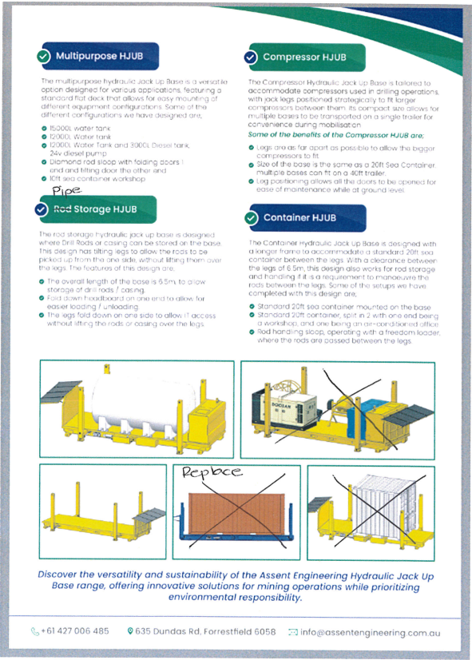
- Remove the pictures with a X through them and replace them with the pictures on the next page.

