DEAD CANYON CELLARS
RESERVE CABERNET SAUVIGNON
FRONT AND BACK LABELS

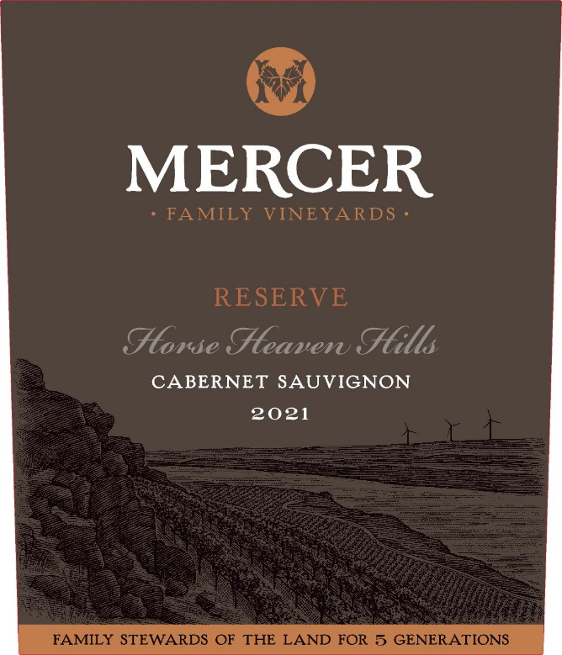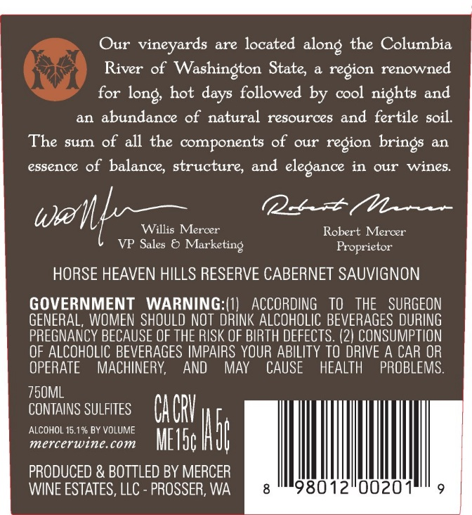
Front Label Example Back label Example
I would like to create a wine label that has a similar look and feel to above label.
Size of front label: 3.25” W x 5”H
Size of back label: 3” W X 3.5” H

Keep the same gray brown feel, a little lighter tho.
Possibly use the attached SCV pencil drawing attached as the background vineyard.

FRONT LABEL

Title the wine:
DEAD CANYON CELLARS
RESERVE
Cabernet Sauvignon
Horse Heaven Hills
2022

Keep the bronze or gold foiled band across the bottom: FAMILY STEWARDS OF THE LAND FOR 5 GENERATIONS
Below I have shown another label used for this brand. If you want you can pull the font and DCR image from that label to use on this new label?
Print RESERVE in cursive or italics to make it stand out.

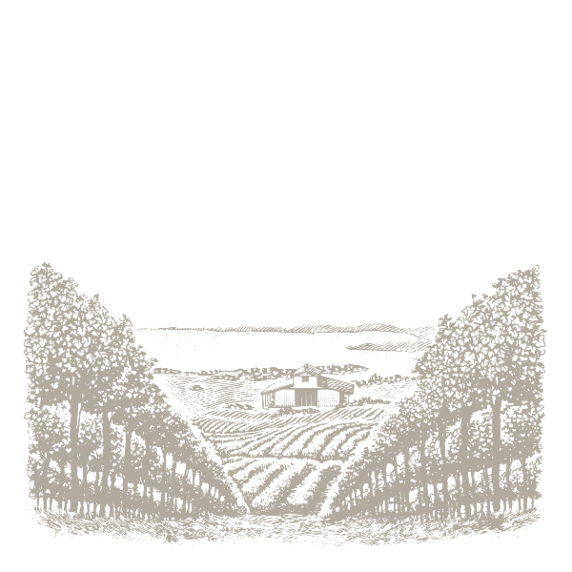Image to use as background

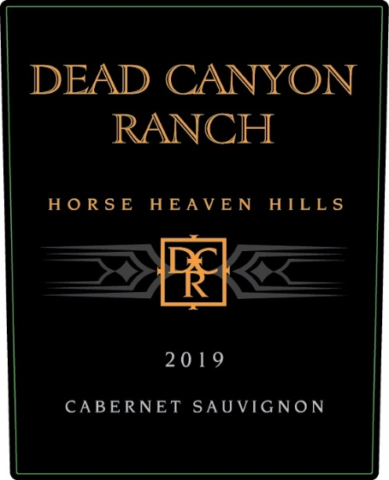 You can use elements from this label such as the DCR icon or Dead Canyon Ranch front
This is an example of the wine it will be grouped with. Can you pull the Dead Canyon Ranch Font from this label and use it for the title (except we are saying Dead Canyon Cellars not RANCH as this one shows).

BACK LABEL

Title:
DEAD CANYON CELLARS

Please use this text in the puffery:
"Our vineyards, nestled along the Columbia River in Washington state, flourish in a region celebrated for its long, hot days and cool, crisp nights. This area, rich in natural resources and fertile soils, imparts a unique essence of balance, structure, and elegance to our wines."

Cheers, Ashley Stephens,
Ashley Stephens, Winemaker

GOVERNMENT WARNING: (1) According to the Surgeon General, women
should not drink alcoholic beverages during pregnancy because of the risk of
birth defects. (2) Consumption of alcoholic beverages impairs your ability to
drive a car or operate machinery, and may cause health problems.

750 ML
CONTAINS SULFITES
15% ALC. BY VOL.
PRODUCED AND BOTTLED BY MERCER WINE ESTATES, LLC, PROSSER WA, USA

LEAVE .5” BY 1.5” SPACE FOR A BAR CODE TO BE ADDED

