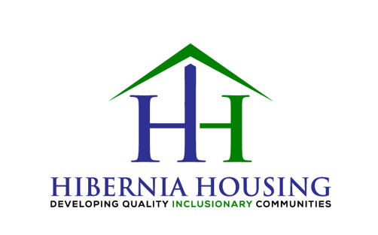
Hibernia Housing Business Card Design Brief

Hi there, we are looking for a great business card design that is business-like, compelling while being high-design

The Hibernia Housing logo files are attached.

The following are the business card contact info and coordinates for Tim McEntee


Design Ideas

We are wide open to all design ideas….but we did have a couple of design ideas/elements for the card, i.e. –

- Thinking of two-sided card
- As tagline “Developing High-Quality Inclusionary Communities” is long, we thought having the logo and long tagline on the back of the card (where there in no contact info are name and more space) thought it might be a good idea as we can make logo and tagline much larger making tagline easier to read. Then on the front of the card just the HH logo with no tagline
- For any background colors OR other color elements would like to use as much green as possible

Two Design Ideas with Examples of Business Card Ideas We Like

- Two-sided cards with just a large logo and tagline on the back of the card. Just logo with no tagline on front of card

- Logo design effect of a indifferent lighter shade (without tagline) or filtered (not sure if I am using right terminology for this design effect) on front of card, see below examples –


- Logo without tagline in a different shade (or filtered) on front of card

Example #1
What we like about this design example –
- Logo design effect without tagline in a different lighter shade or filtered on right side on front of card
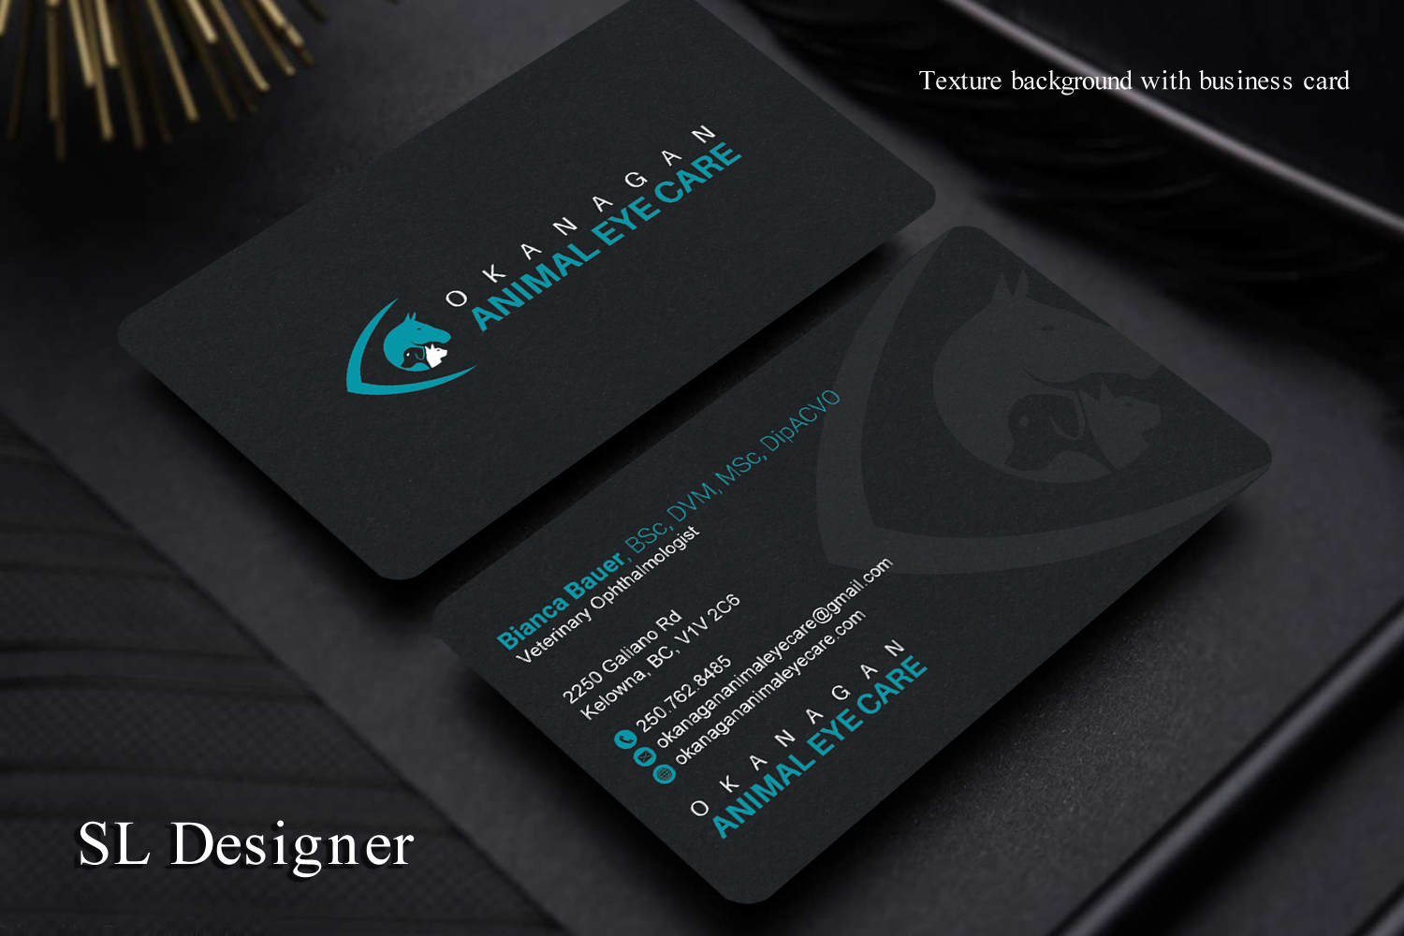

Example #2
What we like about this design example –
- Logo design effect in a different lighter shade or filtered on left side on front of card without tagline
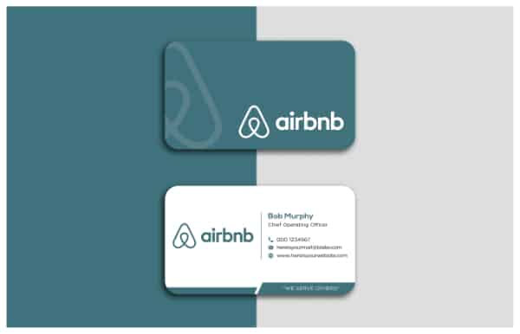

Example #3
What we like about this design example –
- Logo design effect in a different lighter shade or filtered on right side on front and back of card without tagline
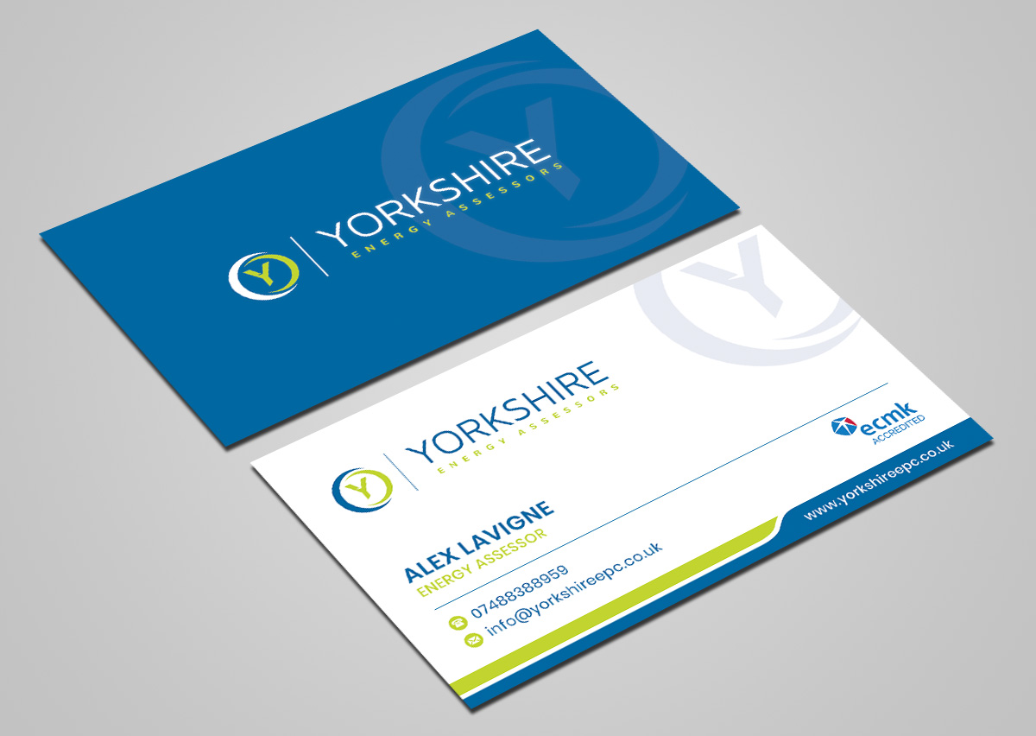

- Examples: Of two-sided cards with just a large logo and tagline on the back of the card. Just logo with no tagline on front of card

Example #1
What we like about this design example –
- Green background on back of card (again trying to use as much green color as possible for background, etc)
- With white front of business card is nice, clean design
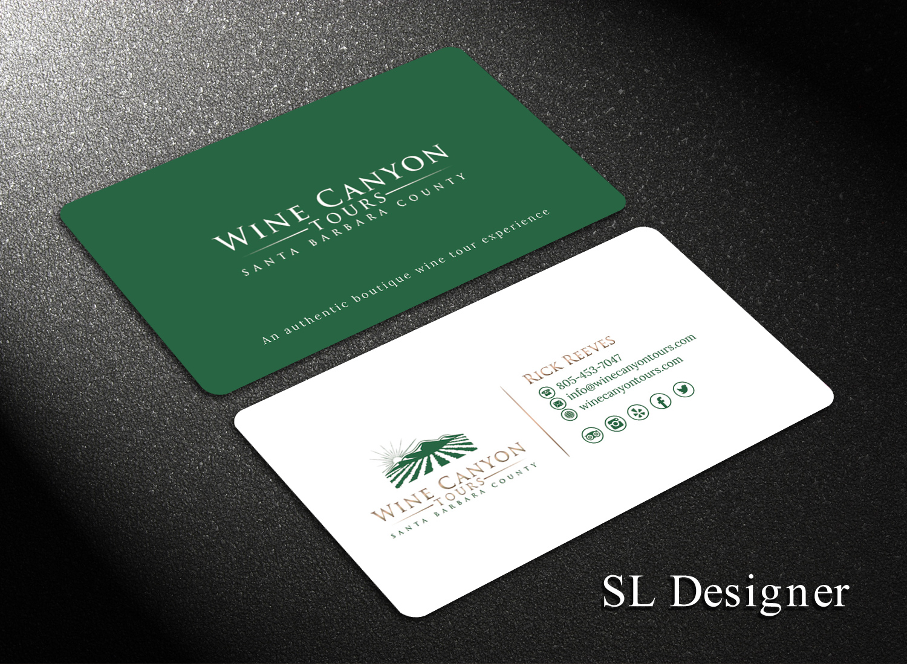

Example #2
What we like about this design example –
- Neat design with background color on both sides of the business card. Again, would like green background color instead of black
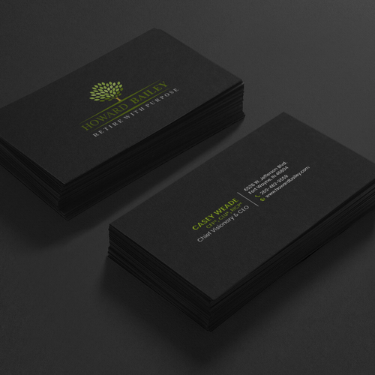

Example #3
What we like about this design example –
- Really thought this was a neat design utilizing two background colors
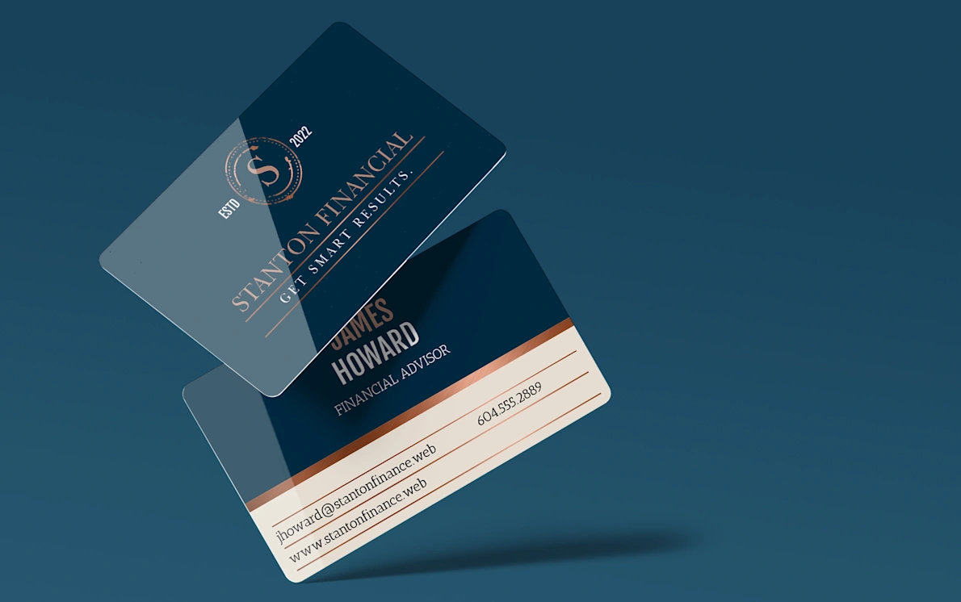

Hope the above helps and look forward to great business card designs!

Thanks!
Kevin O’Brien

