About

Short Sales Bio
For the past 48 years, ACT of Communication® has been the preeminent trial consulting firm in the country in witness preparation and courtroom communication. Our work with attorneys and their witnesses elevates communication effectiveness in and out of the courtroom.

Over 50,000 lawyers have participated in our seminars and workshops. Plaintiffs’ organizations across the country have engaged us to design their curriculum and serve as master instructors. We have been part of trial teams on more than 3,000 cases. Firms across the country have credited working with us with helping them achieve seven-, eight-, nine-, and even ten-figure verdicts.

Our expertise in all manner of litigation, from vehicle collisions to medical negligence and malpractice, from premises liability to product defect, from complex commercial to intellectual property, gives us a global understanding of the needs of lawyers and witnesses in deposition and trial preparation.

Mission
Our mission is to support YOUR story, so the judge or jury absorb, process, and act according to the outcome you desire.

Vision
Our vision is to build a lasting legacy of the positive impact of human-centered storytelling in the law.

Values
We stand for:
- Honesty
- Integrity
- Curiosity
- Play
- Empathy
- Patience
- Effective communication
- Mutual respect
- Outside-of-the-box thinking with human beings at the center

Target Audience
Plaintiff trial lawyers and their clients.
Persona example

Client Needs, Wants, & Values
Justice, helping the “little guy,” to be made whole, to communicate effectively.

Logo

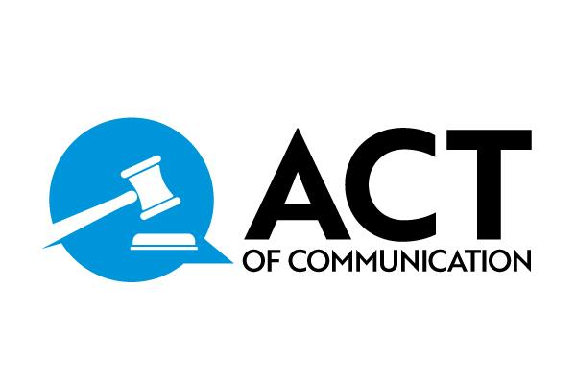
Utilize the speech bubble as a brand mark. Both can be altered for supporting colors.
Sidebar: Logo with Movie Reel in it can be for future filming project?

Colors
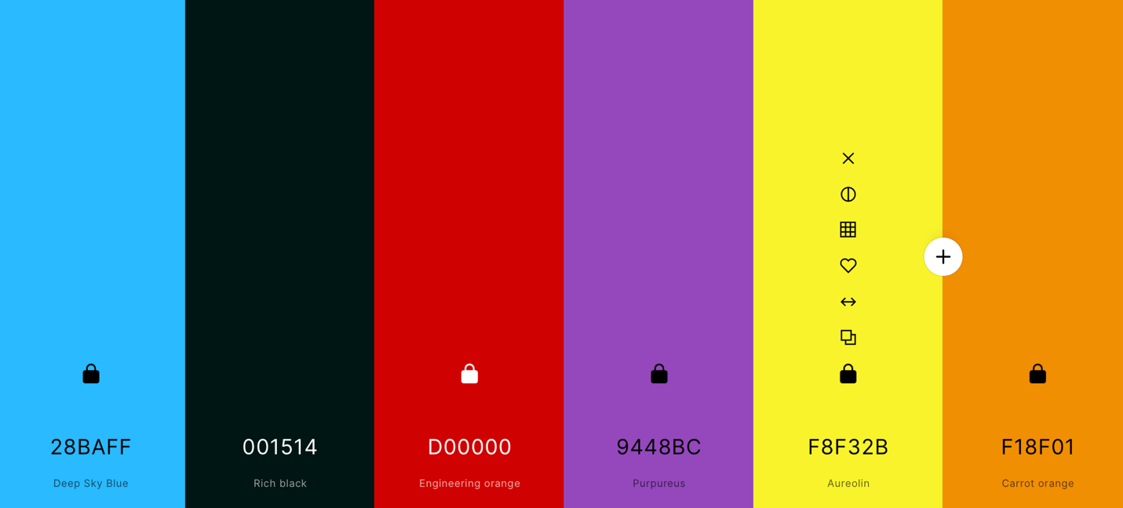

Typography

Web Fonts Used:
We’re using the Helvetica Font Family as the standard font for the new website.

Web Fonts Planned:
Website: We’ve decided to use the Poppins font as the main font for the new website. Poppins is part of
Google Fonts, which is widely used. Google Fonts have become a standard in web development. We chose this font because it looks modern, is easy to read, and complements the font used in the new logo. We’ll use the Poppins font for all titles (H1, H2, H3, H4, H5, H6) as well.
Link to Font: https://fonts.google.com/?query=poppins

Graphic Fonts Used:
Previously, we used the Times New Roman font, which was also used in the old logo. However, we made a switchback in 2019 to Helvetica and Myriad Pro for print graphics. We felt that Times New Roman looked outdated, and we wanted to update our overall design to be more modern and current.

Graphic Fonts Planned:
With the new logo, we plan to use the Brother 1816 font for titles and Call To Action graphics, as it’s the font used in the new logo. We’ll also apply the Brother 1816 font to the body text area for consistency.
However, in certain cases where we need to differentiate graphics, we’ll use a different font. For the second option, we’ll use Poppins, which is the same font as the planned font for the new website.

Visual Guidelines
Logo: Its placement, variations for different platforms and channels, colors, size, and proportions.
Colors: Primary and secondary colors as well the monochrome version
Fonts: Corporate typography to be used in headlines and bodies of text in official documents
Photography: Style and guidelines used for consistent presentation
Brandmark: Where to use it
Other: Patterns, textures, graphics, icons

Communication Guidelines
Language: english, focusing on the US
Style: formatting, technical, and non-technical messaging
Tone of voice: professional, emotional, simple, playful, clear.
Social media presence: in order of importance - LinkedIn, X, Instagram, Facebook (TikTok in the future). Post during traditional lawyer professional hours.
Emails: To the point, playful, kind, room for personality and creative expression.
Readability and grammar: keep things to an 8th grade reading level. Simple, straightforward, uncomplicated, storytelling. types of sentences and its lengths, capitalization, numbers, abbreviations, acronyms, proofreading with Grammarly or any other similar tools

Images
Use clear, in focus, and high resolution photos, illustrations, and graphics from a royalty-free site or Shutterstock. Not posed photos, they need to feel human and impromptu but professional. Make an effort to include equal representation of genders, races, backgrounds.

Have a sense of humor and playfulness with imagery. If using cartoons, illustrations, or vectors, have a similar feel to them or a standard person who can create them.

Overall, sense of humor but professional uniformity and brand consistency.

Do's and Don'ts
We are apolitical in our communication, postings, etc. We deal with a diverse range of clientele and our brand respects that.

