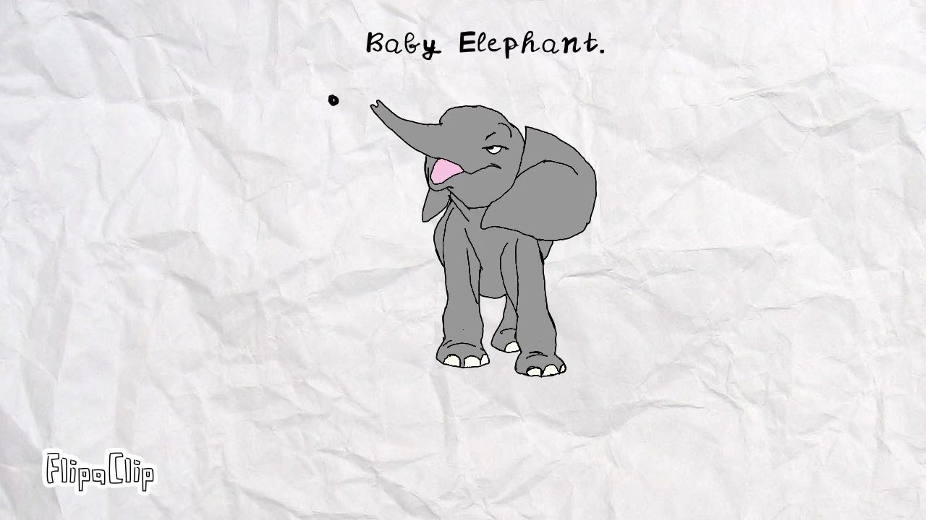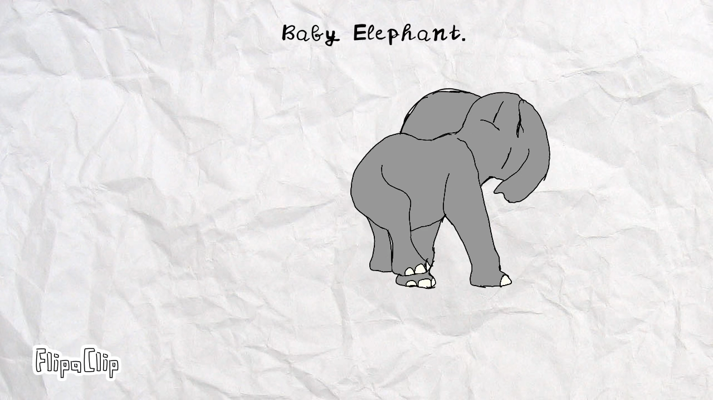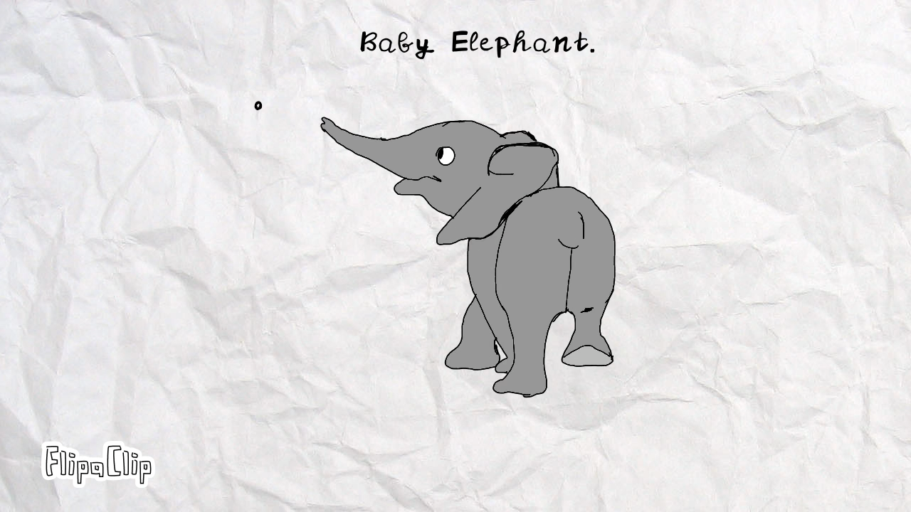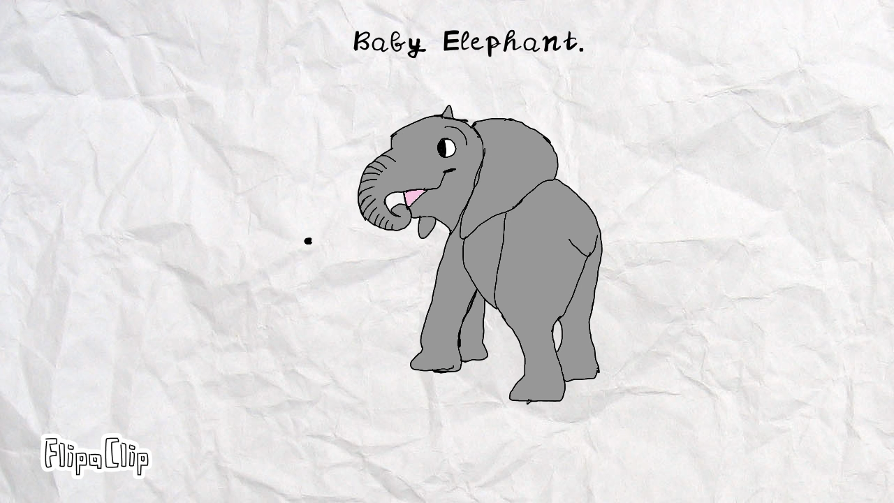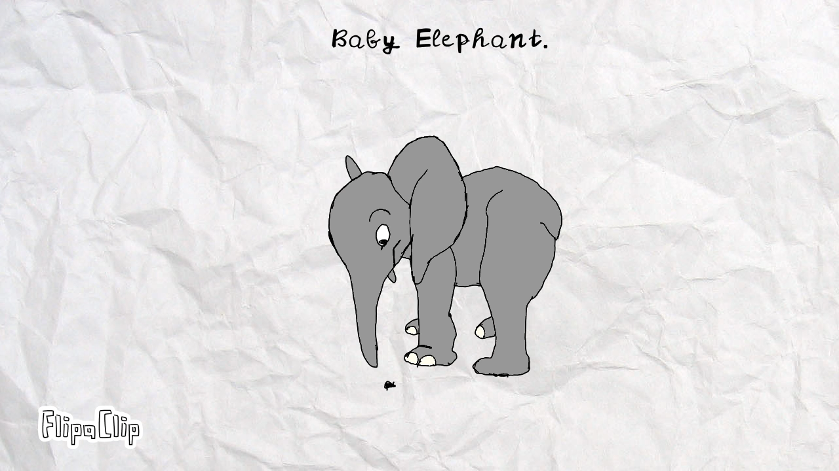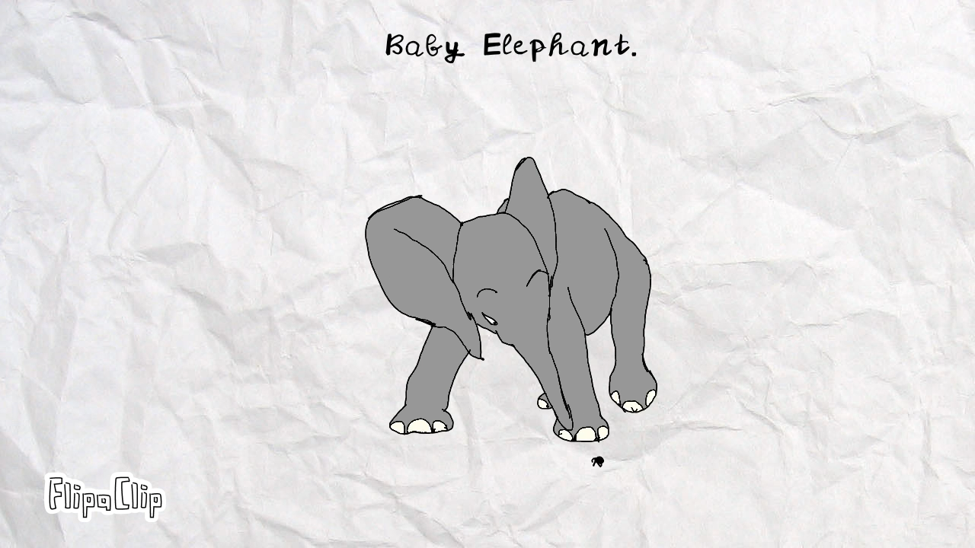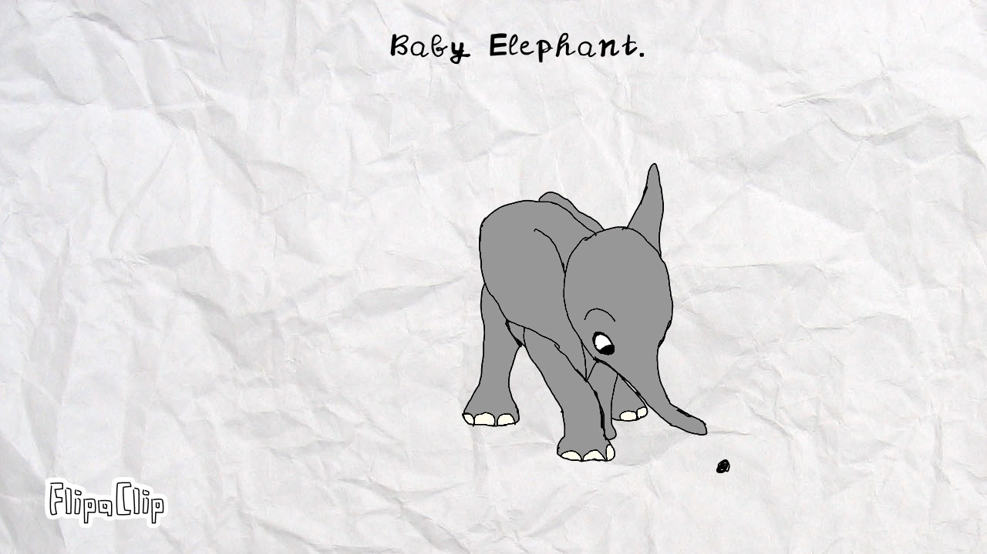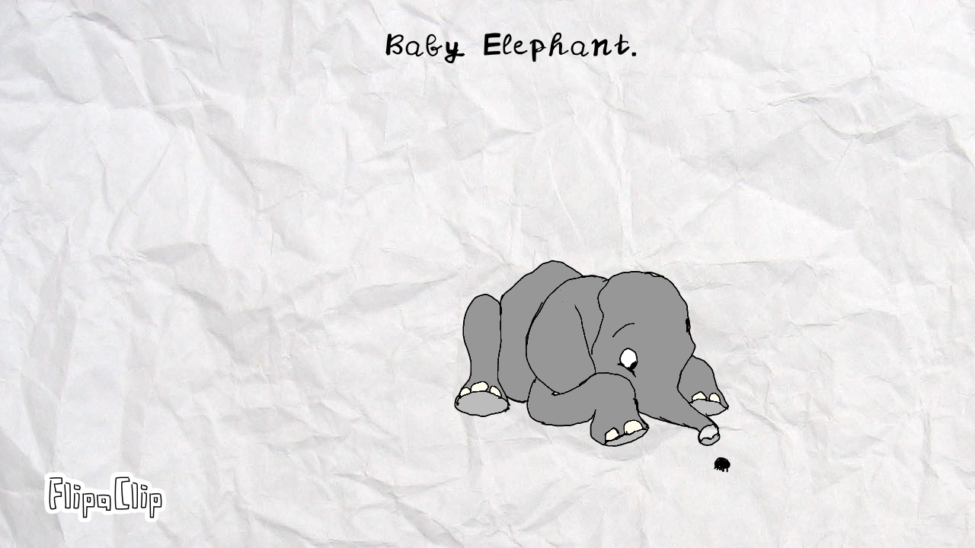

Heaven and earth will pass away, but my words will never pass away…
See, I am doing a new thing! Now it springs up; do you not perceive it? I am making a way in the darkness and streams in the wasteland.
“For I know the plans I have for you,” declares the LORD, “plans to prosper you and not to harm you, plans to give you hope and a future.”
And I am sure of this, that He who began a good work in you will bring it to completion at the day of Jesus Christ.
I will repay you for the years the locusts have eaten…

