AlphaGrow’s copy trading tutorial
Below are the necessary steps for you to start copying AlphaGrow’s trades directly on your Binance account via Binance Copy Trading

Step 1: Ensure your Binance account is associated with an eligible country/region
Binance Futures Copy Trading products and services are available to verified users with identity documents from the following countries and regions:

https://www.binance.com/en/support/faq/binance-futures-copy-trading-service-list-d898460abbd14bd8aab54954ca0d606a

Make sure your Binance account is associated with one of these countries/regions.

Step 2: Connect to Binance
Go to https://binance.com/en/ and log-in using your credentials.

Step 3: Open Futures account
If you have already opened a Futures account, you can skip this step.

Once you are connected, move your mouse over the second icon on the top right area of the screen.

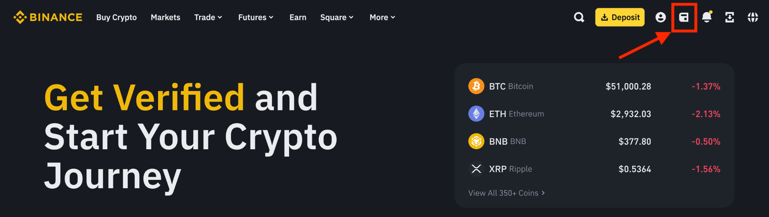

Select “Futures” on the drop-down list that appears.
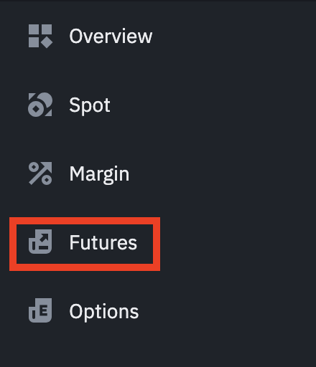

On the next page, agree with the Binance Futures service agreement and click on “Open Now”.

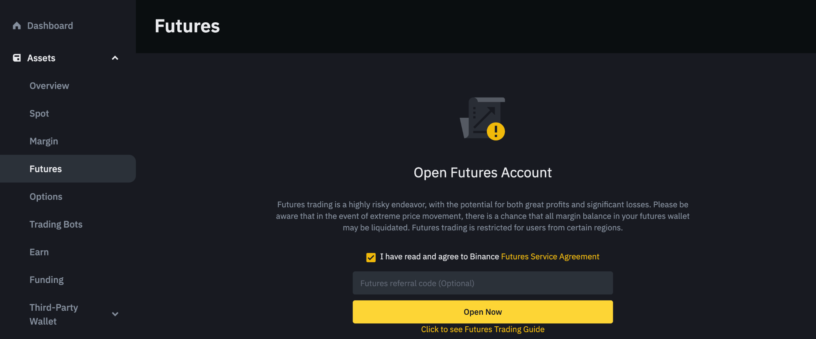

A window pops-up asking you what should be your default leverage. We highly recommend selecting the third option “Customize” with “1x” as default leverage as this is the safest option.

Then, click on “Open Futures Account” to finalise this step.

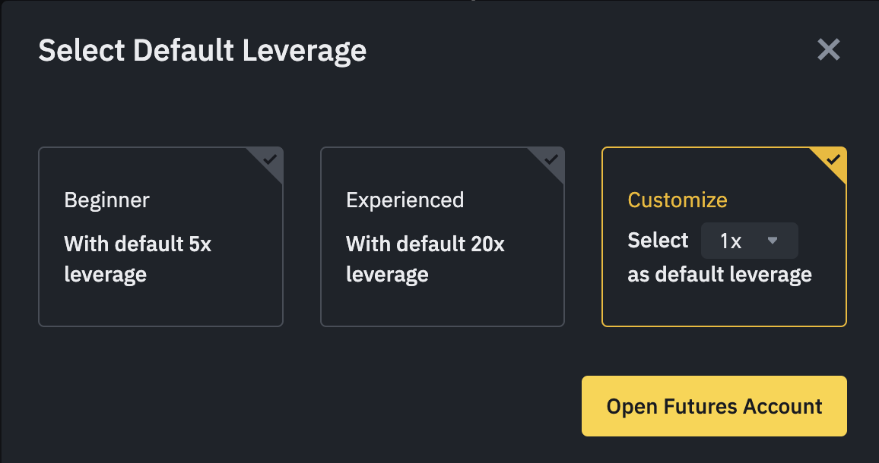

Step 4: Supply your account in USDT
Make sure you have the necessary funds in your Binance Futures account to allow our bot to trade.

Step 5: Set-up copy trading with AlphaGrow
Go to the AlphaGrow trading bot page: https://www.binance.com/en/copy-trading/lead-details/3812864465187352322

You can see information related to the bot performance and trading history.

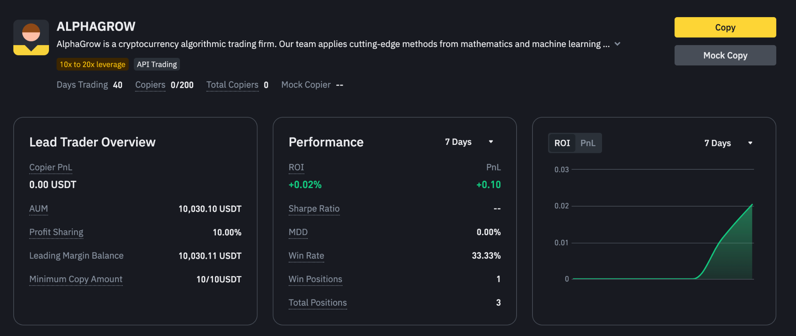

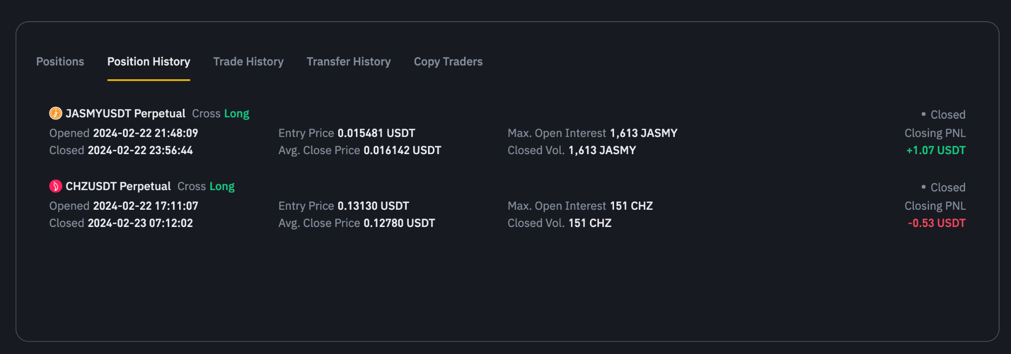

On the top-right corner, next to the bot’s description, click on “Copy”

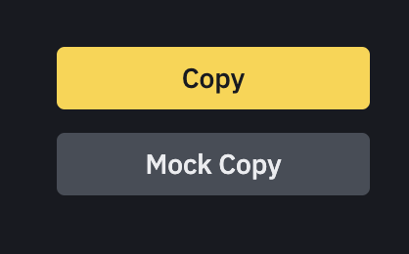

If you haven’t opened a Futures account, a window should appear urging you to open one.
Once the Futures account is created, you can move to the next phase.

To copy our trades, you will have the option between 2 modes: “Fixed Amount” and “Fixed Ratio”.

We highly recommend you select “Fixed Ratio” to get the best out of our strategies.

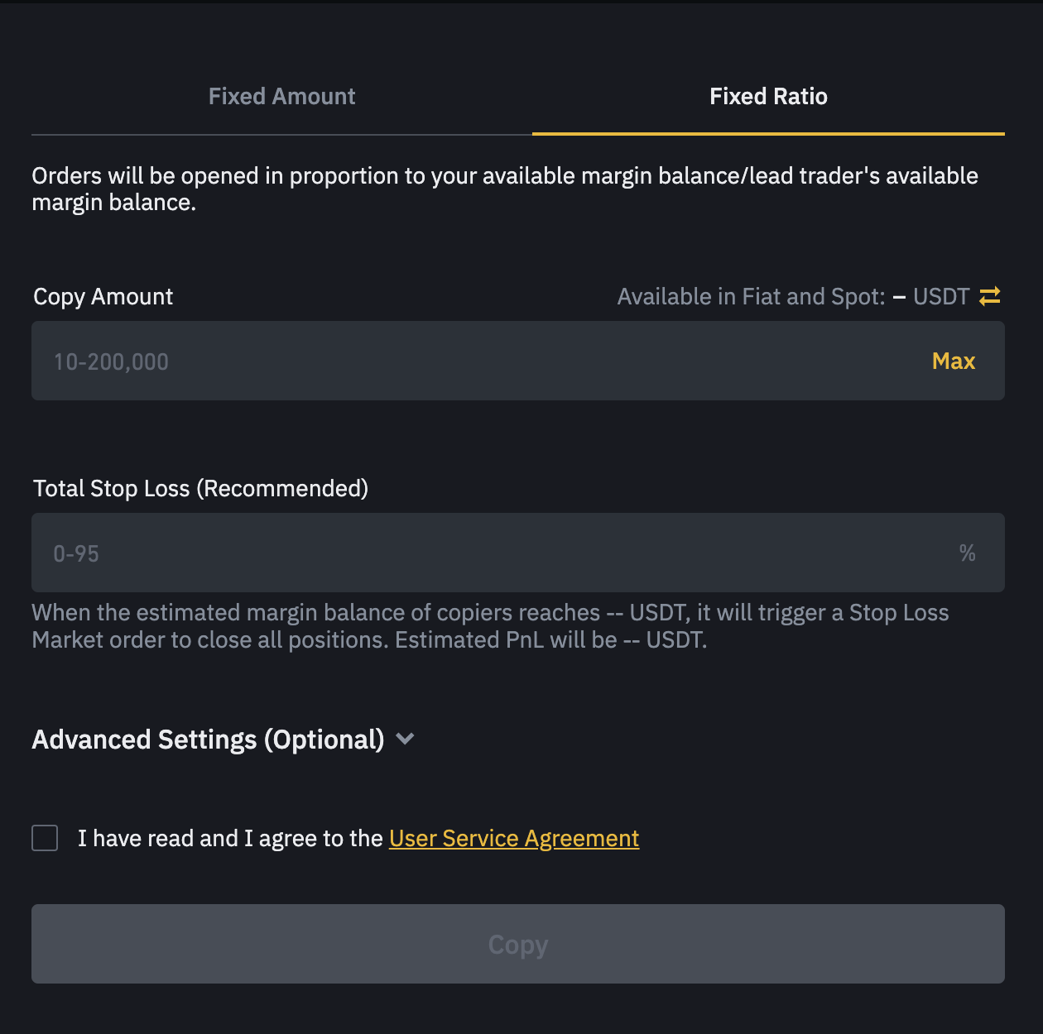

You can then specify the “Copy Amount”, which is the total amount of USDT the bot will be trading for you.

If you want to fully benefit from our trading algorithms, we advise you against configuring the other parameters (Total Stop Loss, Advanced Settings). If you prefer to do so, there is a high chance the performance will deviate from what is expected.

Once you are done, click on “Copy”.

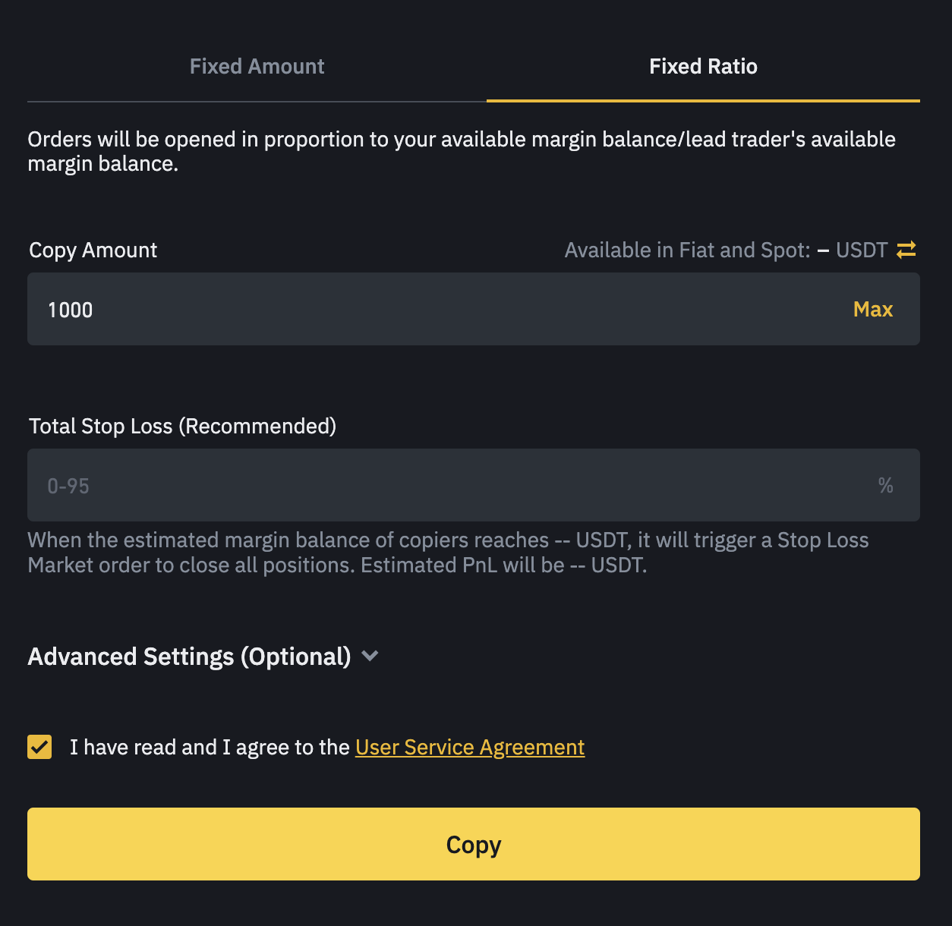

A confirmation page pops-up. Click on “Confirm”.

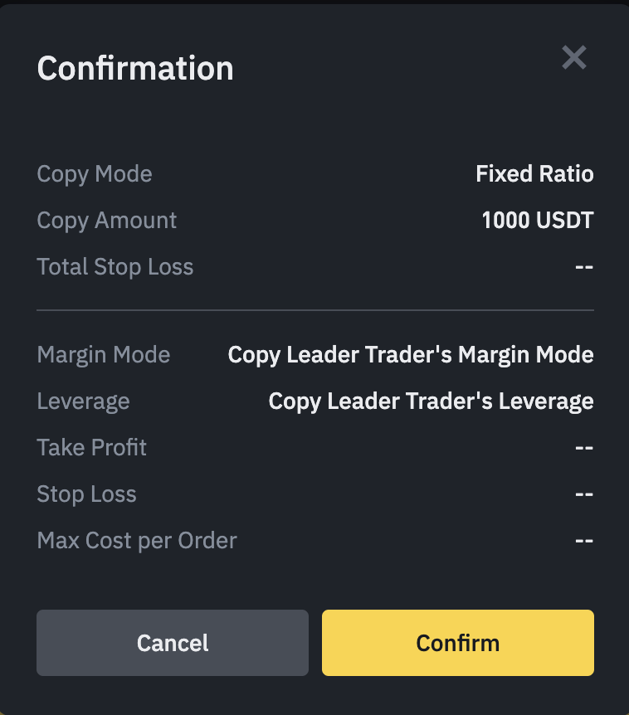

Binance will then start automatically copying our trades on your account.

All opened positions will be shown on your Futures trading account.

You can stop copying at any time.

Take note that it is important to be patient. It may take some time for your profits to grow.

