Product Catalgoue

2024/25

Australia’s only nationwide supplier of Premium Blank Cake products

Contents

Our Story
Why Choose Us
Round Cakes
Slab Cakes
Cupcakes

Gluten Free Range

Product Overview
Selling Concepts

Our Story

From his humble beginnings as a salesman in the baking industry, Paul Wanis discovered a common sentiment among busy moms, decorators, and chefs alike: the laborious task of baking cakes often took up precious time and overshadowed the joy of decorating. Recognizing this gap in the market, Paul envisioned ready-to-decorate cakes as a solution, freeing professionals and even stay-at-home moms to focus solely on their passion for decorating and sharing—or selling, for that matter!
With a commitment to unmatched quality and national distribution, Paul embarked on a journey to establish Bake Me Up as the premier blank cake supplier in Australia. His unwavering dedication to maintaining high-end, premium products with the strictest quality standards sets Bake Me Up apart in the industry. With Paul's pioneering vision, Bake Me Up is poised to revolutionise the market and become Australia's leading blank cake supplier nationwide.
Now, Bake Me Up proudly presents its state-of-the-art bakery nestled in Melbourne's South East. As our presence in the market has surged, so too has the necessity to carve out our own space for crafting our decadent cakes. With this new facility, we have taken control of our destiny, becoming the masters of our craft.
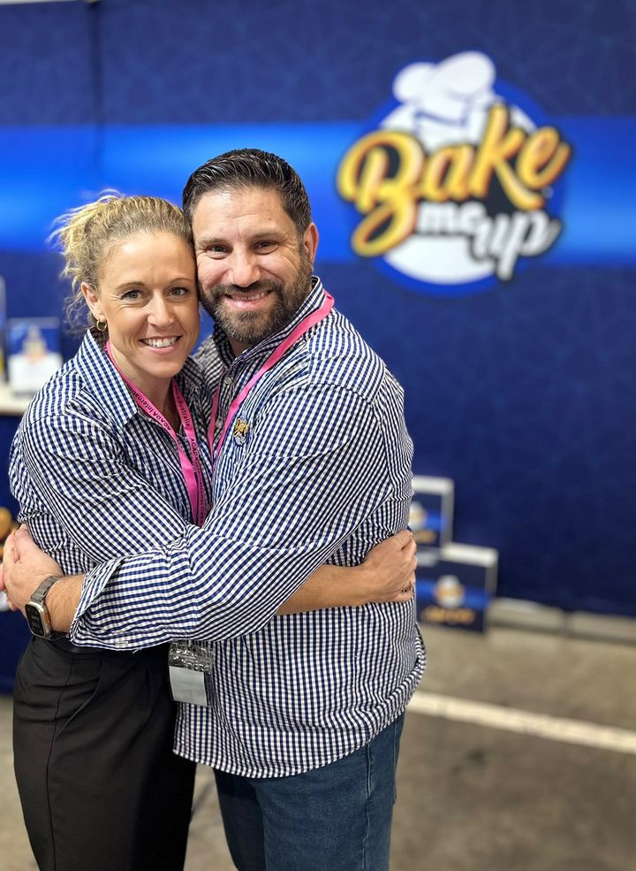

Our Mission
At Bake Me Up, we are dedicated to revolutionising the culinary landscape for professional chefs like you. Our mission is clear: to provide innovative, time-saving cake products of unparalleled quality to our wholesale and food service partners.
With Bake Me Up, you can unlock endless possibilities for your menu, effortlessly expanding your offerings to reach a wider consumer base. Our premium cake offerings not only save you time but also empower you to craft new and decadent creations that captivate and delight your customers.
Join us in our journey to elevate your culinary offerings and transform every moment into a celebration of taste and indulgence. As an Australian-owned company, Bake Me is committed to delivering trusted quality cakes while supporting local manufacturing jobs. Trust Bake Me Up to be your partner in culinary innovation and excellence.

Why Choose Us

Bake Me Up: The Superior Choice for Discerning Consumers!
- Nationwide Availability: From bustling city centers to quaint rural towns, Bake Me Up Cakes readily accessible across the nation, ensuring that everyone can experience its unparalleled excellence.
- Unwavering Quality Standards: At Bake Me Up, we take pride in setting the bar high. Our relentless commitment to quality ensures that every bite of Cake is a testament to excellence, meeting and surpassing the highest industry standards.
- Premium Ingredients, Exceptional Taste: Elevate your culinary experience with our cakes, crafted using only the finest, handpicked ingredients. Each mouthwatering bite is a symphony of flavors, a testament to our unwavering dedication to using only the best.
- HACCP Accreditation for Peace of Mind: Your safety is our priority. Rest assured, every step of our production process adheres to the rigorous standards set by the Hazard Analysis and Critical Control Points (HACCP) accreditation. With Bake Me Up, you can indulge with confidence, knowing that every bite is as safe as it is delicious.
Experience the difference with our blank cake range – where quality meets passion, and every bite tells a story of dedication and excellence. Join the countless satisfied customers who have made Bake Me Up their preferred choice. Try it today and taste the difference for yourself!

Attention Professional Chefs and Restaurateurs,
Are you tired of spending valuable time and resources on the laborious task of baking cakes from scratch? Say goodbye to lengthy prep and oven time with Bake Me Up's cake blanks!
Our cake blanks are the secret weapon you need to effortlessly create stunning cakes for any occasion, from intimate birthday celebrations to extravagant wedding receptions. With these versatile blanks in your freezer, you can skip the time-consuming steps of prepping, baking, and cooling, allowing you to focus on what truly matters – crafting exquisite culinary creations that delight your customers.
Simply defrost and prepare, and in no time, your patrons will be indulging in decadent cakes that taste as if they were made from scratch. Elevate your culinary offerings and streamline your kitchen operations with Bake Me Up's cake blanks. Try them today and experience the convenience and quality that professional chefs and restaurateurs swear by!
Upgrade your baking game with Bake Me Up – because every masterpiece starts with the perfect foundation.
Our facility is 100% Dairy & Nut Free

Round Cake Blanks

The ideal base for celebratory cakes and stunning displays, our cakes are crafted to perfection for effortless slicing and serving.

What sets our cakes apart?
Effortless handling: Just thaw, decorate, and serve.
Extended Shelf-life: Ample time for preparation and sales.
Decadence Assured: Our cakes are meticulously crafted to maintain quality over an extended shelf life.
Make it yours: Infuse it with your unique touch, and no one will suspect it wasn't crafted by your own hands.

3 flavours - Chocolate, Vanilla & Caramel

Information on Gluten Free options on p #

Round Chocolate Mud

Decadent & super moist chocolatey flavour

Ingredients: Sugar, Water, Wheat Flour [Contains Vitamins (Thiamin, Folic Acid)], Canola Oil, Egg, Dark Cocoa Powder (5%), Thickener (1422) (from corn), Maltodextrin, Colour (150c), Iodised Salt, Raising Agents (450, 500), Emulsifiers (471, 475, 481), Humectant (420), Natural Flavour, Preservative (202).

Contains Gluten, Wheat, Egg

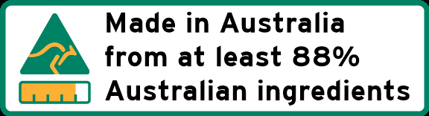

FREE FROM ARTIFICIAL COLOURS, FLAVOURS & PRESERVATIVES

DAIRY & NUT FREE
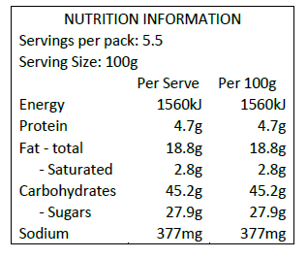

Frozen life up to 12 months
Shelf Life 28 days ambient
Simply thaw and create
Thaw time 180 min
Dairy & Nut Free

Product Code CHR053-4
Size 5 round
Unit weight 550g
Servings 10
Box Content 4cakes/carton
Palletising 16 cartons per layer |11 layers

Product Code CHR063-4
Size 6 round
UNite weight 850g
Servings 14
Box Content 4cakes/carton
Palletising 9 cartons per layer |11 layers

Product Code CHR073-4
Size 7 round
Unit weight 1100g
Servings 19
Box Content 4 cakes/carton
Palletising 9 cartons per layer |11 layers

Product Code CHR-083-4
Size 8 Round
Unit weight 1400g
Servings 25
Box Content 4 cakes/carton
Palletising 4 per layer |11 layers

Product Code CHR093-4
Size 9 round
Unit Weight 2000g
Servings 31
Box Content 4 cakes/carton
Palletising 4 per layer |11 layers

Product Code CHR103-2
Size 10 round
Unit Weight 2400g
Servings 39
Box Content 2 cakes/carton
Palletising 8 per layer |11 layers

Product Code CHR113-2
Size 11 round
Unit Weight 2900g
Servings 47
Box Content 2 cakes/carton
Palletising 8 per layer |11 layers

Round White Mud

Decadent & super moist vanilla flavour

Ingredients: Sugar, Wheat Flour [Contains Vitamins (Thiamin, Folic Acid)], Egg, Canola Oil, Water, Maltodextrin, Thickener (1422) (from corn), Natural Flavour, Humectant (420), Emulsifiers (471, 475, 481), Raising Agents (450, 500), Iodised Salt, Preservative (202).

Contains Gluten, Wheat, Egg

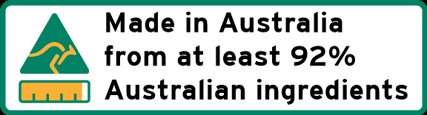

FREE FROM ARTIFICIAL COLOURS, FLAVOURS & PRESERVATIVES

DAIRY & NUT FREE

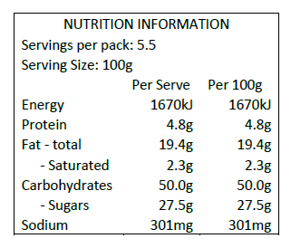

Frozen life up to 12 months
Shelf Life 28 days ambient
Simply thaw and create
Thaw time 180 min
Dairy & Nut Free

Product Code WMR053-4
Size 5 round
Unit weight 550g
Servings 10
Box Content 4cakes/carton
Palletising 16 cartons per layer |11 layers

Product Code WMR063-4
Size 6 round
UNite weight 750g
Servings 14
Box Content 4cakes/carton
Palletising 9 cartons per layer |11 layers

Product Code WMR073-4
Size 7 round
Unit weight 1000g
Servings 19
Box Content 4 cakes/carton
Palletising 9 cartons per layer |11 layers

Product Code WMR-083-4
Size 8 Round
Unit weight 1400g
Servings 25
Box Content 4 cakes/carton
Palletising 4 per layer |11 layers

Product Code WMR093-4
Size 9 round
Unit Weight 1800g
Servings 31
Box Content 4 cakes/carton
Palletising 4 per layer |11 layers

Product Code WMR103-2
Size 10 round
Unit Weight 2000g
Servings 39
Box Content 2 cakes/carton
Palletising 8 per layer |11 layers

Product Code WMR113-2
Size 11 round
Unit Weight 2700g
Servings 47
Box Content 2 cakes/carton
Palletising 8 per layer |11 layers

Round Caramel Mud

Decadent & super moist caramel flavour

Ingredients: Sugar, Wheat Flour [Contains Vitamins (Thiamin, Folic Acid)], Canola Oil, Egg, Water, Thickener (1422) (from corn), Maltodextrin, Flavours, Colour (150c), Stabilisers (413, 415), Humectant (420), Emulsifiers (471, 475, 481), Raising Agents (450, 500), Iodised Salt, Preservative (202).

Contains Gluten, Wheat, Egg

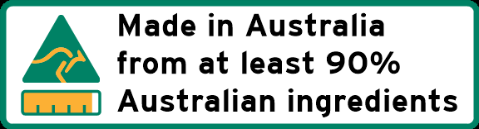

FREE FROM ARTIFICIAL COLOURS & PRESERVATIVES

DAIRY & NUT FREE

Frozen life up to 12 months
Shelf Life 28 days ambient
Simply thaw and create
Thaw time 180 min
Dairy & Nut Free

Product Code WMR053-4
Size 5 round
Unit weight 550g
Servings 10
Box Content 4cakes/carton
Palletising 16 cartons per layer |11 layers

Product Code CAR063-4
Size 6 round
UNite weight 800g
Servings 14
Box Content 4cakes/carton
Palletising 9 cartons per layer |11 layers

Product Code CAR073-4
Size 7 round
Unit weight 1000g
Servings 19
Box Content 4 cakes/carton
Palletising 9 cartons per layer |11 layers

Product Code CAR-083-4
Size 8 Round
Unit weight 1400g
Servings 25
Box Content 4 cakes/carton
Palletising 4 per layer |11 layers

Product Code CAR093-4
Size 9 round
Unit Weight 2000g
Servings 31
Box Content 4 cakes/carton
Palletising 4 per layer |11 layers

Product Code CAR103-2
Size 10 round
Unit Weight 2300g
Servings 39
Box Content 2 cakes/carton
Palletising 8 per layer |11 layers

Product Code CAR113-2
Size 11 round
Unit Weight 2500g
Servings 47
Box Content 2 cakes/carton
Palletising 8 per layer |11 layers

Slab Cakes

Introducing Bake Me Up Slab Cakes – the ultimate crowd-pleaser for professional chefs, restaurateurs, and café owners!
Unlock convenience and efficiency with our versatile range of slab cakes, perfect for big functions, corporate events, festivals, and any occasion that demands delicious cake in abundance, and fast. With Bake Me Up Slabs, you can serve up to 100 generous, mouthwatering slices from just one slab, saving you valuable time and effort in preparation.
Our slab cakes are crafted for guaranteed quality in every mouthful, ensuring that each slice is the perfect indulgence for your customers. Simply ice and slice for the perfect serving every time.
Elevate your offerings and delight your customers with Bake Me Up Slab Cakes – where convenience meets quality, and every slice is a celebration

Frozen life up to 12 months
Shelf Life 28 days ambient 22 degrees
Simply thaw and create
Thaw time 180 min
Dairy & Nut Free

Information on Gluten Free options on p #

Chocolate Mud Slab

The classic, moist & chocolatey gourmet mud cake

Ingredients: Sugar, Water, Wheat Flour [Contains Vitamins (Thiamin, Folic Acid)], Canola Oil, Egg, Dark Cocoa Powder (5%), Thickener (1422) (from corn), Maltodextrin, Colour (150c), Iodised Salt, Raising Agents (450, 500), Emulsifiers (471, 475, 481), Humectant (420), Natural Flavour, Preservative (202).

Contains Gluten, Wheat, Egg

FREE FROM ARTIFICIAL COLOURS, FLAVOURS & PRESERVATIVES

DAIRY & NUT FREE
Product Code CHSL400-2
Size 400mm x 300mm x 50mm
Unit weight 3.5kg
Servings 96
Box Content 2 slabs/carton
Palletising 9 cartons per layer |5 layers

White Mud Slab

Delicious moist white mud cake refined with the finest vanilla flavour

Ingredients: Sugar, Wheat Flour [Contains Vitamins (Thiamin, Folic Acid)], Egg, Canola Oil, Water, Maltodextrin, Thickener (1422) (from corn), Natural Flavour, Humectant (420), Emulsifiers (471, 475, 481), Raising Agents (450, 500), Iodised Salt, Preservative (202).

Contains Gluten, Wheat, Egg

FREE FROM ARTIFICIAL COLOURS, FLAVOURS & PRESERVATIVES

DAIRY & NUT FREE

Product Code WMSL400-2
Size 400mm x 300mm x 50mm
Unit weight 3.5kg
Servings 96
Box Content 2 slabs/carton
Palletising 9 cartons per layer |5 layers

Cupcakes
Introducing our perfect solution for quick and easy prep: our cupcakes!
Crafted to perfection and conveniently frozen, they thaw in a jiffy, awaiting your creative touch. With our products, you can add your culinary flair without the hassle of taking up precious oven time.
Simple. Easy. Ready whenever you need it.
Available in three delicious flavours and also offered in gluten-free, our products are designed to streamline your kitchen operations while ensuring delightful dining experiences for your patrons.

Frozen life up to 6 months
Shelf Life 14 days ambient 22 degrees
Simply thaw and create
Thaw time 90 min

All cupcakes come in a handy 12 unit tray.

Chocolate Mud
Product Code CCC12-6
Unit Weight 40g
Box Content 72pcs /6 trays with 12 pcs
Palletising 16 per layer |4 layers

White Mud
Product Code WCC12-6
Unit Weight 40g
Box Content 72pcs /6 trays with 12 pcs
Palletising 16 per layer |4 layers

Caramel Mud
Product Code CAC12-6
Unit Weight 40g
Box Content 72pcs /6 trays with 12 pcs
Palletising 16 per layer |4 layers

Gluten Free Range

So Good, you won’t believe it’s Gluten Free

Certified, Lab Tested Gluten Free Range

Endorsed by Coeliac Australia

At Bake Me Up, we firmly believe that gluten-free should never mean sacrificing taste. We're dedicated to perfecting our recipes to ensure that every bite is a culinary masterpiece. Our philosophy revolves around creating flavors so irresistibly delicious, they'll keep you coming back for more.

While our Gluten-Free Range is designed to cater to coeliacs and gluten-sensitive individuals, it's crafted for everyone to enjoy. We believe that exceptional taste knows no bounds, and our gluten-free offerings reflect that belief. Whether you have dietary restrictions or simply appreciate exquisite flavor, our Gluten-Free Cakes are sure to satisfy your cravings and leave you wanting more.

Indulge in our exceptional selection of gluten-free delights, meticulously crafted to exceed expectations. Each bite promises an explosion of flavor and texture, setting a new standard for gluten-free indulgence.

At our bakery, we're committed to providing the highest quality gluten-free options. We take pride in using only the finest gluten-free flours in a meticulously maintained nut and dairy-free environment. This dedication allows us to create a stunning array of delicate and delicious baked cakes that cater to every palate.

Whether you're gluten intolerant or seeking a healthier alternative, our gluten-free cakes guarantee satisfaction for even the most discerning of tastes. Experience the difference with our premium gluten-free offerings, crafted with care and baked with love.

Gluten Free Chocolate
Ingredients: Sugar, Egg, Oil Canola, Water, Alkalised Cocoa Powder, Tapioca Starch, Rice Flour, Potato Starch, Modified Starch(1422), Raising Agents (450,500), Emulsifier (471), Iodised Salt, Natural Chocolate Flavour, Humectant (422), Thickener (415), Preservative (202).
Gluten, Dairy & Nut Free
Round Gluten Free Mud Round
Chocolate
Product Code GFC063-4
Size 6 round
Unit weight 800g
Servings 14
Box Content 4cakes/carton
Palletising 9 cartons per layer |11 layers

Product Code GFC073-4
Size 7 round
Unit weight 1300g
Servings 19
Box Content 4 cakes/carton
Palletising 9 cartons per layer |11 layers

Product Code GFC-083-4
Size 8 Round
Unit weight 1600g
Servings 25
Box Content 4 cakes/carton
Palletising 4 per layer |11 layers

Product Code GFC093-4
Size 9 round
Unit Weight 2000g
Servings 31
Box Content 4 cakes/carton
Palletising 4 per layer |11 layers

Gluten Free Mud Slab

Chocolate

Product Code GFCSL400-2
Size 400mm x 300mm x 50mm
Unit weight 3.5kg
Servings 96
Box Content 2 slabs/carton
Palletising 9 cartons per layer |5 layers

Gluten Free Cupcakes
Chocolate
Gluten Free Chocolate Mud
Product Code GFC12-6
Unit Weight 40g
Box Content 72pcs /6 trays with 12 pcs
Palletising 16 per layer |4 layers

Product overview ( will provide full details asap)

This will be a table of all Sku’s. Including barcodes, box sizes, weights etc.

Eg.

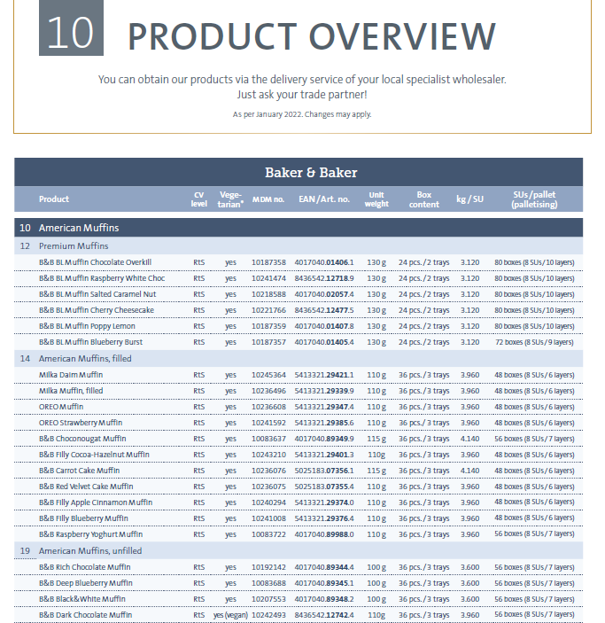
Selling Concepts

Nice to have if I have time to come up with any??
Contact Us

bmuwholesale.com.au

1300 50 30 40

info@bakemeup.com.au

Factory:
3/17-19 Lathams Rd,
Carrum Downs VIC 3201

Find us on linkedin
linkedin.com/company/bakemeupaus

