TiCOAT new rear
Summary: We need a design with less black that is more green. Here is our new cover front page. This contest is for the rear redesign using the same elements. We wish to use the image from our homepage on the spray gun spraying the product vs the image of the product itself.
Current Front design can color pallete.

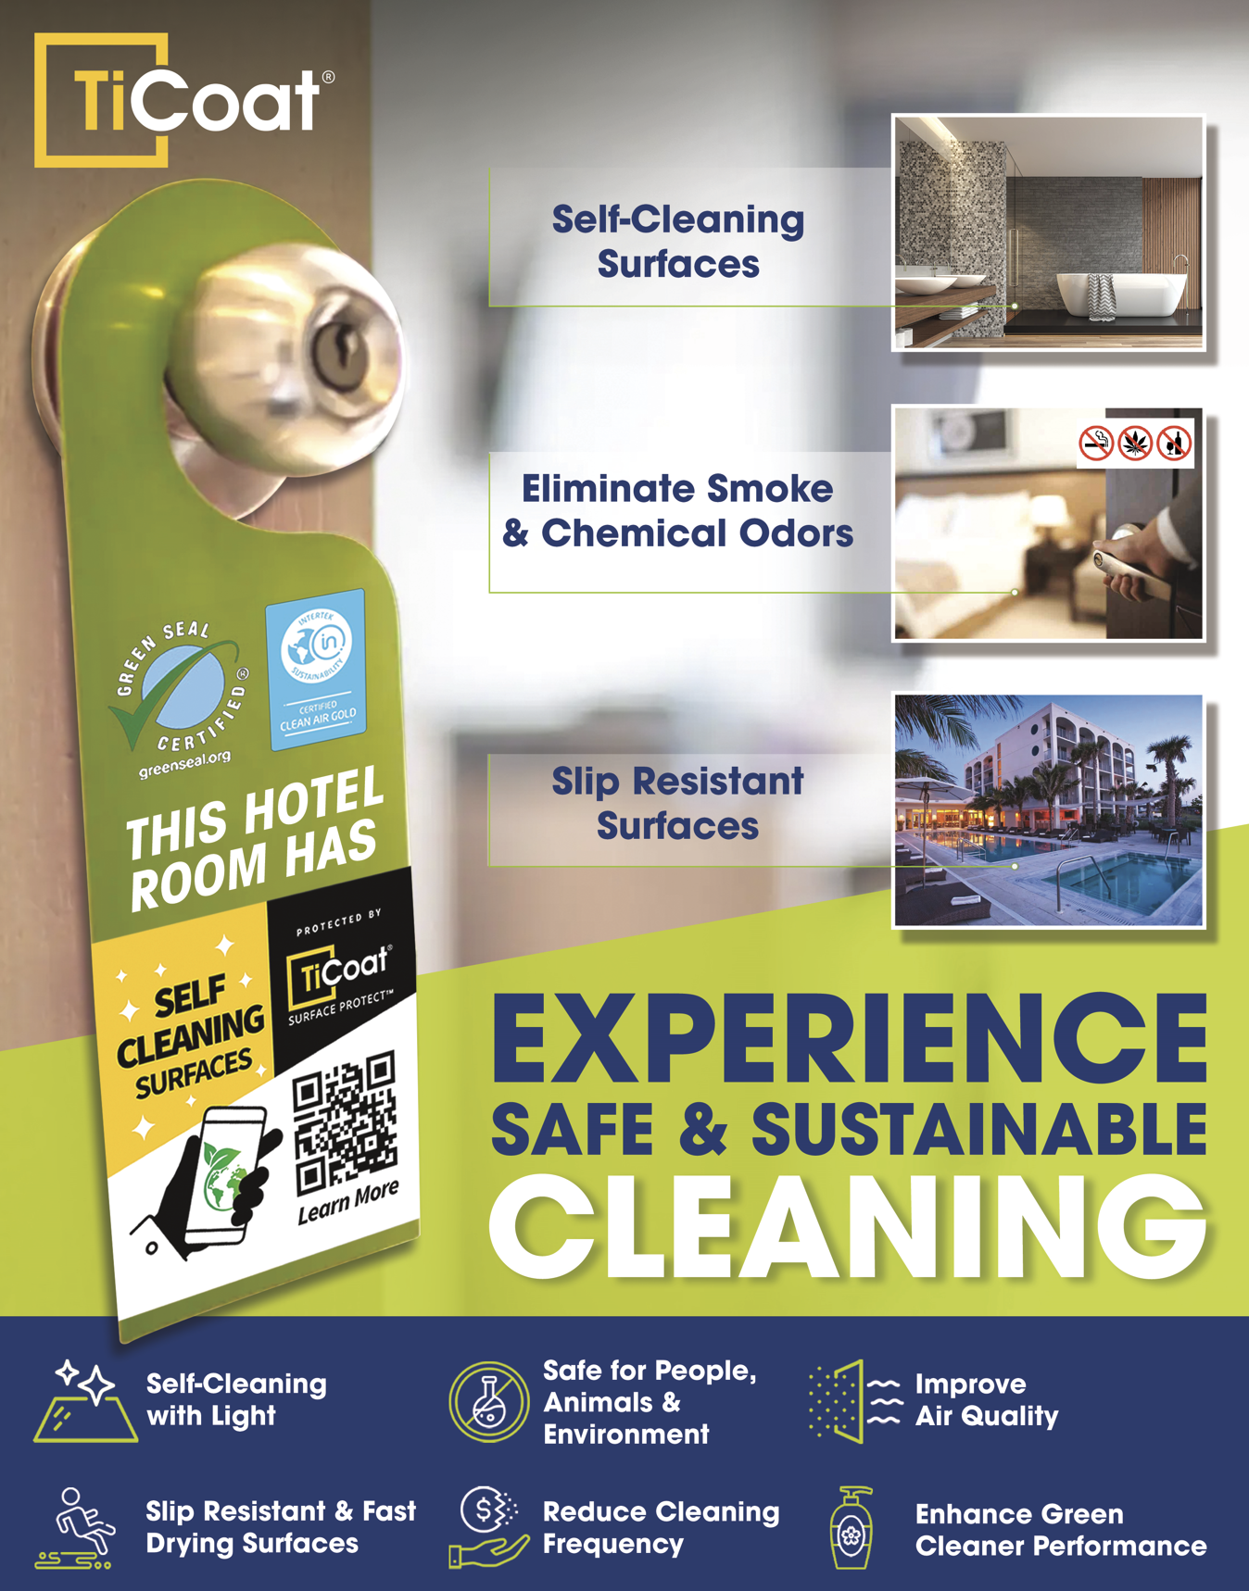

Changes to text and content for OLD Back design
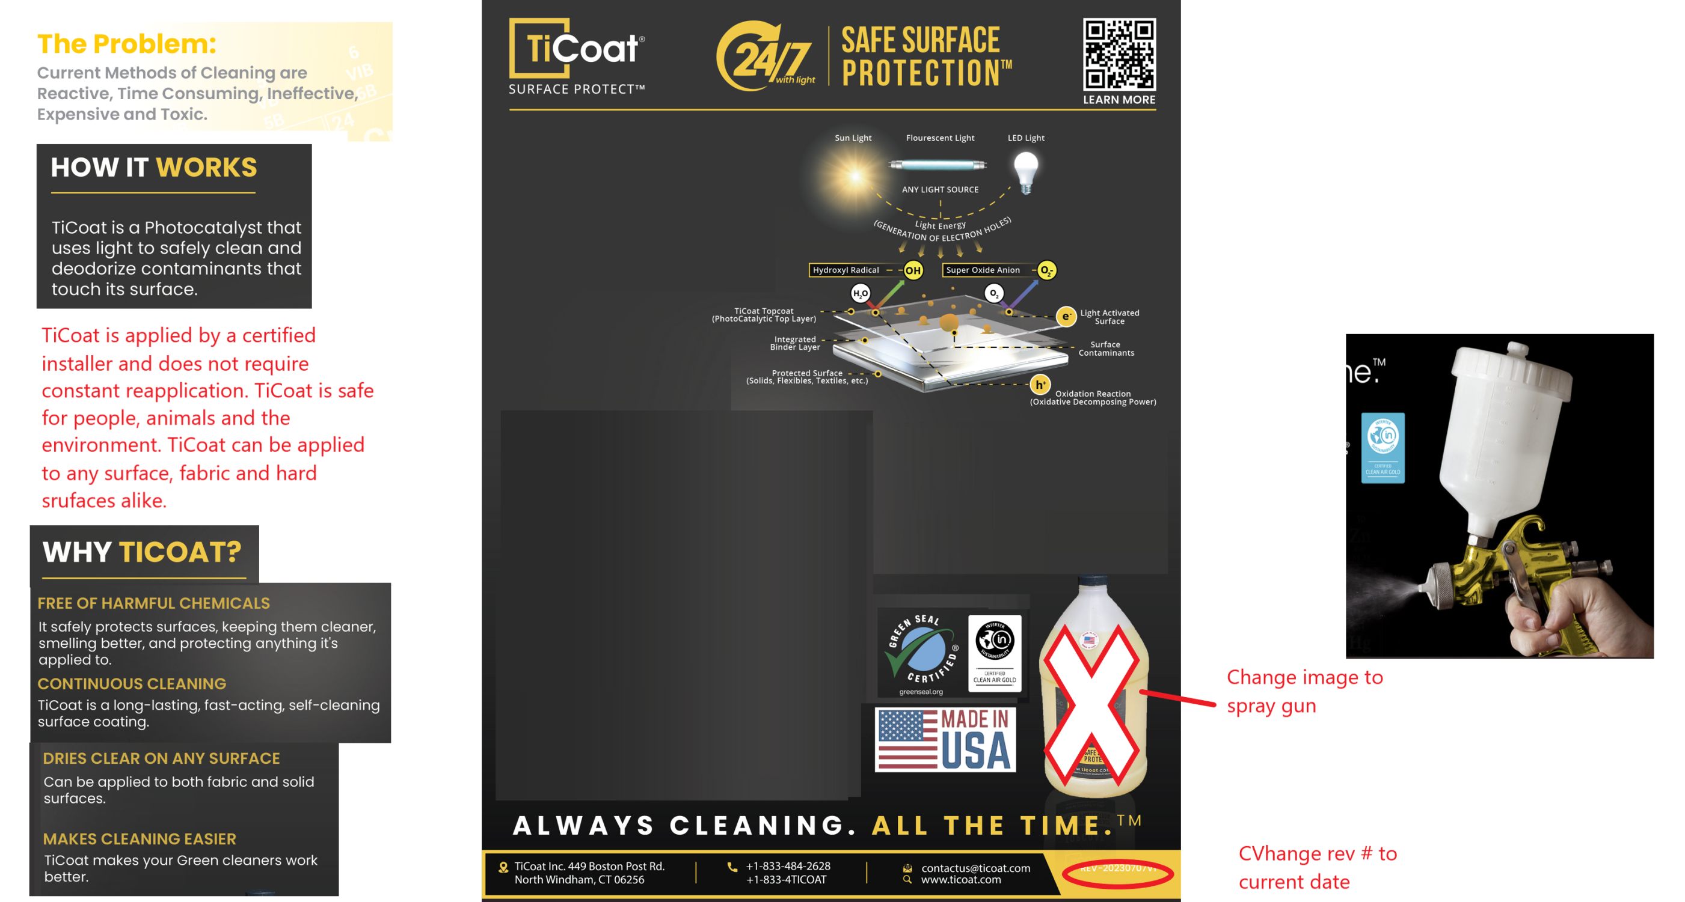
KEY POINTS; WE NEED LESS BLACK> NO YELLOW TEXT ON WHITE backgrounds. Must be easy to read and look clean.

