T Shirt Design Brief (Slogans)

Please find a brief for some help in designing a t-shirt - aimed at gamers. The target market is gamers - but a lot of the people buying will be parents/siblings/relatives of gamers - as well as gamers themselves.

We have the opportunity to sell some t-shirts online from within the online gaming domain. We have access to a few hundred thousand gamers consuming content on websites via desktop and mobile. The main audience is 15-35 year olds (65% Male). It’s mainly around PC and Console gaming - perhaps the thinking should be framed around people who play COD/Minecraft/Fortnight/Roblox/LOL etc

We have created a working title of Slogans & we hope that this becomes the overall Brand name.

We need help designing t-shirts for this venture that are exclusively desirable to gamers & people who would purchase them on behalf of gamers.

The premise is to create T-Shirts that are slogan centric, with the slogan being a generic gaming saying or sound bite. The design needs to be eye-catching and font-based with use of additional imagery being minimal or essential to the design. The idea is to ramp-up the slogan as the main artwork & this can take any form that suits the slogan well. It is a freestyle brief.

For this initial brief, could you please choose any of the ‘slogans’ below and work it up in a freestyle manner whilst following the above ambition?

Initial Slogans:

Gaming Mode ON
5 More Minutes
Only Real Gamers MOD

We are looking for a professional design that sits well alongside large gaming brands - without compromising or emulating their brand. We cannot plagiarise their brand in any way - we do not wish to enter any legal territory here!

Hitting the brief

- The main part of the design is centred around the text - as there are lots of slogans - which can be used.
- Most slogans are 2/7 words - max.
- We would ideally like the brand ‘Slogan’ - to appear - this could be on the sleeve, the back, front etc. We do not have a logo design as yet so you can use a space saver or a mocked up logo for now.
- Considered speech marks only if needed
- Also consider fonts and whether, as we wish to build a recognisable brand, continuity is required?
- Perhaps this continuity would come in the form of consistent graphic styles?
- The T Shirt are being sold online - via ads like this, so an image of the t-shirt, needs to look good & stand out in this environment to attract people to click through & buy

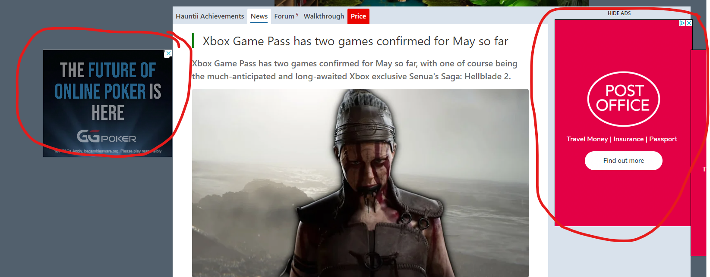

Things to consider

- Ideally it’s one side printed - but we will consider Front, Back, Arms
- Drop Ship Printing is often limited to the front ‘square’ so probably need to accommodate this (unless we change this model)
- Will the design increase and decrease in size from XS - XXXL?
- Will the design allow for different colour base t-shirts to be used?

Assumptions

- Research suggests simplistic design is attractive - but we will be governed by your experience
- Ideally we’d like the brand to be recognised - so even if the slogan is about COD - and one about Roblox - we can recognise they are the same brand. But this can not come before sales.
- It may well be - this is about choosing the right font and using the right punctuation.
- It may be the logo is what pulls this together

