444450_Pre-note
- The art is supplied as CMYK. It appears there are 3 distinct colors in the primary art; Black, Red spot color, and a Dark Gray spot color. And then the ‘Vanilla’ emblem which looks to be Magenta, Yellow, plus a Spot Brown.
- The Dark Gray is very close to being black but there is a noticeable difference between the two colors. For example, the below snapshot shows a Black shadow on the Dark Gray background.
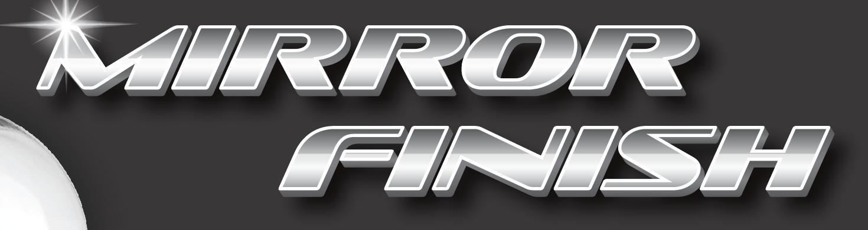
- To simplify the design and reduce inks, the solid Dark Gray areas could be converted to solid Black. All Black on Gray drop shadows would be eliminated in this scenario.
- If the Dark Gray is required, the white outline around ‘Mirror Finish’ will present a registration challenge. Also, the white outline around this text located on the red background areas will be problematic. White outlines will have to be thickened up considerably or else eliminated.
- The images of the polish bottle and the wipes contain very small Red elements which presents a printability challenge. First, minimum trap amounts will not be attainable in these areas. Second, an exact color match may not be achievable based on how the spot red will look tinted down. And finally, the Red separation has large solid areas (screens and solids on the same plate could be problematic). We could convert them to 1-color Black (grayscale) to avoid all these issues, if that’s acceptable.
- For the ‘Vanilla’ emblem, concessions will have to be made for printability; however registration will still be a challenge. The yellow areas could be made with a combination of yellow and red, and the brown areas could be converted to black. For the yellow we could use a Pantone yellow or process yellow. The brown letters and the vanilla beans will be problematic since making them black might not be an acceptable option, but making them a 3-color build to achieve brown will be a challenge as well due to how small the emblem is (it’s 13/16” in diameter). The below snapshot on the left is the original emblem. The snapshot on the right is representation of what it would look like as Red, Yellow, & Black.
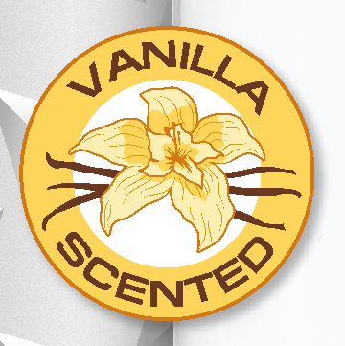 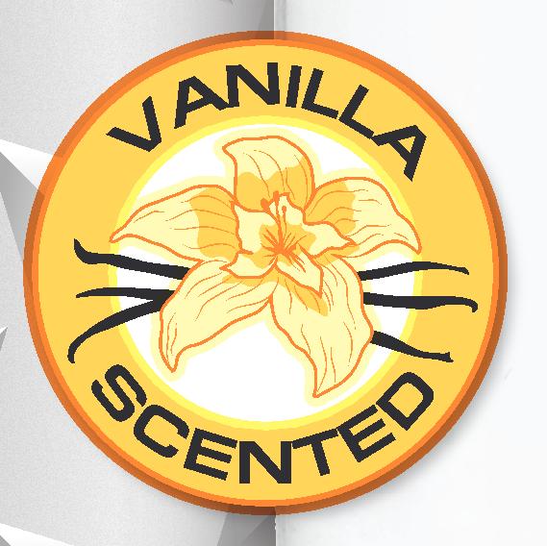
Another option would be to add a spot brown, however that would only be possible if the Spot Gray was eliminated.
- Modifications will have to be made to achieve trap and adequate white space. In many areas, only the minimum trap amount (1/64”) will be achievable.
- Due to the liner being Mottled White, 102 LPI is not advisable.
- Color options:
  - Option #1 – 4 color
Black, Spot Red, Spot Dark Gray, and Spot yellow (or process).
The ‘vanilla’ emblem and the images will be color managed to get the closest match to the target using the available colors.
  - Option #2 – 3 color
Black, Spot Red, and Spot yellow (or process).
If the customer is okay with converting the Dark Gray areas to Black and eliminating drop shadows. Again, the ‘vanilla’ emblem and the images will be color managed to get the closest match to the target using the available colors.
  - Option #3 – 4 color
Black, Spot Red, Spot yellow (or process), and Spot Brown.
If the customer is okay with converting the Dark Gray areas to Black and eliminating drop shadows. Again, the ‘vanilla’ emblem and the images will be color managed to get the closest match to the target using the available colors. Spot brown would be used for the ‘Vanilla scented’ text and vanilla beans.

