Archatrak ‘Incendio’ Pedestal
Adjustable height, all steel, corrosion resistant and non-combustible pedestal with fire resistant polypropylene head cap fitted with spacer tabs. Seven pedestal models cover the height range from 1” to 19 1/4″. Incendio pedestals are supplied as fully assembled units with base and screwed columns. The plastic head cap is simply snapped onto the head of the pedestal.
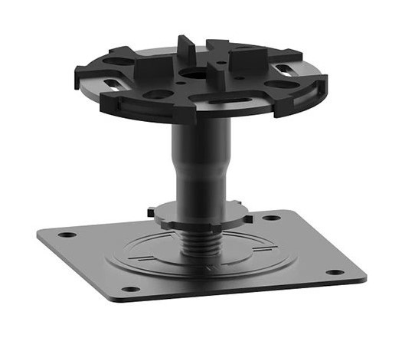
- Totally non-combustible – will not catch fire, create smoke, or spread flames,
Mild steel construction passes ASTM E 136 ‘Combustibility at 750°C’ and NFPA 220 criteria.
- Seven pedestals span the range 1" to 19 ¼”.
- Electrophoretic coating provides excellent corrosion resistance.
- Snap on polypropylene head cap with inbuilt spacer tabs.
- Locking ring ensures pedestals are secured at desired height.
- Screwed columns provide continuous incremental height adjustment.
- High load bearing - over 21,000 lb.
Specifications & Testing
Property | Description | Specification
Materials | Base & screwed columns | Mild steel
 | Head | Fire resistant polypropylene
 | Spacer tabs (inbuilt) | ½” high x 3/16” thick (std.)
Base | Square with rounded corners | 4” x 4”
Central column | Screwed with locking ring | 2 mm thick steel
Head |  | 3 ½” dia.
Height range | Continuous incremental adjustment | 1” - 19 ¼”
Max. compressive load |  | Over 21,000lb.
ASTM E136 | Combustibility at 750°C | Pass – Mild Steel
Warranty |  | 3 years

Height Progression

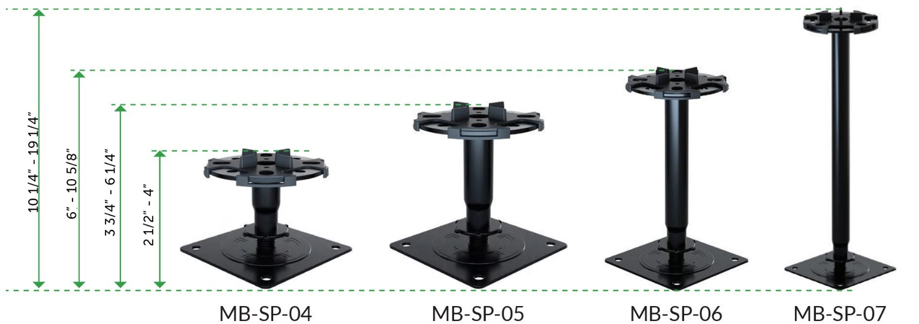

Installation Guide
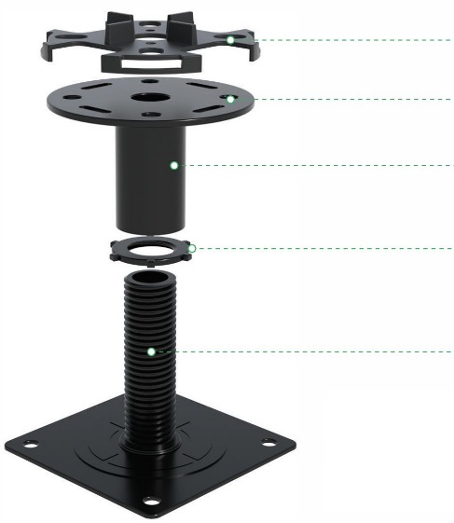
- Snap on polypropylene head cap. Cut off excess spacer tabs as needed.

- Head fitted with tapped hole for Archatrak wind uplift mitigation system.

- Rotate column to adjust height. DO NOT overextend.

- Tighten locking ring when desired height has been set.

- Install buffer pads under base of pedestal if needed or specified.

Wind Uplift Mitigation System for Porcelain Pavers
The Archatrak wind uplift mitigation system utilzes Incendio pedestals with a tapped head to securely hold down both 2cm and 3cm thick porcelain pavers onto the pedestal supports. Incendio tapped head steel pedestal provide much superior hold down capability compared with plastic pedestals with similar screw and washer assemblies as the screw is tightly secured into the threaded metal head. The hold down system is slightly different for 3cm paver c.f. 2cm pavers.
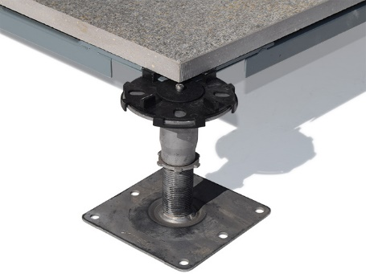
T20 (2cm thick) porcelain pavers
Pavers are bonded to Archatrak ‘SpanSafe’ galvanized, powder coated trays with beads of Chemlink M1 or 3M 550 adhesive applied at each of the four corners.
A custom-made stainless steel hold-down washer is slotted into the space between the metal tray and the paver and screwed down tightly into to the tapped head of the Incendio pedestal with a stainless-steel screw.

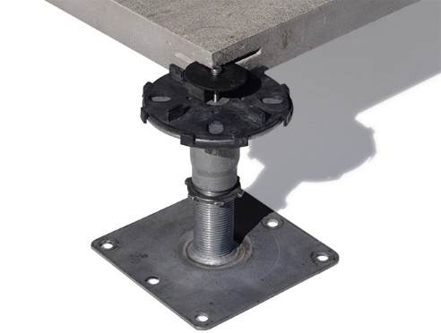
T30 (3cm thick) porcelain pavers,
A small semi-circular kerf is cut in each corner of the paver to accept a custom-made stainless steel hold-down washer.
The pavers are then securely fixed to the pedestal head with a stainless-steel screw inserted through the center of the washer which in turn screws into the tapped head of the Incendio pedestal.

Special Note with Porcelain Paver Installations
All pavers must be butted as tightly as possible against tabs on the pedestal heads.
A solid edge restraint is required around all sides of the deck. Ensure there is no space exceeding 3/16” between the edge of the pavers and the restraining walls on all sides of the deck.
When laying 2cm porcelain pavers where deck heights exceed 4”, appropriate reinforcement mesh, self-adhesive sheets or protection plates should be installed on the underside of the pavers in case of damage due to careless use or accidental impact with heavy tools, heavy or other hard objects. Archatrak Spansafe metal plates and Shock Control 2.0 self-adhesive sheets are available for this purpose.

