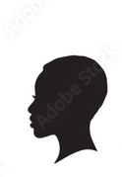+ 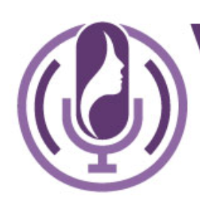=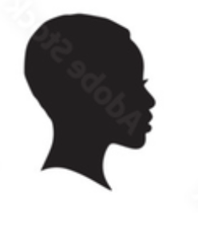

Hi,

Thank you for all your efforts thus far. We feel we're very close to finalizing the design, and you are our favourite so far!

We are particularly fond of the version featuring the logo on the left with the letters styled in uppercase as "NOVAH." Please maintain this element in the design.

Additionally, we appreciated the original design's use of flowing, rounded shapes. We would like to see these elements incorporated into the depiction of a woman who resembles someone from Africa. While we've attempted to illustrate our vision with the attached images, we recognize that our graphic design skills don't match yours. To be clear: we still like the woman to be inside the mic in a white colour!

Could you please adjust the design accordingly? If you need further clarification on our request, do not hesitate to reach out.

Best regards,

