Organisational name: Novah

Tagline: No violence at home

Mission: We aim to prevent domestic violence (intimate partner violence) with edutainment radio shows that change societal norms, to change behaviours.

Organisation’s activities:
- We are a new, small NGO (a charity)
- We research the local drivers for domestic violence in Eastern Africa.
- Together with local scriptwriters and producers, we write, produce and air radio shows that aim to change social norms around violence against women (e.g. radio dramas, talk shows, etc.).

Ask:
- Logos with the text Novah
  - A logo that uses our tagline (to be used at conference etc )
  - The same logo without the tagline (to be used locally and which can easily be printed at materials etc)
  - 2 versions: horizontal + vertical (square for social media)

Style preferences:
Simple, minimalist, clean, rather abstract than literal. Simple colour palette, eg. 1-3 colours. Should work on white and dark backgrounds.

- Elegant to bold: 50%
- 0= Playful to 100% serious: 70%
- Traditional to modern: 70%
- Personable to pro: 40%
- Feminine to masculine: 40%
- Colorful to conservative: 60%
- Economical to upmarket: 40%

- Pictorial/combination logo
- Wordmark
- Abstract

Keywords:
- Intergenerational cycle of violence
- Safe homes
- Radio
- Radio waves
- Transmitter
- Stop
- Prevent

Guidelines:
- Novah is NOT in full upper letters
- Our website font will be Lato - the logo font can be different but should match it
- Purple is usually recognised as the colour of the fight against gender based violence
- We will work with radio, so anything that suggests a media or a radio transmitter or radio wave could probably be interesting (but should not be to literal e.g. radio + text)
- No direct reference to women or to violence in the logo (we don’t want to be so literal)

Geographic focus: we will focus our work in Eastern Africa, but remain a global organisation

Language: Viewers of the logo may not be English speakers.

Objective: Design a logo to appear on our website, fundraising/marketing materials, and in our communications. We will communicate with
- Funders such as government agencies or philanthropic organisations
- Local radio stations
- Local freelancers
- Local public officials
- Gender equality organisations (local and international)
- Academic researchers

Preferred format: Please include editable formats e.g. .ai, SVG, and then high-resolution PNG (>2000px in each dimension).

Inspiration:

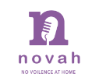
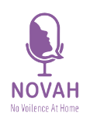
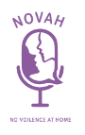
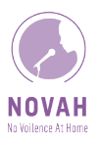

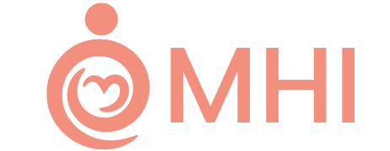
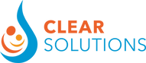

What we like:
- The combination of the name with a vague visual representation of what the organisation does.

Logo can NOT look too much like this:
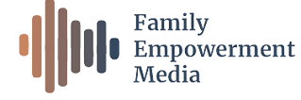

Colour inspiration:
- We like the first purple, and we have used once this color palette in a document
- If you feel other variants of purple/other colours are more beautiful, feel free to use them
