Image examples
https://www.istockphoto.com/en/photo/sign-on-a-door-handle-cruisin-gm682753496-127372919 Hotel room image
https://www.istockphoto.com/photo/entering-the-room-gm512883946-87352415?searchscope=image%2Cfilm
https://www.istockphoto.com/photo/modern-contemporary-bathroom-with-nature-view-3d-render-gm1063241040-284251209?searchscope=image%2Cfilm
https://www.istockphoto.com/vector/prohibited-signs-2-gm1069488634-286087413?searchscope=image%2Cfilm

Adjust Main Image of this flyer and incorporate hospitality story.
Key points:
Promote Self-Cleaning Surfaces in Hotel Rooms
Odor Free Spaces – Eliminate Smoke and Chemical Smells
VOC and SVOC free Spaces
Slip Resistant Surfaces
Reduce Cleaning Expenses
Green Cleaners Work Better

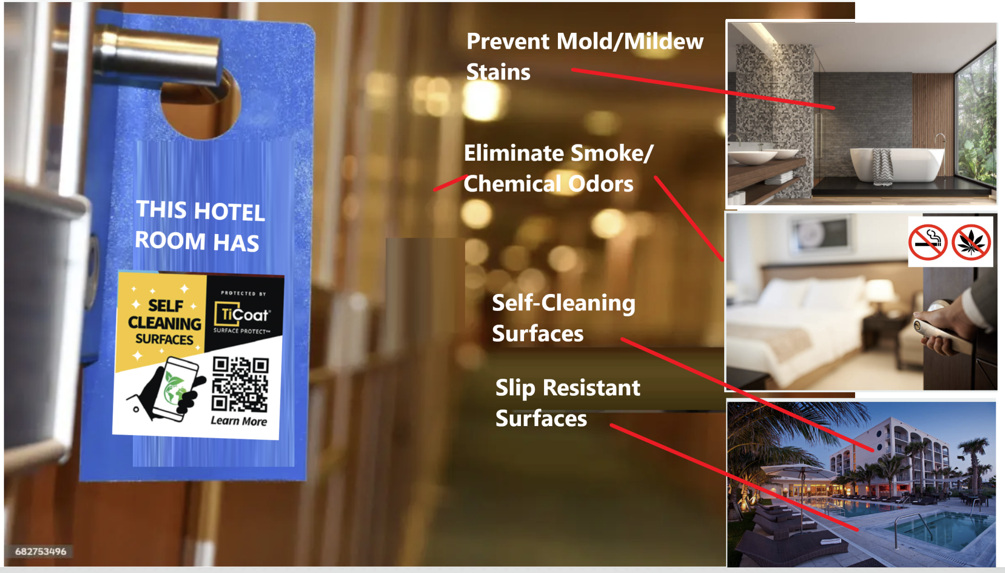
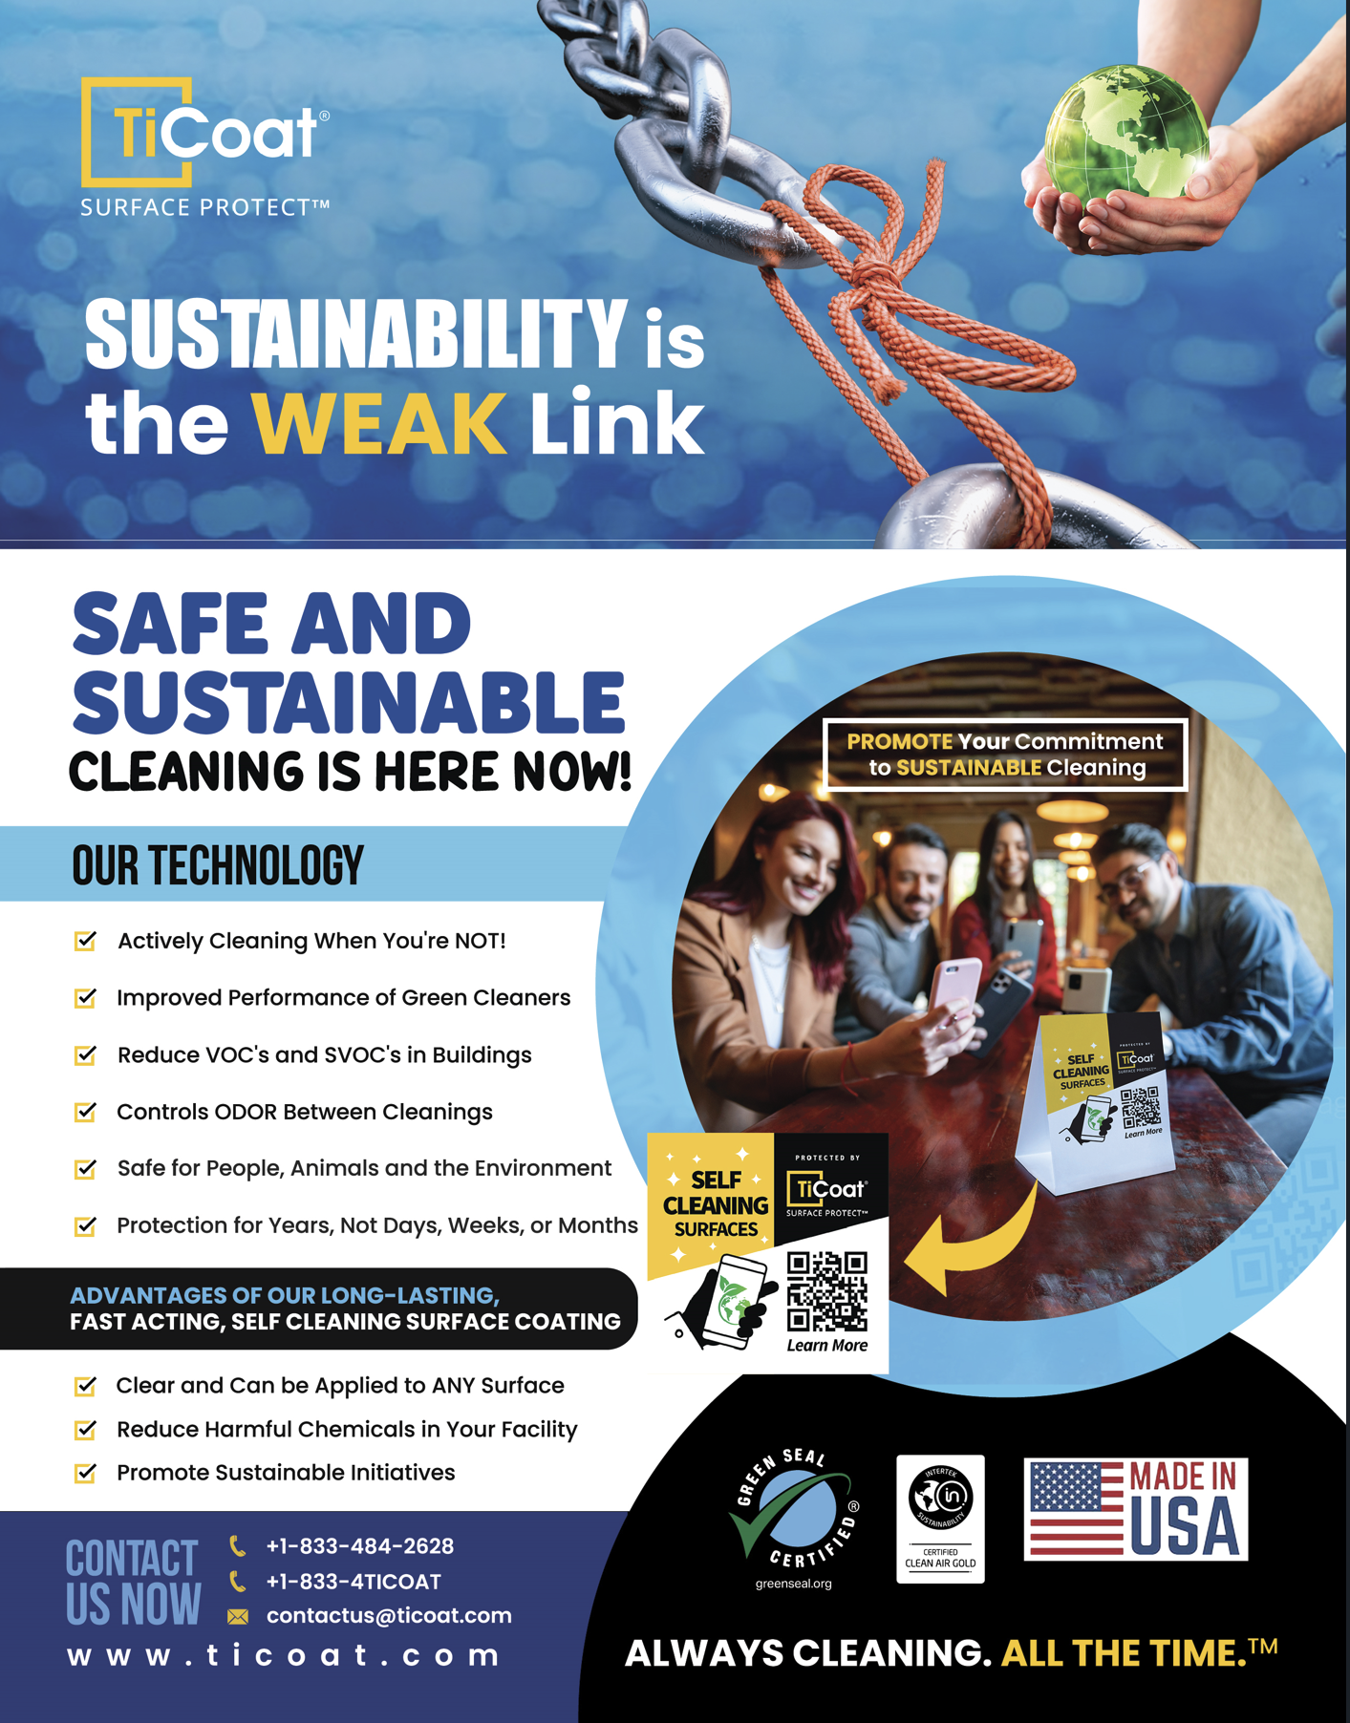CURRENT CORPORATE OVERVIEW FLYER

