NEW UPDATES FOR BUS WRAP

Drivers Side (Focus on Anglers Academy):
Images to include:
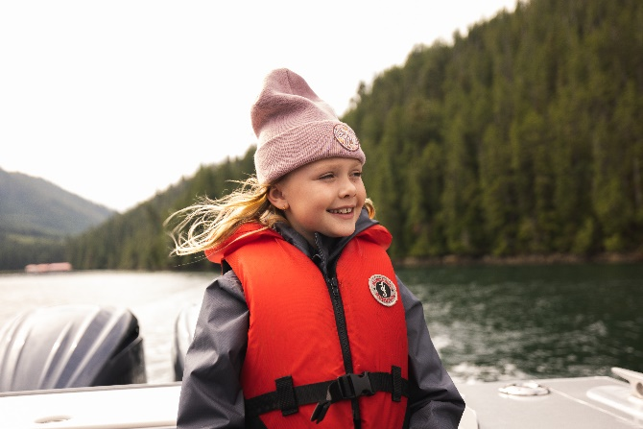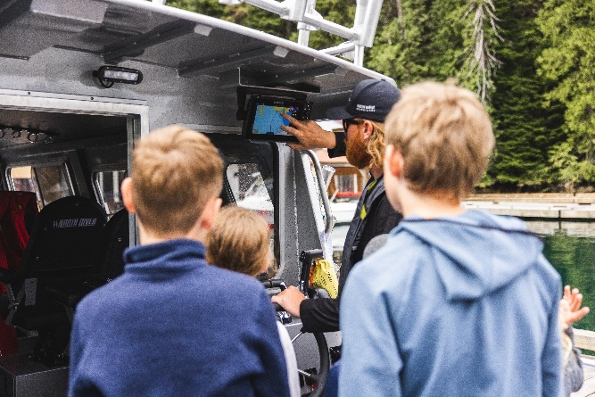
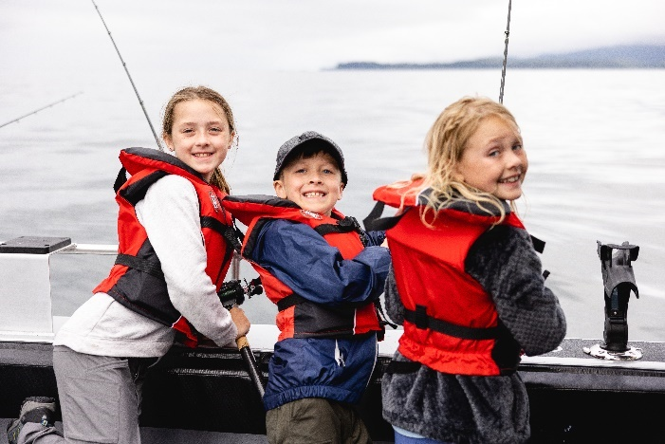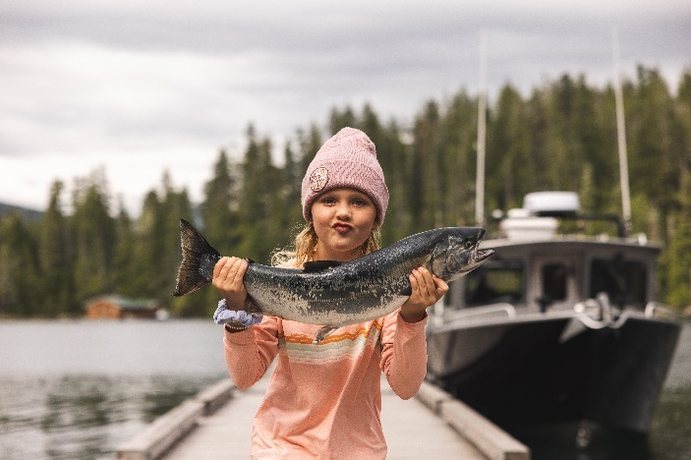
** Need to show the journey with these images. The first image is to indicate before partaking in Anglers Academy, Second they are learning, third the are applying the application and fourth is the success of the academy. These words do not need to be indicated, but we need to show some kind of route or journey.
Maybe some dashed lines between the images to show there is a journey?

Text To Include:
Anglers Academy (We need to create Logo – use NMA Logo for now)
An immersive learning experience
On board the classroom you’ll learn:
- Boat Safety
- Understanding Salt-water Tides
- Where to Fish
- Fishing Basics & Gear
- Understanding Fish Finders
- Fish Species and Identification

Include website: nootkamarineadventures.com
Include phone number: 1-877-337-5464
Include email: info@nootkamarineadventures.com
Include Logo:
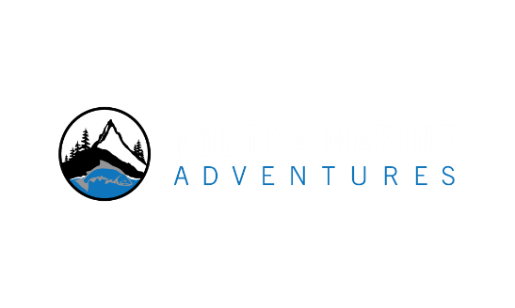

Passenger Side:
Images to include:
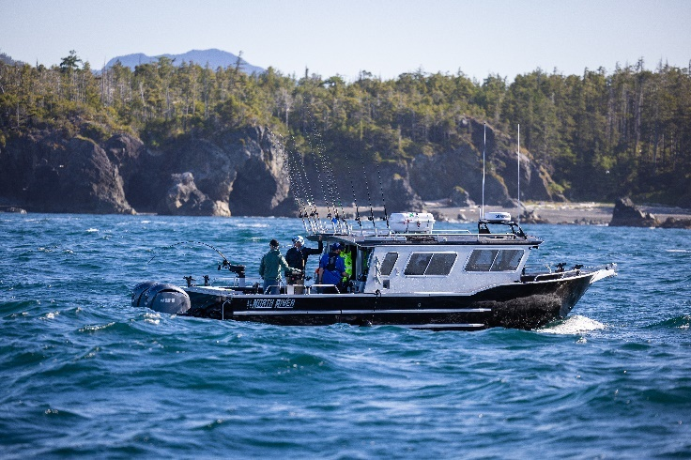 (_ERO8456 – In Action)


**All of our North River Boats (boat pictured above) are fitted with Seakeeper gyroscopic stabilizers and is a major differentiator for us
**Top two images to be placed towards the back of the bus, text to appear near the centre of the bus, lodge image to appear on the other side of the text towards the front.
** There needs to be a good blending and not just flat images pasted onto the bus
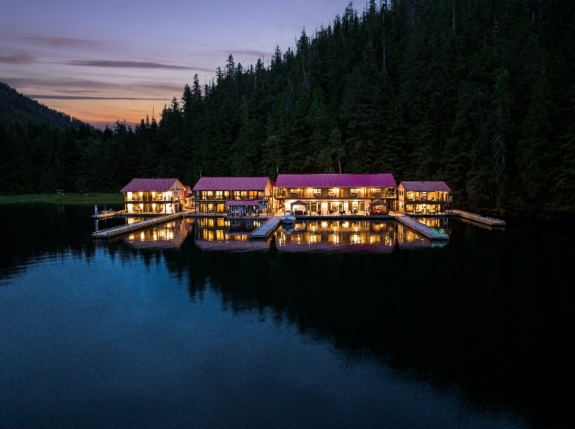

Text to include:
Setting the standard for an unrivaled experience on the water
- 10 32-foot North River Seahawks
- Seakeeper gyroscopic stabilizers. Eliminate up to 95% of boat roll and the seasickness that comes with it.
- Grady White, Trophy, and Bayliner boats
- 22-24 foot ABD Rental Boats
- Bring your own boat
- Transforming your experience on the water. Call today to learn more

Include website: nootkamarineadventures.com
Include phone number: 1-877-337-5464
Include email: info@nootkamarineadventures.com
Include Logo:
BACK OF BUS:
Image to include:

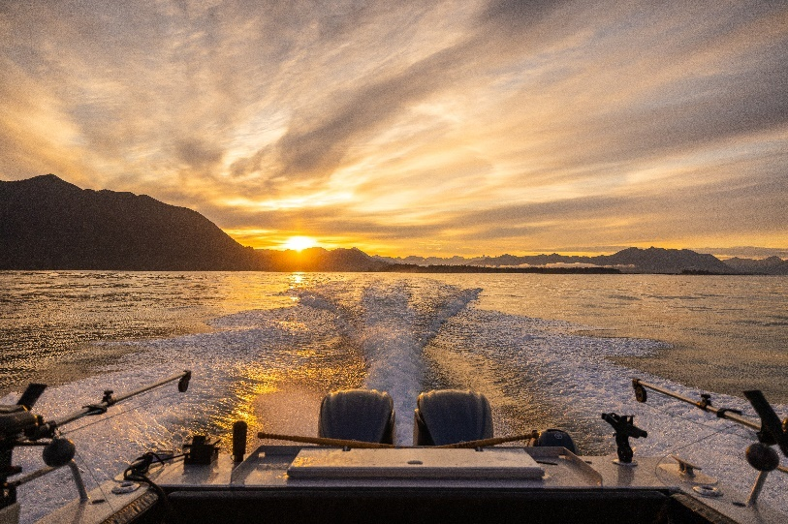 (_ERO7494 – Landscapes)
**Use this image to cover the back of the bus
**Fade the top third of the image to create a better space for text
Text to Include:
Transforming Teams, Empowering Success
Welcome to Boardrooms without Boundaries
Inquire for your Corporate Retreat today!

Include website: nootkamarineadventures.com
Include phone number: 1-877-337-5464
Include email: info@nootkamarineadventures.com
Include Logo:

