Website Home Page Brief:

Home Page – section 1

Your Automation, IT and Data Centre Solutions Provider
A Rockwell Automation Distributor Specialising in Life Sciences and Data Centres.
Contact Us

Moving imagery – Life Science Automation – Data Centre Project Preparation – Rockwell Authorised Distributor (carousel)

Home Page – section 2

Hanley Automation provides a wide range of automation and IT solutions used in manufacturing operations.
Our solutions span a broad spectrum of technology from physical machines and robots to cloud based management solutions for these systems.
Along with Rockwell Automation, we work closely to keep track of supply trends and invest wisely to prepare for customers' future DC projects.
We have a large team of specialist technical people spanning the breadth of skills to be able to deploy and support these technologies.
Authorised Distributor for Rockwell Automation (Allen Bradley and Guardmaster are Rockwell Automation brands)
EPSON Robotics Solutions' official distributor
Read More

Home Page – section 3
Hanley Technology Partners
4 Partners: 
Maybe make large images with links to the partner websites – scrolling carousel where the partner in the middle frame increases in size:
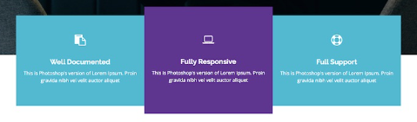

Home Page – section 4
Our customers
A map of all Hanley customers highlighted on the website.
Moving imagery

