About Us
Envision Aid Foundation is dedicated to improving and transforming the lives of people through enhanced vision and hearing health in the developing world. Our mission is to bridge the gap in access to essential eye and hearing care, ensuring that everyone, regardless of their circumstances, has the opportunity to see and hear clearly. With over 70 years of humanitarian aid across our members, we are passionate to provide innovative, sustainable, ethical and professional symbiotic solutions across multiple health programs. This includes:
- Providing eye care and treating preventable blindness
- Preventing and treating curable hearing loss and deafness
- Improving overall health through access to clean water, nutritious food and education
- Increase awareness in communities and education for preventing eye and ear diseases
- Strengthen health systems through clinics & training of local doctors, nurses and other professionals
With a focus on sustainability and empowerment, we collaborate with local partners and healthcare professionals that address the root causes of vision and hearing impairments. By investing in preventative care, we aim to create lasting change and foster healthier, more inclusive societies around the world.
We currently provide eye and ear programs in the following countries:
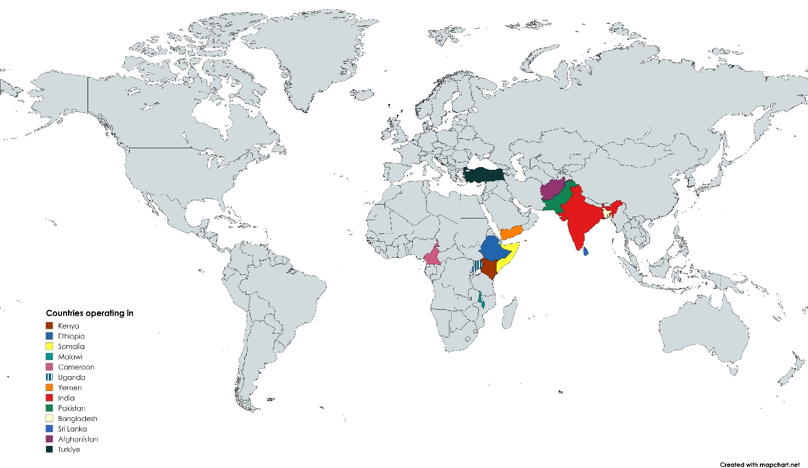
Ethiopia, Kenya, Cameroon, Malawi, Yemen, Turkiye, Pakistan, India, Afghanistan, Bangladesh, Sri Lanka, Kashmir, Somalia, Uganda,
Join us in our mission to bring clarity and connection to those who need it most. Together, we can envision a world where everyone has the opportunity to thrive.
Our team
Sheikh Hassan Elsetohy
Founding member
MBA, M.Eng, ITIL, SNIA CA
Sheikh Hassan is currently one of Envision’s founding members of the organsisation. A local community leader with both domestic and international presence, he has pursued a life of knowledge in many facets of life. With decades of experience and working in multiple roles in charity organistions, he has dedicated his life to helping the less fortunate and wanting to make an everlasting impact in the world. Sh. Hassan has a passionate vision for Envision Aid foundation to become a global leader in eye and ear care and to create sustainable and everlasting programs for the masses.

Shabbir Kharodia
Founding member & Patron
FCPA, FCCA, CTA, JP
Shabbir Kharodia is the founding member and patron of Envision Aid Foundation. Historically serving on various Not-for-profit organisation boards, he has embarked on establishing his legacy with Envision. Shabbir’s major humanitarian works span 4 decades – including emergency relief, community development, construction and income sustainability. The last 15 years he has dedicated to his true passion in health with a focus on eye preventable blindness and hearing restoration. Shabbir’s work has impacted millions of lives around the world with over 250,000 beneficiaries in Envision Aid Foundation. Envision is his dream to create a lasting legacy for future generations to come.

Mesud Sinanovic
Strategic Development Director

Mesud is a founding member and director of Envision Aid. With a track record of success, he has held executive level roles in numerous non-for-profit organisations over the last decade. With a focus on customer excellence, he brings a unique skillset and mindset to Envision Aid’s operations and management. He has a passion to develop strategic and sustainable programs that will endeavour to create positive changes for communities.

Adam Kharodia
Marketing Manager
APIA AFA Bcom Acc JP

Adam is a board member and marketing manager of Envision Aid. He has worked with multiple charity organisations in various roles such as accounting, financial consulting and marketing over the last 5 years. Adam has strived to help people those in less fortunate situations, to uplift their livelihoods and make a lasting difference. He hopes to make a positive impact at Envision by bringing awareness to the importance of eye blindness prevention programs and treatment of curable ear diseases.

Ammarah Ahmed
Volunteer
Dip. ASCA, Dip. Comm. ASCA, Cert. Comm. ASCA
As a committed volunteer, Ammarah is honoured to be part of the Envision Aid team. Drawing from a background deeply influenced by the healthcare sector, her outlook is shaped by familial experiences and a personal drive for social justice. Alongside her experiences working for Amnesty International, she brings insights gleaned from these influences and her ongoing studies in Law and International Relations. Her passion lies in fostering inclusivity and addressing systemic disparities, particularly in healthcare access, as we strive for meaningful and sustainable change. Ammarah is deeply invested in our mission to provide crucial eye and hearing care to marginalised communities.

Why Health?

Charities often focus on the last component of aid, which is at times critically required without focusing on the root cause of poverty. Envision Aid Foundation focuses on the fundamental factors of poverty through providing health programs such as preventable blindness operations and hearing loss restoration.

Our approach is to
- establish mobile eye clinics in needing communities around the world. These communities are pinpointed by our on the ground contacts & medical practitioners
- creation of clean and purifying water systems helps to increase water quality and accessibility and prevent water borne diseases.
- Hearing clinics are also built where required to provide cochlear implantation procedures and auditory support services for those who are unable to afford treatment.

By restoring health and vital senses, it enables adults the ability to work and provide for the households whilst children gain the capacity to go to school and have a more fruitful childhood. In turn this improves the livelihoods of patients and creates a more productive society.

The beloved Prophet Muhammed (Peace Be Upon Him) advised humanity to take care of the sick. “When you visit the sick, give him hope for a long life”. Envision Aid Foundation’s goal is to give hope to those less fortunate and to give anyone in need a new and improved life.

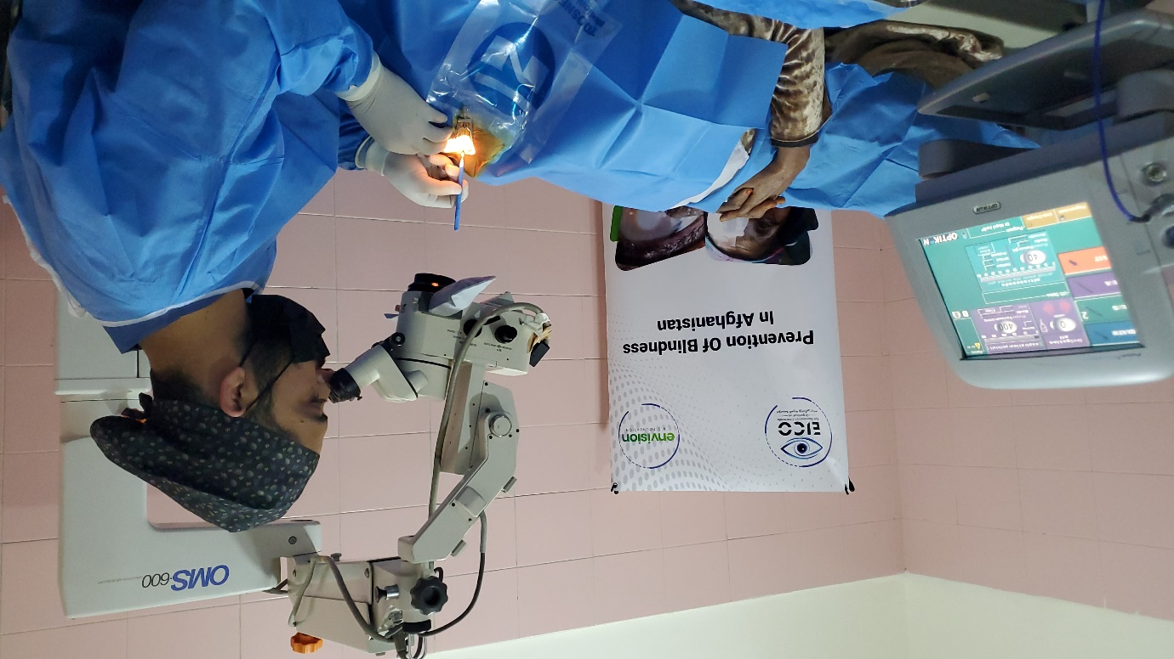

Did you know?

- $410.7 Billion loss in productivity occurs in the world due to sight loss. Restoring sight loss will create positive change and restores life.

- 2 billion people drink annually from a contaminated water source leading to half a million diarrheal deaths. Improving quality water systems will prevent death and diseases

- 430 Million people have disability level hearing loss in low and middle income countries. Establishing cochlear implant and hearing aid clinics will help people hear their loved ones again and are less dependent on daily community assistance.

(bubble art)

Eye Care Programs

We all need our eyes to see and to complete our daily activities with ease. Imagine losing your eyesight, becoming dependent on family and friends for help and support to complete even the basic of activities. The loss of ability to take care of your family and work to make an honest living. This is the harsh reality for a lot of people in underprivileged communities. Often people living in blindness are in a high level of poverty due to their helplessness.
Envision Aid Foundation works to provide a range of eye care programs to the less fortunate we have identified in countries we operate in. This includes :

- Establishing mobile eye clinics that provide cataract surgeries, vision correction surgeries, treatment of glaucoma and providing other eye health accessibility services.
- Treating preventable blindness such as Trachoma which is the world’s leading infectious cause of preventable blindness
- Correcting refractive errors of the eye with glasses, contact lenses or fixing the error with surgery if required
- Educating communities of the importance of taking care of your eyes, the importance of washing eyes with clean and safe water to prevent diseases

Cataract is the leading cause of avoidable blindness and vision loss in the world. It is prevalent in low socio-economic countries and communities. We have provided more than 200,000 eye cataract surgeries over 10 years to reverse blindness. Help Envision Aid Foundation in supporting and changing lives for the better.

Ear Care Programs

Hearing is a vital sense and gives us the ability to communicate with others in a way that none of our other senses can achieve. The loss of hearing can have a negative impact both on individuals and societies at large. It can lead to social isolation, the inability to work in the community and taking care of the family. Envision Foundation Australia helps to establish mobile hearing clinics that include:

- Cochlear implants procedures to improve hearing and understanding speech
- Providing and fitting hearing aid devices
- Tympanostomy tube insertions to decrease middle ear infections
- Auditory/verbal support to educate individuals in using hearing devices and aids

By aiding the hearing of individuals, it has an empowering impact on improving the livelihoods of patients as well as having a positive effect on their mental health. Moderate hearing loss triples the risk of dementia so reducing this risk is very important. Support Envision Aid Foundation in its fight against hearing loss and improve the lives of many.

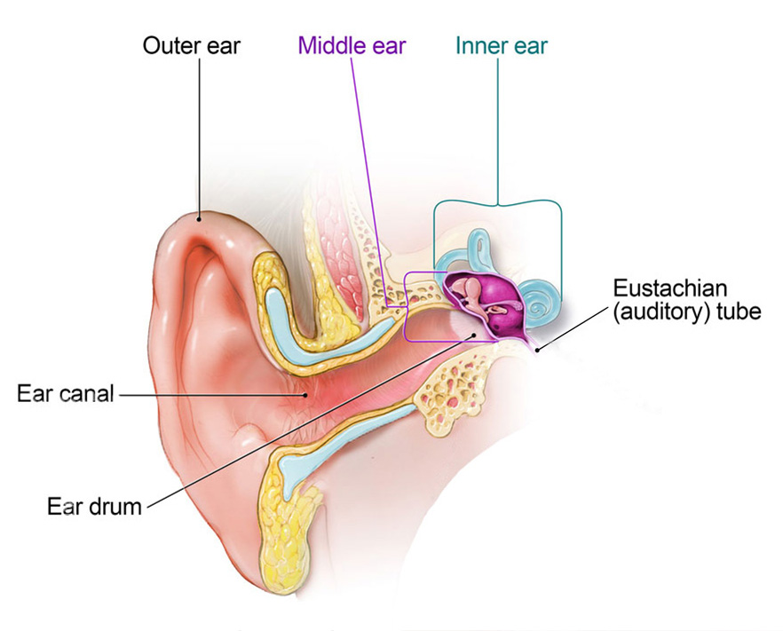

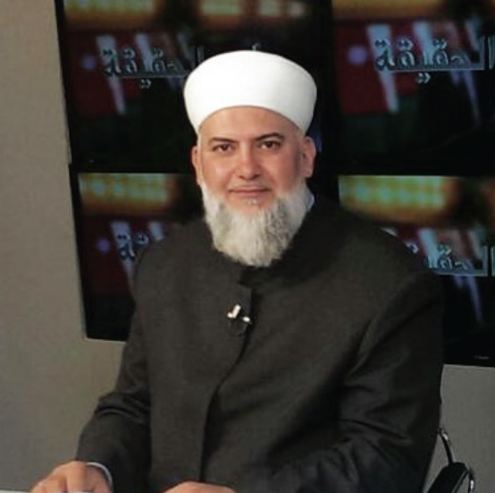

Contact Us
Thank you for your interest in Envision Aid Foundation. Please feel free to reach out to us using the information below or send us a message in the box provided.
Address: Envision Aid Foundation
Email: admin@envisionaid.org.au
Social media: Follow us on Facebook, Twitter, and Instagram @EnvisionAidFoundation for updates and news.
We look forward to hearing from you!
(insert contact message box)

