FRONT COVER:
Photo of my embroidery. I took this photo from my iPhone. I hope it’s good enough to use?
Title words for cover: I am a child of light. I walk in love and live in beauty.

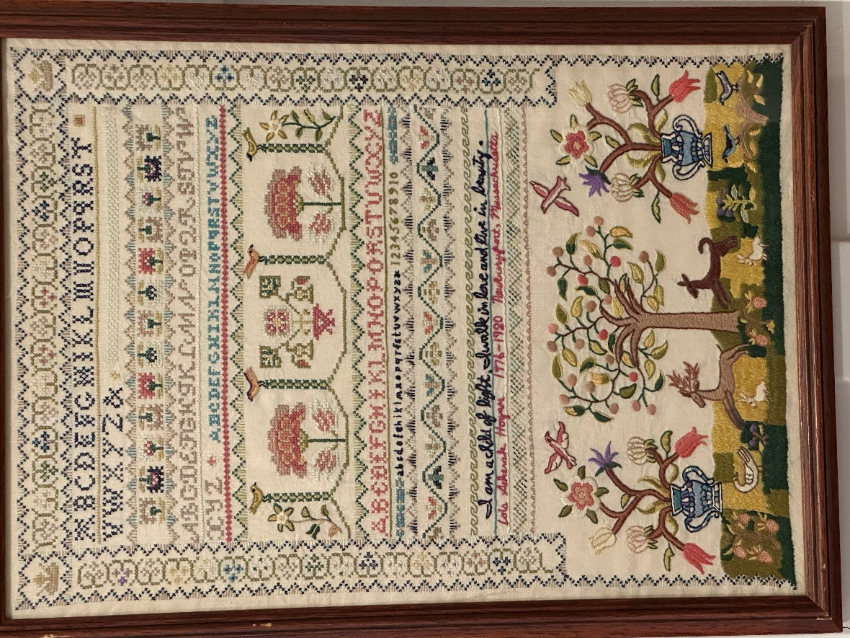

INSIDE COPY for spread:
Nearly fifty years ago as a young bride in the historic seaport of Newburyport, Massachusetts, I became intrigued by 18th century embroidery samplers, created by young girls as part of their education to learn basic needlework skills needed to operate the family household. Samplers depicting alphabets and numerals served as a pattern book -- from simple cross-stitch, back-stitch and whip-stitch to more elaborate techniques like chain-stitch, blanket-stitch, satin-stitch, and French knots.
As luck had it, I chanced upon a kit to create a replica of a sampler sewn in 1760 by 11-year-old Newburyporter Mary Starkey. My sewing skills were extremely limited (I am a duct tape & staple hemmer), but I was determined to recreate this charming artifact of colonial life in our picturesque harbor town.
Four needle-pricking, patience-worn, eye-straining years later, my sampler was nearly finished. Despite my clumsy stitches, it was a silk-threaded marvel of rainbow-colored alphabets, urns of flowers and vines, scrolling flourishes and geometric borders, deer and rabbits gamboling under a fruit tree. Mary’s original sampler – like many -- featured a pious religious statement, so all my piece lacked was a Bible verse or moral quotation that would personalize my piece for posterity. Given the endless pokes, jabs and mind-numbing tedium I had experienced in the making of my sampler, I was tempted to stitch a record of my frustration: “I vow never to attempt a #%$&!# sampler ever again!” Sobered by the potential shame of how this might reflect on me 100 years hence, I instead recalled an inspirational verse I had often used in meditation: “I am a child of light. I walk in love and live in beauty.”
More aspirational than representative of my life, those words were like a light at the end of a tunnel -- guiding me toward a way of being that I wanted to be more of my default. Words have a power that we don’t often appreciate in ordinary speech, as depicted in many stories about magic spells. There may be a basis of truth at the heart of these fairy tales. For example, the sorcerer’s incantation abracadabra is reputed to come from the Hebrew and means “I create what I speak” – or at root, “what is spoken is what becomes.” With a wave of a wand and recitation of the word, shazam! -- magic can happen!
This is more than just woo-woo New Age thinking. There’s also science behind how the way we speak and what we say shapes our perceptions, actions and experiences. Positive affirmations can create and strengthen neural pathways in our brain, serving as a kind of unconscious compass to point us in the direction we want to go. For me, the words of my sampler remind me to lean into moments where I feel joy and lightness.
The dark hours of our being have their place in our lives, and while they can be painful or unwanted, there is even sometimes safety or solace in shadow. In truth, we cannot have one without the other – much like a flower whose petals reach up toward the light must also let its roots dangle deeply in soil. Yet, there are moments like when my beloved grandson Harry reaches up to hug me spontaneously or when a piece of music enthralls me or when the eyes of my barista smile as I put a small tip in her jar, I am indeed “a child of light, walking in love and living in beauty.”

BACK COVER
(thumbnail reduction of cover here)
I am a child of light is the 17th in a series of Labor Day essays inviting a moment of reflection on living a more meaningful, more mindful life
Lois Sekerak Hogan, Ph.D.
Crane Neck House
74 Main Street
West Newbury, Massachusetts 01985

Mobile: 978-764-7650
Email: Lshogan@comcast.net

©2024
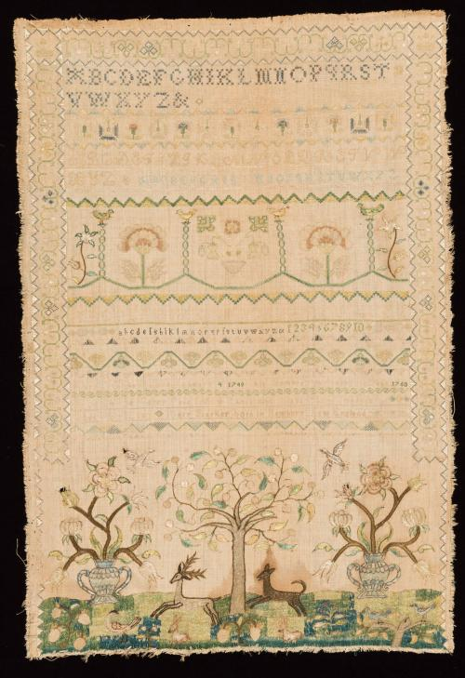
(reduce photo of antique sampler (jpeg attached) to about 2x3 and incorporate it with the copy below titled “About the original sampler”)

About the original sampler:
The embroidery sampler that I reproduced is a part of the Colonial Williamsburg textile collection and is known as “The Chase Sampler” because of the dog chasing a leaping stag. It is considered a rare example of American needlework design because it combines an embroidered picture with alphabet lists and includes the embroiderer’s name (Mary Starkey), place of birth, date the sampler was made, as well as a pious statement: Goodness and Mercy Ever follow those who shape their Conduct by Gods Holy Laws.

About embroidered samplers: In Colonial days, needlework skills were important for the future management of a girl's household. Alphabets allowed girls to practice the marking of linen; sheets, undergarments and other personal items were initialed or named so they came back to their right owners after wash day. Various motifs and border patterns were used to decorate both clothes and domestic furnishings. In these times there were no pattern books, so when women saw a stitch they wanted to use, they quickly sewed a small example on a piece of cloth – their “sampler.” The completed work was usually framed and hung in the parlor as a testament to the maker’s obedience, patience, and skill.

Potential graphics:

Potential accent colors for brochure: pastel pink, green, or blue – as seen in the embroidery

Line drawings of various embroidery tools, e.g.:
- Scissors
- Thimble
- Threaded sewing needle
- Spool of thread unwinding
- Embroidery stitches
Some examples/ideas: (do NOT use sewing machines, dress forms, hangers, irons, or other tools unrelated to the sewing technique of embroidery)
- 

 