Hibernia Housing Logo Design Ideas/Theme

Hello Logo Designers,
We are looking for a SUPER logo for --
-- Company name -- “Hibernia Housing”
-- With tagline “Developing High-Quality Immersive Apartment Communities”

We have no design talent but are sure the designers on Crowd Design have tons of talent and we will get a great Logo! 😊
Here is a description of what Hibernia Housing does --
Hello Designers
We are looking for a GREAT logo for our apartment development company called "Hibernia Housing" What is unique about Hibernia Holdings we will build large luxury apartment buildings (typically between 200-400 units) where ~20% of the units are set aside for adults with Autism and a learning disability

We have surfed the web for logo idea and below are some logos and themes we thought were good
We really want to the logo to incorporate/highlight --
- The color green (shade Emerald, Shamrock or Kelley) as “Hibernia is an Irish word and the founder Tim McEntee is of Irish descent!
- Also if it works to incorporate an abstract image of an apartment building (see below ideas)
- Also very open to other logo idea concepts
Below are our logo design ideas (would be great if we could several examples of each of our ideas) --
- The single letter H for ‘Hibernia’ OR two letters, i.e. -- “HH” for ‘Hibernia Housing”, example (but again logo needs to incorporate color green) --

- Incorporate an abstract image of an apartment building and/or a home image

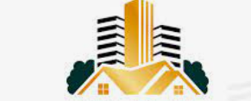
Thought this logo was good as incorporates two apartment building types
_________________________________
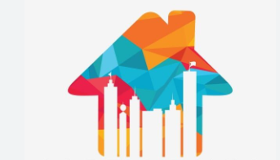
Also thought this was logo good BUT in the bottom half of the logo there are 6 abstract images of what looks like tall office skyscraper buildings, would rather have one abstract image of a more “boxy” image of an apartment building
___________________________________
- Incorporate an abstract image of an apartment building and/or a home image
As mentioned, 20% of the building will be dedicated to units are set aside for adults with Autism and a learning disability
One possible logo idea is to show this with a building with squares that represent apartment units, where 20% are a different or darker colors to highlight the communities are immersive, see below image --
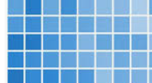

Or another idea is to use puzzle pieces, see below image --
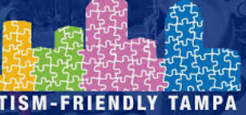
___________________________________

- OR a VERY Abstract logo idea?


Look forward to seeing great logo designs! (Will leave a generous gratuity for winning designer)

Thanks!,
Kevin

