Project Title: Logo Design for ITAA (International Textiles and Apparel Association)
Project Overview: We are seeking a fresh, modern logo and website style guide for our organization, the International Textiles and Apparel Association (ITAA) (www.itaaonline.org). While we have had a logo that has served us well over several decades, ITAA is gearing up for a new website, updated logo, and cohesive branding for our organization. As part of our comprehensive initiative, we are looking to modernize our logo and website landing page to better align with our organization’s identity. The new logo will serve as the visual representation of our brand across various platforms including digital and print media. Our objective is to effectively communicate professionalism, educational values, and innovation.
About ITAA: ITAA is a professional, educational association composed of scholars, educators, and students in the textile, apparel, and merchandising disciplines in higher education. ITAA welcomes professionals employed in those fields who wish to join with members of the Association in the pursuit of knowledge, interchange of ideas, and dissemination of knowledge through meetings, special events, and publications.
The International Textile and Apparel Association promotes the discovery, dissemination, and application of knowledge and is a primary resource for its members in strengthening leadership and service to society.
Core Purpose Statement: ITAA advances and advocates for scholars in the textile and apparel disciplines.
Mission Statement: Advocate for and advance the textile and apparel fields through innovative and inclusive research, education, and resources.
Envisioned Future Statement: ITAA is recognized as the premier association for textile and apparel educators through its innovative and inclusive resources, strong diverse community, and collaborative efforts. University faculty and students depend on ITAA to provide leadership and excellence in education and scholarship.
Deliverable: Logo in color and grayscale in high resolution .tif file.
Design Requirements:
- The logo should effectively convey professionalism, educational values, and innovation. We prefer a modern and minimalist design approach. Avoid overly intricate designs to ensure clarity and adaptability across various applications.
- The logo should be visually appealing, easily recognizable, and scalable, ensuring versatility across various mediums and platforms.
- The logo must work well in both color and grayscale.
- Incorporating elements that reflect textiles and apparel would effectively convey the unique identity of ITAA.
- Specific Colors will be determined in the next phase of our project.
DesignCrowd Upload Specifications: File size max is 20 MB. File format for upload can be png, jpeg, tif, or pdf. Selected work will require high resolution tif image files.
Possible Design Ideas: Here are the current ITAA logo as well as several alternative logo design ideas explored by the members of ITAA and another designer. We haven’t yet seen anything that we really like.
Logo 1 – Current Logo

Logo 2 – Student team submission from the Website Branding Contest
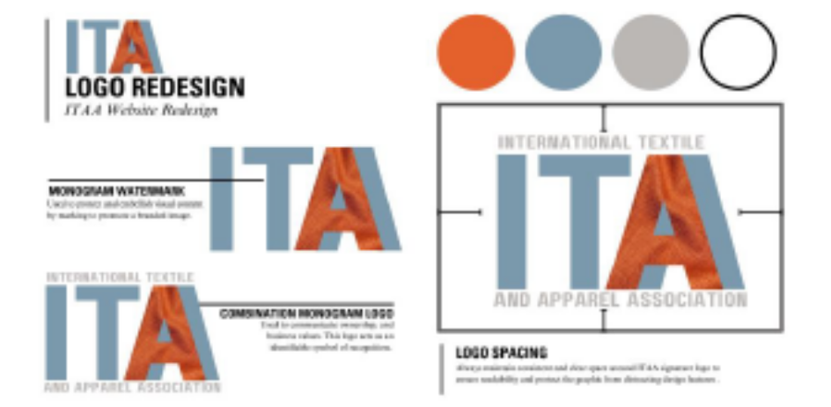
Logo 3 – A logo that was outsourced on Fiverr.


Contact info:
For inquiries and submissions, please contact Sherry Schofield itaasherry@gmail.com or Luis Quijano at l.quijano@hdr.qut.edu.au

