REM Logics LOCKED PLEASE DONT CHANGE

Home
Module Hero: ELEMENTAL.

Welcome to REMLogics — an infinitely composable Enterprise Applications Platform (EAP) for real estate.

Far beyond what’s possible with tired, legacy real estate ERP software, REMLogics offers a complete industry solution, architected as flexible modules that can be assembled and configured into an infinite combination of processes and workflows.

The REMLogics Enterprise solution seamlessly delivers both modular software and bundled services to transform your business with less risk, greater security, and lower cost.

About
One Solution - Infinite Possibilities

REMLogics Enterprise
REMLogics was born from decades of real estate enterprise software development and implementation experience — spanning hundreds of blue chip global real estate investment firms. But REMLogics is unlike anything you’ve experienced before.

No more multi-million-dollar disruptive implementations. No more waiting for upgrades and enhancements that never come. No more trailing projects and disappointing customizations. No more settling for less than exactly what you want.

You can begin using REMLogics simply — starting with a single module. Then, you can build-on with additional modules at your own pace.

REMLogics Enterprise combines software and services in a simple, annual subscription.

The Modules of REM (aka Platform?)

Simple - Secure - Scalable

REMLogics is the real estate industry’s only infinitely composable Enterprise Applications Platform (EAP), ensuring scalability, security, auditability, and compliance. REMLogics is a complete solution covering all functional areas of real estate investment, development, finance, accounting, management and operations.

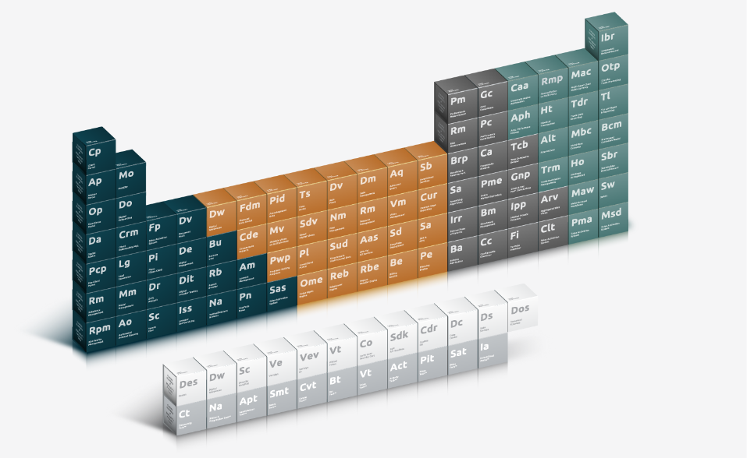

No more business disruption, downtime, high costs, diminishing ROI, and inflexibility. Run your business your way, break the cycle of technical debt, and focus on high-value, innovative opportunities.

Platform
Stop settling for less than exactly what you want

REMLogics combines the best of all worlds in our Enterprise Applications Platform (EAP): the simplicity and scalability of custom, no-code, software and the security and confidence of a complete, SOC 2 compliant industry solution. Our modular approach enables rapid innovation and re-invention of your business by casting off the shackles of legacy ERP technology and delivering a modern, agile solution that bridges the gaps for all of your real estate workflows.

No more closed systems, complicated integrations, overreliance on spreadsheets, and complex or unavailable customizations. In their place is REMLogics’ robust set of preconfigured yet flexible capabilities that can be deployed as point-solutions or to compose larger business processes.

About Us

REMLogics is the real estate industry’s modern alternative to rigid, legacy ERP systems. With decades of real estate enterprise software development and implementation expertise — spanning hundreds of blue chip global real estate investment firms — we have a proven track record of enterprise excellence.

