Home Page – section 1

Strategic Talent Resourcing and Operational Technology Experts
Specialising in Life Sciences and Data Centres.
Contact Us

Moving imagery
Home Page – section 2

Oleson is proud to be providing top-tier resources to the life sciences sector, specialising in delivering high-quality talent and solutions that enhance the capabilities and operational excellence of our customers.
Our operational technology expertise and talent pool has evolved over the past decade with successful project delivery for numerous life sciences organisations, so we are uniquely positioned to understand and meet your requirements.
We are focused on matching the dynamic needs of life sciences firms with skilled professionals, thereby driving innovation and growth in this critical sector across Ireland.
Read more

Home Page – section 3
Meet our Team
Oleson employees have a variety of skills and experience, but they all are professional, experienced in their field and enjoy the variety of working at different client sites over time.
They get a feeling of success seeing a project through to completion, and are always willing to go the extra mile for our clients.
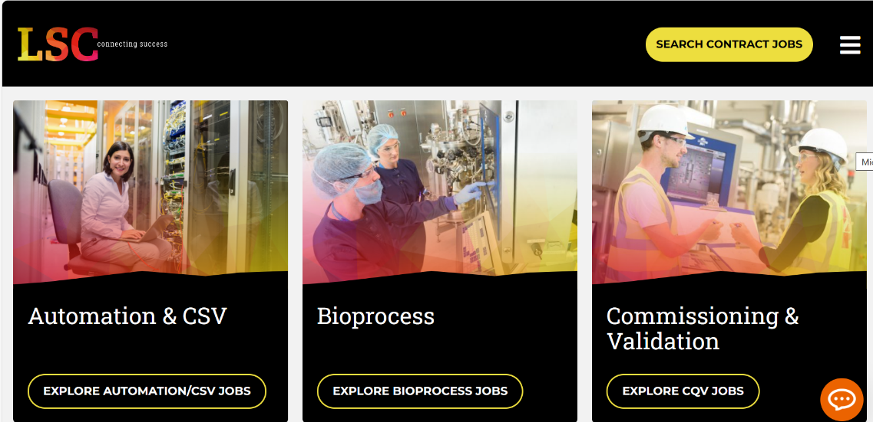
Featured roles – maybe show 2 rows x 3 profiles, eg.

Home Page – section 4
Stats X 3 eg.
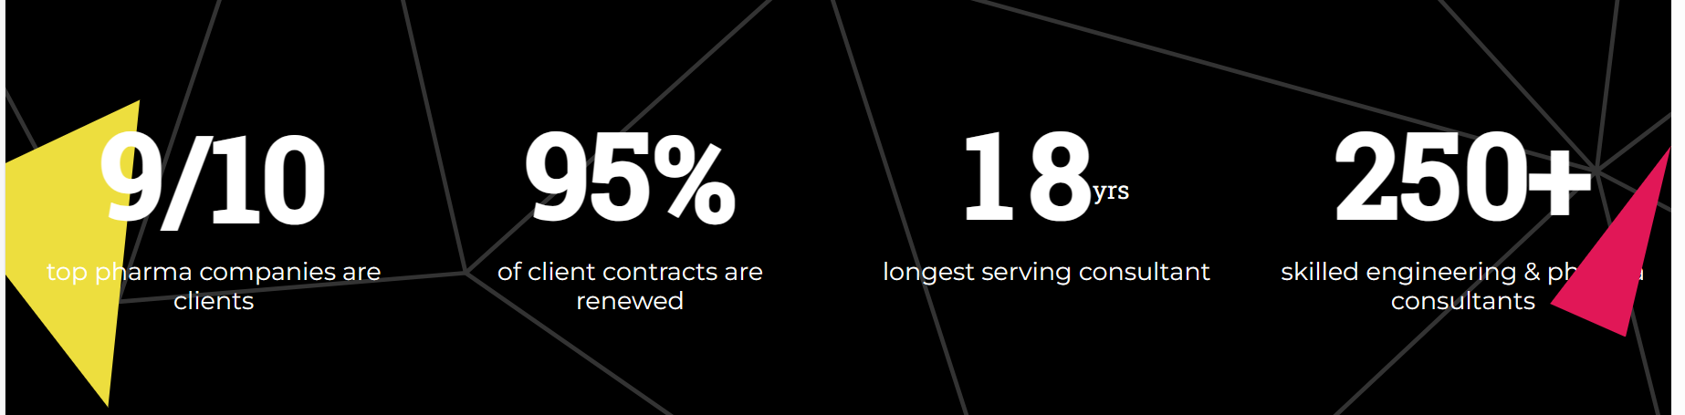

50+
Number skilled automation engineers
25+
Customers currently using Oleson
99%
Customer retention

