Come take my hand
We walk this road together
through the storm
Whatever weather
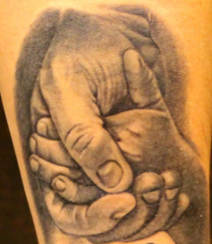
cold or warm
you're not alone
we're on the same road

Come take my hand
We walk this road together
through the storm
Whatever weather

cold or warm
you're not alone
we're on the same road


Come take my hand
We walk this road together
through the storm
Whatever weather
cold or warm
you're not alone
we're on the same road
