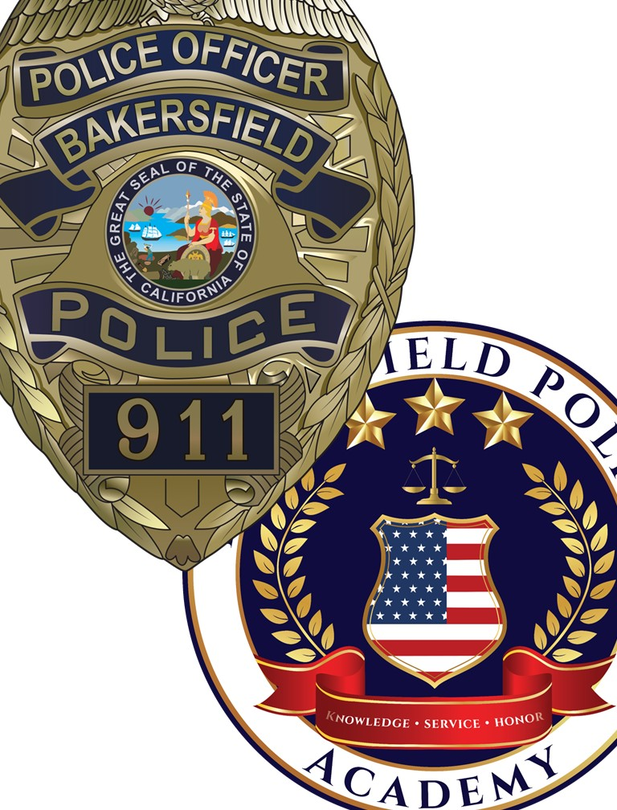
The Training Way
Divisional Mission:
We recruit and train desirable candidates, while supporting our department with meaningful and relevant training.
Divisional Vision:
Create an effective internal design and valuable community and professional relationships to support long-term recruitment and training goals.
Divisional Values:
- We are innovative – continuous pursuit of improved methods and practices
- We are adaptive – willingness to adjust or change as necessary or beneficial
- We are resolute – obstacles will not hinder our success
- We do what is right – right is right, even if everyone is against it
- We are a team – make the team better, lead by giving
Expectations:
- Contribute to a productive environment that promotes solidarity.
- Communicate often with the team and express your thoughts and ideas.
- Be present while at work and be present while at home.
- Promote an advantageous learning environment.
- Operate with a mindset of supporting our department.
- Function as the Department’s training hub, recognizing/identifying conflicts and ensuring quality.
- Communicate openly and early with our department.
- Develop yourself as well as your team.

