Discover the art of exceptional living.
At Castillo Housing Group, LLC, we don't just build homes; we craft personalized masterpieces that reflect your discerning taste and unique vision. Through our seamless design-build approach, we transform dreams into stunning realities.

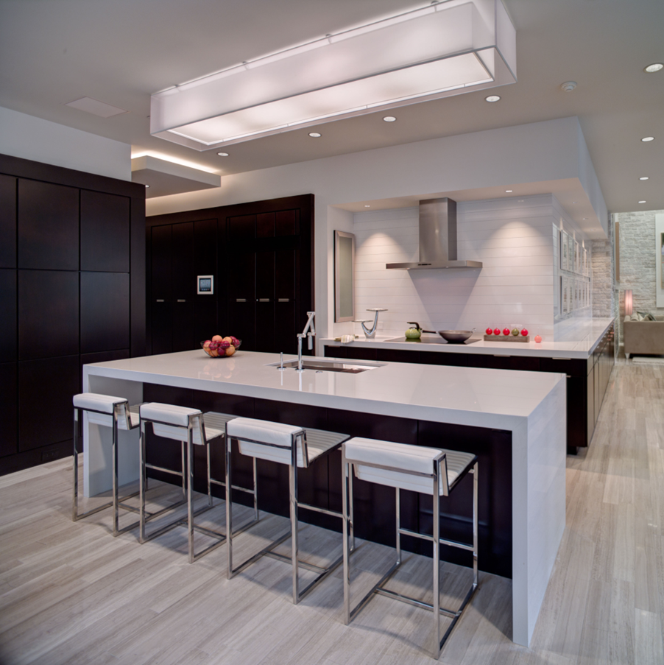
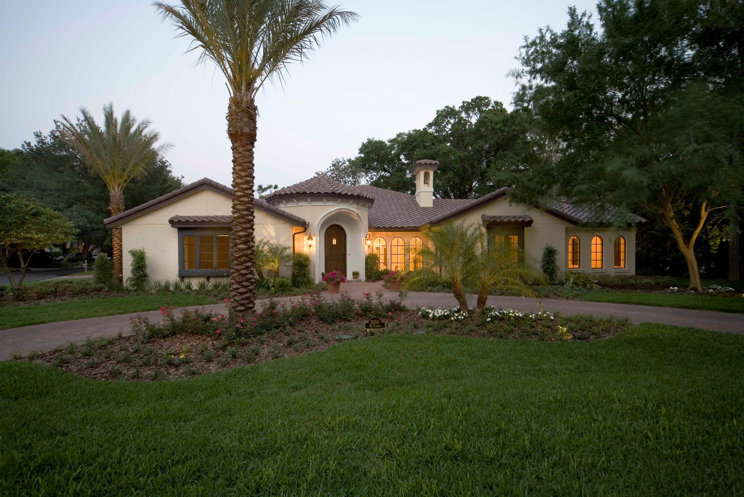
Castillo Housing Group: Where Your Vision Meets Uncompromising Excellence
Discerning homeowners seeking a truly unique residence demand more than just a builder; they require a partner. At Castillo Housing Group, we've perfected the art of building custom homes that reflect your unique style, fulfill your most exacting requirements, and stand the test of time.
Your home is your sanctuary, and it deserves to be as individual as you are. Castillo Housing Group, LLC is your partner in creating a custom residence that embodies your style and fulfills your every desire.
Our integrated design-build approach, including architectural and interior design expertise, ensures a collaborative journey where your vision meets our meticulous craftsmanship.
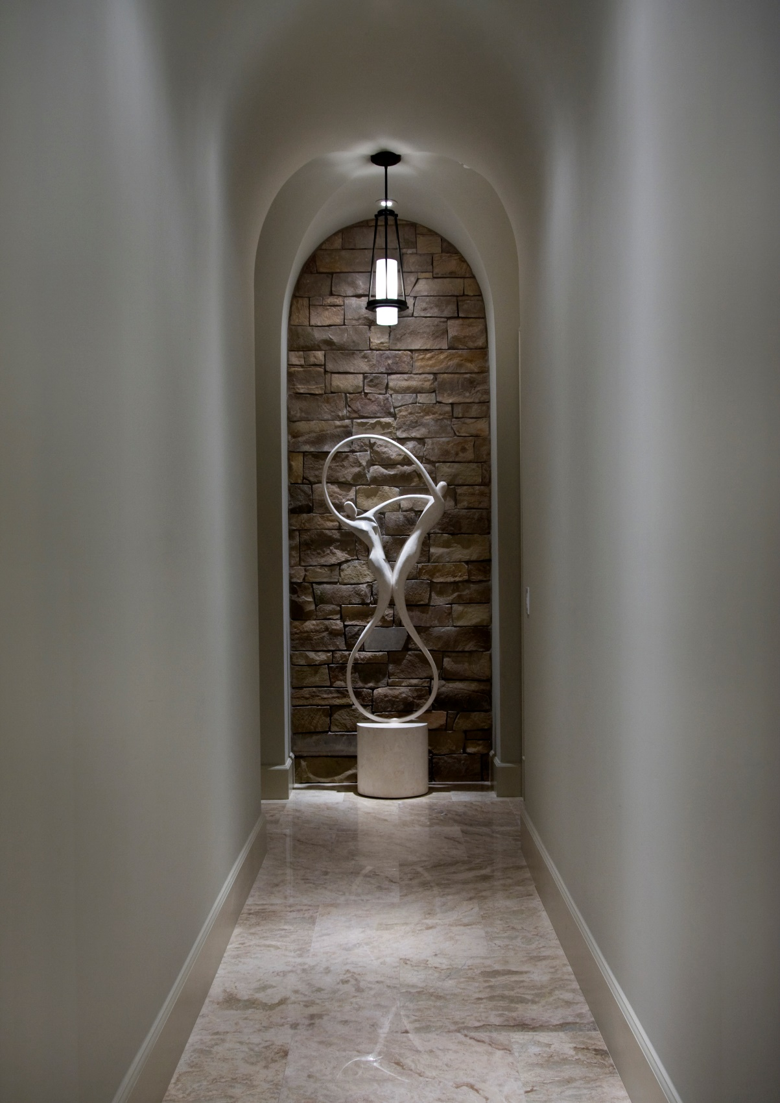
Simple space made elegant. We believe that good design is timeless. Our homes are crafted with enduring principles of elegance and functionality, ensuring they remain beautiful and livable for generations to come.
Our Commitment to You:
- Proven Expertise: Our extensive portfolio and glowing client testimonials speak to our mastery of craftsmanship and our dedication to exceptional quality.
- Design-Driven Approach: Whether your vision leans towards timeless elegance or contemporary innovation, our in-house architectural team brings your dream to life with precision and style.
- Transparent Collaboration: We prioritize open communication and your active involvement throughout the entire process, ensuring seamless decision-making and confidence in every detail.
- Meticulous Execution: From groundbreaking to final walkthrough, our obsession with superior craftsmanship shines through in every impeccably executed finish.
- Enduring Legacy: We utilize the finest materials and cutting-edge techniques to ensure your Castillo home isn't just beautiful, but built to remain a source of pride and comfort for generations.
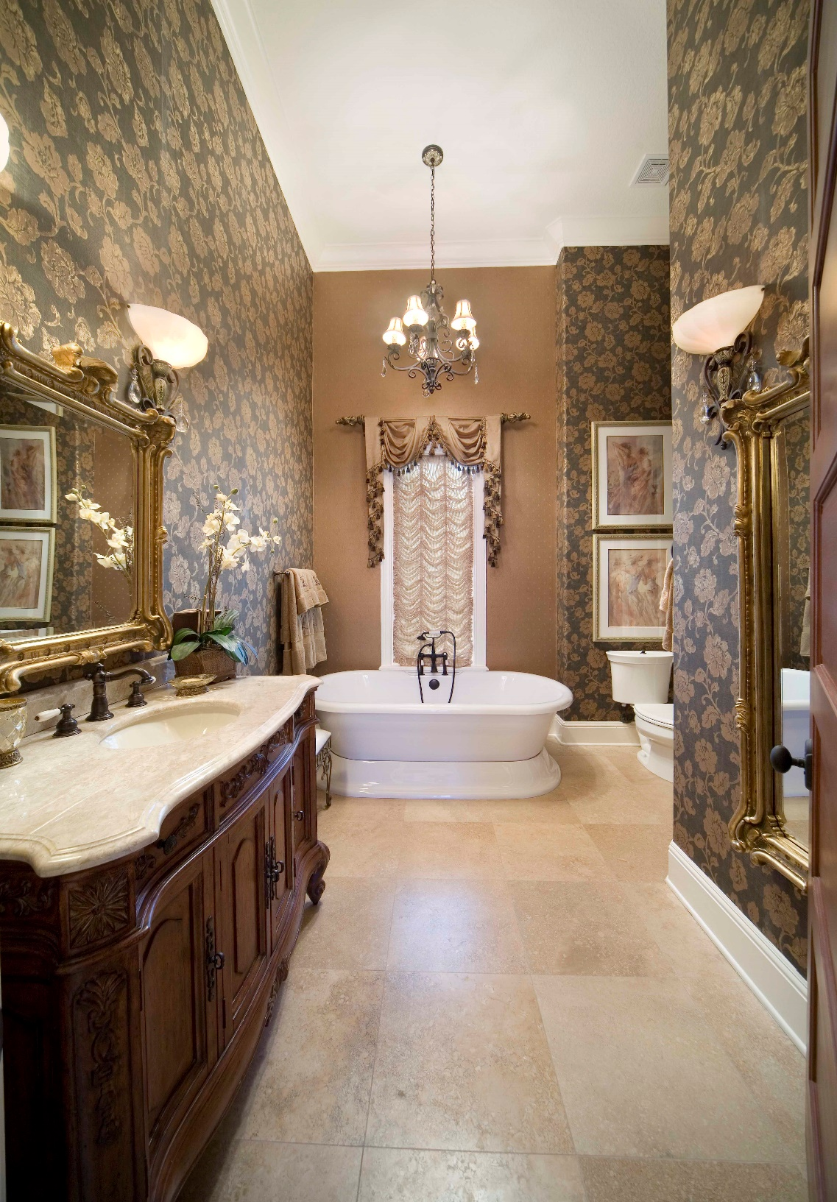
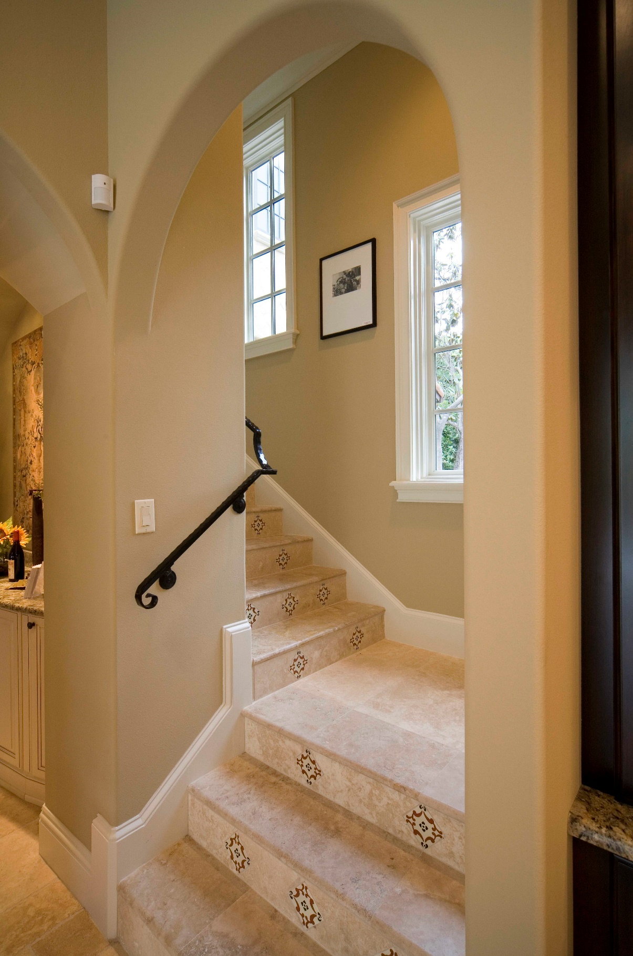 Uncompromising Craftsmanship
Uncompromising Craftsmanship 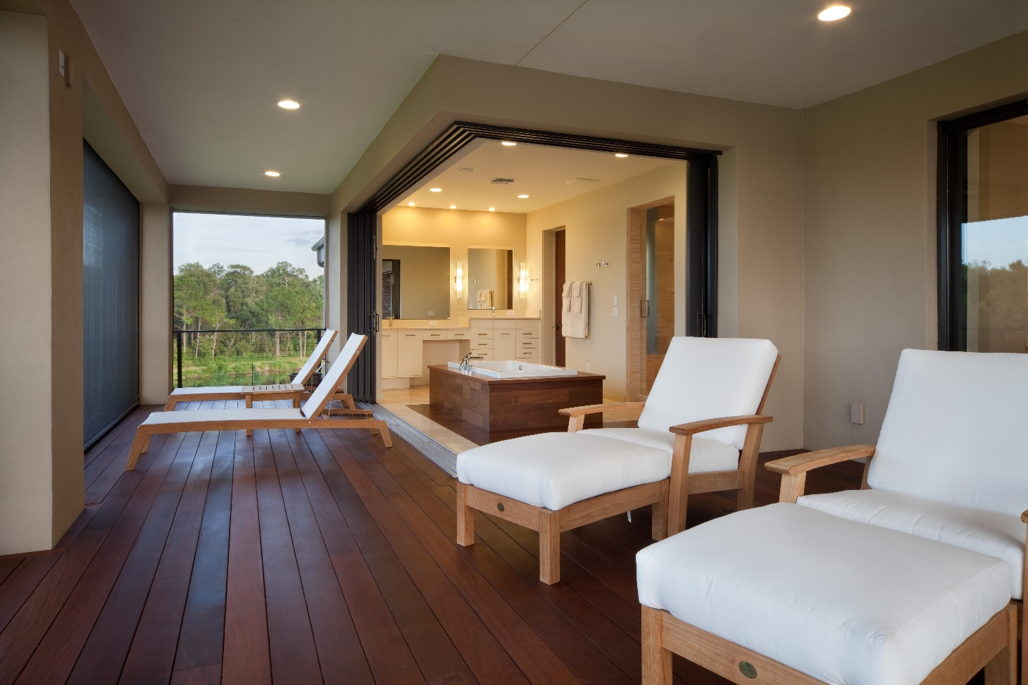
Multi-functional spaces

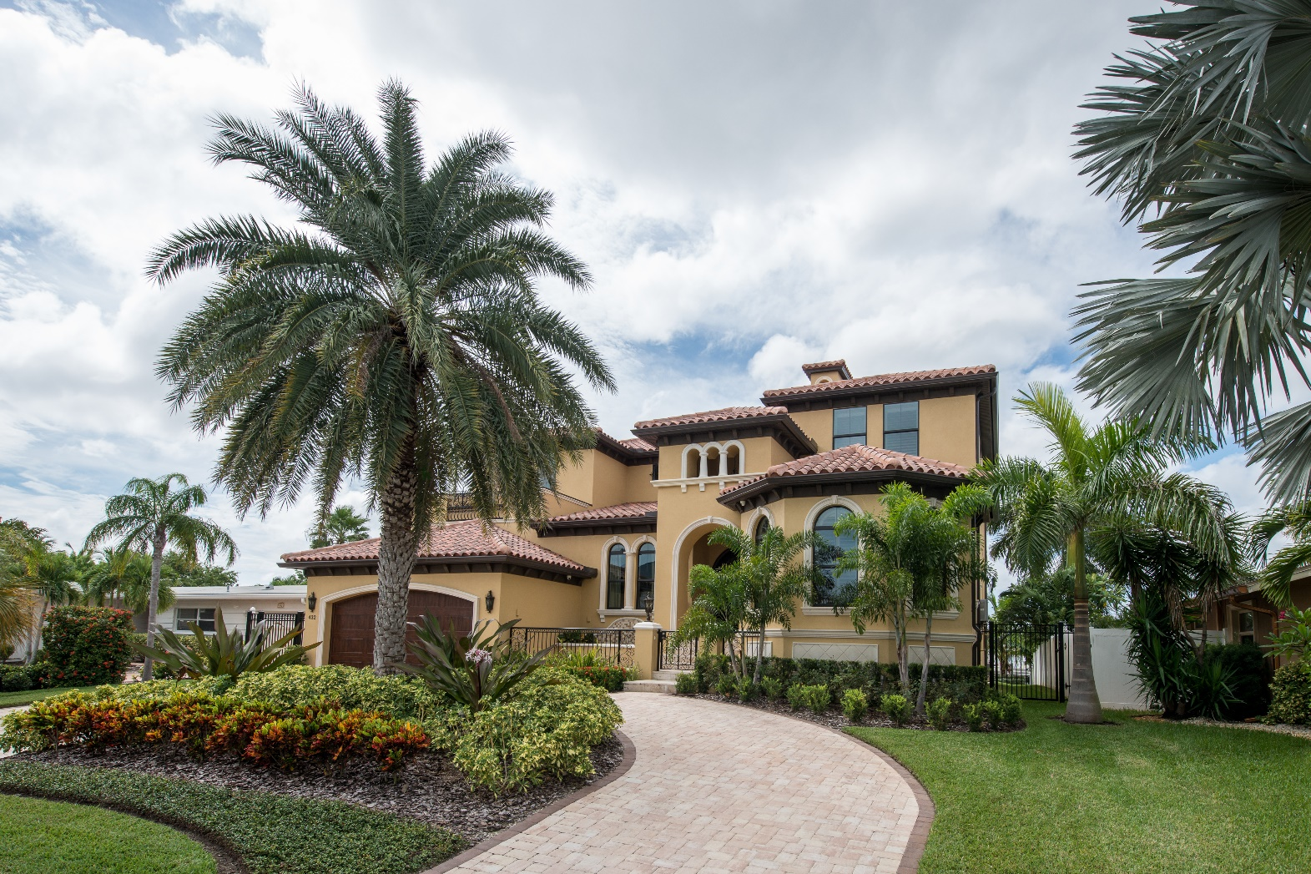
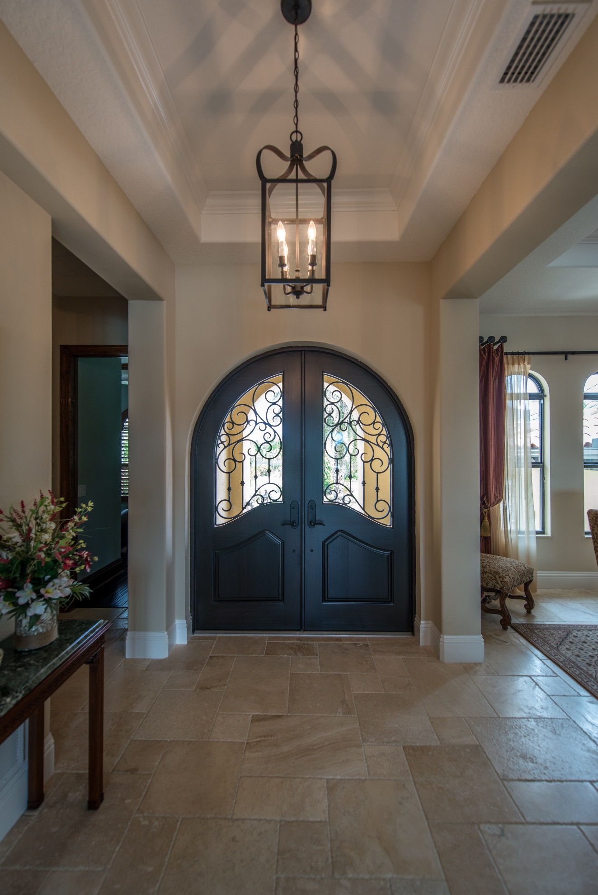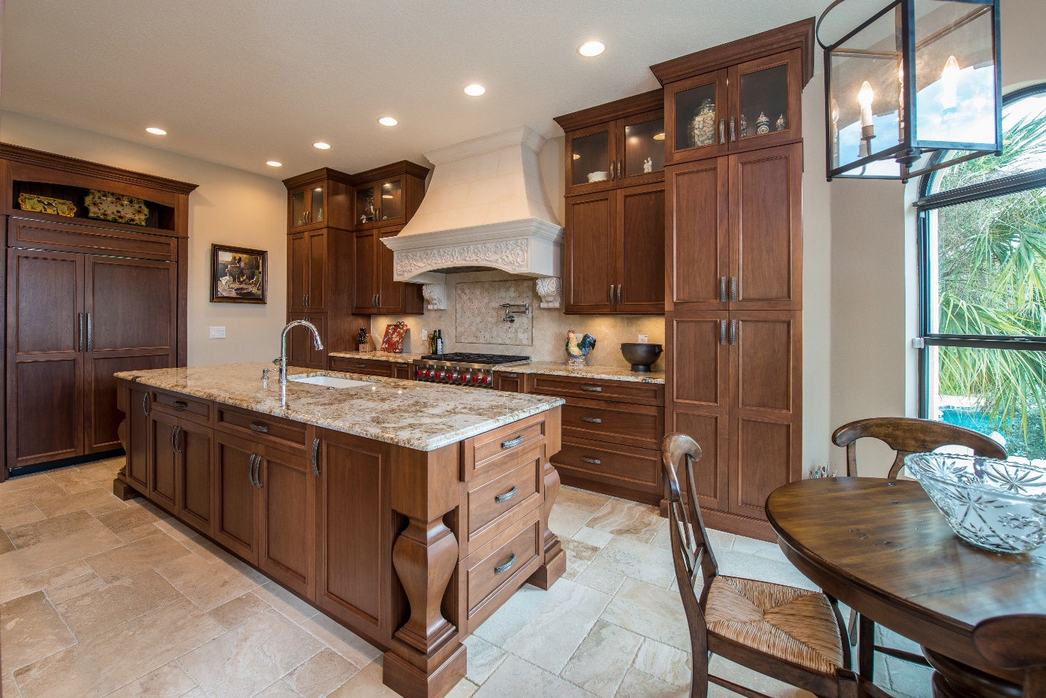
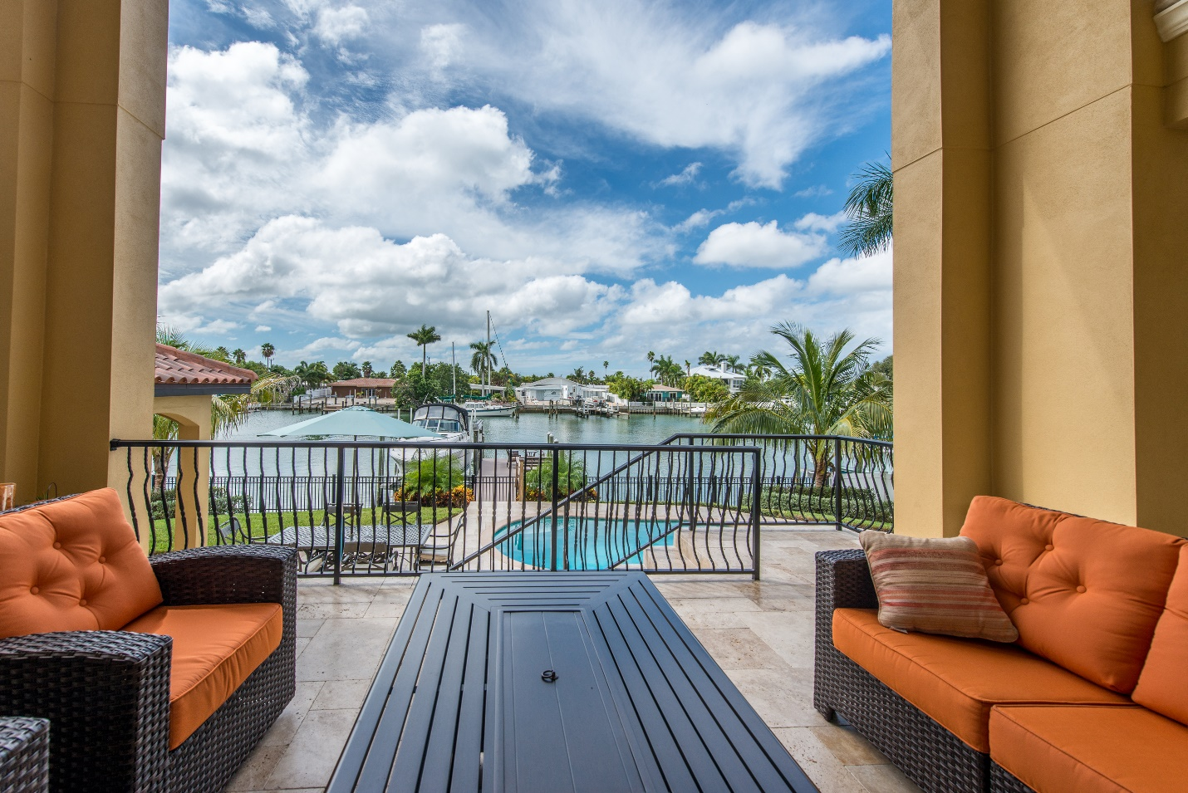

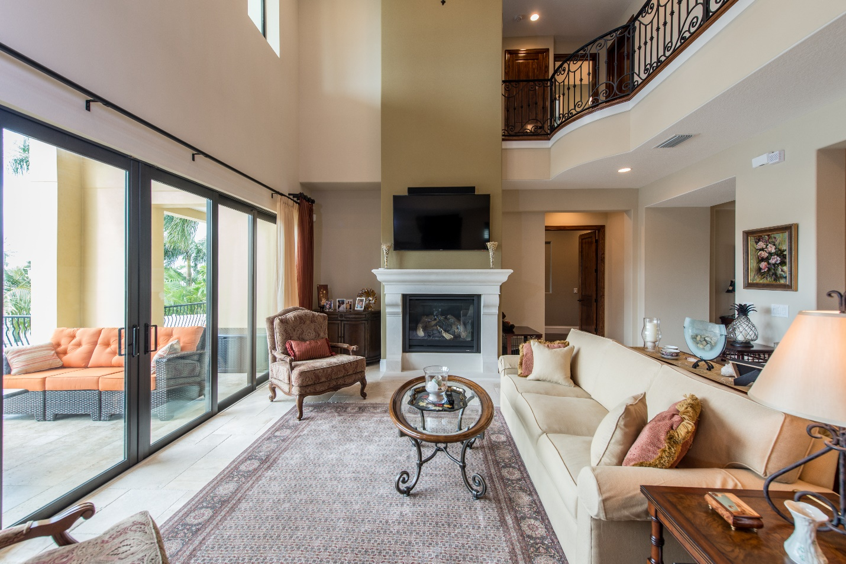
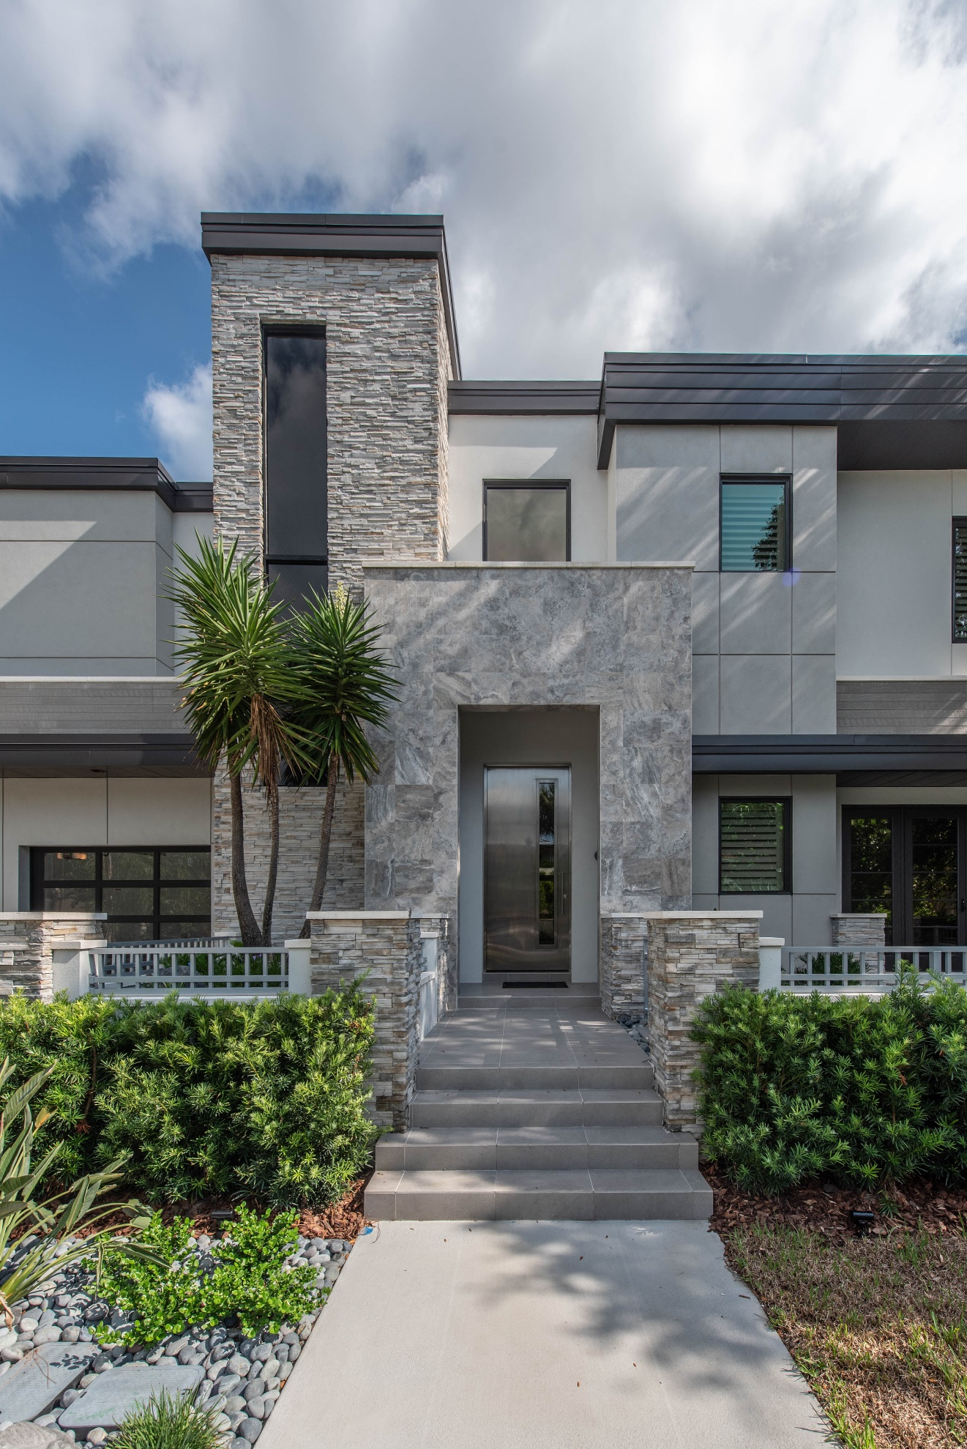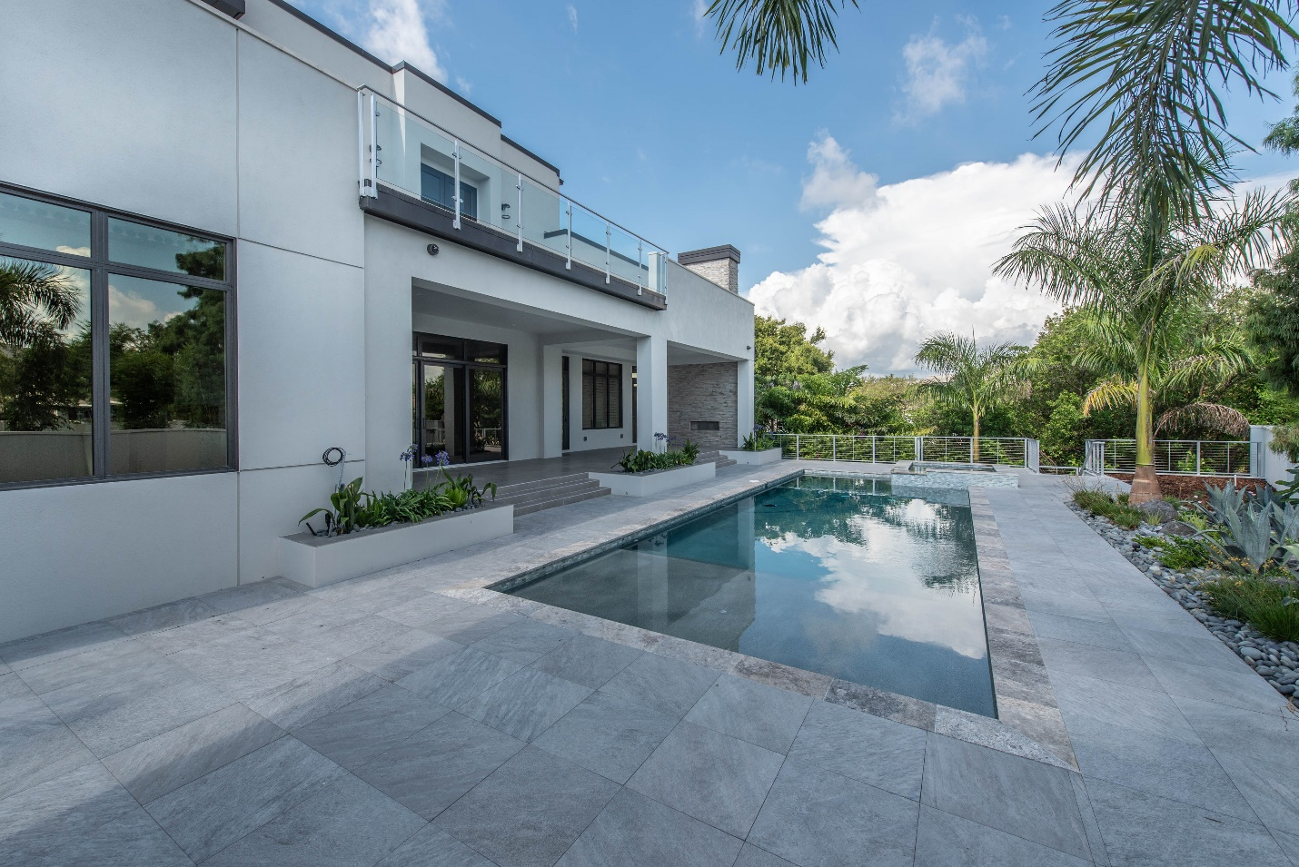
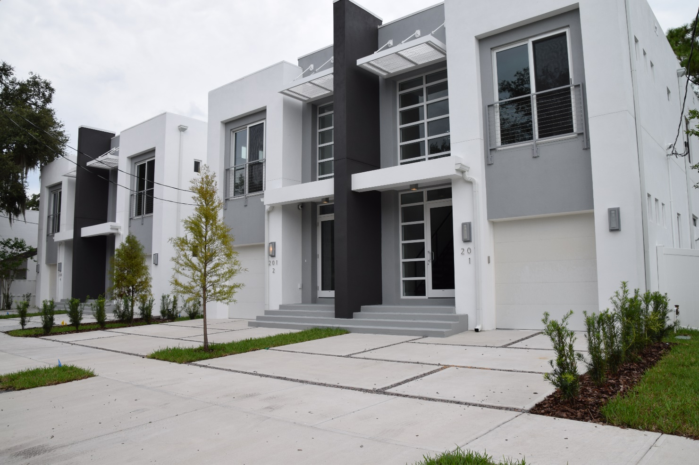

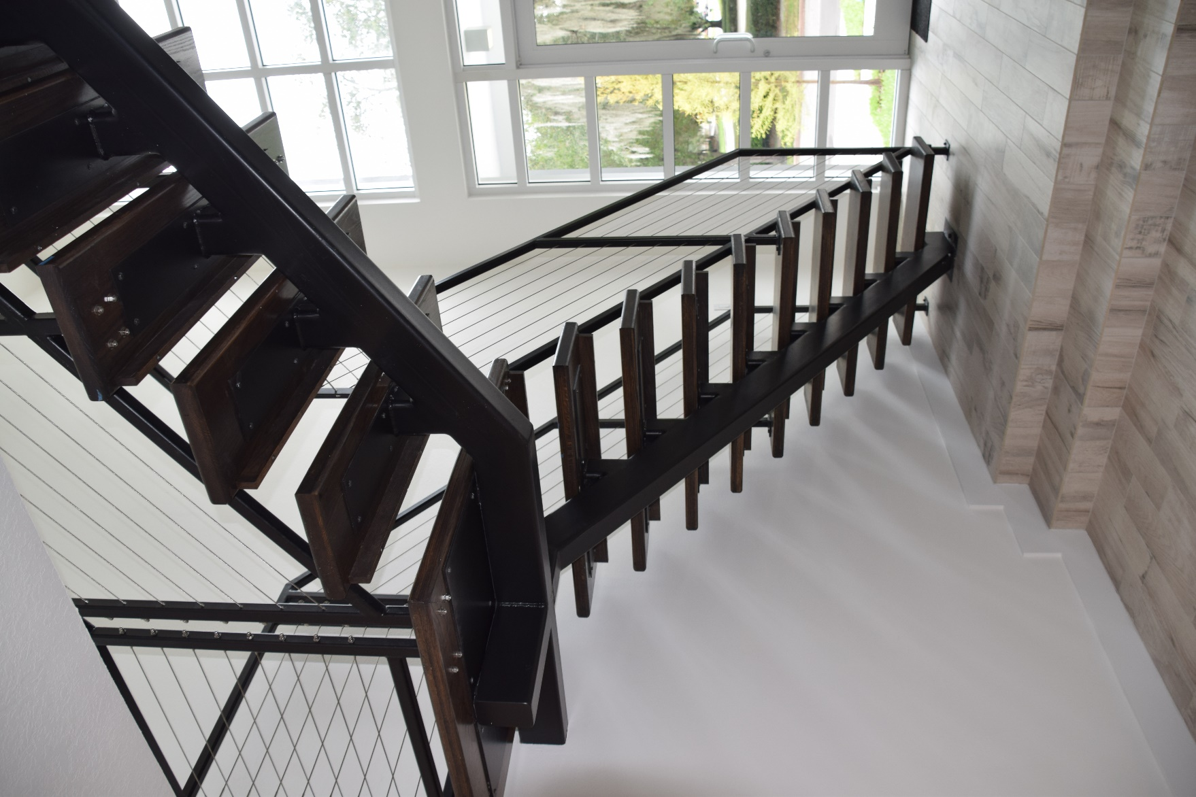
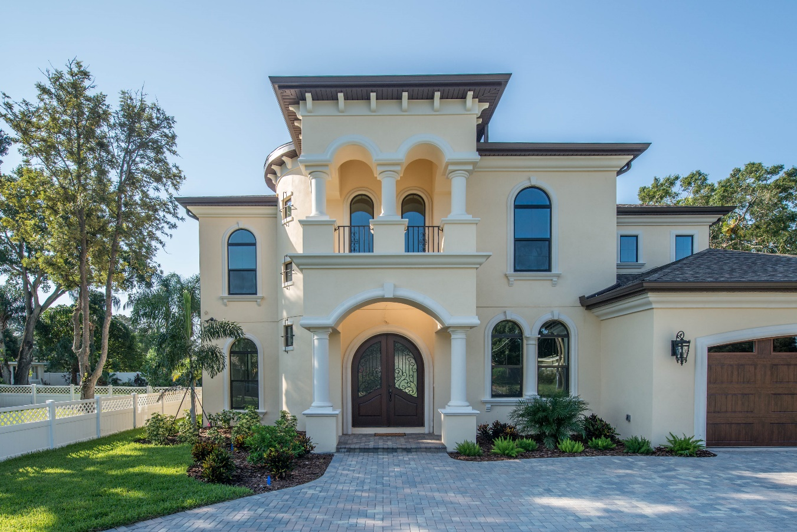
With a background rooted in construction and a degree in management and organizational leadership, Andrew Castillo established Castillo Housing Group on a foundation of excellence. His twenty-plus years of custom home building experience, including the completion of over 350 homes, have honed his ability to translate your vision into a stunning reality. His multifaceted industry expertise ensures exceptional craftsmanship and an unwavering commitment to your satisfaction. 
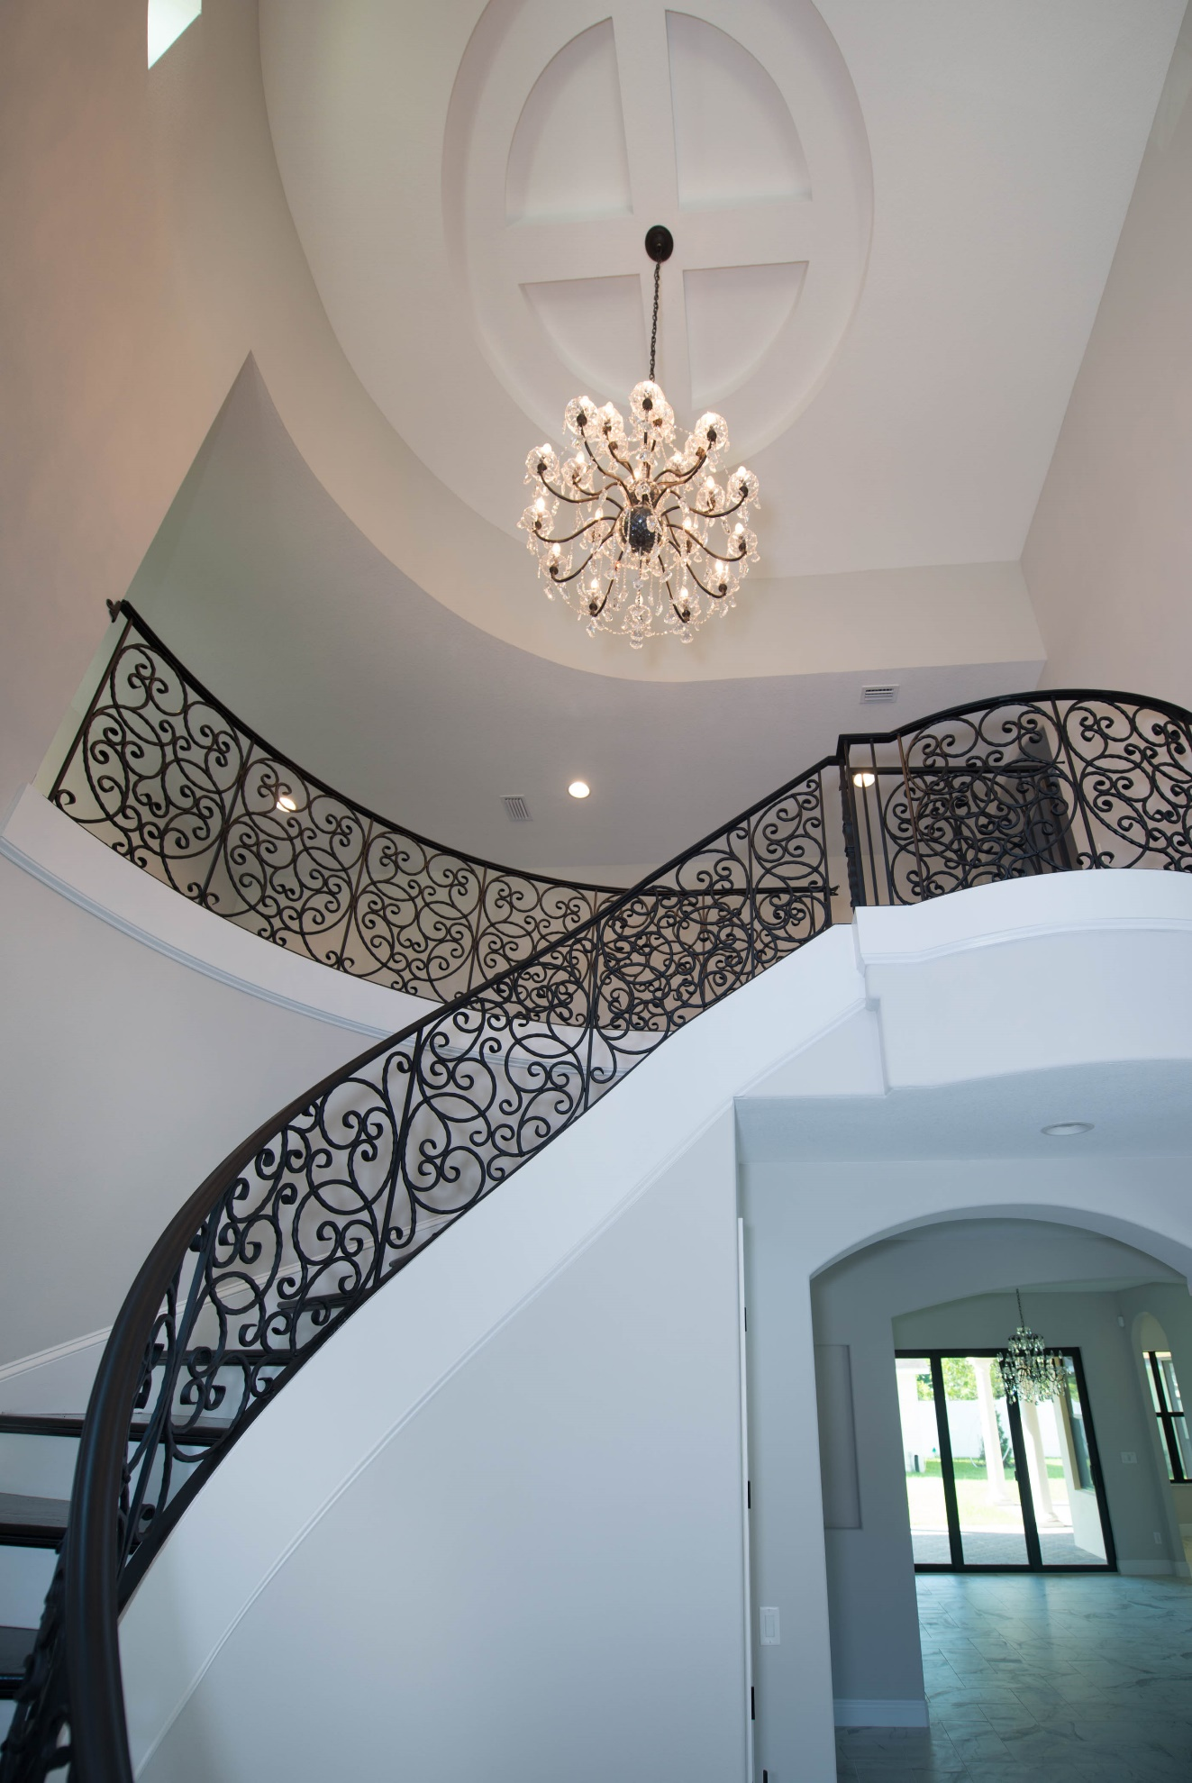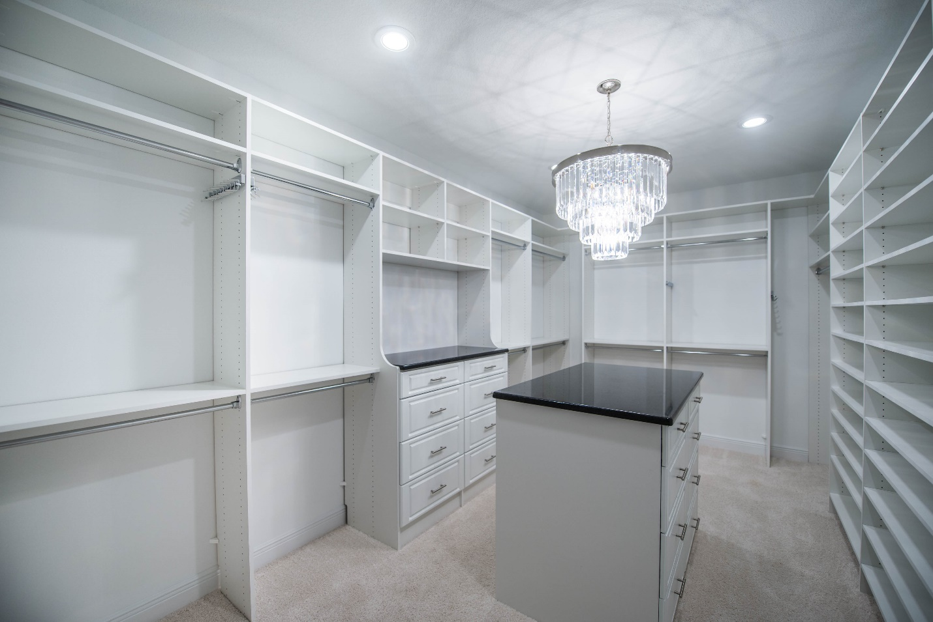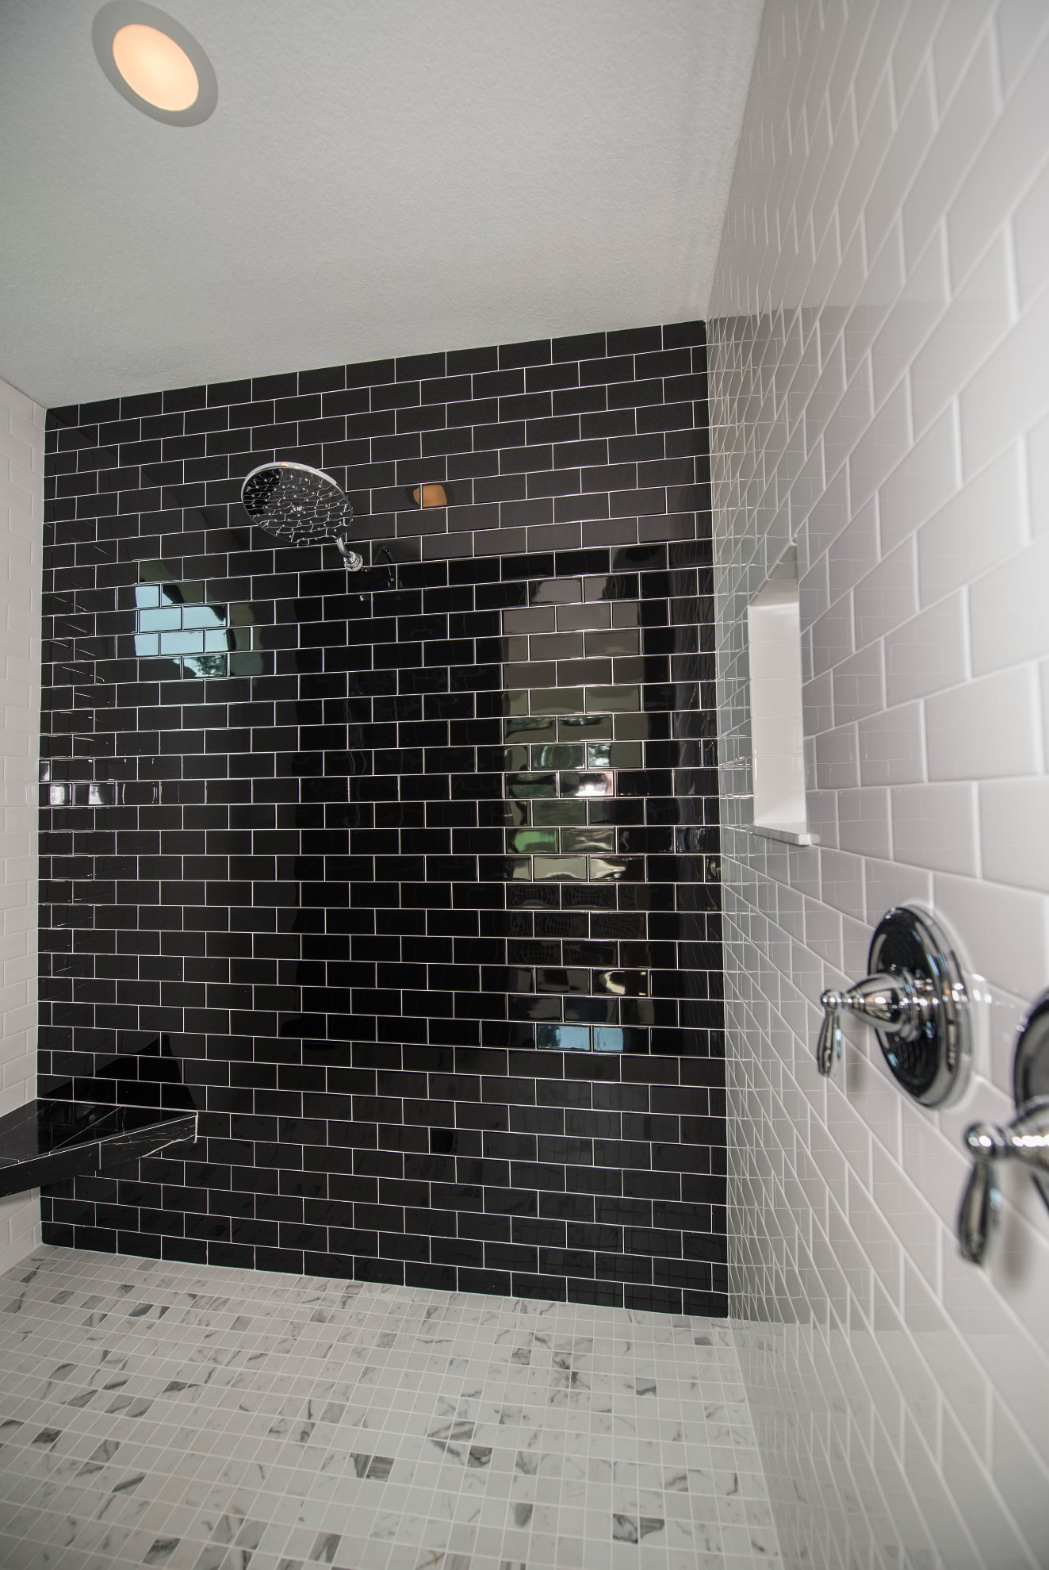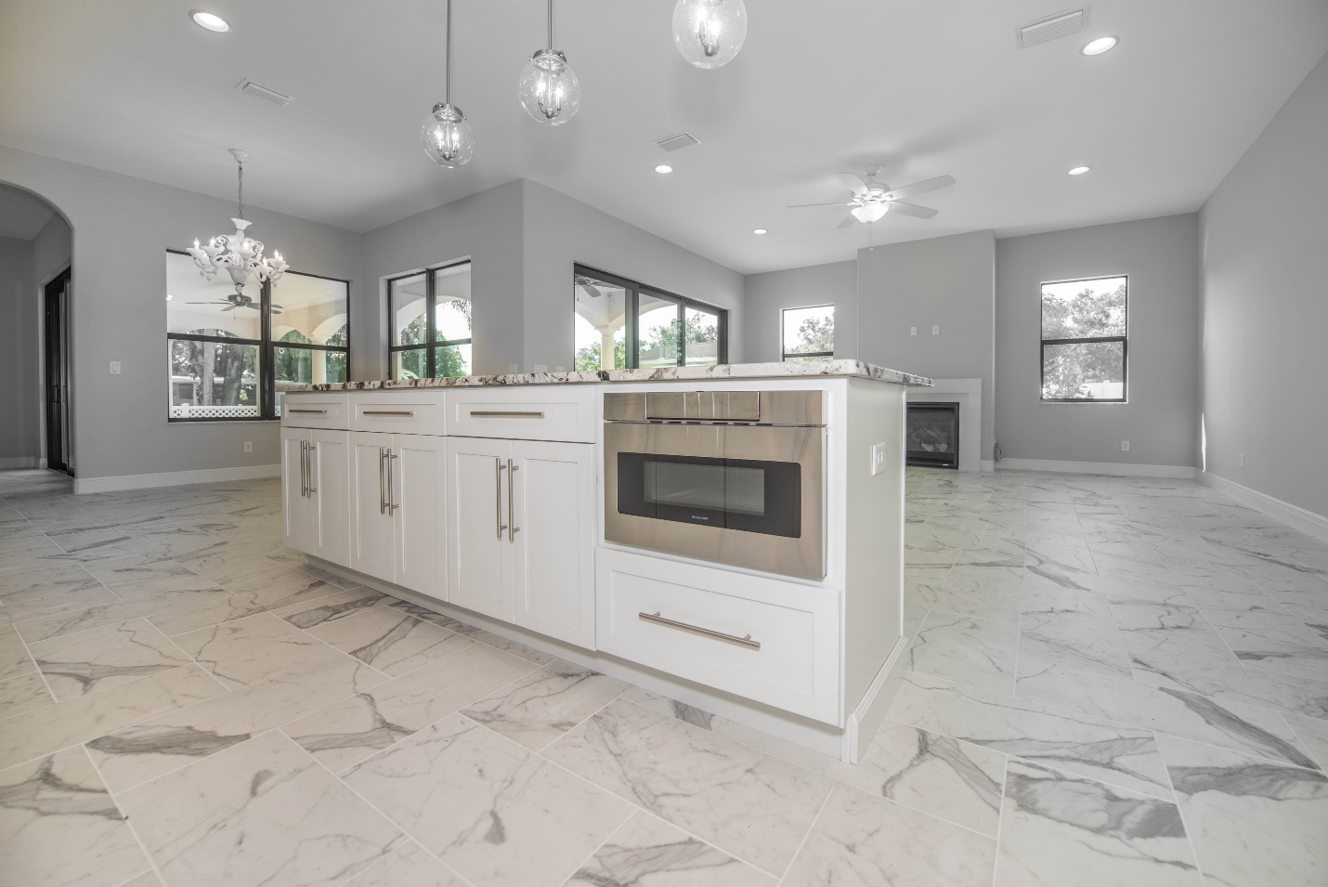
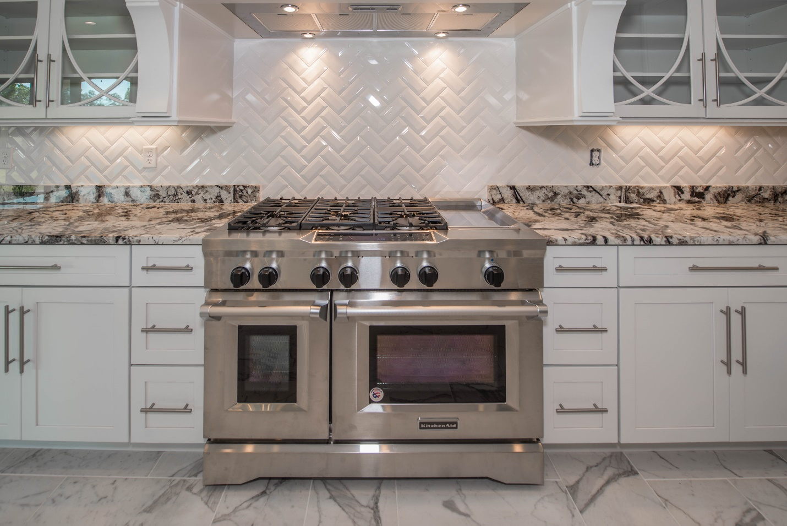
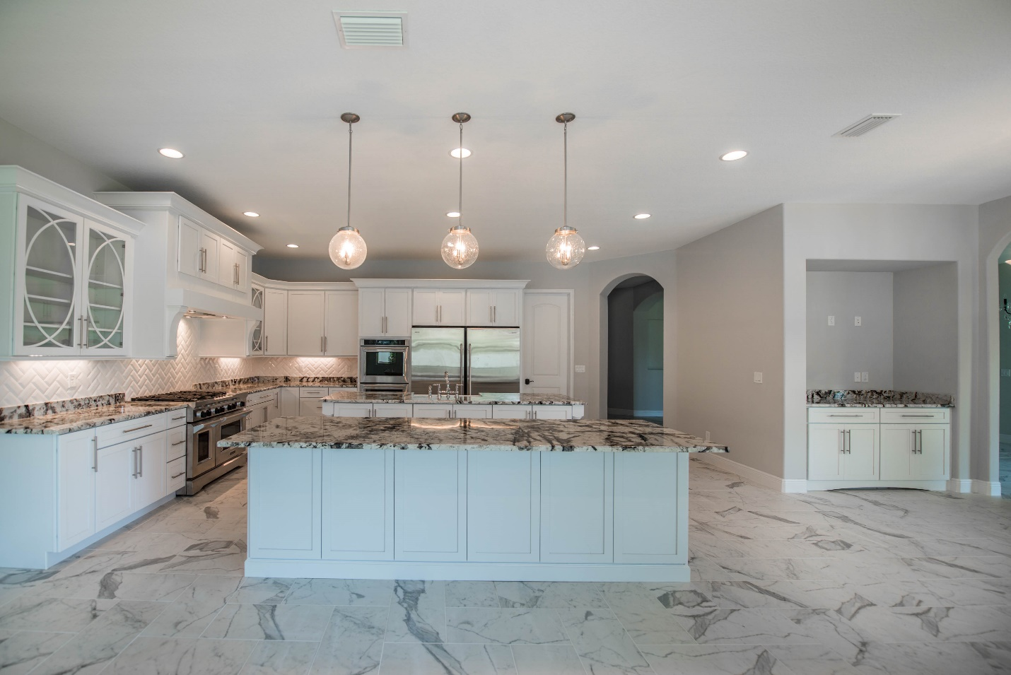

Experience the Castillo Difference. Contact us today to begin the journey toward your extraordinary custom home.

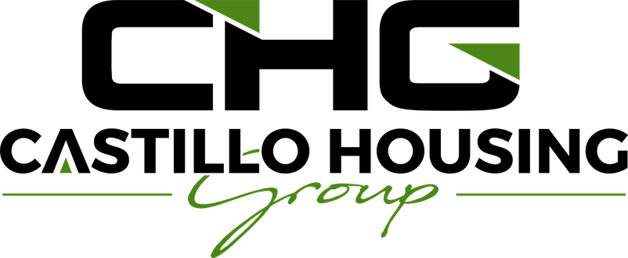
4115 W Spruce Street, Suite 200, Tampa, Florida 33607
acastillo@castillohousing.com
(813)-263-7835

