DL Thurott Flyer Edits
Company main website for reference https://dlthurrott.com/
Some good photos to use
Front images we like
https://www.istockphoto.com/photo/diverse-group-of-workers-at-manufacturing-plant-gm183857220-16418416 could use as main image on front
https://www.shutterstock.com/image-photo/factory-equipment-126121829 Nice pump image
https://www.istockphoto.com/photo/engineer-inspects-a-large-industrial-centrifugal-pump-gm1417032059-464403665?phrase=pump+repair+technician&searchscope=image%2Cfilm
https://www.istockphoto.com/photo/stationary-engeneer-at-work-gm464593706-58557390?phrase=pump+repair+technician&searchscope=image%2Cfilm
https://www.istockphoto.com/vector/customer-service-24-hours-open-sign-gm504792746-83342111?phrase=24%2F7+emergency+service&searchscope=image%2Cfilm 24/7 service
https://www.shutterstock.com/image-photo/asian-engineer-maintenance-checking-technical-data-1516961312 Repair tech image
https://www.shutterstock.com/image-vector/wrench-gear-cogwheel-icon-trendy-flat-1907716114 Some icons to be more bold for front.
back of flyer images we like
https://www.istockphoto.com/vector/new-england-region-colored-map-a-region-in-the-united-states-of-america-gm1278978551-377729455?phrase=+northeast+usa++map&searchscope=image%2Cfilm Map example for back of flyer
https://www.istockphoto.com/photo/water-pump-package-gm1157145150-315641058?phrase=pump+skid&searchscope=image%2Cfilm Somehow incorporate a pump skid assembly. Label under it. “Design & Assembly Services”
https://www.dreamstime.com/industry-skid-mounted-fire-pump-engine-set-fire-pump-engine-image174567215 Another design and assembly example
https://www.dreamstime.com/fire-water-pump-fire-water-pump-package-fire-fighting-pump-isolated-white-background-image155468660
Front of flyer
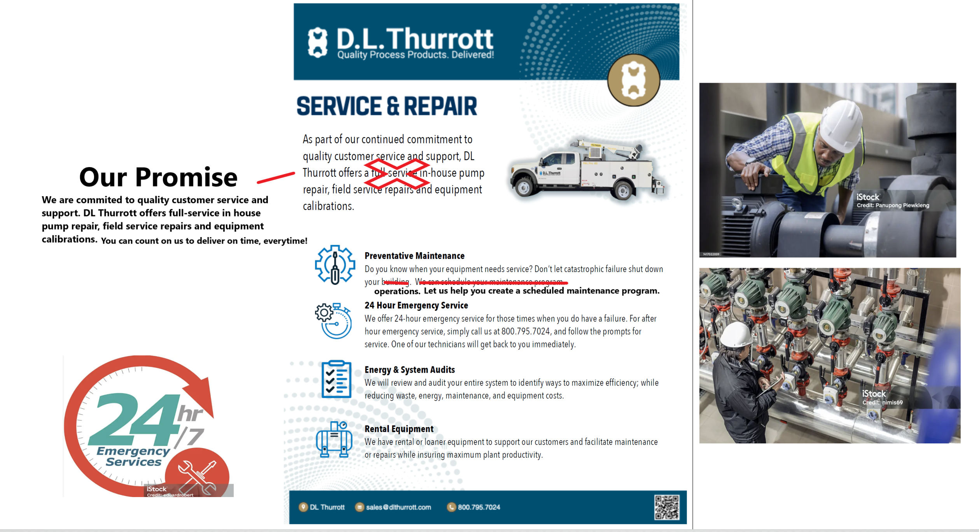
HEADER ON FRONT SHOULD SAY ‘SERVICE, FITMENT & REPAIR’

Back
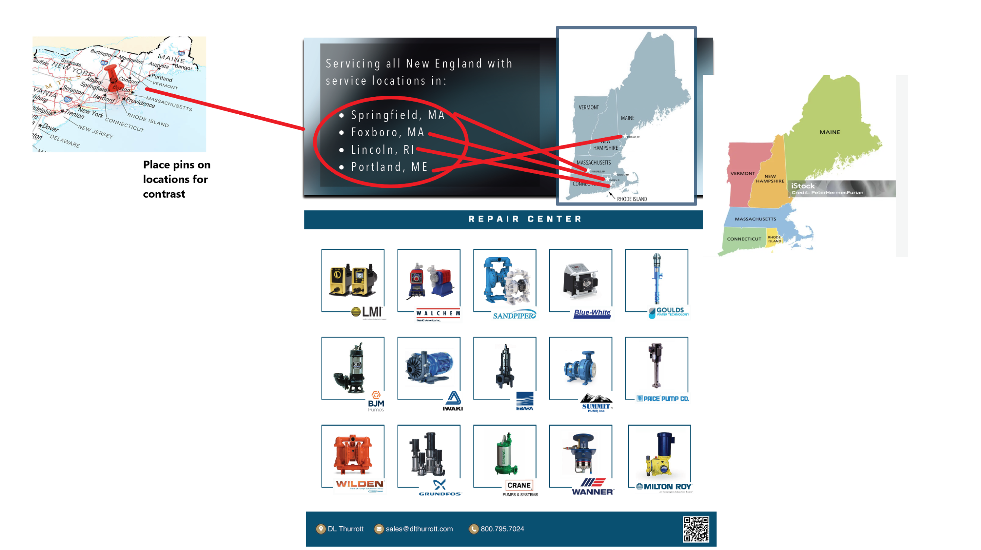
THE BACK ALSO NEEDS A STAINLESS-STEEL TANK ON IT. Showing that they can fabricate a tank. Under it state “TANK FITMENT, SERVICES AND REPAIR” Example image below. Perhaps a tank welder person would be good also.
https://www.istockphoto.com/photo/industrial-factory-interior-scene-gm1296100187-389615793?phrase=stainless%2Bsteel%2Btanks&searchscope=image%2Cfilm

