Factory Direct Service!
Introducing Nukind Ingredients the home of factory direct pricing from right here in the United States specializing in plant protein. Tired of paying those enormous markups? Needing to get additional product information in real-time to meet compliance requirements? Desiring a secondary supplier that has a neutral creamy flavor profile?
We have distribution centers on both coasts so quick delivery time will be a key offering! Available in both Conventional, Organic and ultra-low sodium. In addition, we are a key provider for Mung and Fava bean protein.
If you are interested in receiving a sample, simply send us your specifications and we will match you up with a product that we think will surpass your expectations.
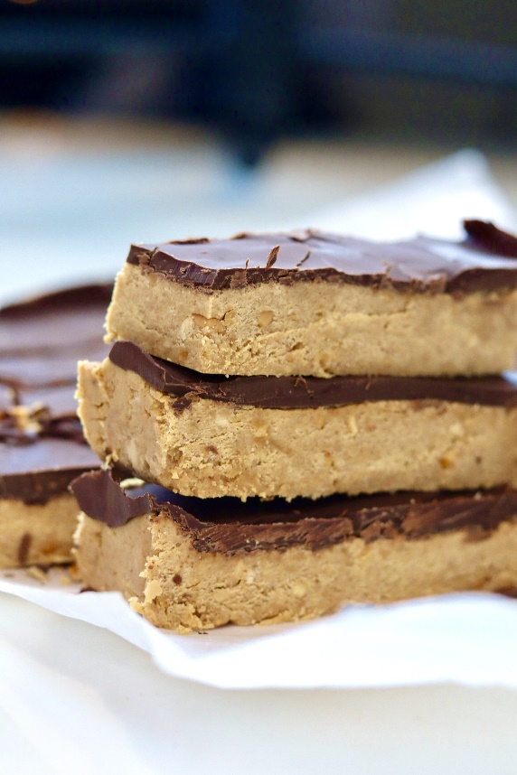
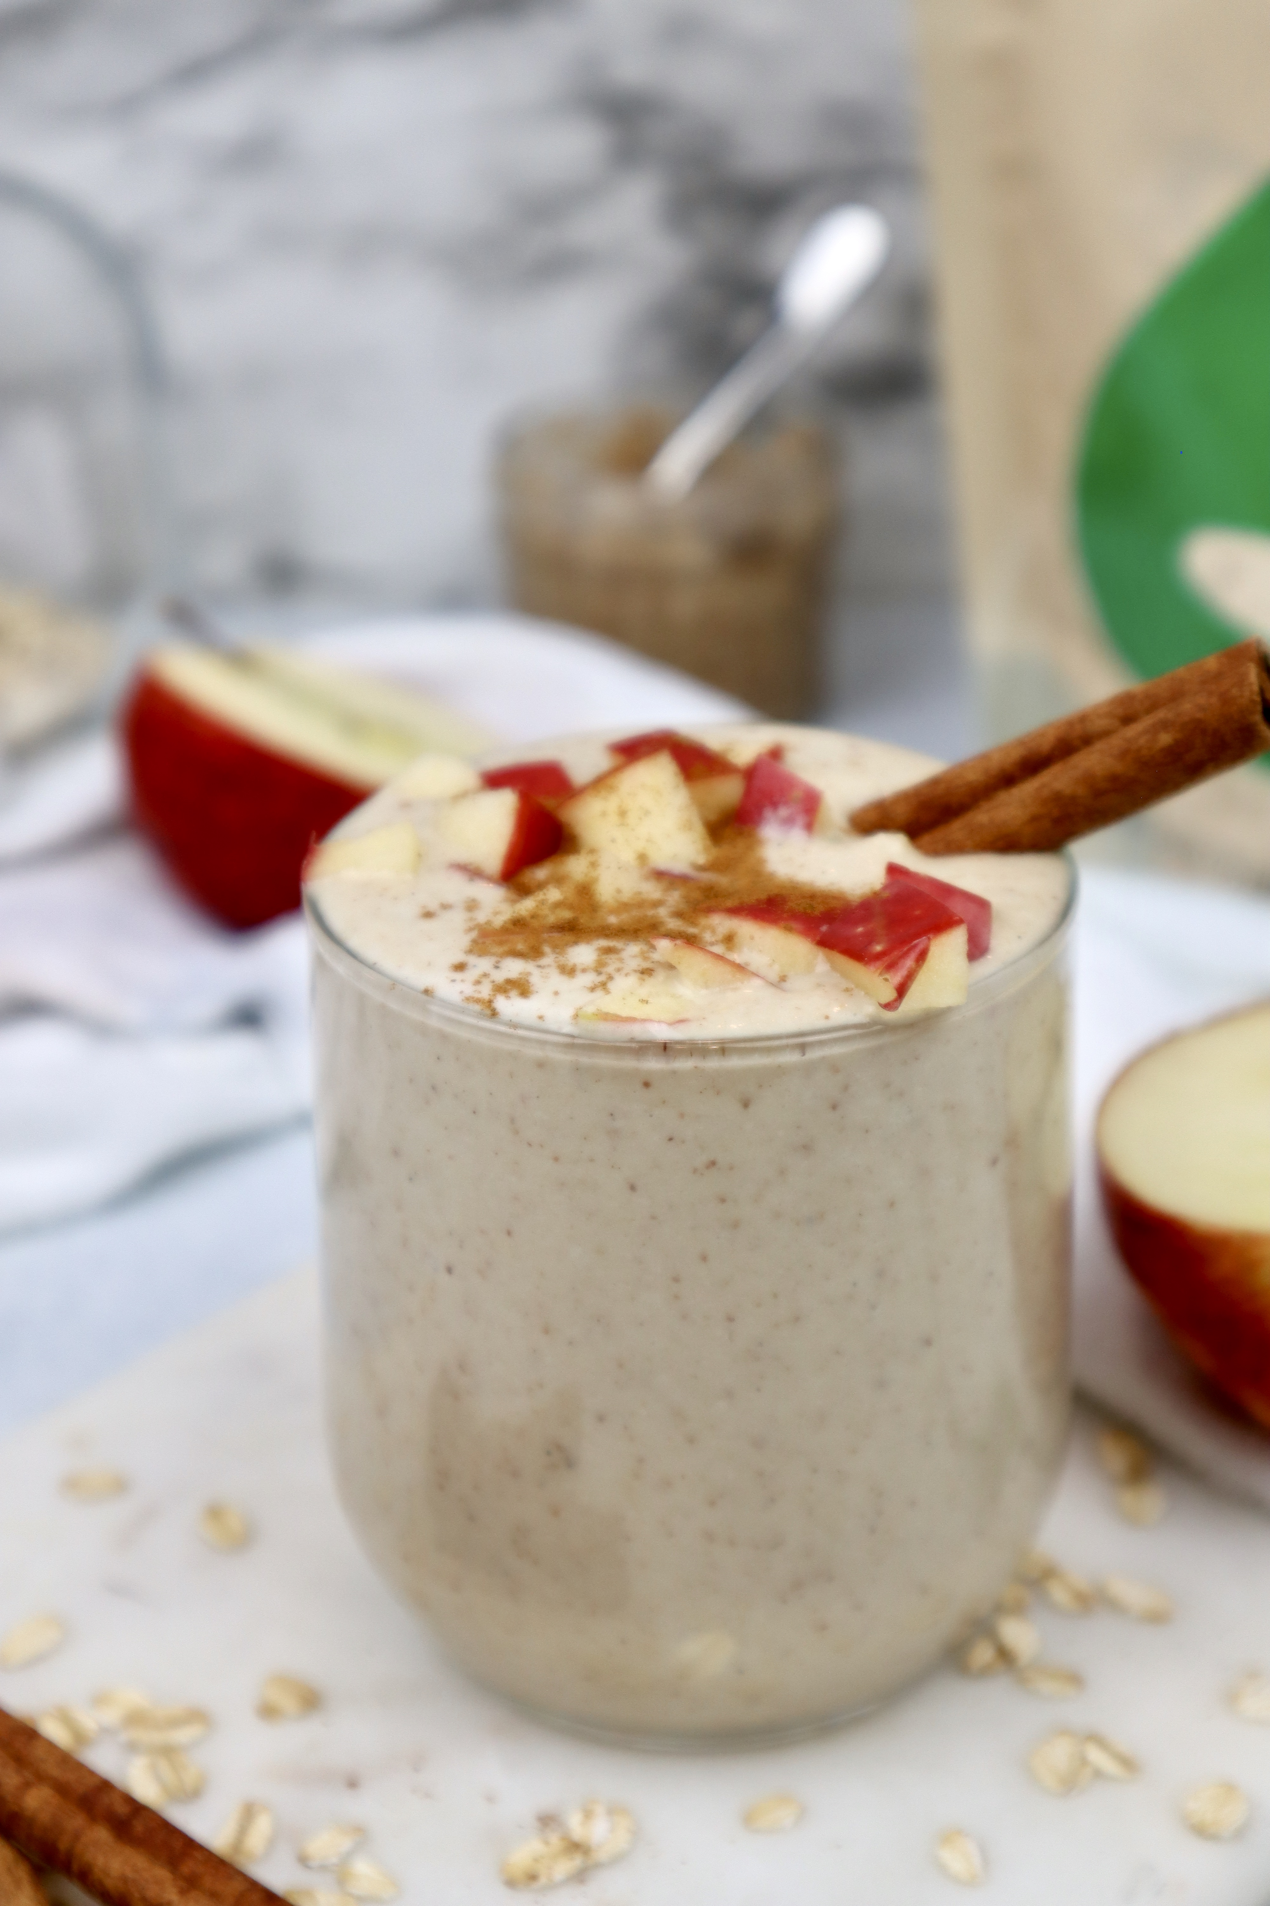

Email kip@nukindingredients.com or Cell phone 623-243-2525

