LOGO DESIGN BRIEF

COMPANY BACKGROUND
1. Company name to be used in the logo? *Only one name can be used.

CLEO Jewellery

2. Is there a unique story behind the name and business or why you started this business in the first place? This can be something about the owner, business history, etc.

Wendy has always been a highly creative person. With a successful career in marketing, she’s worked for various major B2B brands. She loves her job, but she also had other passions that she wanted to pursue. She is a mother of two and enjoys balance in her life, spending time with her family and friends and staying fit and healthy.

When the COVID-19 pandemic hit she discovered silversmithing as an outlet for the challenges.
Wendy had always loved jewellery, especially chunky and unique items, and she decided to learn how to make her own. She spent every waking hour that she could on silversmithing, finding it therapeutic and rewarding. She loved the process of designing, shaping, soldering, polishing, and finishing her pieces.

Fast forward four years and Wendy has completed diplomas in Silversmithing and Fine Jewellery. Wendy’s first brand, the Little Silver Studio, served well as a sandpit to practice her skills and sell practice pieces.

Launching CLEO
CLEO Jewellery was waiting for the right time when Wendy felt her skills were honed and she was ready to launch a bigger and more professional brand. She named her brand CLEO Jewellery, after the ancient Egyptian queen Cleopatra who was known for her power, intelligence, and beauty.
Wendy wanted CLEO to embody the values of Queen Cleopatra in the modern women through jewellery. She creates jewellery that is beautiful, bold, and multifaceted, just like the women who wear it. She celebrates the diversity and complexity of women, and to encourage them to embrace all the different parts of their lives. She makes jewellery that can suit any occasion, mood, or style, and that make women feel confident and empowered.
3. Please describe what your business does and who it's targeting ?
I make and sell hand-made jewellery – predominantly out of silver and a little gold.
You can see examples of the kind of thing I make here on my previous brand – my favourite items are hammered silver earrings, and bracelets, and the more ornate scarab beetle necklaces (with and without wings): Instagram.com/thelittlesilverstudio

Target Audience:
Women (or people who identify as female) – 35-55 years of age - who want to stand-out and be seen - The style is to suit an edgy, feminine, professional persona. She looks after herself, is stylish, quite smart and wants to be noticed.

They may be ambitious leaders or influencers – they are used to being centre-stage. They embody the traits of a successful person.

They are multifaceted women – many things to many people. Career women, leaders, mothers, multi-talented.

4. Do you have a particular culture or set of brand values you want to portray in your logo?
Respect | Hard work | Women power | Balance | Discipline | Integrity | Health and mental health

5. If you have an existing brand identity, why isn't it working for you?

The Little Silver Studio was my place to try out everything. It was all about me and didn’t focus on my target audience. I never sat down and tried to create a brand – I just made all kinds of jewellery and some friends and family bought some of my items. I didn’t have a website, a consistent brand and it didn’t flourish as a business.

PROJECT OVERVIEW
1. Do you have a specific idea in mind for your logo?
Yes – I have some ideas on the PPT that I sent you. I would like CLEO Jewellery written (If it looks much better I would consider Cleo in lower case but I think I prefer CLEO in upper case).
2. Do you have a slogan you want incorporated in your logo?

No
3. Try thinking of your logo as having a personality; which adjectives would you use to describe it? What words would you choose to describe your desired vibe and look?
Please choose between 3-5 adjectives: modern, classic, vintage, flat minimal, calm and serious, luxury, playful, loud and lively, quiet, subtle, soft.

Luxury | Feminine | Bold | Modern
4. Do you have any color preferences for your logo?

This is my colour palette – please don’t use gold as most of my jewellery is silver:
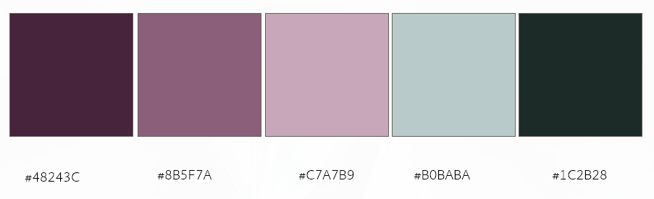

5. Do you have specific icon, symbol or image that you wish or do not wish to be included in your logo? Or are you looking for text based logo (typography logo)?
I would like versions of both. CLEO Jewellery (without icon) and CLEO Jewellery with icon. Possibly a scarab beetle holding a jewel or gemstone. I had a play below – I like how the scarab beetle is holding a jewel (as in some of my pieces of jewellery). But there is more detail on the beetle than I would like. I would like the lines of the beetle to complement the font too:
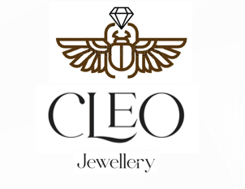
Please don’t use any imagery that it too Egyptian such as a pharaoh, Cleopatra herself or – I don’t want to be that obvious.
6. Are there any inspiring visuals associated with your business?
Scarab beetle | Gemstone: 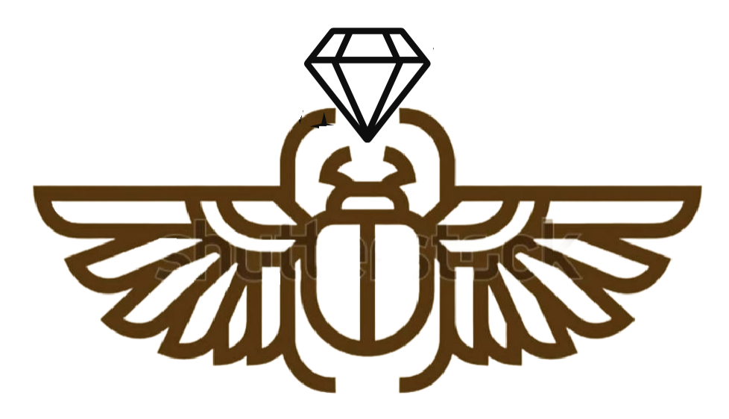 
7. Any font styles that you like and why? Any font styles that you dislike and why?
Unique & Classy Font Bundle | Creative Market – (4th option down)
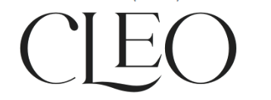 I like how the E sits on top of the L

Please include some examples of logos that you like which I could use for inspiration. This would help me to understand your graphic design style preferences better. *This point is mandatory.

