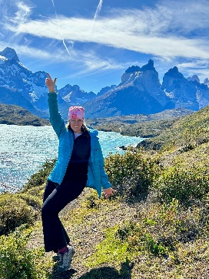

Experiential Luxury: Australia ~New Zealand~Chile~Canada

The Antipodal portfolio:
Australia: Luxury Lodges of Australia
Qualia Great Barrier Reef
Baillie Lodges:
Capella Lodge; Longitude 131°; Silky Oaks Lodge; Southern Ocean Lodge; The Louise

New Zealand: Huka Lodge, Taupo, North Island
FLOCKHILL Lodge, South Island
The Lindis Group, North & South Islands

Canada: Clayoquot Wilderness Lodge ~ Baillie Lodges

Chile: Tierra Hotels ~ Baillie Lodges


Luxury Lodges of Australia
A collection of independently owned and operated luxury lodges and high-end camps located in some of our most inspiring and uniquely Australian regions. Our luxury is deeply connected to exclusivity of access to Australia's extraordinary locations and people. Each lodge has created signature experiences and activities to showcase the unique and outstanding aspects of its region – precious natural landscapes and wildlife, both land and
marine, our First Nations peoples and culture, our rich and diverse food and beverage scene, positive impact and more. It is these experiences that define Australian luxury and showcase Australia’s extraordinary diversity. www.LuxuryLodgesofAustralia.com.au

Baillie Lodges: Australia~New Zealand~Chile~Canada
Baillie Lodges is an intimate portfolio of luxury lodges setting new benchmarks for premium experiential travel. Set in exclusive locations of unique natural or cultural significance, the boutique properties appeal to the discerning global traveler seeking a remarkable experience. Combining world-class local dining, design that welcomes the outside in, interiors that reflect the environment and its community as well as genuine, first name service, the collection is renowned for setting benchmarks in premium experiential travel. The Australia-based collection was founded in 2003 by James and Hayley Baillie and includes Longitude 131° at Uluru-Kata Tjuta, Capella Lodge on Lord Howe Island and Silky Oaks Lodge at the Daintree Rainforest. Flagship property Southern Ocean Lodge on Kangaroo Island was destroyed in the 2020 bushfires and its rebuild is currently underway with a reopening planned for December 6, 2023. Most recently, Tierra Hotels in Chile, Clayoquot Wilderness Lodge on Canada’s Vancouver Island and New Zealand’s Huka Lodge joined the Baillie Lodges portfolio, marking the collection’s foray into international waters. www.BaillieLodges.com.au

Capella Lodge, Lord Howe Island, New South Wales ~Baillie Lodges
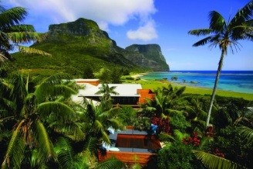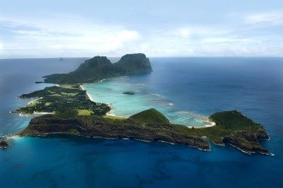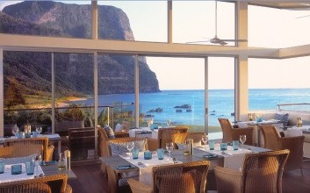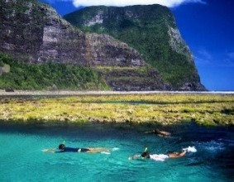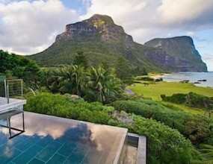

Celebrated as the pinnacle of luxury on World Heritage-listed Lord Howe Island, Capella Lodge rests atop romantic Lovers Bay and welcomes spectacular views of the ocean, reef and mountains. A feeling of relaxed sophistication attracts the discerning experiential traveler, and guests seeking a civilized sub-tropical island escape, home to the world’s most southern coral reef. Luxurious surrounds, exceptional island-inspired dining and a barefoot luxury vibe, combine to create an outstanding lodging experience. 9 Suites|10+ yrs www.CapellaLodge.com.au

Longitude 131, Uluru-Kata Tjuta, Northern Territory ~Baillie Lodges
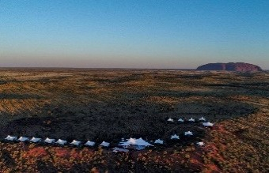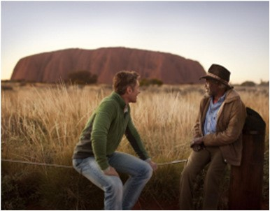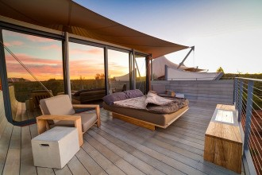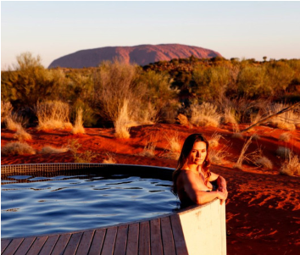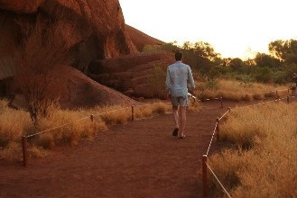

Longitude 131° offers immersion in the Australian outback, a true sense of stillness and beauty in this desert landscape, rich in cultural heritage and history. Luxury tented pavilions yield unparalleled views of fabled icon Uluru (Ayers Rock). Combining exclusive ‘Red Centre’ experiences, local cuisine and world-class service, Longitude 131° delivers an unforgettable encounter. 16 Tents | 10+ yrs www.Longitdue131.com.au

Silky Oaks Lodge, Daintree Rainforest, Queensland ~Baillie Lodges
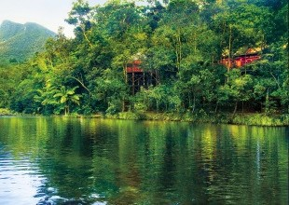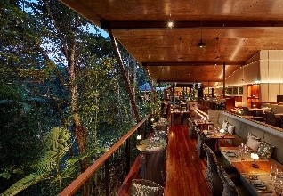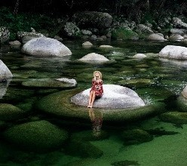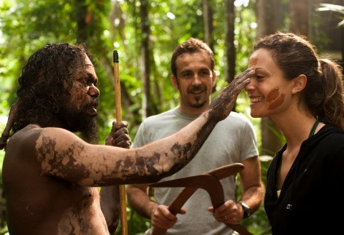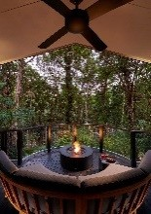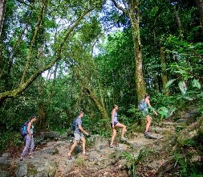

Long regarded as Tropical North Queensland’s luxury basecamp, Silky Oaks Lodge is ideally located for access to the region’s spectacular natural attractions, including the Daintree Rainforest, Mossman Gorge, the Great Barrier Reef and Cape Tribulation. With views over the crystal-clear Mossman River and enveloped by the lush rainforest, guests relax in one of forty private treehouses. The generously inclusive tariff offers tropical breakfast, dinner with inspired daily menu matched with selected premium wines, signature evening drinks’ hour (including canapés), selected in-suite bar, guided rainforest walk, morning yoga class and one return scheduled shuttle to Port Douglas per day. Following a $20 million refurbishment, the new-look luxury lodge reopened December 2021. 40 suites | 10+ yrs www.SilkyOaksLodge.com.au

Southern Ocean Lodge, Kangaroo Island, South Australia ~Baillie Lodges
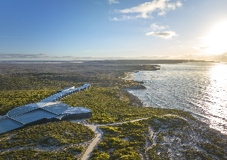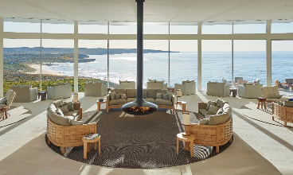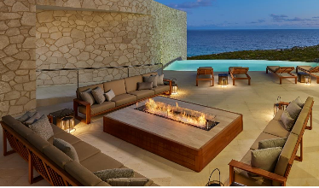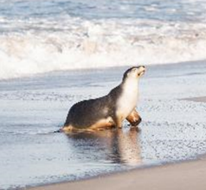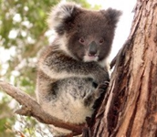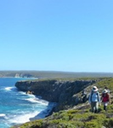
The rebuild for the iconic Southern Ocean Lodge commenced in February 2022 and a reopening date of December 6, 2023. SOL 2.0 will be located in the same magnificent clifftop location above Hanson Bay, the design will be similar to the original with beautiful enhancements and a slightly larger inventory of 25 suites. The suites will have maximized views and added amenities, and there will be a new premium four-bedroom Ocean Pavilion, sitting atop the cliffs. The Spa and Fitness center (new), will offer enhanced space and serenity. Follow the rebuild on social media: IG - SOL 2.0 25 Suites | 10+ yrs www.SouthernOceanLodge.com.au

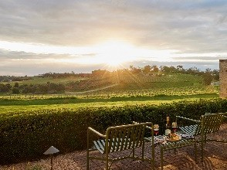
The Louise, Barossa Valley, South Australia ~Baillie Lodges
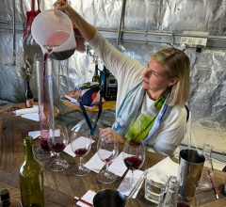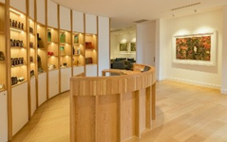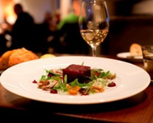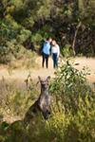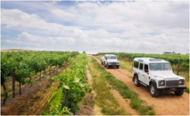
Now apart of the Baillie Lodges’ portfolio, The Louise, an idyllic luxury vineyard retreat, encompassing acclaimed restaurant Appellation, is situated on a gentle hill surrounded by hundreds of acres of vines, with breathtaking vistas across the world famous Barossa Valley. Work has begun on Baillie Lodges redesign of acclaimed luxury lodge slated for reopening September 5th. The $3 million ‘glamover’ will deliver a new experience of the Barossa for local and overseas guests, starting with generous villa-style suites opening to the valley’s picturesque rolling vineyards, and extending to a revitalized dining and drinks scene – a newly designed restaurant, walk-in Wine Cellar, Private Dining Room and Speakeasy Bar. Guests enjoy access to personalized tours of the region’s gourmet and cultural attractions. 15 Suites. www.TheLouise.com.au

qualia, Hamilton Island, Queensland
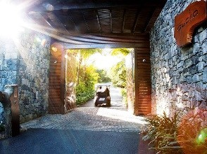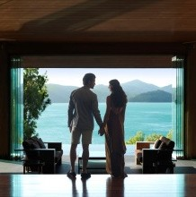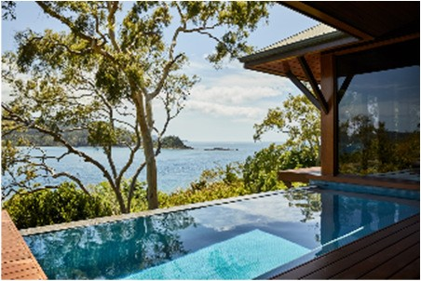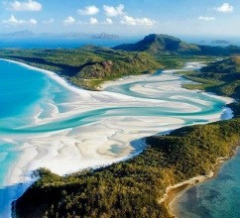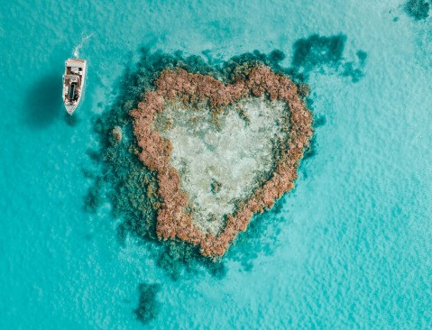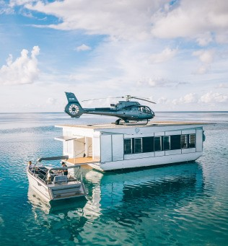

qualia, located on Hamilton Island offers an exquisite Great Barrier Reef experience. Unsurpassed beauty, sophistication, privacy and intuitive service allow you to unwind and immerse yourself in the quintessential Great Barrier Reef experience. qualia is a rare destination where everything has been meticulously considered so it relaxes the mind, yet completely spoils the senses. Recommended 3-4 night stay to allow for exploration of Hamilton
Island, cruise to Whitehaven Beach and journey out to the Great Barrier Reef. 60 Pavilions |16+ yrs www.qualia.com.au

Chile: Tierra Hotels : Atacama, Chiloé and Patagonia ~Baillie Lodges

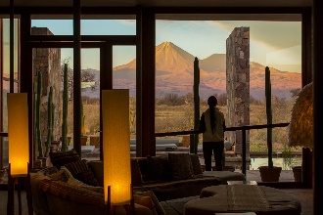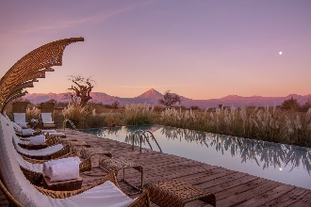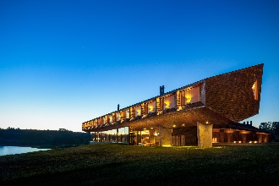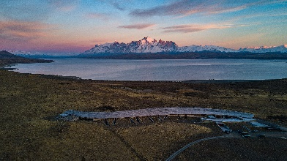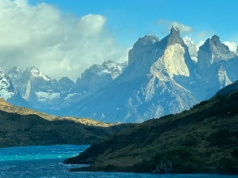
Tierra Hotels are a collection of small boutique hotels located throughout Chile, showcasing the country’s diverse natural landscapes. These remote and beautiful regions of South America – Tierra Atacama is to be found in the arid, colorful landscapes of the Atacama Desert; Tierra Chiloé on the mythical Chiloé Island, steeped in legends and with a rich culture; and Tierra Patagonia, blending into the magnificence of the endless pampas and mountains of Torres del Paine National Park in Patagonia. These properties are family run and welcoming to children 10+ yrs. These lodges are some of the most sustainable hotels in Chile, with a tangible energy and a true connection to place. 28-40 suites | 10+ yrs Info@tierrahotels.com

Canada: Clayoquot Wilderness Lodge, Vancouver Island, British Columbia ~Baillie Lodges
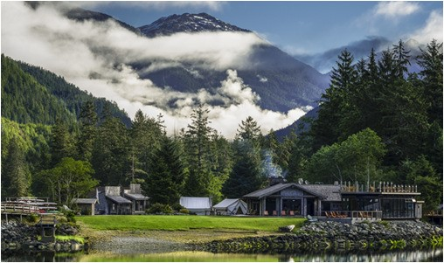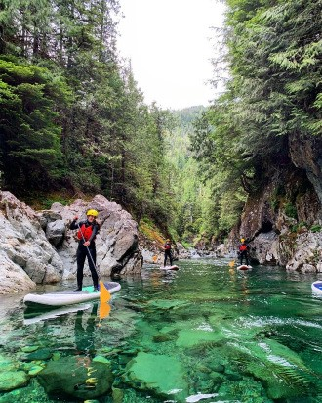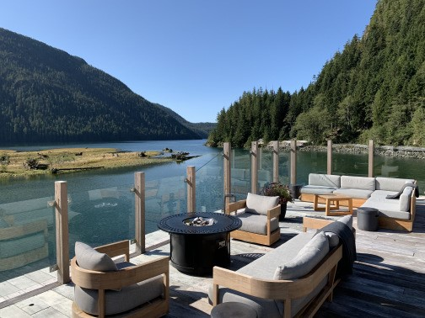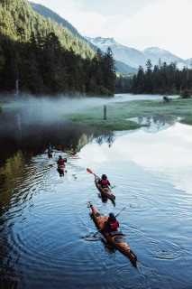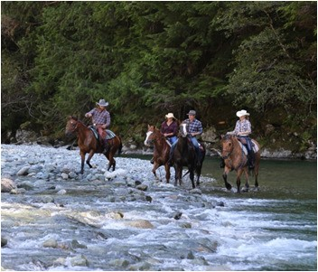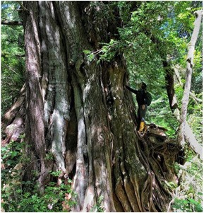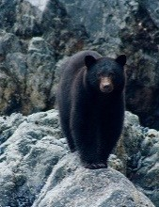

Clayoquot Wilderness Lodge, located in the naturally remote Vancouver Island, British Columbia, delivers wild, luxury under canvas. Clayoquot delivers a true Canadian Safari experience. Fully inclusive to a premium, your glamping experience includes a generous spirit of hospitality. Wake up to the sights and sounds of the wild; fill your days with our inclusive exploration of our old growth forest: guided hiking, mountain biking, horseback riding, kayaking, canyoning, fishing, archery, and rock climbing. Jump in a zodiac in search of black bears, humpback whales, orcas, sea lions, bald eagles and sea otters. 3nt, 4 nt &7 nt stays with arrivals on Sundays & Thursdays. 25 tents | 6+ yrs www.ClayoquotWildernessLodge.com

New Zealand

Huka Lodge, Taupo, North Island ~Baillie Lodges
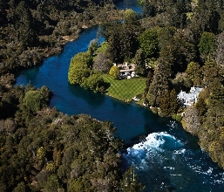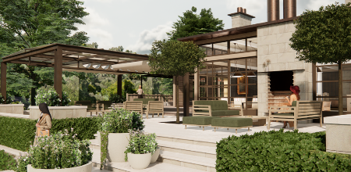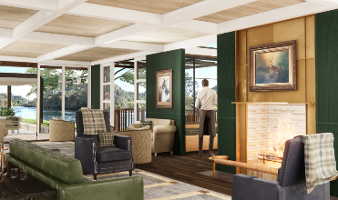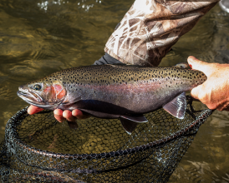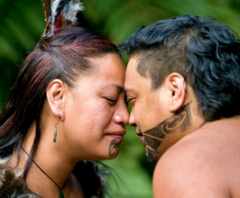
Huka Lodge, one of New Zealand’s fly fishing premium lodges, offers a sensory and sublime experience. Now apart of the Baillie Lodges’ portfolio, Huka Lodge delivers warm hospitality and breathtaking views of the the Waikato River. Enjoy the exceptional culinary experience and explore the wide range of experiences available in the Taupo region - Fly fishing, boating, hiking, rafting, cultural Maori experiences, golf, jet boating, spa and wellness, heli excursions and bungy jumping. A 3 night stay is ideal 22 Suites/Residences www.hukalodge.com

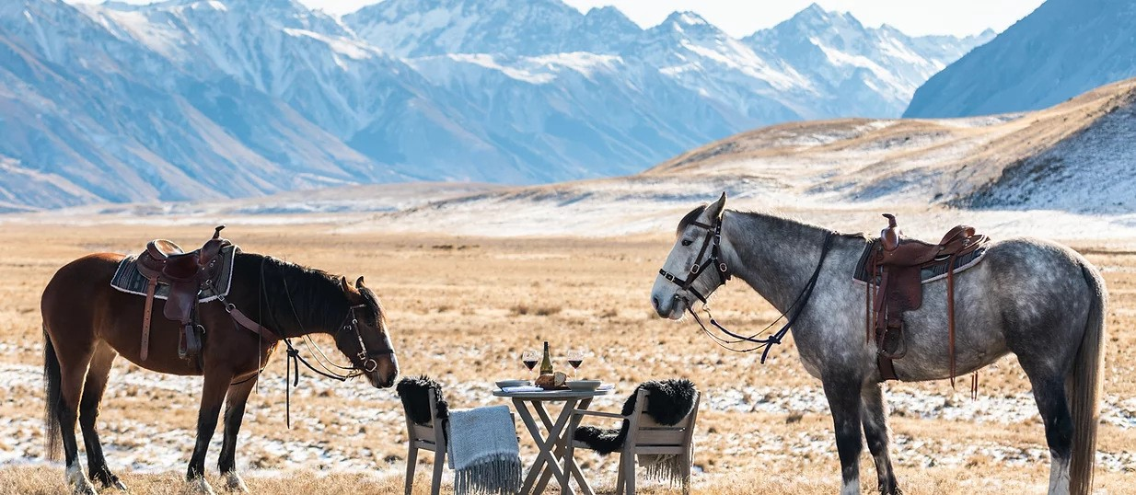
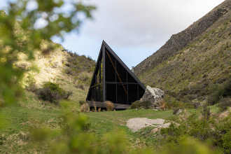
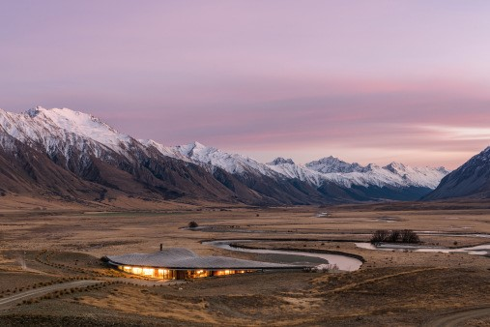
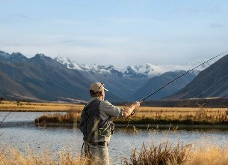
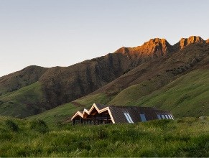
The Lindis Group, North & South Islands

As New Zealand’s unmatched portfolio of destinations—The Lindis, Paroa Bay and Mt Isthmus—all boasting some of New Zealand’s most amazing scenery, and refined yet artistic architecture to complement the environments. Our flagship property—The Lindis—is a beautifully modern lodge residence. Nestled almost imperceptibly in the Ahuriri Valley in the country’s South, the lodge is architecturally designed to mimic the rolling contours of the high-country valley floor. The Lindis: 5 Lodge suites and 3 Pods www.thelindisgroup.com
These distinctly New Zealand destinations provide us with so much more than scenery. Firstly, the incredible flora and fauna from which we design our menus—utilizing ingredients such line caught Kingfish from the Bay of Islands and wild Fiordland Venison in the South—mean our culinary offerings, paired with our unparalleled selection wines, are matched only by the landscapes that surround them.
To the country’s North, in the Bay of Islands, you will find Paroa Bay & Winery—featuring three luxury villas, a winery estate, and Sage, our incredible restaurant. Located on the South Island is Mt. Isthmus, is a luxury sole use premium villa experience on the shores of the incredible Lake Hāwea. 4 bedrooms, Sole Use
FLOCKHILL Lodge, Craigieburn Valley, South Island
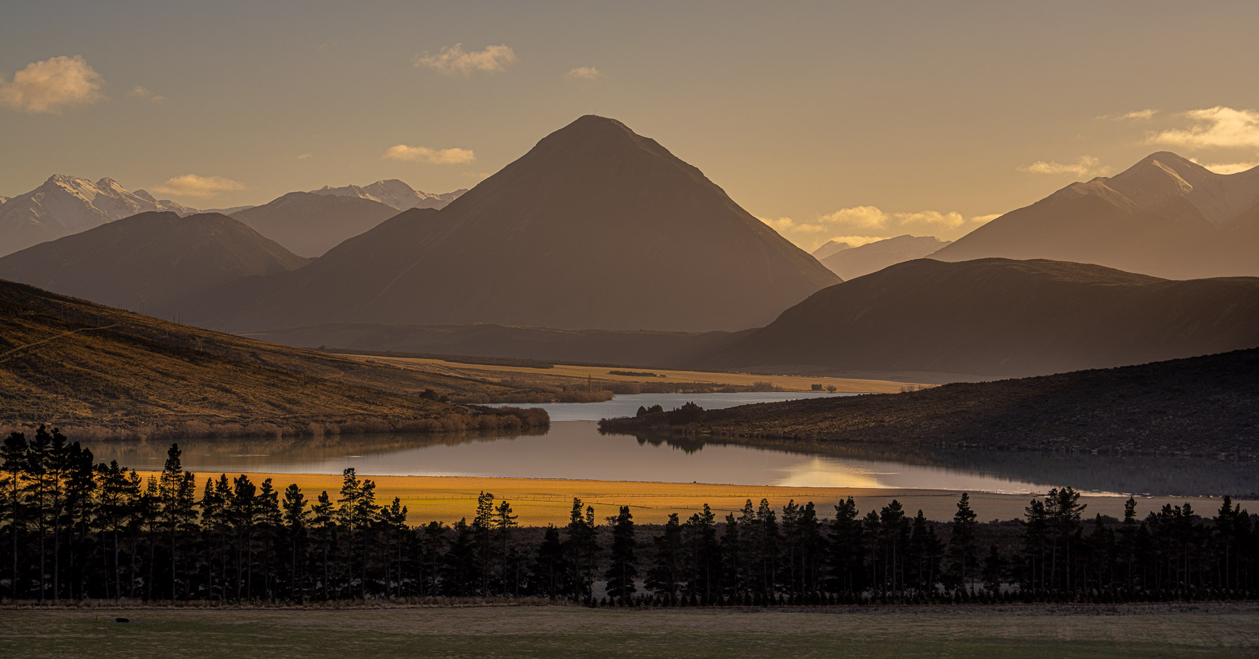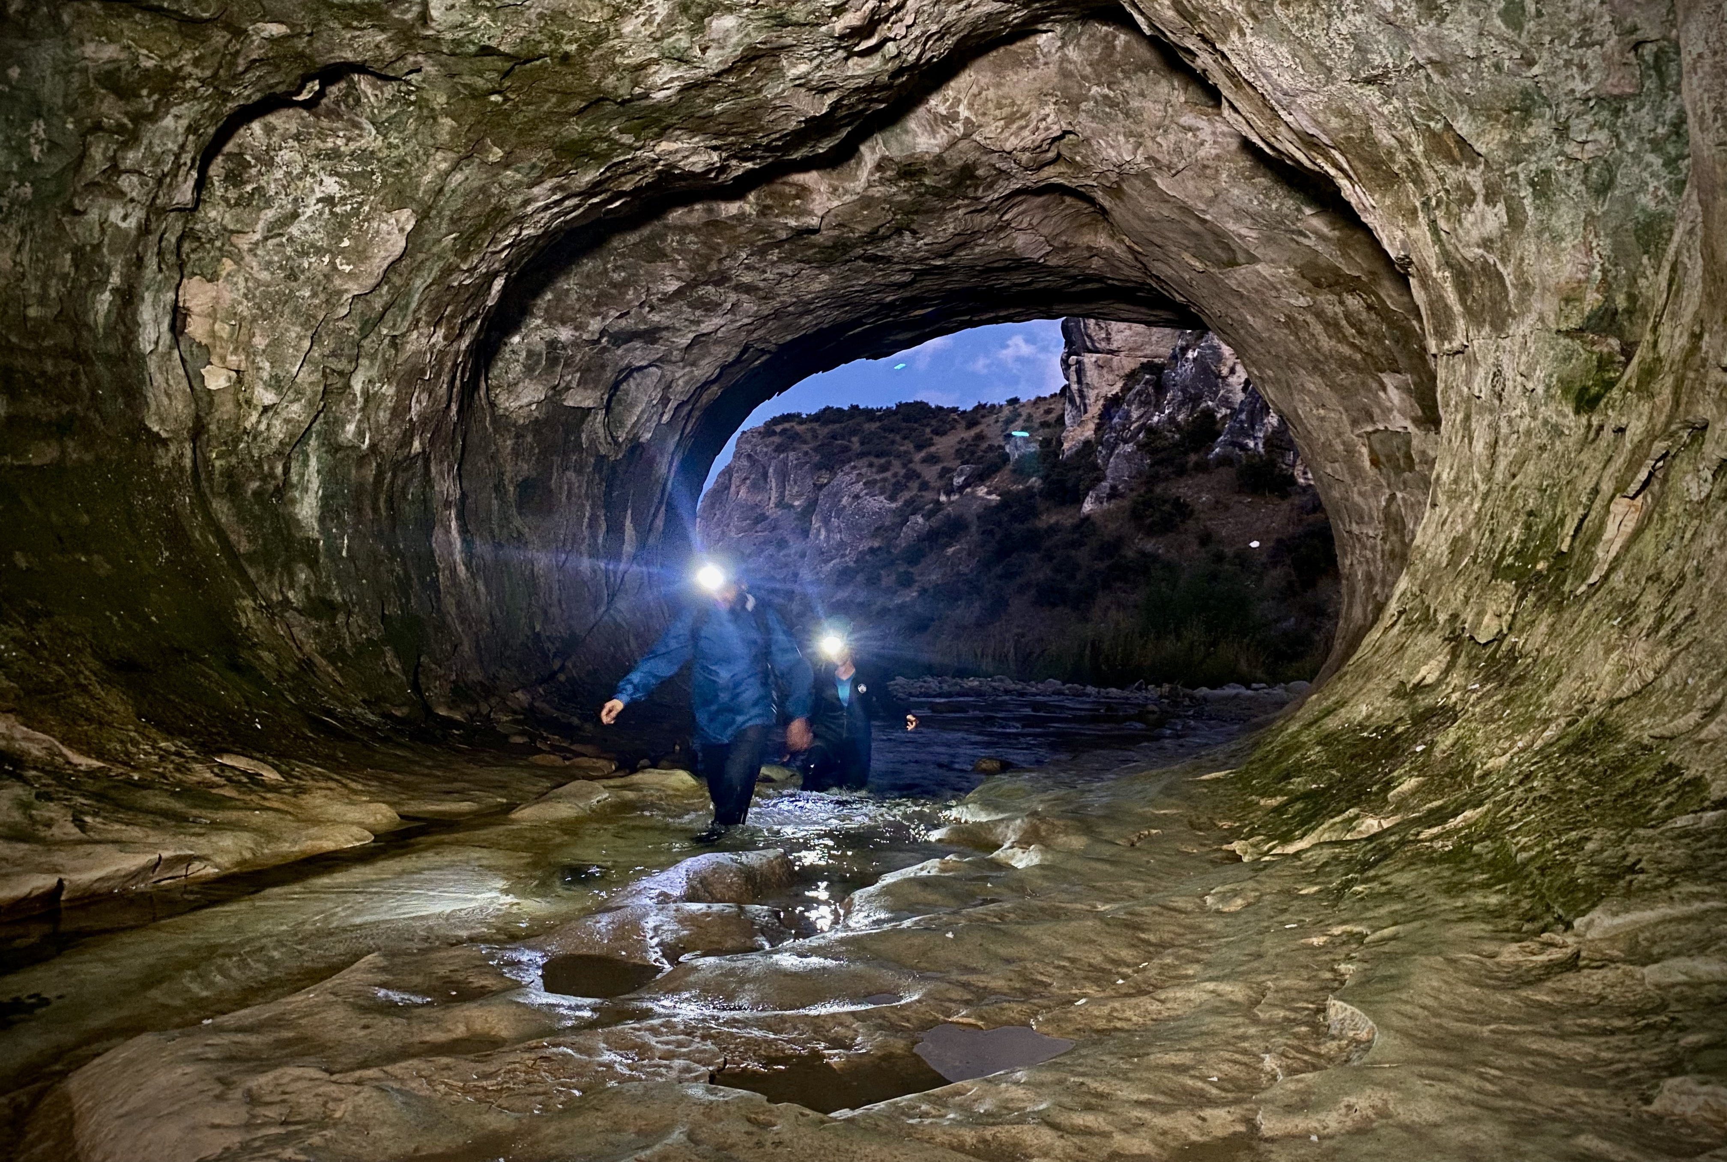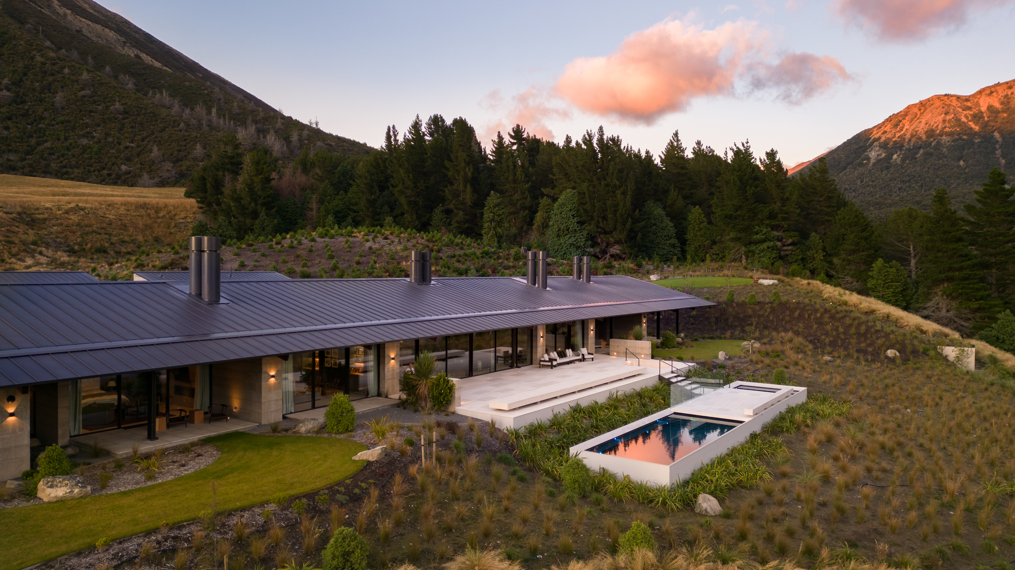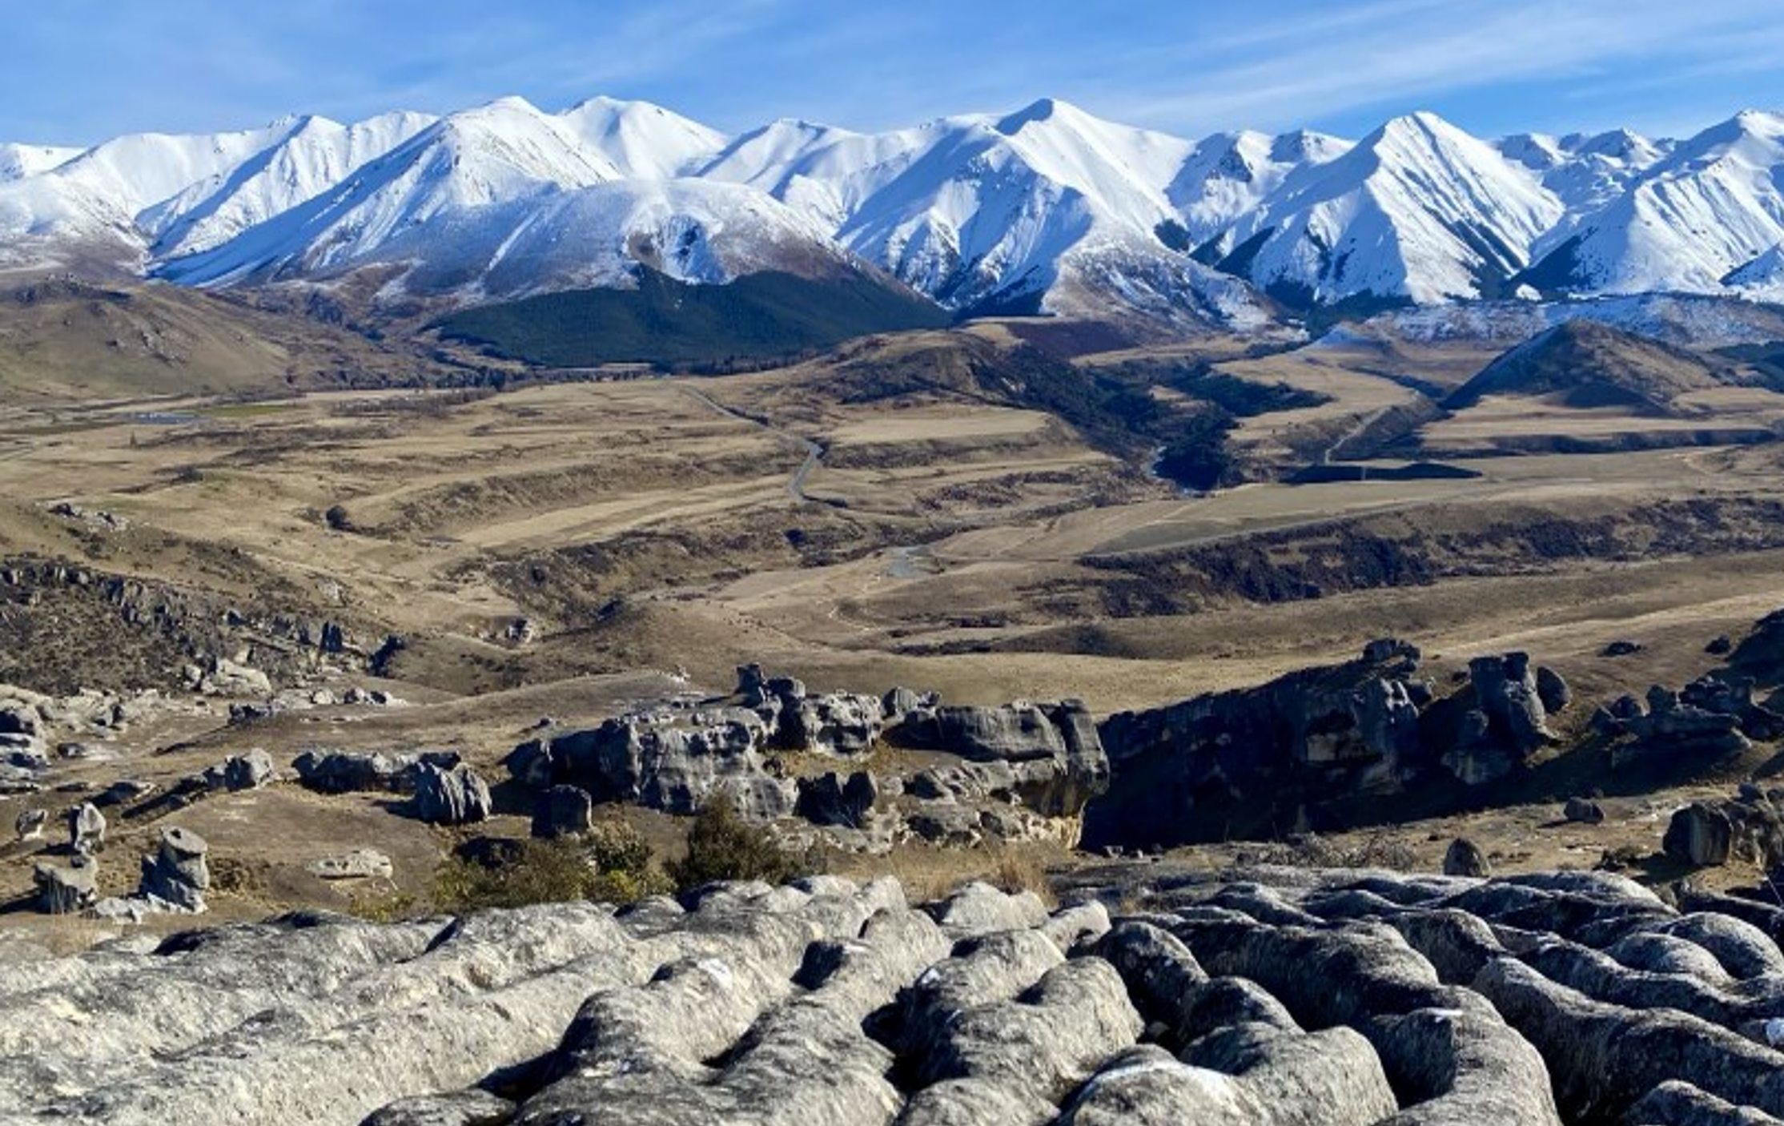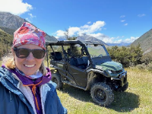

Located 90 min from Christchurch, the FLOCKHILL Lodge is comprised of the Homestead, a 4 bedroom villa set within 36000 naturally-pristine acres, (incidentally the Homestead can also be sold as a 2bd). FLOCKHILL inspires adventure and exploration. In an exclusive wilderness where nothing is manufactured, FLOCKHILL is far removed from the crowds, like having your own national park. We welcome those with an adventurous spirit and refined taste to delight in the FLOCKHILL experience which includes: a farm tour, bouldering, pack rafting, ATV touring, hiking, caving, e-biking, Station sheep musters or jet-boating. Itineraries can also be crafted for visitors to accommodate personal preferences, including exclusive off-site seasonal activities like heli-skiing, golf, hunting and wine tours.
December 2024 an additional 14 one-bedroom villas come into inventory along with a main Lodge and Sugarloaf restaurant. An alpine high country lodge with wild surroundings. FLOCKHILL delivers outdoor adventure : vast- dramatic- sensory. www.flockhillnz.com

