Logo Design Brief
GameHead
Contact Information:
Alan Hochman
Alan@pastimes.net
1. Company name
GameHead (could use any iteration of GameHead, gamehead, Gamehead, Game Head)
2. Company Description and Goal
We are a new company that manufactures and sells tabletop games, accessories and lifestyle items aimed at geek culture. We are looking for a modern looking, clean, professional logo which will be easily recognizable by customers. We want the logo to be clear on business cards and when stitched on a shirt or hat. We would like the company identity to be important to our customers - we are hoping it will bring a good feeling of confidence when they see the logo on a game or on our other items.
3. Customer / Demographic
The end user of our products is 18-40 years old, enjoys card games such as Magic the Gathering, Yu-Gi-Oh; role playing games such as Dungeons and Dragons and board games such as Exploding Kittens and Catan. This person also probably plays video games like World of Warcraft and enjoys playing games on their Switch.
Besides the end user, our customers are the retailers and distributors who carry our products and sell them to similar consumers. This is an important segment of our sales.
4. Products and Services
We sell a variety of products and will be expanding the lines of what we sell substantially over the next 12-24 months. You can see some of the items at www.gamermats.com
- Gamemats - mousepads, tcg playmats, wargaming mats, desk gaming mats and more
- Drinkware and coasters, mugs tumblers etc…
- Pins
- Stickers
5. What Brand Personality would we like to see in our logo?
Quality, Entertainment, Fun

6. Goals and expectations of your logo?
We want a logo that is professional, recognizable and that works easily into our company’s ability to use it for business cards, apparel, packaging, social media and on products. We want the logo to express a trustworthy, confident brand that creates and manufactures items for fans of games and pop culture.
7. Competitor Review:
Competitor 1: ____InkedGaming___________________________________________
This company sells many items we do, though our quality is better. Right now they have a better assortment of items, but we will have more in the next 12 months. Inkedgaming does not focus on being professional or selling to distributors or retail partners, they only focus on their online customer.

Competitor 2: ___Ultra Pro____________________________________________
This company makes many products, but focuses on licenses. This is good for them and we hope to have more licenses in the near future. People do not think this company has high quality, but customers like the art from the licenses this company has. They have been in the industry for a very long time and have a well established brand.

Competitor 3: _Rollacrit______________________________________________
This company is very similar to the items we are going to be selling - games and accessories

8. Design preferences
I appreciate the following logos because they are professional and work well on shirts, business cards and on their products. They are clean, but fun and very recognizable.

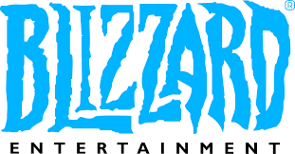 | 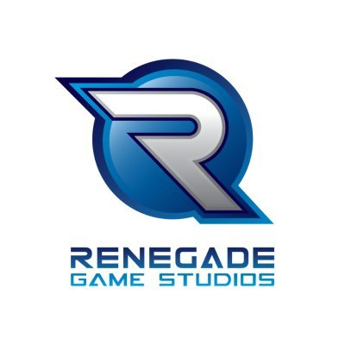 | 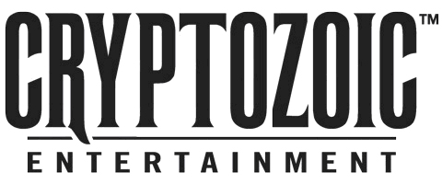
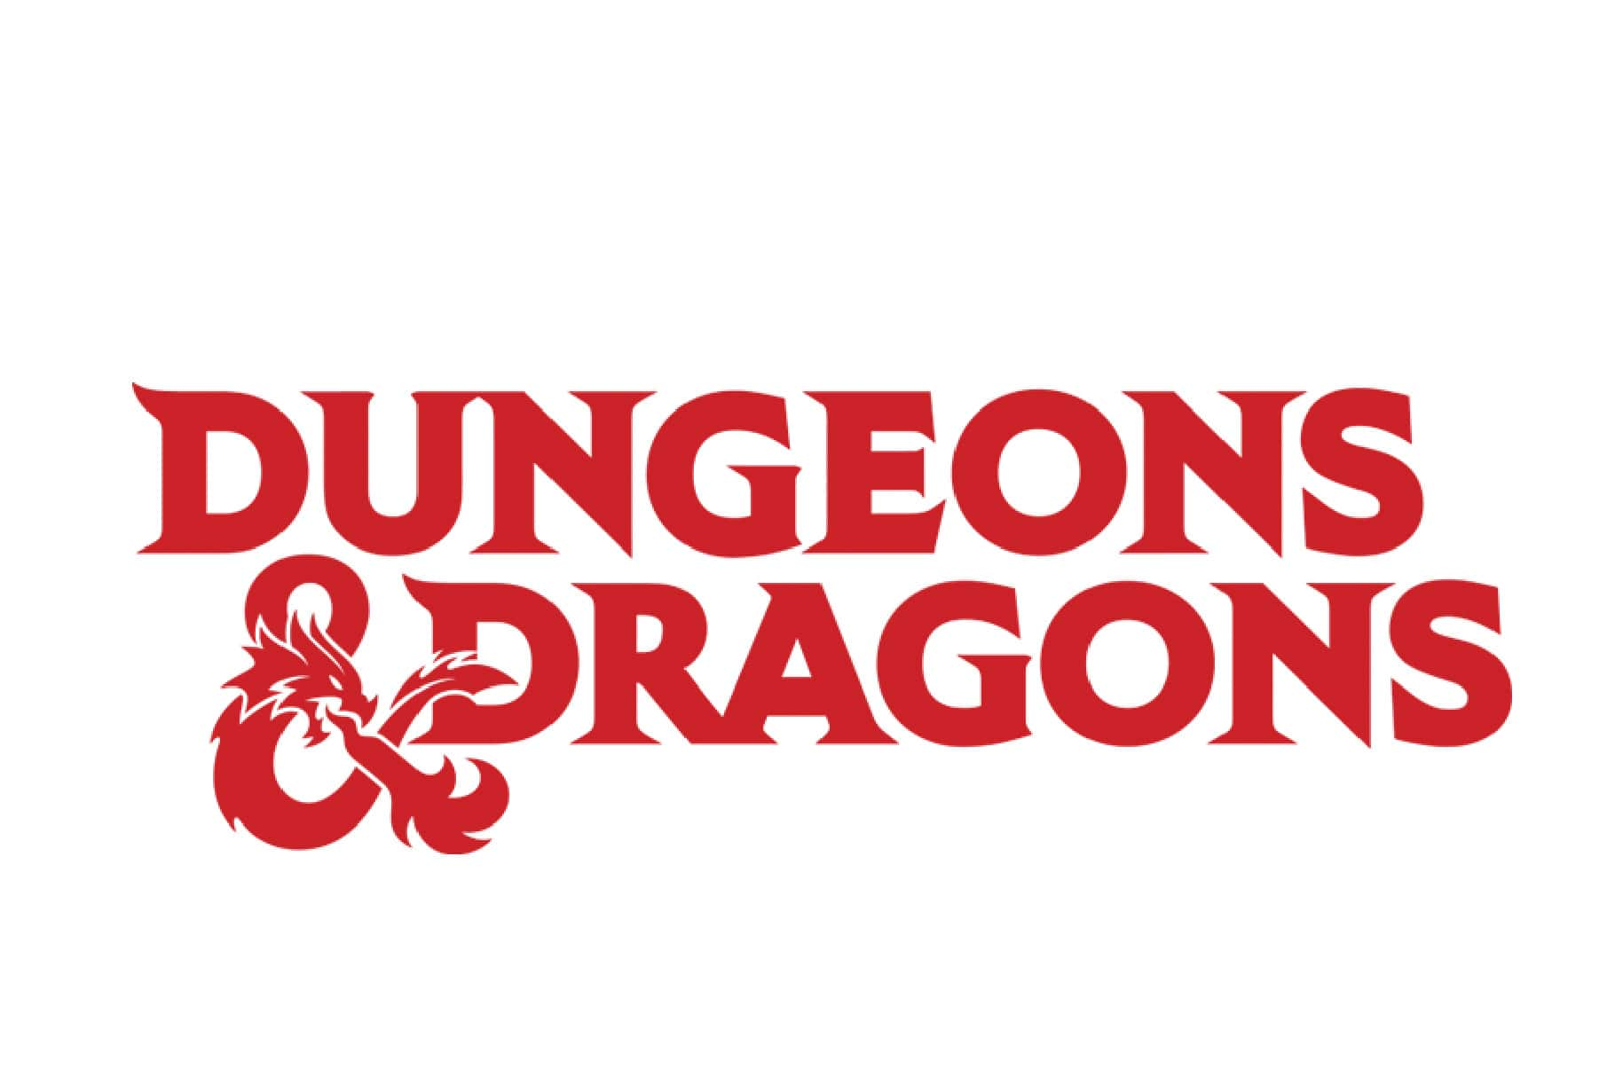 | 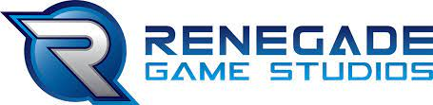 | 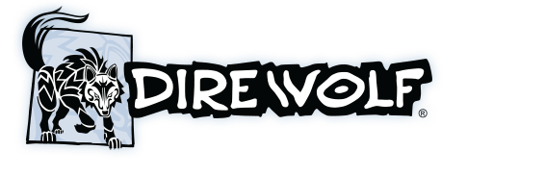
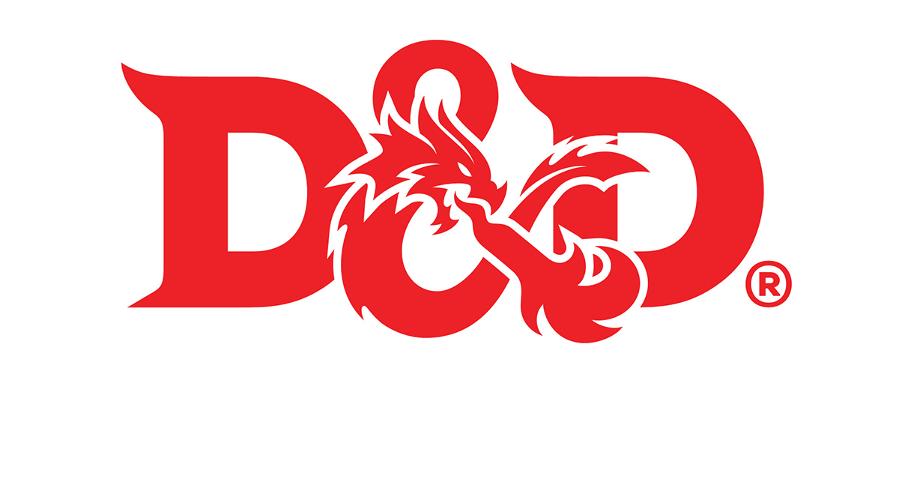 | 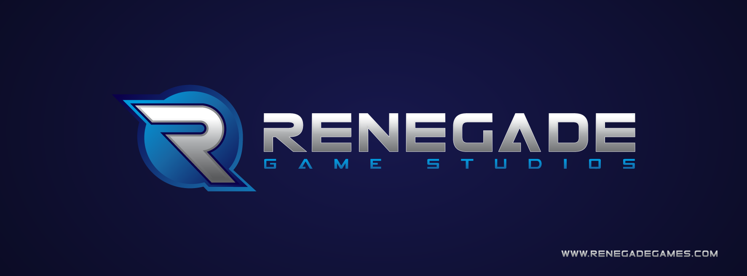 | 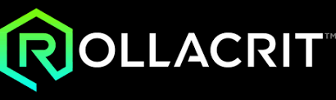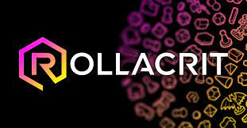
9. Colors?
We are open to suggestions. I believe most of the apparel the logo would go on would be black, so light colors such as light blue, or gold, orange or white all would work. Perhaps it would be a logo that is not color dependent?
10. Particular symbol that could be included in the logo?
No
Also - the name of the company is gamehead
I am not sure if we want it to be considered:
gamehead
GameHead
Gamehead
It could really be any of these. Mostly I want what looks best
11. Where will the logo be used?
Product packaging, such as boxes for games, on stickers, shirts, hats, coffe mugs etc….
12. What is the first impression you want when people see your logo?
Professional, fun, clean - see who our company is

13. What kind of logo do you think is good? Explain
I think a logo that quickly conveys the message of who we are and what we represent is good. The name of the company is important - we will build our reputation around that and create loyalty to that brand/logo
14. What are the important things to avoid
I do not want the logo to look too busy or cluttered. People should not have to work to figure out why this is our logo, or what does it say or mean.
15. Words or phrases you think of when you think of your Company?
Artistic, useful, fun, fantasy, quality, professional

